|  |  |
| --- | --- |
|  | **MINISTRY OF EDUCATION AND TRAINING** |

|  |
| --- |
| **FPT UNIVERSITY** |
| Capstone Project Document |
| **Student Counseling and Support System with Advanced Search at FPTU HCM Campus** |

|  |  |
| --- | --- |
| **GFA24SE27** | |
| **Group Members** | Trình Vĩnh Phát - Team leader - phattvse170042  Vũ Ngọc Hải Đăng - Team member - dangvnhse170225  Đoàn Tiến Phát- Team member - phatdtse170440  Phạm Trần Sơn Nguyên- Team member - nguyenptsse170048  Nguyễn An Khánh - Team member - khanhnase170431 |
| **Supervisor** | Mr. Huỳnh Công Việt Ngữ  Mrs. Lê Võ Minh Thư |
| **Capstone Project code** | FA24SE111 |

- Ho Chi Minh, November 2024 -

**Definition and Acronyms** 20

**I. Project Introduction** 21

**1. Overview** 21

**1.1 Project Information** 21

**1.2 Project Team** 21

**2. Product Background** 21

**3. Existing Systems** 21

**4. Business Opportunity** 22

**5. Software Product Vision** 22

**6. Project Scope & Limitations** 22

**6.1 Major Features** 22

**6.2 Limitations & Exclusions** 23

**6.2.1 Limitations** 23

**6.2.2 Exclusions** 23

**II. Project Management Plan** 24

**1. Overview** 24

**1.1 Scope & Estimation** 24

**1.2 Project Objectives** 25

**1.3 Project Risks** 25

**2. Management Approach** 26

**2.1 Project Process** 26

**2.2 Quality Management** 26

**2.3 Training Plan** 26

**3. Project Deliverables** 27

**4. Responsibility Assignments** 27

**5. Project Communications** 28

**6. Configuration Management** 28

**6.1 Document Management** 28

**6.2 Source Code Management** 28

**6.3 Tools & Infrastructures** 28

**III. Software Requirement Specification** 29

**1. Product Overview** 29

**2. User Requirements** 29

**2.1. Actors** 29

**2.2. Use Cases** 30

**2.2.1. Diagram(s)** 30

**2.2.2. Descriptions** 30

**2.2.2.1. Administrator Use Case Description** 30

**2.2.2.2. Counselor Use Case Description** 32

**2.2.2.3. Manager Use Case Description** 34

**2.2.2.4. Support Staff Use Case Description** 35

**2.2.2.5. Student Use Case Description** 36

**3. Functional Requirements** 37

**3.1. System Functional Overview** 37

**3.1.1. Screens Flow** 37

**3.1.1.1. Administrator Screen Flow** 37

3.1.1.2. Counselor Screenflow 38

3.1.1.3. Manager Screen Flow 39

3.1.1.4. Support Staff Screenflow 40

3.1.1.5. Student Screenflow 40

**3.1.2. Screen Descriptions** 41

3.1.2.1. Administrator Screen Description 41

**3.1.2.2. Counselor Screen Description** 42

**3.1.2.3. Manager Screen Description** 44

3.1.2.4. Support Staff Screen Description 45

3.1.2.5. Student Screen Description 45

**3.1.3. Screen Authorization** 47

**3.1.3.1. Web Screen Authorization** 47

**3.1.3.2. Mobile Screen Authorization** 49

**3.1.4. Non-Screen Functions** 49

**3.1.5.1 Conceptual Model** 50

**3.1.5.2 Logical Model** 50

**3.2. Functional requirements** 52

**3.2.1. Accounts Feature** 52

**3.2.2.** **Authentications Feature** 53

**3.2.3.** **Booking Counseling Feature** 54

**3.2.4.** **Appointment Feature** 56

**3.2.5.** **Q&A Feature** 57

**3.2.6. Counseling** **Demand Feature** 58

**3.2.7. Dashboards Feature** 59

**3.2.8. Manage Student Feature** 59

**3.2.9. Manage Counselor Feature** 61

**4. Non-Functional Requirements** 63

**4.1. External Interfaces** 63

**4.1.1. User Interfaces** 63

**4.1.2. Communications Interfaces** 64

**4.2. Quality Attributes** 64

**4.2.1. Usability** 64

**4.2.2. Reliability** 64

**4.2.3. Performance** 64

**4.2.4. Security** 64

**5. Requirement Appendix** 64

**5.1. Business Rules** 64

**5.2. Common Requirements** 65

**5.3. Application Messages List** 65

**5.3.1. Web application** 65

**5.3.2. Mobile application** 68

**IV. Software Design Description** 70

**1. System Design** 70

**1.1. System Architecture** 70

**1.1.1. Overall System Architecture (TBD)** 70

1.2. Package Diagram 71

1.2.1. Web Application Package Diagram (TBD) 71

1.2.2. Mobile Application Package Diagram 72

**1.2.3. Backend Application Package Diagram** 74

**2. Database Design** 75

**2.1. Database** 75

**2.2. Data Dictionary** 75

**2.2.1. Academic counselor table** 75

**2.2.2. Academic_transcript table** 76

**2.2.2. Account table** 76

**2.2.3. Appointment feedback Table** 76

**2.2.4. Appointment_for_demand table** 77

**2.2.5. Appointment_report  table** 77

**2.2.6.** **attendance_detail table** 77

Table 46 - attendance_detail tabel 77

**2.2.7. Available_date_range table** 78

**2.2.8. certifications table** 78

**2.2.9. Chat_session table** 78

**2.2.10. contributed_question_card_category table** 78

**2.2.11. contribution_question_card table** 79

**2.2.12. Counseling_appointment table** 79

**2.2.9. Counseling_appointment_request** 79

**2.2.10. Counseling_demand Table** 80

**2.2.11. Counseling_slot table** 81

**2.2.12. Counselor table** 81

**2.2.13. Counselor_slot table** 81

**2.2.14. Demand_problem_tag table** 81

**2.2.15. Department table** 82

**2.2.16. Expertise table** 82

**2.2.18. Login_type table** 82

**2.2.19. Major table** 82

**2.2.20. Message table** 82

**2.2.21. Non_academic_counselor table** 83

**2.2.22. Notification table** 83

**2.2.23. Offline_appointment  table** 83

**2.2.24. Online_appointment table** 83

**2.2.25. Problem_category  table** 83

**2.2.26. Problem_tag  table** 84

**2.2.27. Profile  table** 84

**2.2.27. qualifications table** 84

**2.2.28. Question_ban table** 85

**2.2.29. Question_card  table** 85

**2.2.30. Question_flag  table** 86

**2.2.31. Semester table** 86

**2.2.31. slot_of_counselor table** 86

**2.2.32. Specialization table** 86

**2.2.33. Student table** 87

**2.2.34. Student_counseling_profile table** 87

**2.2.35. student_following table** 87

**2.2.35. student_study table** 88

**2.2.35. Support_staff  table** 88

**2.2.36. Topic table** 88

**2.2.37. Certifications table** 89

2.2.38. Contributed_question_card_category table 89

**2.2.39. contribution_question_card table** 89

**2.2.40. qualifications table** 89

**3. Detailed Design** 90

**3.1 Booking, handling, and tracking counseling appointments:** 90

**3.1.1. Class Diagram** 90

**3.1.1.1. Class Specification** 90

**3.1.1.1.1. CounselorController class** 90

**3.1.1.1.2. CounselorService class** 91

**3.1.1.1.3. CounselorServiceImpl class** 91

**3.1.1.1.4. NotificationServiceImpl class** 92

**3.1.1.1.5. CounselingAppointmentRequestServiceImpl class** 92

**3.1.1.1.6. BookingCounselingController class** 92

**3.1.1.1.7. CounselorRepository class** 93

**3.1.1.1.8. CounselingAppointmentRequestService class** 93

**3.1.1.1.9 . OpenAIServiceImpl class** 94

**3.1.1.1.10 . OpenAIServiceImpl class** 94

**3.1.1.1.11. NotificationService class** 95

**3.1.1.1.12 . OpenAIService class** 95

**3.1.1.1.13 . NotificationRepository class** 95

**3.1.1.1.14 . Notification class** 96

**3.1.1.1.15 . CounselingAppointmentService class** 96

**3.1.1.1.16 . CounselingAppointmentServiceImpl class** 96

**3.1.1.1.17 . AppointmentFeedback class** 97

**3.1.1.1.18 . AppointmentFeedbackRepository class** 97

**3.1.1.1.19 . AppointmentReportRepository class** 97

**3.1.1.1.20 . AppointmentReport class** 97

**3.1.1.1.21 . CounselingAppointmentRequestRepository class** 98

**3.1.1.1.22 . Counselor class** 98

**3.1.1.1.23 . CounselingAppointmentRequest class** 99

**3.1.1.1.24 . CounselingAppointment class** 99

**3.1.1.1.25. AppointmentForDemand class** 99

**3.1.1.1.26 . StudentRepository class** 99

**3.1.1.1.27. CounselingDemandRepository class** 100

**3.1.1.1.28. CounselingAppointmentRepository class** 100

**3.1.1.1.29 . Student class** 100

**3.1.1.1.30 . CounselingDemand class** 100

3.1.2. Sequence Diagram 102

**3.1.2.1. Sequence Diagram** 102

**3.1.2.1.1. Student quick matching counselor** 102

**3.1.2.1.2. Student creates appointment request** 103

**3.1.2.1.3. Counselor Approves appointment request** 104

**3.1.2.1.4. Take attendance** 104

**3.1.2.1.5. Student provide feedback** 105

**3.1.2.1.6. Counselor cancel appointment** 105

**3.1.2.1.7. Student cancel appointment** 106

**3.1.3. Activity Diagram** 107

**3.1.3.1. Create Booking request with quick booking** 107

**3.1.3.2. Create booking request with choosing a specific counselor** 108

**3.1.3.3. Take attendance** 109

**3.1.3.4. Provide Feedback** 110

**3.1.3.5. Cancel Appointment** 111

3.1.4. State Machine Diagram 113

3.1.4.1. Booking Appointment State Machine Diagram 113

3.1.4.2. Taking Appointment State Machine Diagram 114

**3.2. Student Questions and Counselor Support** 115

**3.2.1. Class Diagram** 115

**3.2.1.1. Class Specification** 115

**3.2.1.1.1. Counselor class** 115

**3.2.1.1.2 . StudentRepository class** 116

**3.2.1.1.3. CounselorRepository class** 116

**3.2.1.1.4. Student class** 116

**3.2.1.1.5. QuestionCard class** 117

**3.2.1.1.6. QuestionBan class** 117

**3.2.1.1.7. NotificationService class** 117

**3.2.1.1.8. NotificationServiceImpl class** 118

**3.2.1.1.9 . NotificationRepository class** 118

**3.2.1.1.10. Notification class** 118

**3.2.1.1.11. ChatSession class** 118

**3.2.1.1.12. Message class** 119

**3.2.1.1.13. MessageRepository class** 119

**3.2.1.1.14. MessageRepository class** 119

**3.2.1.1.15. QuestionFlag class** 119

**3.2.1.1.16. QuestionFlagRepository class** 119

**3.2.1.1.17. QuestionBanRepository class** 119

**3.2.1.1.18. QuestionCardServiceImpl class** 120

**3.2.1.1.19. QuestionCardController class** 121

**3.2.1.1.20. QuestionCardController class** 121

**3.2.1.1.21. OpenAIService class** 122

**3.2.1.1.22. QuestionCardRepository class** 123

**3.2.1.1.23. OpenAIService class** 123

**3.2.1.1.24. NonAcademicCounselor class** 123

**3.2.1.1.25. AcademicCounselor class** 124

**3.2.1.1.26. ExpertiseRepository class** 124

**3.2.1.1.27. AcademicCounselorRepository class** 124

**3.2.1.1.28. NonAcademicCounselorRepository class** 124

**3.2.1.1.29. Expertise class** 124

**3.2.2. Sequence Diagram** 125

**3.2.2.1. Create question card** 125

**3.2.2.2. Answer question sequence diagram** 126

**3.2.2.3. Counselor Close question sequence diagram** 126

**3.2.2.4. Student Close question sequence diagram** 127

**3.2.2.5 Student initiate question sequence diagram** 127

**3.2.3. Activity Diagram** 128

**3.2.3.1. Create question activity diagram** 128

**3.2.3.2. Answer question activity diagram** 129

**3.2.3.3. Flag question activity diagram** 130

**3.2.3.4. Close question activity diagram** 131

**3.2.3.5. Chat in session activity diagram** 132

**3.2.4. State Machine Diagram** 133

**3.2.4.1. Q&A State Machine Diagram** 133

**3.3. Staff-Driven Student Support and Counselor Matching for student’s demand** 133

**3.3.1. Class Diagram** 133

**3.3.1.1. Class Specification** 134

**3.3.1.1.1. CounselorController class** 134

**3.3.1.1.2. CounselorService class** 134

**3.3.1.1.3. CounselorServiceImpl class** 135

**3.3.1.1.4. CounselorRepository class** 135

**3.3.1.1.5. Counselor class** 135

**3.3.1.1.6. Student class** 136

**3.3.1.1.7. CounselingDemand class** 136

**3.3.1.1.8. StudentFollowing class** 137

**3.3.1.1.9. StudentRepository class** 137

**3.3.1.1.10. SupportStaffRepository class** 137

**3.3.1.1.11. CounselingDemandController class** 137

**3.3.1.1.12. CounselingDemandRepository class** 138

**3.3.1.1.13. SupportStaff class** 138

**3.3.1.1.14. CounselingDemandService class** 138

**3.3.1.1.15. CounselingDemandService class** 138

**3.3.1.1.16. CounselingDemandServiceImpl class** 139

**3.3.1.1.17. CounselingDemandService class** 139

**3.3.1.1.18. StudentServiceImpl class** 139

**3.3.2. Sequence Diagram** 141

**3.3.2.1. Follow student sequence diagram** 141

**3.3.2.2. Unfollow student sequence diagram** 141

**3.3.2.3. Mapping a suitable non-academic counselor for student sequence diagram** 142

**3.3.2.4. Mapping a suitable academic counselor for student** 142

**3.3.2.5. Create demand card sequence diagram** 143

**3.3.2.6. Counselor create appointment and attach to demand card sequence diagram** 144

**3.3.2.7. Counselor solves demand card sequence diagram** 145

**3.3.3. Activity Diagram** 146

**3.3.3.1. Staff Create demand card for mapping counselor with student activity diagram** 146

**3.3.3.1. Counselor Create appointment for demand if student need activity diagram** 147

**3.3.3.2. Staff Follow student activity diagram** 148

**3.3.3.3. Staff Unfollow student activity diagram** 149

**3.3.3.4. Solve demand activity diagram** 150

**3.3.4. State Machine Diagram** 150

**3.3.4.1. Demand Mapping State Machine Diagram** 150

**V. Software Testing Documentation** 150

1. Overall Description 151

**2. Test Strategy** 151

**2.1. Testing Types** 151

**2.2. Test Levels** 151

**2.3. Supporting Tools** 151

**3. Test Plan** 152

**3.1. Human Resources** 152

**3.2. Test Environment** 152

**3.3. Test Milestones** 152

4. Test Cases & Test Reports 152

**VI. Release Package & User Guides** 152

**1. Deliverable Package** 153

**2. Installation Guides** 153

**2.2. Installation Instruction** 154

**2.2.1. Environment Setup** 154

**2.2.1.1. Mobile Application Development** 154

2.2.1.2. Web application 154

**2.2.1.3. Back-end Server** 155

**2.2.1.3.1. Install Intellij** 155

**2.2.1.3.2. Install Environment** 155

**2.2.1.3.3. SCSS Server** 156

**3. User Manual** 165

**3.1. Overview** 165

**3.2. Web Application** 165

**3.2.1. Authentication** 165

**3.2.1.1. Login** 165

**3.2.1.2. Reset Password** 166

**3.2.1.3. Edit Password** 167

**3.2.2.  Booking counseling appointment** 169

**3.2.2.1. Quick booking a counselor** 169

3.2.2.2. Booking a specific counselor 173

3.2.2.3. Approve an appointment request 176

3.2.2.4. Deny an appointment request 179

3.2.2.5. Take Attendance for Appointment 181

3.2.2.6. Give Feedback for Appointment 184

3.2.2.7. Create report for an appointment 187

3.2.3. Question and answer 190

3.2.3.1. Ask a question 190

3.2.3.2. Edit a question 192

3.2.3.3. Answer a question 194

3.2.3.4. Edit your answer 196

3.2.3.5. Chat about a question 198

3.2.3.6. Close a question 200

3.2.3.7. Contribute to FAQ 202

3.2.3.8. Edit contributed FAQ 205

3.2.4. Counseling demand 208

3.3.4.1. Create counseling demand 208

3.3.4.2. Create an appointment from demand 212

3.3.4.3. Solve a counseling demand 214

3.2.5. Counselor Management 217

3.3.5.1. Update counselor availability 217

3.3.5.2. Update counselor weekly schedule 219

3.3.5.3. Update counselor date range 221

3.2.6. Account Management 223

3.3.6.1. Create non-academic/academic counselor  account 223

3.3.6.2. Create manager/support staff account 229

3.2.7. Resource Management 231

3.3.7.1. Create problem tag 231

3.3.7.2. Create problem tag’s category 234

3.3.7.3. Create counseling time slot 237

3.3.7.4. Remove problem tag’s category 239

3.3.7.5. Remove problem tag 242

3.3.7.6. Remove problem tag 245

**3.3. Mobile Application** 248

**3.3.1. Authentication** 248

**3.3.1.1. Login** 248

3.3.1.2. Reset Password 251

**3.3.1.3. Edit Password** 254

**3.3.2.  Booking counseling appointment** 258

**3.3.2.1. Quick booking a counselor** 258

**3.3.2.2. Booking a specific counselor** 267

**3.3.2.3. Approve Appointment Request** 276

3.3.2.4. Deny Appointment Request 285

**3.3.2.5. Take Attendance for Appointment** 292

**3.3.2.6. Write Feedback for Appointment** 299

**3.3.2.7. Write Report for Appointment** 307

**3.3.2.8. Cancel Appointment** 317

**3.3.3.  Question and Answer** 334

**3.3.3.1. Create a question** 334

**3.3.3.2. Edit a question** 341

**3.3.3.3. Delete a question** 345

**3.3.3.4. Answer a question** 348

3.3.3.5. Edit Answer of a question 355

3.3.3.6. Create a chat session 358

3.3.3.7. Close a question 362

3.3.3.8. Create a contribution question 371

3.3.3.9. Edit a contribution question 378

3.3.3.10. Delete a contribution question 382

3.3.4. Counseling Demands 385

3.3.4.1. View Demands List 385

3.3.4.2. Create Appointment through Demand 390

3.3.4.3. Solve Demand 393

**List of Tables**

Table 1- Acronym and Definition 20

Table 2 - Project team 21

Table 3 - Scope & Estimation 24

Table 4 - Project Objectives 25

Table 5 - Project Risks 25

Table 6 - Training Plan 27

Table 7 - Project Deliverables 27

Table 8 - Responsibility Assignments 27

Table 9 - Project Communications 28

Table 10 - Tools & Infrastructures 29

Table 11 - Actors 30

Table 12 - Administrator Use Case Description 31

Table 13 - Counselor Use Case Description 33

Table 14 - Manager Use Case Description 35

Table 15 - Support Staff Use Case Description 36

Table 16 - Student Use Case Description 36

Table 17 - Aministrator Screen Description 42

Table 18 - Counselor Screen Description 44

Table 19 - Manager Screen Description 45

Table 20 - Support Staff Screen Description 46

Table 21 - Student Screen Description 47

Table 22 - Web Screen Authorization 48

Table 23 - Mobile Screen Authorization 50

Table 24 - Non-Screen Functions 50

Table 25 - Entities Description 51

Table 26 - Authentications Feature 54

Table 27 - Booking Counseling Feature 55

Table 28 - Appointment Feature 57

Table 29 - Q&A Feature 58

Table 30 - Counseling Demand Feature 59

Table 31 - Dashboards Feature 60

Table 32 - Manage Student Feature 61

Table 33 - Manage Counselor Feature 62

Table 34 - Business Rules 65

Table 35 - Web application 66

Table 36 - Mobile application 69

Table 37 - Web Package Descriptions 72

Table 38 - Mobile Package Descriptions 74

Table 39 - Backend Package Descriptions 75

Table 40 - Academic counselor Table 76

Table 41 - Academic transcript table 77

Table 42 - Account table 77

Table 43 - Appointment feedback Table 77

Table 44 - Appointment_for_demand table 78

Table 45 - Appointment_report table 78

Table 47 - contributed_question_card_category table 79

Table 47 - contribution_question_card table 80

Table 48 - Counseling_appointment table 80

Table 49 - Counseling_appointment_request 80

Table 50 - Counseling_demand Table 81

Table 51 - Counseling_slot table 82

Table 52 - Counselor table 82

Table 53 - Counselor_slot table 82

Table 54 - Demand_problem_tag table 82

Table 55 - Department table 83

Table 56 - Expertise table 83

Table 58 - Login_type table 83

Table 59 - Major table 83

Table 60 - Message table 83

Table 61 - Non_academic_counselor table 84

Table 62 - Notification table 84

Table 63 - Offline_appointment table 84

Table 64 - Online_appointment table 84

Table 65 - Problem_category table 84

Table 66 - Problem_tag table 85

Table 67 - Profile table 85

Table 67 – qualifications table 85

Table 68 - Question_ban table 86

Table 69 - Question_card table 86

Table 70- Question_flag table 87

Table 71 - Semester table 87

Table 71 - slot_of_counselor table 87

Table 72 - Specialization table 87

Table 73 - Student table 88

Table 74 - Student_counseling_profile table 88

Table 75 - student_following table 88

Table 75 - student_study table 89

Table 75 - Support_staff table 89

Table 76 - Topic table 89

Table 77 - Certifications table 90

Table 78 - Contributed_question_card_category table 90

Table 79 - contribution_question_card table 90

Table 80 - qualifications table 90

Table 81 - CounselorController class 91

Table 82 - CounselorController method class 91

Table 83 - CounselorService method class 92

Table 84 - CounselorServiceImpl class 92

Table 85 - CounselorServiceImpl method class 92

Table 86 - NotificationServiceImpl class 93

Table 87 - NotificationServiceImp method class 93

Table 88 – CounselingAppointmentRequestServiceImpl class 93

Table 89- CounselingAppointmentRequestServiceImpl method class 93

Table 90 - BookingCounselingController class 93

Table 91 - BookingCounselingController method class 94

Table 92 - CounselorRepository class 94

Table 93 – CounselingAppointmentRequestService method class 94

Table 94 - OpenAIServiceImpl class 95

Table 95 - OpenAIServiceImpl method class 95

Table 96 – OpenAIServiceImpl method class 95

Table 97 - NotificationService class 96

Table 98 - OpenAIService class 96

Table 99 - OpenAIService method class 96

Table 100 - NotificationRepository class 96

Table 101 - Notification class 97

Table 102 - CounselingAppointmentService method class 97

Table 103 - CounselingAppointmentServiceImpl class 97

Table 104 - CounselingAppointmentServiceImpl method class 97

Table 105 - AppointmentFeedback class 98

Table 106 - AppointmentFeedbackRepository method class 98

Table 107 - AppointmentReportRepository method class 98

Table 108 - AppointmentReport class 98

Table 109 - CounselingAppointmentRequestRepository method class 99

Table 110 - Counselor class 99

Table 111 - CounselingAppointmentRequest class 100

Table 112 - CounselingAppointment class 100

Table 113 - AppointmentForDemand class 100

Table 114 - StudentRepository method class 100

Table 115 - CounselingDemandRepository method class 101

Table 116 - CounselingAppointmentRepository method class 101

Table 117 - Student class 101

Table 118 - CounselingDemand class 101

Table 119 - Counselor class 114

Table 120 – StudentRepository method class 115

Table 121 – CounselorRepository method class 115

Table 122 - Student class 115

Table 123 - QuestionCard class 116

Table 124 - QuestionBan class 116

Table 125 – NotificationService method class 116

Table 126 - NotificationServiceImpl class 117

Table 127 - NotificationServiceImpl method class 117

Table 128 - NotificationRepository method class 117

Table 129 - Notification class 117

Table 130 - ChatSession class 117

Table 131 - Message class 118

Table 132 - MessageRepository method class 118

Table 133 - MessageRepository method class 118

Table 134 - QuestionFlag class 118

Table 135 - QuestionFlagRepository class 118

Table 136 - QuestionBanRepository method class 118

Table 137 - 3.2.1.1.18. QuestionCardServiceImpl class 119

Table 138 - QuestionCardServiceImpl method class 119

Table 139 - QuestionCardController class 120

Table 140 - QuestionCardController method class 120

Table 141 - QuestionCardController method class 120

Table 142 - OpenAIService method class 121

Table 143 - QuestionCardRepository method class 122

Table 144 - OpenAIService class 122

Table 145 - OpenAIService method class 122

Table 146 - NonAcademicCounselor class 122

Table 147 - AcademicCounselor class 123

Table 148 - ExpertiseRepository method class 123

Table 149 - AcademicCounselorRepository method class 123

Table 150 - NonAcademicCounselorRepository method class 123

Table 151 - Expertise class 123

Table 152 - CounselorController class 133

Table 153 - CounselorController method class 133

Table 154 – CounselorService method class 133

Table 155 - CounselorServiceImpl class 134

Table 156 - CounselorServiceImpl method class 134

Table 157 - CounselorRepository method class 134

Table 158 - Counselor class 134

Table 159 - Student class 135

Table 160 - CounselingDemand class 135

Table 161 - StudentFollowing class 136

Table 162 – StudentRepository method class 136

Table 163 - SupportStaffRepository method class 136

Table 164 - CounselingDemandController class 136

Table 165 - CounselingDemandController method class 136

Table 166 - CounselingDemandRepository method class 137

Table 167 - SupportStaff class 137

Table 168 - CounselingDemandService method class 137

Table 169 - CounselingDemandService method class 137

Table 170 - CounselingDemandServiceImpl class 138

Table 171 - CounselingDemandServiceImpl method class 138

Table 172 - CounselingDemandService method class 138

Table 173 - StudentServiceImpl class 138

Table 174 - StudentServiceImpl method class 139

Table 175 - Test Levels 150

Table 176 - Supporting Tools 150

Table 177 - Human Resources 151

Table 178 - Test Environment 151

Table 179 - Test Milestones 151

Table 180 - Deliverable Package 152

Table 181 - Website application 152

Table 182 - Mobile application 152

Table 183 - Software requirements 152

**List of Figures**

Figure 1 - The Scrum Framework Process 25

Figure 2 – Sysyem Context Diagram 29

Figure 3 - Administrator Use Case Diagram 31

Figure 4 - Counselor Use Case Diagram 33

Figure 5 - Manager Use Case Diagram 33

Figure 6 - Support Staff Use Case Diagram 34

Figure 7 - Student Use Case Diagram 35

Figure 8 - Administrator Screen Flow 45

Figure 9 - Counselor Screenflow 46

Figure 10 - Manager Screen Flow 47

Figure 11 - Support Staff Screenflow 47

Figure 12 - Student Screenflow 48

Figure 13 - Entity Relationship Diagram 59

Figure 14 - Overall System Architecture 78

Figure 15 - Web Application Package Diagram 79

Figure 16 - Mobile Application Package Diagram 81

Figure 17 - Backend Application Package Diagram 82

Figure 18 - Database Diagram 84

Figure 19 - Booking, handling, and tracking counseling appointments class diagram 106

Figure 20 - Student quick booking academic counselor sequence diagram 118

Figure 21 - Student quick booking non-academic counselor sequence diagram 118

Figure 22 - Create appointment request sequence diagram 119

Figure 23 - Take attendance sequence diagram 119

Figure 24 - Student provide feedback sequence diagram 120

Figure 25 - Cancel appointment for counselor sequence diagram 120

Figure 26 - Cancel appointment for student sequence diagram 121

Figure 27 - Create Booking request with quick booking activity diagram 124

Figure 28 - Create booking request with choosing a specific counselor activity diagram 125

Figure 29 - Take attendance activity diagram 126

Figure 30 - Provide Feedback activity diagram 127

Figure 31 - Cancel Appointment activity diagram 128

Figure 32 - Approve appointment request activity diagram 129

Figure 33 - Create report activity diagram 130

Figure 34 - Booking Appointment State Machine Diagram 130

Figure 35 - Student Questions and Counselor Support class diagram 131

Figure 36 - Create question card sequence diagram 141

Figure 37 - Answer question sequence diagram 142

Figure 38 - Counselor Close question sequence diagram 142

Figure 39 - Student Close question sequence diagram 143

Figure 40 - Student initiate question sequence diagram 143

Figure 41 - Create question activity diagram 144

Figure 42 - Answer question activity diagram 145

Figure 43 - 3.2.3.3. Flag question activity diagram 146

Figure 44 - Close question activity diagram 147

Figure 45 - Chat in session activity diagram 148

Figure 46 - Q&A State Machine Diagram 149

Figure 47 - Staff-Driven Student Support and Counselor Matching for student’s demand class diagram 149

Figure 48 - Follow student sequence diagram 157

Figure 49 - Unfollow student sequence diagram 157

Figure 50 - Mapping a suitable non-academic counselor for student sequence diagram 158

Figure 51 - Mapping a suitable academic counselor for student 158

Figure 52 - Create demand card sequence diagram 159

Figure 53 - Counselor create appointment and attach to demand card sequence diagram 160

Figure 54 - Counselor solves demand card sequence diagram 161

Figure 55 - Staff Create demand card for mapping counselor with student activity diagram 162

Figure 56 - Counselor Create appointment for demand if student need activity diagram 163

Figure 57 - Staff Follow student activity diagram 164

Figure 58 - Staff Unfollow student activity diagram 165

Figure 59 - Solve demand activity diagram 166

Figure 60 -Demand Mapping State Machine Diagram 166

**Acknowledgement**

We would like to extend our heartfelt gratitude to our supervisors, Mr. Huỳnh Công Việt Ngữ and Mrs. Lê Võ Minh Thư, for their invaluable mentorship throughout our project journey. Their continuous support and expert guidance over the past four months have played a crucial role in our development as developers. Their professional advice on both project execution and career development has been essential in keeping us on track and ensuring the successful completion of our project.

Additionally, we wish to express our sincere appreciation to Mr. Lam Huu Khanh Phuong, Ms. Vo Thi Thanh Van, Mr. Nguyen Ngoc Lam, and Mr. Le Nguyen Son Vu for dedicating their time to reviewing our work and providing valuable feedback.

We are also deeply thankful to every member of our capstone project team. Each individual’s dedication, time, enthusiasm, and collaborative spirit have greatly contributed to our shared success. Special recognition goes to our leader, Mr. Trinh Vinh Phat, for his exceptional leadership and unwavering commitment. His comprehensive understanding of the project allowed him to assist team members in overcoming challenges effectively. We also extend our appreciation to Mr. Vu Ngoc Hai Dang, Mr. Doan Tien Phat, and Mr. Pham Tran Son Nguye, Mr. Nguyen An Khanh for their outstanding teamwork and dedication.

Lastly, we owe a profound debt of gratitude to our families for their unconditional love and unwavering support throughout this journey. We also want to acknowledge our friends, who offered both emotional and practical support along the way. Finally, we are grateful to FPT University and all of its lecturers for equipping us with valuable knowledge and experiences that will guide us throughout our future careers.

# **Definition and Acronyms**

Table 1- Acronym and Definition

|  |  |
| --- | --- |
| **Acronym** | **Definition** |
| PWM | Psychology website |
| SCSS | Student Counseling and Support System |
| BA | Business Analysis |
| BR | Business Rule |
| ERD | Entity Relationship Diagram |
| GUI | Graphical User Interface |
| PM | Project Manager |
| SDD | Software Design Description |
| SPMP | Software Project Management Plan |
| SRS | Software Requirement Specification |
| UAT | User Acceptance Test |
| UC | Use Case |
| API | Application Program Interface |

# **I. Project Introduction**

## **1. Overview**

### **1.1 Project Information**

• Project name: Student Counseling and Support System with Advanced Search

• Project code: FA24SE111

• Group name: GFA24SE27

• Software type: Web application, Mobile application

### **1.2 Project Team**

Table 2 - Project team

|  |  |  |  |
| --- | --- | --- | --- |
| **Full Name** | **Role** | **Email** | **Mobile** |
| Huỳnh Công Việt Ngữ | Lecturer | nguhcv@fe.edu.vn | 0912656836 |
| Lê Võ Minh Thư | Lecturer | thulvm@fe.edu.vn | 0909570819 |
| Trình Vĩnh Phát | Leader | phattvse170042@fpt.edu.vn | 0941428082 |
| Vũ Ngọc Hải Đăng | Member | dangvnhse170225@fpt.edu.vn | 0868305462 |
| Đoàn Tiến Phát | Member | phatdtse170440@fpt.edu.vn | 0832551316 |
| Phạm Trần Sơn Nguyên | Member | nguyenptsse170048@fpt.edu.vn | 0913783124 |
| Nguyễn An Khánh | Member | khanhnase170431@fpt.edu.vn | 0947047331 |

## **2. Product Background**

The Student Counseling and Support System (SCSS) is designed to offer comprehensive counseling and support services for students at FPT University HCM Campus. SCSS focuses on three key services: proactive appointment scheduling and a Q&A system; passive counseling features allow staff to filter students having problems with built-in advanced search. The system will enable students to book counseling sessions with counselors, submit questions for passive advice, and receive real-time answers from counselors.

Additionally, the system integrates role-based access for students, counselors, support staff, managers, and administrators. The goal of SCSS is to streamline the counseling process and improve the overall student support experience at the university.

## **3. Existing Systems**

Currently, there is no dedicated system at FPT University HCM Campus that offers comprehensive support for student counseling. Students face challenges in finding the right help and scheduling appointments efficiently. SCSS addresses this gap by introducing an easy-to-use platform where students can book counseling sessions, ask questions, and receive guidance on their academic and personal matters.

## **4. Business Opportunity**

The development of SCSS presents a significant business opportunity for FPT University. By creating this platform, the university can position itself as a leader in providing student-centered services. SCSS will enhance the student experience by offering seamless access to counseling services and personalized guidance.In addition, SCSS has the potential to expand to other universities, providing an opportunity for FPT University to license or collaborate on this platform with other institutions. This could result in a new revenue stream while also enhancing the university's reputation as a leader in educational innovation.

## **5. Software Product Vision**

The goal of SCSS is to provide a user-friendly platform for students to access counseling services and personal development advice. With features like proactive appointment booking, an advanced search system for counselors, and a Q&A section for passive counseling, SCSS will simplify the process of receiving guidance.The system will also provide tools for counselors to manage appointments and respond to student queries effectively. By offering a seamless experience for both students and staff, SCSS aims to become the go-to platform for student support services at FPT University.

## **6. Project Scope & Limitations**

### **6.1 Major Features**

As a Student, I want to:

* Proactive Counseling Appointment Booking: Students can schedule counseling sessions with available counselors.
* Q&A System: Students can submit questions and receive answers from counselors.
* Appointment History: Students can track and review past counseling appointments.
* Counselor Search: Students can search for counselors based on availability, expertise, or ratings.

As a Counselor, I want to:

* Manage Appointments: Counselors can view and manage student appointments, approve or cancel sessions.
* Q&A Management: Counselors can respond to student-submitted questions.
* Profile Access: Counselors can view student profiles to understand their background and needs.
* FAQ Management: Counselors can contribute frequently asked questions to the FAQ page.

As a Manager, I want to:

* Access Activity Reports: Review reports on counselor and student activities.
* Manage Counselor: Manage the availability and schedule of counselors along with further information.
* Control Counseling Slots: Manage the availability and allocation of counseling slots.
* Evaluate Counselor Performance: Monitor and assess the effectiveness and performance of counselors.
* View Student Profiles: Access and review student profiles to understand their background and needs.
* Manage Support Staff: Oversee the roles and responsibilities of support staff, ensuring they perform tasks efficiently and accurately.

As an Administrator, I want to:

* Manage User Accounts: Create, update, block, or unblock user accounts for system access.
* Manage Counseling Slots: Oversee the list of available counseling slots for scheduling.
* Generate Reports & Analytics: Access and review system activity, generating reports and statistics for management.
* Oversee and manage each role in systems.

As a Support staff, I want to:

* Using built-in advanced search for browsing student having problem
* Provide passive counseling by matching suitable counselors for each student case.

### **6.2 Limitations & Exclusions**

#### **6.2.1 Limitations**

* Feature Restrictions: Some necessary features, like advanced analytics or custom reporting, may not be available in the current system version.
* Counseling Availability: Limited to designated hours; no booking outside these times.
* No Third-party Integration: Initial version excludes external systems (e.g., Google Calendar).
* Resource Limitations: Limited support and documentation may slow down troubleshooting

#### **6.2.2 Exclusions**

* Offline Support: In-person or face-to-face counseling services must be managed outside the system.
* External User Access: Only FPT University students, counselors, and staff can use the system; external users (e.g., from other universities) are excluded.

# **II. Project Management Plan**

## **1. Overview**

### **1.1 Scope & Estimation**

Table 3 - Scope & Estimation

|  |  |  |  |
| --- | --- | --- | --- |
| **#** | **WBS Item** | **Complexity** | **Est. Effort**  **(man-days)** |
| **1** | **Requirement analysis** |  | **8** |
| 1.1 | Define background and context of product | Complex | 3 |
| 1.2 | Find problems and solutions of project | Medium | 3 |
| 1.3 | Determine project scope | Medium | 2 |
| 1.4 | List requirements | Medium | 1 |
| **2** | **Project Planning** |  | **7** |
| 2.1 | Discussion project scope | Complex | 3 |
| 2.2 | Estimate time of scope | Complex | 2 |
| 2.3 | Assign roles to each member of the project | Complex | 2 |
| **3** | **Document writing** |  | **21** |
| 3.1 | Write project introduction | Medium | 2 |
| 3.2 | Write project management plan | Medium | 3 |
| 3.3 | Write software requirement specification | Complex | 4 |
| 3.4 | Write software design document | Complex | 6 |
| 3.5 | Write test document | Medium | 2 |
| 3.6 | Write user guide document | Medium | 2 |
| 3.7 | Write final document | Medium | 2 |
| **4** | **Workspace setup** |  | 7 |
| 4.1 | Setup resource storage workspace | Medium | 3 |
| 4.2 | Setup resource and version control | Medium | 4 |
| **6** | **Implementation** |  | **77** |
| 6.1 | Implement authentication/authorization features | Complex | 7 |
| 6.2 | Implement Admin features | Complex | 15 |
| 6.3 | Implement Student features | Complex | 20 |
| 6.4 | Implement Counselor features | Complex | 15 |
| 6.5 | Implement Manager features | Complex | 10 |
| 6.6 | Implement Support Staff features | Complex | 10 |
| **7** | **Testing** |  | 7 |
| 7.1 | Create test cases | Medium | 2 |
| 7.3 | System testing | Complex | 5 |
| **8** | **Closing** |  | 2 |
| 8.1 | Create Final Project Report | Complex | 2 |
| ***Total Estimated Effort (man-days)*** | | | ***113*** |

### **1.2 Project Objectives**

Table 4 - Project Objectives

|  |  |  |  |  |
| --- | --- | --- | --- | --- |
| **#** | **Testing Stage** | **No. of Defects** | **% of Defect** | **Notes** |
| 01 | Integration Test | <20 | 13,3% |  |
| 02 | System Test | <15 | 12,5% |  |

### **1.3 Project Risks**

Table 5 - Project Risks

|  |  |  |  |  |
| --- | --- | --- | --- | --- |
| **#** | **Risk Description** | **Impact** | **Possibility** | **Response Plans** |
| 01 | Team member is illness | Medium | Low | Give tasks for each member, not too big or too small. So that they can catch up when they recover. |
| 02 | The team member's computer is possible to be damaged | Medium | Low | The computer needs to be fixed, so the task should be assigned to another member until it is repaired. |
| 03 | Requirement changes: requirements unexpected changes | High | High | Choose an alternative solution to adapt to those changes. |
| 04 | Technology risk: cannot find the suitable solution for technique problems, the software cannot fulfill the expectation | High | Medium | Conduct more research using official resources and discuss it with mentors. |

## **2. Management Approach**

Figure 1 - The Scrum Framework Process

**SCRUM Methodology**: The SCSS project will follow a SCRUM development process with iterations for each major feature, ensuring continuous feedback and delivery.

### **2.1 Project Process**

### **2.2 Quality Management**

**Defect Prevention**: Continuous code reviews and adherence to coding standards.

**Unit Testing**: Ensure at least 95% test coverage.

**Integration Testing**: Test all integrated features before system testing.

**System Testing**: Validate the overall functionality with comprehensive test cases.

### **2.3 Training Plan**

Table 6 - Training Plan

|  |  |  |  |
| --- | --- | --- | --- |
| **Training Area** | **Participants** | **When, Duration** | **Waiver Criteria** |
| Java Spring Boot | Trình Vĩnh Phát | 7 days | Mandatory |
| Git, Github | All members | 3 days | Mandatory |
| React Native | Nguyễn An Khánh  Phạm Trần Sơn Nguyên | 7 days | Mandatory |
| React JS | Vũ Ngọc Hải Đăng  Đoàn Tiến Phát | 7 days | Mandatory |
| DevOps tools (Docker) | All members | 7 days | Mandatory |

## **3. Project Deliverables**

Table 7 - Project Deliverables

|  |  |  |  |
| --- | --- | --- | --- |
| **Sprint** | **Deliverable** | **Due Date** | **Notes** |
| 1 | Project Plan Document, SRS Document | 14 days | Project Planning, Software Requirement |
| 2 | Authentication module, Admin module | 14 days | Architecture Design, Basic Design, Detail Design and Database Design |
| 3 | Student module, | 14 days | Code & API test cases & System test cases |
| 4 | Counselor Module | 14 days | Code & API test cases & System test cases |
| 5 | Manager module | 14 days | Code & API test cases & System test cases |
| 6 | Support staff module | 14 days | Code & API test cases & System test cases |
| 7 | Test Reports, Guide Documents, Final Project Package | 14 days | User manual guides, Final code, documents. |

## **4. Responsibility Assignments**

Table 8 - Responsibility Assignments

|  |  |  |
| --- | --- | --- |
| **Fullname** | **Role** | **Responsibility** |
| Huỳnh Công Việt Ngữ  Lê Võ Minh Thư | Supervisor | * Instruct project team * Supervise project status * Review deliverables * Answer questions about the project |
| Trình Vĩnh Phát | Leader | * Managing process * Clarifying requirements * Prepare documents * Quality management * Support other team members * Arrange meeting |
| Vũ Ngọc Hải Đăng  Đoàn Tiến Phát  Phạm Trần Sơn Nguyên  Nguyễn An Khánh | Team members | * Designing database * Clarifying requirements * Prepare documents * Coding Create test plan * Testing GUI design * Support other team members |

## **5. Project Communications**

Table 9 - Project Communications

|  |  |  |  |  |
| --- | --- | --- | --- | --- |
| **Communication Item** | **Who/ Target** | **Purpose** | **When, Frequency** | **Type, Tool, Method(s)** |
| Daily Stand-up Meetings | All member | Check the progress of all members. Assign new task | Daily | Google Meet, Discord |
| Weekly Progress Report | All member | Provide status updates | Weekly | Google Meet, Discord |
| Sprint Planning & Review | All member | Plan and review sprint progress | Weekly | Jira |

## **6. Configuration Management**

### **6.1 Document Management**

All project documents will be managed using **Google Docs Online** for version control. Changes will be tracked using document version history table to ensure traceability.

### **6.2 Source Code Management**

**GitHub** will be used for source code management. Branching strategies (feature branches, development, and release branches) will be enforced, and code reviews will be mandatory before merging into the main branch to ensure code quality and traceability.

### **6.3 Tools & Infrastructures**

Table 10 - Tools & Infrastructures

|  |  |
| --- | --- |
| **Category** | **Tools / Infrastructure** |
| **Technology** | ReactJS (FrontEnd), React-Native (App), Java/SpringBoot (BackEnd) |
| **Database** | MySQL |
| **IDEs/Editors** | Visual Studio Code, IntelliJ |
| **Diagramming** | StarUML, DrawIO |
| **Documentation** | Ms Office, Google Docs/Sheets/Slides |
| **Version Control** | Github(Source Codes), Google Drive (Documents) |
| **Deployment server** | Azure, Docker |
| **Project management** | Jira, Zalo(Task Management) |

# **III. Software Requirement Specification**

## **1. Product Overview**

The Student Counseling and Support System (SCSS) is a comprehensive platform designed to provide essential support services to students at FPT University HCM Campus. This system includes a wide range of services such as academic counseling, career guidance, and mental health resources. To improve user experience, the platform features an advanced search functionality, enabling students and staff to efficiently locate the resources and services they need. The system also incorporates a Manager role, which is crucial for overseeing operations, managing resource allocation, and monitoring counselor performance. Overall, SCSS is designed to be a robust and effective tool that not only offers vital counseling and support services but also includes advanced management features to ensure smooth and efficient administration at the FPTU HCM Campus.

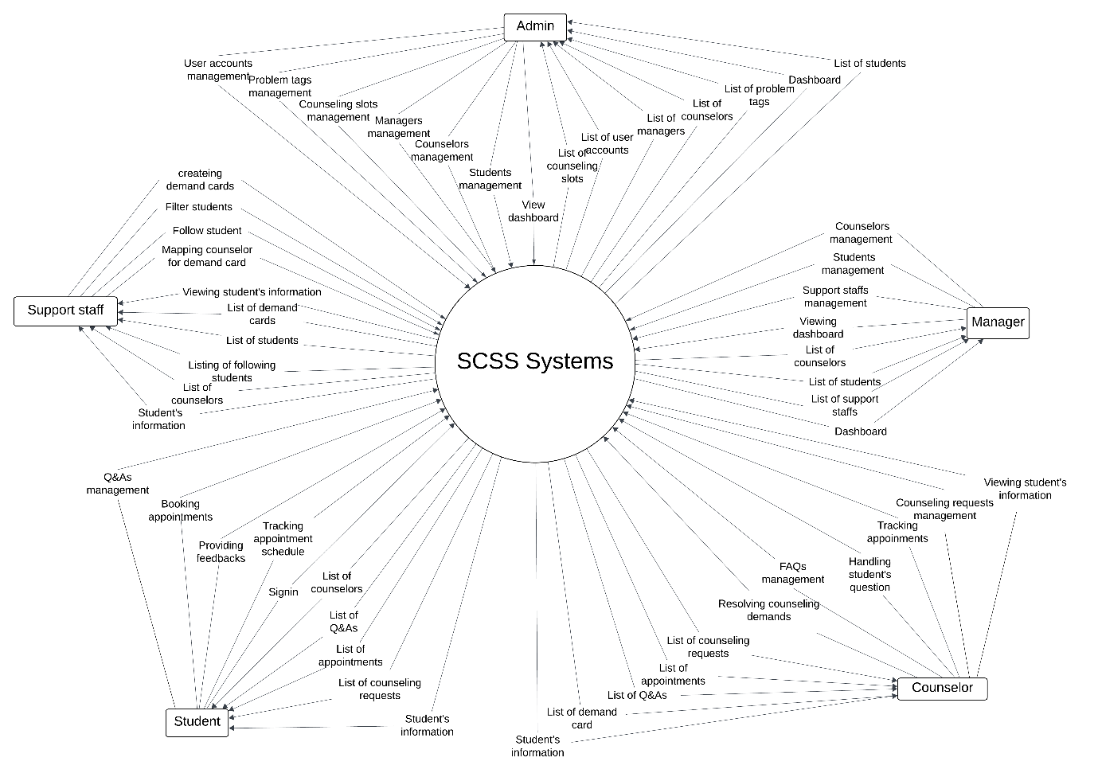

Figure 2 – Sysyem Context Diagram

## **2. User Requirements**

### **2.1. Actors**

Table 11 - Actors

|  |  |  |
| --- | --- | --- |
| **#** | **Actor** | **Description** |
| 1 | Students | A person who logs in, books appointments, creates questions. |
| 2 | Counselors | A person who manages counseling slots, Q&A and takes appointments with students. |
| 3 | Managers | A person who manages counselors, support staff. Assign a counseling slot to the counselor. |
| 4 | Support Staffs | A person who assigns counselors to the student base on demand form system. |
| 5 | Administrator | A person who manages the SCSS system. |

### **2.2. Use Cases**

#### **2.2.1. Diagram(s)**

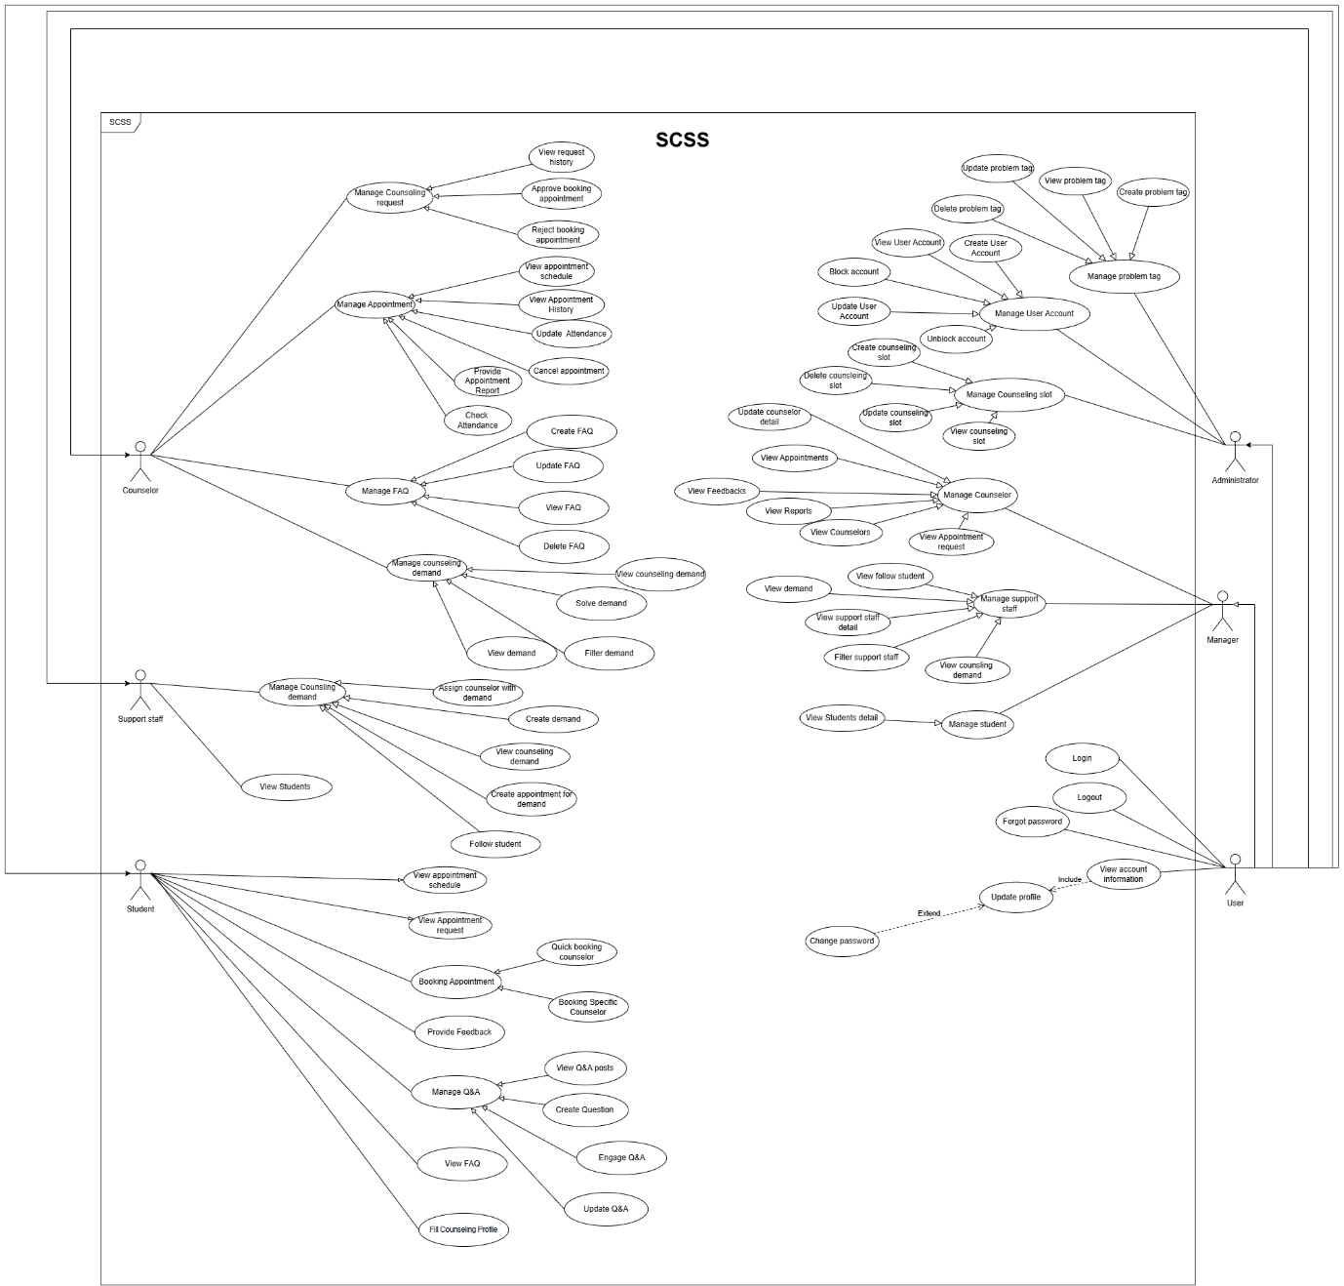

Figure 3 - Use case diagram

#### **2.2.2. Descriptions**

##### **2.2.2.1. Administrator Use Case Description**

Table 12 - Administrator Use Case Description

|  |  |  |  |
| --- | --- | --- | --- |
| **ID** | **Use Case** | **Actors** | **Use Case Description** |
| 01 | Login | Administrator | This use case allows “Admin” to login by gmail. |
| 02 | Logout | Administrator | This use case allows “Admin” to logout from SCSS Web applications. |
| 03 | View dashboard | Administrator | This use case allows “Admin” to view dashboard. |
| 04 | View Profile | Administrator | This use case allows “Admin” to view user’s profile. |
| 05 | View user accounts | Administrator | This use case allows “Admin” to view user accounts. |
| 06 | Filter account | Administrator | This use case allows “Admin” to filter account. |
| 07 | View user detail | Administrator | This use case allows “Admin” to view user details. |
| 08 | Update profile | Administrator | This use case allows “Admin” to search update profile. |
| 09 | Create user account | Administrator | This use case allows “Admin” to create a new user account and assign roles. |
| 10 | Delete user account | Administrator | This use case allows “Admin” to delete user accounts. |
| 11 | Update user account | Administrator | This use case allows “Admin” to update user account roles and information. |
| 12 | Ban user | Administrator | This use case allows “Admin” to block user account. |
| 13 | Unban user | Administrator | This use case allows “Admin” to unblock user accounts. |
| 14 | Create problem tag | Administrator | This use case allows “Admin” to create problem tag. |
| 15 | View problem tag | Administrator | This use case allows “Admin” to view problem tag. |
| 16 | Update problem tag | Administrator | This use case allows “Admin” to update problem tag. |
| 17 | Delete problem tag | Administrator | This use case allows “Admin” to delete problem tag. |
|  | Create counseling slot | Administrator | This use case allows “Admin” to create counseling slot. |
| 16 | View Counseling slots | Administrator | This use case allows “Admin” to view counseling slot list. |
| 17 | View Counseling slot | Administrator | This use case allows “Admin” to view counseling slot details. |
| 18 | Search counseling slot | Administrator | This use case allows “Admin” to search counseling slot. |
| 19 | Update counseling slot | Administrator | This use case allows “Admin” to update counseling slot. |
| 20 | Delete counseling slot | Administrator | This use case allows “Admin” to delete counseling slots. |
| 21 | Update counselor | Administrator | This use case allows “Admin” to delete update counselor. |
| 22 | View counselor detail | Administrator | This use case allows “Admin” to view counselor detail. |
| 23 | Update student | Administrator | This use case allows “Admin” to view update student. |
| 24 | View student detail | Administrator | This use case allows “Admin” to search view student detail. |
| 25 | Update manager | Administrator | This use case allows “Admin” to update update manager. |
| 26 | View manager detail | Administrator | This use case allows “Admin” to delete view manager details. |
| 27 | Update support staff | Administrator | This use case allows “Admin” to view update support staff. |
| 28 | View support staff | Administrator | This use case allows “Admin” to view support staff. |

##### **2.2.2.2. Counselor Use Case Description**

Table 13 - Counselor Use Case Description

|  |  |  |  |
| --- | --- | --- | --- |
| **ID** | **Use Case** | **Actors** | **Use Case Description** |
| 01 | Login | Counselor | This use case allows “Counselor” to Login. |
| 02 | Logout | Counselor | This use case allows “Counselor” to Logout. |
| 03 | Update password | Counselor | This use case allows “Counselor” to update password. |
| 04 | View Profile | Counselor | This use case allows “Counselor” to View Profile. |
| 05 | Filter student | Counselor | This use case allows “Counselor” to Filter students. |
| 06 | View student detail | Counselor | This use case allows “Counselor” to View student detail. |
| 07 | View request history | Counselor | This use case allows “Counselor” to View request History. |
| 08 | View request detail | Counselor | This use case allows “Counselor” to View request detail. |
| 09 | Filter request history | Counselor | This use case allows “Counselor” to Filter request history. |
| 10 | Approve booking appointment | Counselor | This use case allows “Counselor” to Approve booking appointments. |
| 11 | Approve Online Request | Counselor | This use case allows “Counselor” to Approve Online Request. |
| 12 | Approve Offline Request | Counselor | This use case allows “Counselor” to Approve Offline Requests. |
| 13 | Reject booking appointment | Counselor | This use case allows “Counselor” to Reject booking appointments. |
| 14 | View appointment schedule | Counselor | This use case allows “Counselor” to View appointment schedules. |
| 15 | View Appointment History | Counselor | This use case allows “Counselor” to View Appointment History. |
| 16 | View Appointment detail | Counselor | This use case allows “Counselor” to View Appointment detail. |
| 17 | Filter appointment history | Counselor | This use case allows “Counselor” to Filter appointment history. |
| 18 | Update Attendance | Counselor | This use case allows “Counselor” to Update Attendance. |
| 19 | Provide Appointment Report | Counselor | This use case allows “Counselor” to Provide Appointment Report. |
| 20 | View report | Counselor | This use case allows “Counselor” to View report. |
| 21 | Check Attendance | Counselor | This use case allows “Counselor” to Check Attendance. |
| 22 | Create report | Counselor | This use case allows “Counselor” to Create report. |
| 23 | Engage Q&A | Counselor | This use case allows “Counselor” to Engage Q&A. |
| 24 | Chat Student | Counselor | This use case allows “Counselor” to Chat Student. |
| 25 | Answer Question | Counselor | This use case allows “Counselor” to Answer Question. |
| 26 | Close Q&A | Counselor | This use case allows “Counselor” to Close Q&A. |
| 27 | View Q&A post | Counselor | This use case allows “Counselor” to View Q&A post. |
| 28 | Reject question | Counselor | This use case allows “Counselor” to reject questions. |
| 29 | Flag question | Counselor | This use case allows “Counselor” to flag questions. |
| 30 | Filter Q&A | Counselor | This use case allows “Counselor” to Filter Q&A. |
| 31 | View Q&A detail | Counselor | This use case allows “Counselor” to View Q&A detail. |
| 32 | View counseling demand | Counselor | This use case allows “Counselor” to VIew counseling demand. |
| 33 | Filter demand | Counselor | This use case allows “Counselor” to Filter demand. |
| 34 | View demand | Counselor | This use case allows “Counselor” to View demand. |
| 35 | Create appointment for demand | Counselor | This use case allows “Counselor” to Create appointments for demand. |
| 36 | Create FAQ | Counselor | This use case allows “Counselor” to create FAQs. |
| 37 | Update FAQ | Counselor | This use case allows “Counselor” to update FAQs. |
| 38 | View FAQ | Counselor | This use case allows “Counselor” to view FAQs. |
| 39 | Delete FAQ | Counselor | This use case allows “Counselor” to delete FAQs. |

##### **2.2.2.3. Manager Use Case Description**

Table 14 - Manager Use Case Description

|  |  |  |  |
| --- | --- | --- | --- |
| **ID** | **Use Case** | **Actors** | **Use Case Description** |
| 01 | Login | Manager | This use case allows “Manager” to login. |
| 02 | Logout | Manager | This use case allows “Manager” to Logout. |
| 03 | View Profile | Manager | This use case allows “Manager” to View Profile. |
| 04 | Update profile | Manager | This use case allows “Manager” to Update profile. |
| 05 | View Counselors | Manager | This use case allows “Manager” to View Counselors. |
| 06 | View Counselor Profile | Manager | This use case allows “Manager” to View Counselor Profile. |
| 07 | Search Counselor | Manager | This use case allows “Manager” to Search Counselor. |
| 08 | Change Status | Manager | This use case allows “Manager” to Change Status. |
| 09 | Assign Slot | Manager | This use case allows “Manager” to Assign Slot. |
| 10 | Update date range | Manager | This use case allows “Manager” to Update date range. |
| 11 | View Appointment request | Manager | This use case allows “Manager” to View Appointment requests. |
| 12 | View Appointments | Manager | This use case allows “Manager” to View Appointments. |
| 13 | View Feedbacks | Manager | This use case allows “Manager” to View Feedbacks. |
| 14 | View Reports | Manager | This use case allows “Manager” to View Reports. |
| 15 | View Students | Manager | This use case allows “Manager” to View Students. |
| 16 | View Student Profile | Manager | This use case allows “Manager” to View Student Profile. |
| 17 | Search student | Manager | This use case allows “Manager” to Search students. |

##### **2.2.2.4. Support Staff Use Case Description**

Table 15 - Support Staff Use Case Description

|  |  |  |  |
| --- | --- | --- | --- |
| **ID** | **Use Case** | **Actors** | **Use Case Description** |
| 01 | Login | Support Staff | This use case allows “Support Staff” to login. |
| 02 | Logout | Support Staff | This use case allows “Support Staff” to Logout. |
| 03 | Reset password | Support Staff | This use case allows “Support Staff” to reset password. |
| 04 | Create demand | Support Staff | This use case allows “Support Staff” to create demand. |
| 05 | View counseling demand | Support Staff | This use case allows “Support Staff” to view counseling demand. |
| 06 | Filter counseling demand | Support Staff | This use case allows “Support Staff” to filter counseling demand. |
| 07 | View counseling detail | Support Staff | This use case allows “Support Staff” to view counseling details. |
| 08 | Assign counselor with demand | Support Staff | This use case allows “Support Staff” to assign counselor with demand. |
| 09 | Find counselor | Support Staff | This use case allows “Support Staff” to find counselor. |
| 10 | Fill student contact note | Support Staff | This use case allows “Support Staff” to fill student contact note. |
| 11 | Search student detail | Support Staff | This use case allows “Support Staff” to Fill student contact notes. |
| 12 | View Students | Support Staff | This use case allows “Support Staff” to View Students . |
| 13 | View student detail | Support Staff | This use case allows “Support Staff” to View student detail. |
| 14 | Filter student | Support Staff | This use case allows “Support Staff” to Filter students. |

##### **2.2.2.5. Student Use Case Description**

Table 16 - Student Use Case Description

|  |  |  |  |
| --- | --- | --- | --- |
| **ID** | **Use Case** | **Actors** | **Use Case Description** |
| 01 | Login | Student | This use case allows the “Student” to log in to the platform using their university credentials. |
| 02 | View profile | Student | This use case allows “Student” to view their profile. |
| 03 | Update password | Student | This use case allows “Student” to update their password. |
| 04 | Logout | Student | This use case allows “Student” to logout. |
| 05 | View dashboard | Student | This use case allows “Student” to view dashboard. |
| 06 | View appointment schedule | Student | This use case allows “Student” to view the appointment schedule . |
| 07 | View counseling booking request | Student | This use case allows “Student” to view counseling booking requests. |
| 08 | View appointment details | Student | This use case allows the “Student” to view appointment details. |
| 09 | Filter appointment request | Student | This use case allows the “Student” to view filter appointment requests. |
| 10 | View detail request | Student | This use case allows the “Student” to view detail requests. |
| 11 | Booking Appointment | Student | This use case allows the “Student” to book appointments. |
| 12 | Quick booking counselor | Student | This use case allows the “Student” to quickly book a counselor. |
| 13 | Booking Specific Counselor | Student | This use case allows the “Student” to book a Specific Counselor. |
| 14 | Booking academic counselor | Student | This use case allows the “Student” to book an academic counselor. |
| 15 | Booking non-academic counselor | Student | This use case allows the “Student” to book a non-academic counselor. |
| 16 | Provide counseling feedback | Student | This use case allows the “Student” to provide feedback. |
| 17 | View Q&A post | Student | This use case allows the “Student” to view Q&A posts. |
| 18 | Create Question | Student | This use case allows the “Student” to create question |
| 19 | Filter Question | Student | This use case allows the “Student” to filter question posts. |
| 20 | Engage Q&A | Student | This use case allows the “Student” to engage Q&A. |
| 21 | Chat counselor | Student | This use case allows the “Student” to chat with a counselor. |
| 22 | Update Question | Student | This use case allows the “Student” to update Q&A. |
| 23 | Delete Question | Student | This use case allows the “Student” to delete questions. |
| 24 | Edit Question | Student | This use case allows the “Student” to edit question |
| 25 | Close question | Student | This use case allows the “Student” to close question |
| 26 | View Appointment History | Student | This use case allows the “Student” to view Appointment History list |
| 27 | Filter appointment history | Student | This use case allows the “Student” to filter appointment history |
| 28 | View Appointment detail | Student | This use case allows the “Student” to view appointment details. |
| 29 | Fill counseling profile | Student | This use case allows the “Student” to fill counseling profile |

## **3. Functional Requirements**

### **3.1. System Functional Overview**

#### **3.1.1. Screens Flow**

##### **3.1.1.1. Administrator Screen Flow**

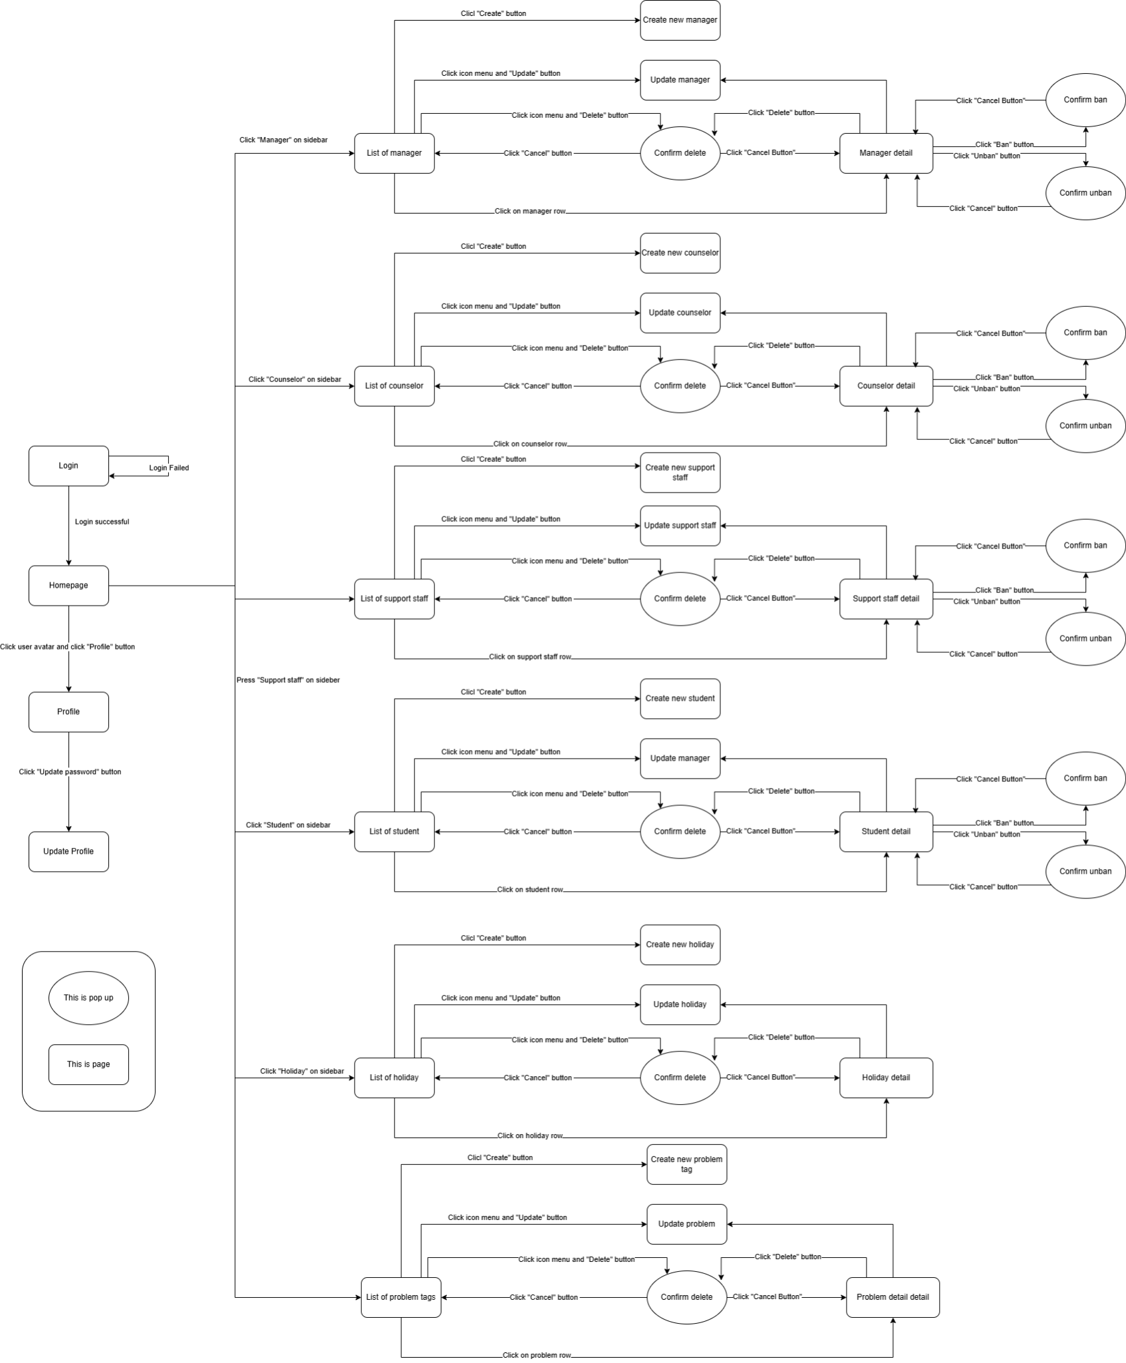

Figure 4 - Administrator Screen Flow

##### 3.1.1.2. Counselor Screenflow

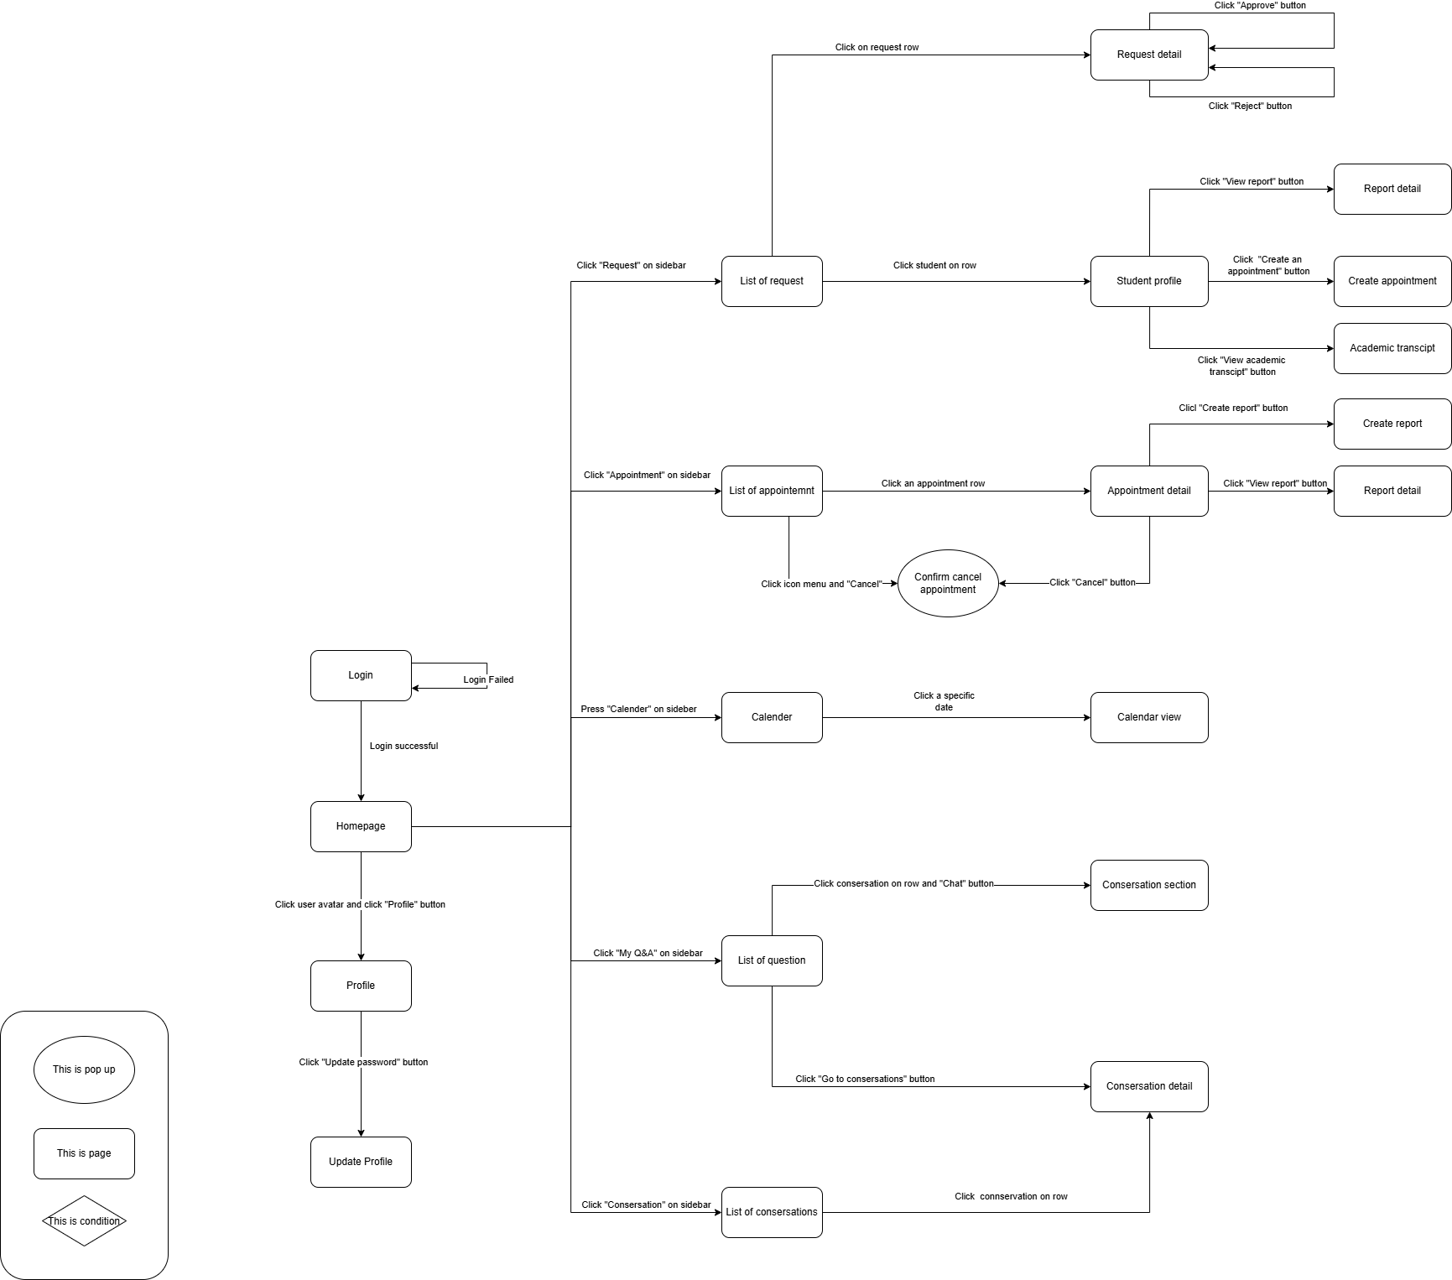

Figure 5 - Counselor Screenflow

##### 3.1.1.3. Manager Screen Flow

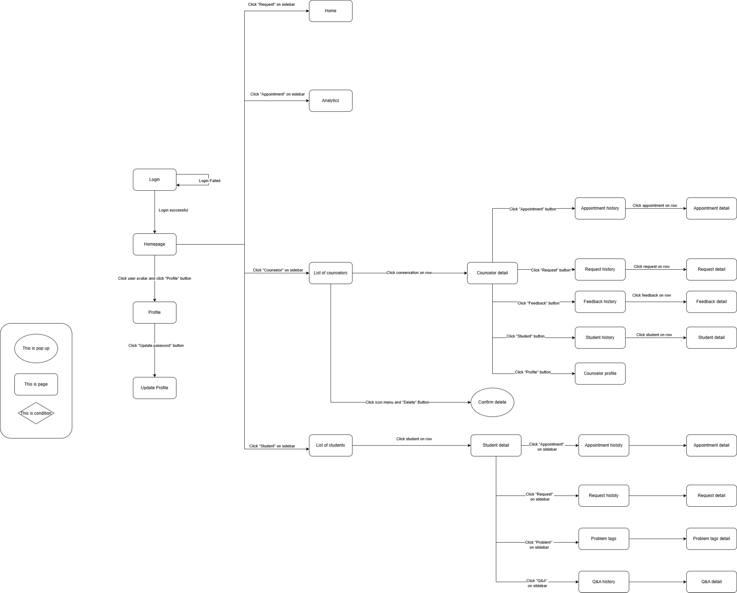

Figure 6 - Manager Screen Flow

##### 3.1.1.4. Support Staff Screenflow

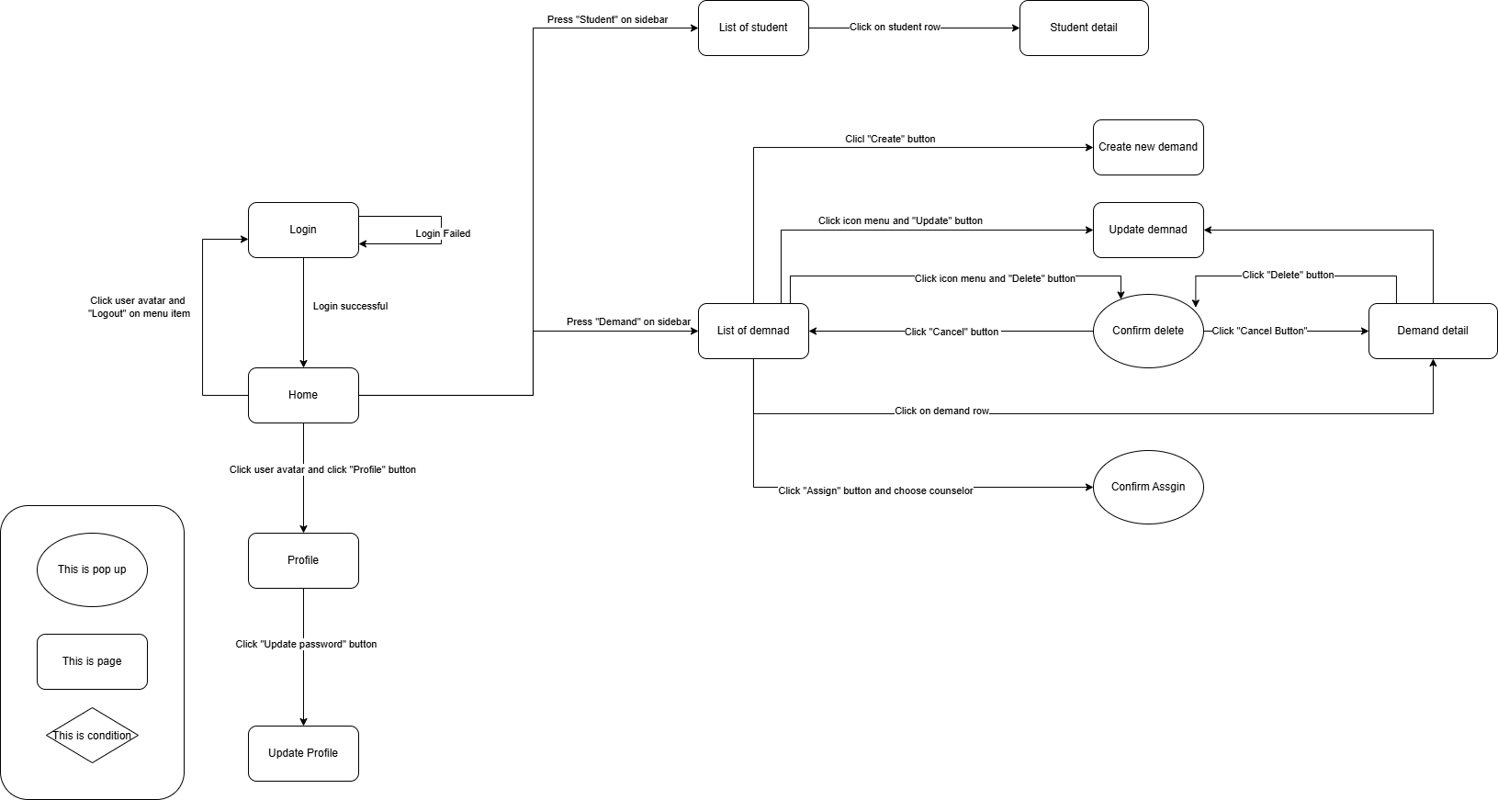

Figure 7 - Support Staff Screenflow

##### 3.1.1.5. Student Screenflow

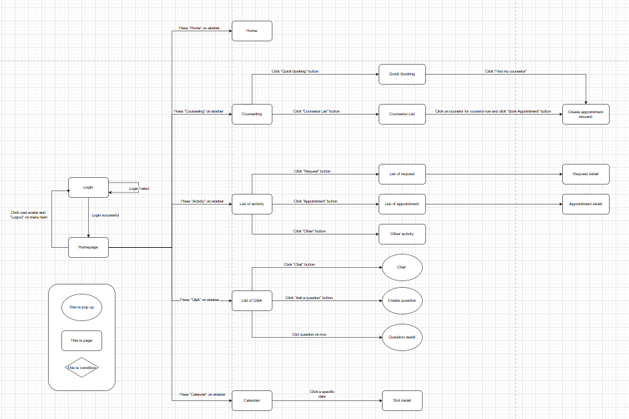

Figure 8 - Student Screenflow

#### **3.1.2. Screen Descriptions**

##### 3.1.2.1. Administrator Screen Description

Table 17 - Aministrator Screen Description

|  |  |  |  |
| --- | --- | --- | --- |
| # | Feature | Screen | Description |
| 1 | Login | Login | Admin can login into the system by gâmil |
| 2 | View homepage | Homepage | Admin can view a few information: accounts, notifications, … |
| 3 | View list of manager | List of manager | Admin can view list of managers in the system. Include all information of manager |
| 4 | View list of counselor | List of counselor | Admin can view list of counselor sin the system. Include all information of manager |
| 5 | View list of counselor | List of support staff | Admin can view list of support staff in the system. Include all information of manager |
| 6 | View list of student | List of student | Admin can view list of student in the system. Include all information of manager |
| 7 | Create new manager | Create new manager | Admin can create a new manager for the system with input manager information. |
| 3 | Update manager | Update manager | Admin can update manager information with input manager information |
| 4 | View manager detail | Manager detail | Admin can view all information of manager. |
| 5 | Delete manager | List of manager, Manager detail | Admin can delete manager’s account. |
| 6 | Ban manager | Manager detail | Admin can ban manager. |
| 7 | Unban manager | Manager detail | Admin can unban manager |
| 8 | Create new counselor | Create new counselor | Admin can create a new counselor for the system with input manager information. |
| 9 | Update counselor | Update counselor | Admin can update counselor information with input counselor information |
| 10 | View counselor detail | Counselor detail | Admin can view all information of counselor. |
| 11 | Ban manager | Manager detail | Admin can ban counselor. |
| 12 | Unban manager | Manager detail | Admin can unban counselor |
| 12 | Create new support staff | Create new support staff | Admin can create a new support staff for the system with input manager information. |
| 13 | Update support staff | Update support staff | Admin can update support staff information with input manager information. |
| 14 | View support staff detail | Support staff detail | Admin can view all information of support staff. |
| 15 | Ban manager | Manager detail | Admin can ban support staff.. |
| 16 | Unban manager | Manager detail | Admin can unban support staff. |
| 17 | Create new student | Create new student | Admin can create a new student for the system with input manager information. |
| 18 | Update student | Update student | Admin can update student information with input manager information. |
| 19 | View student detail | Student detail | Admin can view all information of student. |
| 20 | Ban manager | Manager detail | Admin can ban student. |
| 21 | Unban manager | Manager detail | Admin can unban student. |
| 20 | View list of holiday | List of holiday | Admin can view list of holiday |
| 21 | Create new holiday | Create new holiday | Admin can create a new holiday for the system with input holiday information. |
| 22 | Update holiday | Update holiday | Admin can update holiday information with input manager information. |
| 23 | View holiday detail | Holiday detail | Admin can view all information of support staff. |
| 24 | Delete holiday | List of holiday | Admin can delete a holiday |
| 25 | View list of problem tags | List of problem tags | Admin can view list of problem tags |
| 26 | Create new problem tag | Create new problem tag | Admin can create a new problem tag for the system with input holiday information. |
| 27 | Update problem tag | Update problem tag | Admin can update holiday information with input manager information. |
| 29 | Problem tag detail | Problem tag detail | Admin can view all information of support staff. |

##### **3.1.2.2. Counselor Screen Description**

Table 18 - Counselor Screen Description

|  |  |  |  |
| --- | --- | --- | --- |
| **#** | **Feature** | **Screen** | **Description** |
| 1 | Loign | Login | Counselor can login into the system by gmail. |
| 2 | View homepage | Homepage | Counselor can view a few information: upcoming appointments, … |
| 3 | View profile | Profile | Counselor can view profile. |
| 4 | Update profile | Update profile | Counselor can update their profile. |
| 5 | View list of requests | List of request | Counselor can view list of requests. |
| 6 | View request detail | Request detail | Counselor can view request detail. Include all details of request. |
| 7 | Approve request | Request detail | Counselor can approve request |
| 8 | Reject request | Request detail | Counselor can reject request |
| 9 | View student profile | Student profile | Counselor can view student profile. Include all information of student. |
| 10 | View report detail | Report detail | Counselor can view report detail. Include all information of report. |
| 1 | Create an appointment | Create appointment | Counselor can create an appointment for student with select date, slot, time, meeting type (online/offline). |
| 12 | View academic transcript | Academic transcript | Counselor can view academic transcript of student, each row of table list has no, term, semester, subject code, prerequisite, replaced subject,subject name, credit, grade, status. |
| 13 | View list of appointment | List of appointment | Counselor can view list of appointment, each row has date, time, meeting type, student profile.attendance status |
| 14 | Cancel appointment | List of appointment, Appointment detail | Counselor can cancel appointment |
| 15 | View appointment detail | Appointment detail | Counselor can view appointment detail. Include all information of appointment |
| 16 | Create report | Create report | Counselor can create report with input consultation goal, consultation content, consultation conclusion, intervention. |
| 17 | View report | Report detail | Counselor can view all information of report. |
| 18 | View calendar | Calendar | Counselor can view calendar by day, week, month |
| 19 | View calendar detail | Calendar view | Counselor can view all appointment in that day. |
| 20 | View list of question, Answer the question | List of question | Counselor can view list of question, each row has student name, question and counselor can answer the question. |
| 21 | Chat with student | Conversation detail, conversation section | Counselor can chat with the student to clarify the answer for them. |

##### **3.1.2.3. Manager Screen Description**

Table 19 - Manager Screen Description

|  |  |  |  |
| --- | --- | --- | --- |
| **#** | **Feature** | **Screen** | **Description** |
| 1 | Loign | Login | Manager can login into the system by gmail. |
| 2 | View homepage | Homepage, Home | Manager can view a few information: upcoming appointments, … |
| 3 | View analytics | Analytics | Manager can view analytics of the system. |
| 4 | Update profile | Update profile | Manager can update their profile. |
| 5 | View list of counselor | List of counselor | Manager can view list of counselors. |
| 6 | View counselor detail | Counselor detail | Manager can view request details. Include all details of counselor. |
| 7 | View appointment history | Appointment history | Manager can view appointment history. |
| 8 | View appointment detail | Appointment detail | Manager can view appointment detail |
| 9 | View request history | Request history | Manager can view request history. |
| 10 | View request detail | Request detail | Manager can view request detail |
| 11 | View feedback history | Feedback history | Manager can view feedback history. |
| 12 | View feedback detail | Feedback detail | Manager can view feedback detail |
| 13 | View student counseling history | Appointment history | Manager can view student counseling history. |
| 14 | View student counseling detail | Appointment detail | Manager can view student counseling detail |
| 15 | View counselor detail | Counselor profile | Manager can view counselor’s profile. |
| 16 | View list of student | List of student | Manager can view list of students. Include all details of student. |
| 17 | View problem tag history | Problem tag | Manager can view all the student's problem tags. |
| 18 | View problem tag detail detail | Problem tag detail | Manager can view student’s problem tag detail |
| 19 | View student appointment history | Appointment history | Manager can view student appointment history. |
| 20 | View student appointment detail | Appointment detail | Manager can view student appointment history. detail |
| 21 | View student request history | Request history | Manager can view student request history. |
| 22 | View student appointment detail | Request Detail | Manager can view student request history detail |
| 23 | View student Q&A | Q&A history | Manager can view student Q&A history |
| 24 | View student Q&A detail | Q&A detail | Manager can view student Q&A detail |

##### 3.1.2.4. Support Staff Screen Description

Table 20 - Support Staff Screen Description

|  |  |  |  |
| --- | --- | --- | --- |
| **#** | **Feature** | **Screen** | **Description** |
| 1 | View list of student | List of student | Support staff can view list of student. |
| 2 | View student’ detail | Student detail | Support staff can view the student with full information. |
| 3 | View list of demand | List of demand | Support staff can view list of demand |
| 4 | Create new demand | Create new demand | Support staff can create a new demand to a specific student. |
| 5 | Update demand | Update demand | Support staff can update demand. |
| 6 | View demand detail | Demand detail | Support staff can view demand detail with full information of that detail. |
| 7 | Delete demand | List of demand | Support staff can delete demand |
| 8 | Assign counselor with demand | List of demand | Support staff can assign a specific counselor with demand. |

##### 3.1.2.5. Student Screen Description

Table 21 - Student Screen Description

|  |  |  |  |
| --- | --- | --- | --- |
| **#** | **Feature** | **Screen** | **Description** |
| 1 | Login | Login | Student can login into the system by gmail or FeID. |
| 2 | View homepage | Home | Student can view a few information: upcoming appointments, … |
| 3 | Counselling | Counselling | Students can book an appointment using Quick Booking or by selecting a counselor from the Counselor List. |
| 4 | View Profile | Profile | Student can view profile. |
| 5 | Quick Booking | Quick Booking | Students can book an appointment using Quick Booking by selecting the counseling type, date, time, counselor's specialization (optional), and counselor's gender (optional). |
| 6 | View counselor list | Counselor List | Students can book an appointment by selecting a specific counselor, counseling type, date, time. |
| 7 | Manage appointment | Appointment Management | Student can view list of appointment, list of request and other activity |
| 8 | View list of request | List of request | Student can view a list of requests, each row of table list has date, time, meeting type, status, counselor profile |
| 9 | View list of management | List of appointment | Student can view a list of appointment, each row of table list has date, time, meeting type,meet URL, status, counselor profile. |
| 10 | View appointment detail | Appointment detail | Student can view appointment detail and provide feedback |
| 11 | Cancer Appointment | Appointment detail, List of appointment | Student can cancel appointment and enter reason. |
| 12 | View other activity | Other Activity | Student can view other activity |
| 13 | View counselor profile | Counselor profile | Student can view counselor profile such as name, major, phone, bio, |
| 14 | View list of Q&A | List of Q&A | Student can view list of Q&Ai in the system, each row of table list has id, type, status, topic, question title, and answer. |
| 15 | Conversation | Conversations | Student can view list of conversations and chat section |
| 16 | Ask a question | Ask a question | Student can submit a question by select question, counseling topic and input content |
| 17 | View calendar | Calendar | Student can view calendar by day, week, month |
| 18 | View calendar detail | Calendar view | Student can view all appointment in a specific day |

#### **3.1.3. Screen Authorization**

##### **3.1.3.1. Web Screen Authorization**

Table 22 - Web Screen Authorization

|  |  |  |  |  |  |
| --- | --- | --- | --- | --- | --- |
| **Screen** | **Admin** | **Counselor** | **Manager** | **Support Staff** | **Student** |
| Login | X | X | X | X | X |
| Homepage | X | X | X | X | X |
| List of manager | X |  |  |  |  |
| List of counselor | X |  | X |  | X |
| List of support staff | X |  |  |  |  |
| List of student | X | X | X | X |  |
| Create new manager | X |  |  |  |  |
| Update manager | X |  |  |  |  |
| Manager detail | X |  |  |  |  |
| Create new counselor | X |  |  |  |  |
| Update counselor | X |  |  |  |  |
| Counselor detail | X |  |  |  |  |
| Create new support staff | X |  |  |  |  |
| Update support staff | X |  |  |  |  |
| Support staff detail | X |  |  |  |  |
| Create new student | X |  |  |  |  |
| Update student | X |  |  |  |  |
| Student detail | X | X | X | X | X |
| List of holiday | X |  |  |  |  |
| Create new holiday | X |  |  |  |  |
| Update holiday | X |  |  |  |  |
| Holiday detail | X |  |  |  |  |
| List of problem tags | X |  |  |  |  |
| Create new problem tag | X |  |  |  |  |
| Update problem tag | X |  |  |  |  |
| Problem tag detail | X |  |  |  |  |
| Counselor detail | X | X | X | X | X |
| Appointment history | X | X | X |  | X |
| Appointment detail | X | X | X |  | X |
| Request history | X | X | X |  | X |
| Request detail | X | X | X |  | X |
| Feedback history | X | X | X |  | X |
| Feedback detail | X | X | X |  | X |
| Student detail |  |  | X |  |  |
| Analytics |  |  | X |  |  |
| Create appointment |  | X |  |  |  |
| Student’s academic transcript | X | X | X | X | X |
| Create report |  | X |  |  |  |
| Report detail |  | X |  |  |  |
| Schedule |  | X |  |  | X |
| Schedule detail |  | X |  |  | X |
| List of question |  | X |  |  |  |
| Conversation detail |  | X |  |  | X |
| Conversation section |  | X |  |  |  |
| List of demand |  |  |  | X |  |
| Create new demand |  |  |  | X |  |
| Update demand |  |  |  | X |  |
| Demand detail |  |  |  | X |  |
| Counselling |  |  |  |  | X |
| Profile |  |  |  |  | X |
| Counselor List |  |  |  |  | X |
| Appointment Management |  |  |  |  | X |
| Other Activity |  |  |  |  | X |
| Counselor profile |  |  |  |  | X |
| List of Q&A |  |  |  |  | X |
| Ask a question |  |  |  |  | X |
| Schedule |  |  | X |  | X |
| Schedule view |  |  | X |  | X |

##### **3.1.3.2. Mobile Screen Authorization**

Table 23 - Mobile Screen Authorization

|  |  |  |
| --- | --- | --- |
| **Screen** | **Student** | **Counselor** |
| Login | X | X |
| Home | X | X |
| Profile | X | X |
| Schedule | X | X |
| Q&A | X | X |
| Personal | X | X |
| Quick booking | X |  |
| Academic booking | X |  |
| Non academic booking | X |  |
| Chat section | X | X |
| Notification | X | X |
| Appointment detail | X |  |
| Feedback detail | X |  |

#### **3.1.4. Non-Screen Functions**

Table 24 - Non-Screen Functions

|  |  |  |  |
| --- | --- | --- | --- |
| **#** | **Feature** | **System Function** | **Description** |
| 01 | Send notification | Send notification | The system will send notifications in the following cases:   * Booking appointment * Question Notification |
| 02 | Send mail | Send mail | The system will send mail in the following cases:   * Forget password |

**3.1.5. Entity Relationship Diagram**

##### **3.1.5.1 Conceptual Model**

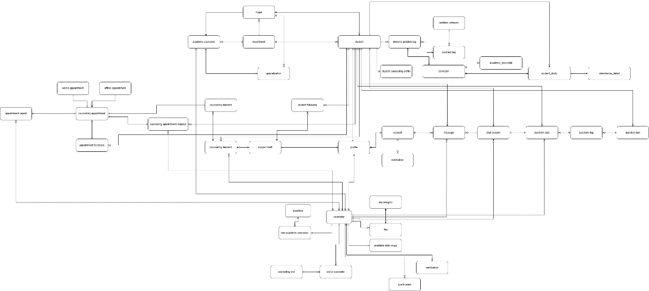

[Figure 9 - Conceptual Model](https://drive.google.com/file/d/1KuNCO51q2DCs1Ss3PW-fbJto0irkGtw-/view?usp=drive_link)

##### **3.1.5.2 Logical Model**

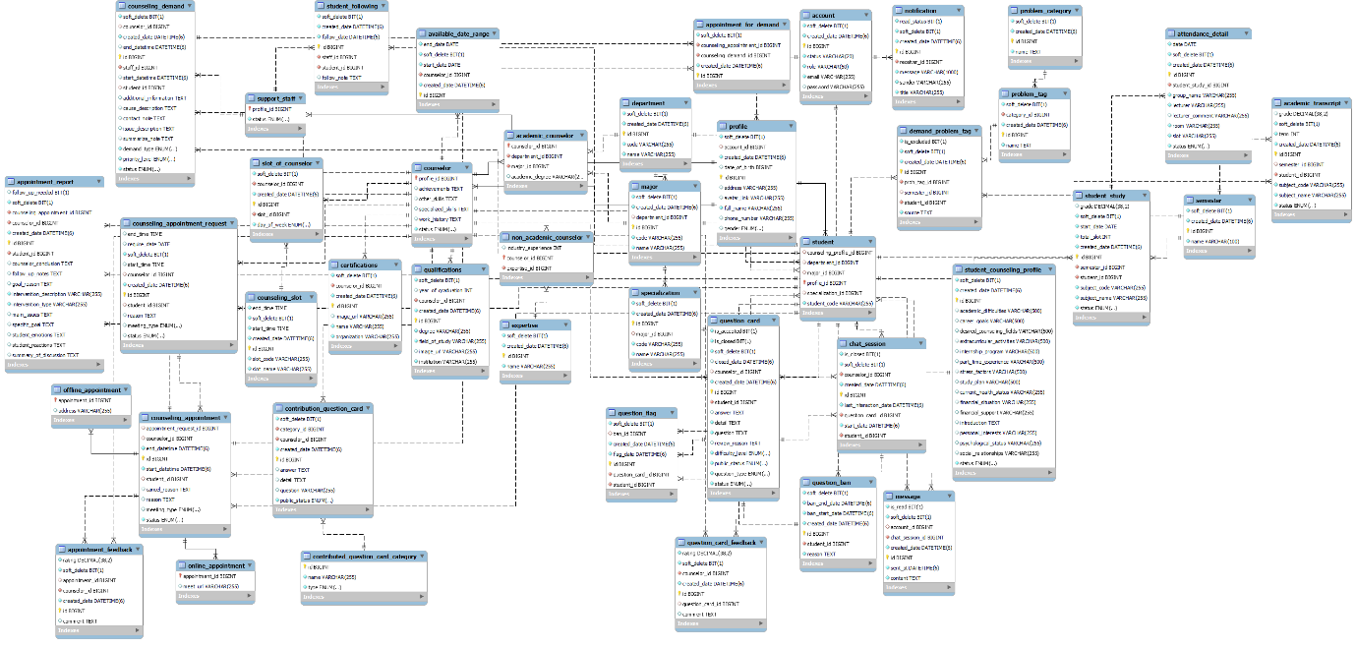

Figure 10 - Logical diagram

**Entities Description**

Table 25 - Entities Description

|  |  |  |
| --- | --- | --- |
| **#** | **Entity** | **Description** |
| 01 | account | Store account in system |
| 02 | academic counselor | Store academic counselor in system |
| 03 | available date range | Store available date range |
| 04 | appointment feedback | Store appointment feedback |
| 05 | appointment report | Store appointment report |
| 06 | counselor | Store certification |
| 07 | certification | Store certification |
| 08 | chat session | Store counseling demand |
| 09 | counseling demand | Store counseling demand |
| 10 | counseling appointment | Store counseling appointment |
| 11 | counseling appointment request | Store counseling appointment request |
| 12 | counseling slot | Store counseling slot |
| 13 | demand problem tag | Store demand problem tag |
| 14 | department | Store department |
| 15 | expertise | Store expertise |
| 16 | faq | Store faq |
| 17 | faq category | Store faq category |
| 18 | message | Store message |
| 19 | major | Store major major |
| 20 | notification | Store notification used through out the system |
| 21 | non academic counselor | Store non academic counselor |
| 22 | online appointment | Store online appointment |
| 23 | offline appointment | Store offline appointment |
| 24 | profile | Store profile of user |
| 25 | problem category | Store problem category |
| 26 | problem tag | Store problem tag |
| 27 | qualification | Store qualification |
| 28 | question card | Store question card |
| 29 | question flag | Store question flag |
| 30 | question ban | Store question ban |
| 31 | slot of counselor | Store slot of counselor |
| 32 | student | Store student |
| 33 | specialization | Store specialization of counselor |
| 34 | support staff | Store support staff |
| 35 | student following | Store student following by support staff |
| 36 | student counseling profile | Store student counseling profile |

### **3.2. Functional requirements**

#### **3.2.1. Accounts Feature**

|  |  |  |  |  |  |
| --- | --- | --- | --- | --- | --- |
| **No** | **Actor** | **Function Name** | **Purpose** | **Data requirements** | **Data validation** |
| 1 | Admin, manager, counselor, support staff, student | View account detail | View information of a specific account | Account id |  |
| 2 | Admin, manager, counselor, support staff, student | View account profile | View account profile | Account id |  |
| 3 | Admin | Ban account | Ban account | Account id |  |
| 4 | Admin | Unban account | Unban account | Account id |  |
| 5 | Admin | Create account | Create account | Email  Password  fullName  phoneNumber  dateOfBirth  avatar  Gender  role | Email:  Type: text field (string)   * Not empty * Max Length = 100 * Email address format   Password:  Type: text field (string)   * Not empty   Fullname:   * Type: text field (string) * Not empty   phoneNumber:   * Type: text field (string) * Not empty   dateOfBirth:   * Type: Datetime picker * Not empty   Avatar:   * Type: file (image) * Not empty * Max size < 5MB * Extension file: .png, .jpg, .webp, .jpeg   Gender:   * Type: Dropdown * Not empty   Role:   * Type: Dropdown * Not Empty |
| 6 | Admin | Delete account | Delete account | Account id |  |

#### **3.2.2.** **Authentications Feature**

Table 26 - Authentications Feature

|  |  |  |  |  |  |
| --- | --- | --- | --- | --- | --- |
| **No** | **Actor** | **Function Name** | **Purpose** | **Data requirements** | **Data validation** |
| 1 | Admin, manager, counselor, support staff, student | Login | Login to website and mobile app | Email  Password | Email:   * Type: text field (string) * Email address format * Not empty   Password:   * Type: text fields (string) |
| 2 | Admin, manager, counselor, support staff, student | Regeneration token | Re-generate pair token from the old pair token provided by the MBKC system before. | Access token Refresh token | AccessToken:   * Type: text field (string) * Not empty   RefreshToken:   * Type: text field (string) * Not empty |
| 3 | Admin, manager, counselor, support staff, student | Logout | Logout to website and mobile app |  |  |

#### **3.2.3.** **Booking Counseling Feature**

Table 27 - Booking Counseling Feature

|  |  |  |  |  |  |
| --- | --- | --- | --- | --- | --- |
| **No** | **Actor** | **Function Name** | **Purpose** | **Data requirements** | **Data validation** |
| 1 | Student | Quick booking counselor | Quick booking counselor | Counseling Type  Date  SlotCode  Counselor's specialization  Gender  Meeting type  Resson | Counseling type:   * Dropdown * Not empty   Date:   * Type:Datetime picker * Not empty   SlotCode:   * Type:Datetime picker * Not empty   Counselor’s specialization:   * Type: Dropdown   Gender:   * Type: Dropdown   Meeting type:   * Type: Dropdown * Not empty   Resson:   * Type; Text field (String) * Not empty |
| 2 | Counselor,  Student | View appointment schedule | View appointment schedule | Appointment id |  |
| 3 | Counselor,  Student | View appointment request | View appointment request | Request id  Start date  End date | Start date:   * Type: text field (string) * Format type dd/MM/yyyy * Must less than or equal End Date   End date:   * Type: text field (string) * Format type dd/MM/yyyy |
| 4 | Admin, manager | View Counselor’s appointment request | View Counselor’s appointment request | Counselor id  Request id |  |
| 5 | Student | Booking specific counselor | Booking specific counselor | Date  Slot  Meeting type  Resson | Date:  + Type:Datetime picker  + Not empty  Meeting type:   * Type: Dropdown * Not empty   Resson:   * Type; Text field (String) * Not empty |
| 6 | Counselor | View counseling request | View a list of request from the system | Student Id  Start date  End date  Meeting type  SortBy | Start date:   * Type: text field (string) * Format type dd/MM/yyyy * Must less than or equal End Date   End date:   * Type: text field (string) * Format type dd/MM/yyyy   Meeting type:   * Required: “Online” or “Offline”   Sort:   * Match with format “id_ASC” or “id_DESC” |
| 7 | Counselor | Approve online request | Approve online request | Request id  Meet url | Meet URL:   * Type: URL format * Not empty |
| 8 | Counselor | Approve offline request | Approve offline request | Request id  Address | Address:   * Type: text field(String) * Not empty |
| 9 | Counselor | Reject booking appointment | Reject booking appointment | Request id |  |

#### **3.2.4.** **Appointment Feature**

Table 28 - Appointment Feature

|  |  |  |  |  |  |
| --- | --- | --- | --- | --- | --- |
| **No** | **Actor** | **Function Name** | **Purpose** | **Data requirements** | **Data validation** |
| 1 | Counselor, student | View list of appointment | Get a list of counselor’s appointment from the system | Appointment id  Start date  Endate  Status | Start date:   * Type: text field (string) * Format type dd/MM/yyyy * Must less than or equal End Date   End date:   * Type: text field (string) * Format type dd/MM/yyyy   Status:   * Must equal “Cancel” or “Attend” or “Absent” or “Expired” |
| 3 | Counselor, student | Cancel appointment | Cancel appointment | Appointment id  Resson | Resson:   * Type: text field (string) * Not empty |
| 4 | Counselor | Check attendance | Check attendance for student by counselor | Appointment id |  |
| 5 | Counselor | Create appointment for specific student | Create an appointment to counseling with student | Student id  Date  SlotCode  Meeting type  Resson | Date:   * Type:Datetime picker * Not empty   SlotCode:   * Type:Datetime picker * Not empty   Meeting type:   * Required: “Online” and “URL” or “Offline” and “Address”   Resson:   * Type; Text field (String) * Not empty |
| 6 | Student | Provide feedback | Provide feedback | Appointment id  Ratting  Commnet | Ratting:   * Type: * Not empty   Comment:   * Type: text field (string) * Not empty |

#### **3.2.5.** **Q&A Feature**

Table 29 - Q&A Feature

|  |  |  |  |  |  |
| --- | --- | --- | --- | --- | --- |
| **No** | **Actor** | **Function Name** | **Purpose** | **Data requirements** | **Data validation** |
| 1 | Student | Create a question | Create a question | Question type  Topic  Content | Question type:   * Type: Dropdown * Not empty   Topic:   * Type: Dropdown * Not empty   Content:   * Text field: (string) * Not empty |
| 2 | Counselor, Admin,  Student | View Q&A posts | View Q&A posts | Question card id |  |
| 3 | Counselor | Close Q&A | Close Q&A | Question card id |  |
| 4 | Counselor | Answer question | Answer question | Question card id  Content | Content:   * Text field: (string) * Not empty |
| 5 | Counselor | Approve question | Approve question | Question card id |  |
| 6 | Counselor | Reject question | Reject question | Question card id |  |
| 7 | Counselor | Flag question | Flag question | Question card id |  |
| 8 | Student | Delete question | Delete question before answer by counselor | Question card id |  |
| 9 | Student | Update question | Update question before answer by counselor | Question card id  Content | Content:   * Type: text field (string) |
| 10 | Counselor | Update answer | Update answer | Question card id |  |
| 11 | Student, counselor | Engage chat session | Engage into chat session for specific question card | Chat session id |  |

#### **3.2.6. Counseling** **Demand Feature**

Table 30 - Counseling Demand Feature

|  |  |  |  |  |  |
| --- | --- | --- | --- | --- | --- |
| **No** | **Actor** | **Function Name** | **Purpose** | **Data requirements** | **Data validation** |
| 1 | Admin, Counselor | View demand list | View demand list | Demand id  Start date  End date | Start date:   * Type: text field (string) * Format type dd/MM/yyyy * Must less than or equal End Date   End date:   * Type: text field (string) * Format type dd/MM/yyyy |
| 2 | Counselor | Create appointment for demand | Create appointment for demand | Demand id  Student id  Date  SlotCode  Meeting type  Resson | Date:   * Type:Datetime picker * Not empty   SlotCode:   * Type:Datetime picker * Not empty   Meeting type:   * Required: “Online” and “URL” or “Offline” and “Address”   Resson:   * Type; Text field (String) * Not empty |
| 3 | Counselor | Solve demand card | Solve demand card | Demand id  Summarize Note | Summarize Note:   * Type: text field(string) * Not empty |
| 4 | Support staff | Create demand card | Create demand card | Demand id |  |
| 5 | Support staff | Assign demand card to counselor | Assign demand to card to counselor by counselor to solve problem of student | Counselor id |  |

#### **3.2.7. Dashboards Feature**

Table 31 - Dashboards Feature

|  |  |  |  |  |  |
| --- | --- | --- | --- | --- | --- |
| **No** | **Actor** | **Function Name** | **Purpose** | **Data requirements** | **Data validation** |
| 1 | Admin | View admin dashboard | View admin dashboard |  |  |
| 2 | Manager | View manager dashboard | View manager dashboard |  |  |
| 3 | Counselor | View counselor dashboard | View counselor dashboard |  |  |

#### **3.2.8. Manage Student Feature**

Table 32 - Manage Student Feature

|  |  |  |  |  |  |
| --- | --- | --- | --- | --- | --- |
| **No** | **Actor** | **Function Name** | **Purpose** | **Data requirements** | **Data validation** |
| 1 | Manager, counselor, admin, support staff | View student list | View student list | Student id  specializationId  sortBy  Keyword  sortDirection  page | sortBy:   * Type: text field (string) * Format type dd/MM/yyyy   Keyword:   * Type: text field (string)   sortDirection:   * Match with format “ID_ASC” or “ID_DESC” |
| 2 | Manager, counselor, admin, support staff | View student profile | View student profile | Student id |  |
| 3 | Manager, counselor, admin, support staff | View student’s academic transcript | View student’s academic transcript | Student id |  |
| 4 | Manager, counselor, admin, support staff | View student attendance report | View student attendance report | Appointment Id |  |
| 5 | Admin, manager, counselor, student | View list of student’s appointment | Get a list of appointment from the system | Appointment id  Start date  End date  Status | Start date:   * Type: text field (string) * Format type dd/MM/yyyy * Must less than or equal End Date   End date:   * Type: text field (string) * Format type dd/MM/yyyy   Status:   * Must equal “Cancel” or “Waiting” or “Attend” or “Absent” or “Expired” |

#### **3.2.9. Manage Counselor Feature**

Table 33 - Manage Counselor Feature

|  |  |  |  |  |  |
| --- | --- | --- | --- | --- | --- |
| **No** | **Actor** | **Function Name** | **Purpose** | **Data requirements** | **Data validation** |
| 1 | Admin, manger, counselor | View list of counselor’s appointment | Get a list of counselor’s appointment from the system | Appointment id  Start date  Endate  Status | Start date:   * Type: text field (string) * Format type dd/MM/yyyy * Must less than or equal End Date   End date:   * Type: text field (string) * Format type dd/MM/yyyy   Status:   * Must equal “Cancel” or “Attend” or “Absent” or “Expired” |
| 2 | Admin, manger | View list of academic counselor | View list of academic counselors in the system | Search  ratingFrom  ratingTo  availableFrom  availableTo  specializationId  SortDirection  sortBy  page | Search:   * Type: text field (string)   ratingFrom:   * Type: number * Must less than or equal rating   ratingTo:   * Type: number * Max number = 5   availableFrom:   * Type: text field (string) * Format type dd/MM/yyyy * Must less than or equal availableTo   availableTo:   * Type: text field (string) * Format type dd/MM/yyyy   SortDirection:   * Match with format “ID_ASC” or “ID_DESC”   SortBy:   * Type: text fields (string) * Fo |
| 3 | Admin, manger | View list of non-academic counselor | View list of non-academic counselors in the system | Search  ratingFrom  ratingTo  availableFrom  availableTo  expertiseId  SortDirection  sortBy  page | Search:   * Type: text field (string)   ratingFrom:   * Type: number * Must less than or equal rating   ratingTo:   * Type: number * Max number = 5   availableFrom:   * Type: text field (string) * Format type dd/MM/yyyy * Must less than or equal availableTo   availableTo:   * Type: text field (string) * Format type dd/MM/yyyy   SortDirection:   * Match with format “ID_ASC” or “ID_DESC”   SortBy:   * Type: text fields (string) * Format type dd/MM/yyyy |
| 4 | Admin, manger | View counselor detail | View a specific counselor’s detail | Counselor id |  |
| 5 | Admin, manger | Change counselor status | Change counselor status | Counselor id  Status | Status:   * Required Status is required some statuses such as: AVAILABLE, UNAVAILABLE. |
| 6 | Admin, manger | Assign slot to counselor | Assign counseling slot to counselor | Counselor id  Slot id |  |
| 7 | Admin, manager | Unsign slot to counselor | Unsign counseling slot to counselor | Counselor id  Slot id |  |

## **4. Non-Functional Requirements**

### **4.1. External Interfaces**

#### **4.1.1. User Interfaces**

* **Language**: Supports Vietnamese and English.
* **Icons**: Easy to identify.
* **Colors**: Sufficient contrast.
* **Font**: Easy to read.

#### **4.1.2. Communications Interfaces**

* **HTTP Methods**: Uses HTTP request methods for data transfer.
* **Protocol**: HTTP for Web Application and server communication.

### **4.2. Quality Attributes**

#### **4.2.1. Usability**

* **Language**: UI text in Vietnamese and English.
* **Ease of Use**: Simple to use after training.
* **Training**: One-hour training is sufficient.
* **Standards**: Follows usability and accessibility standards.

#### **4.2.2. Reliability**

* **Training**: All users need training.
* **Availability**: 99.9% uptime.
* **Failure Rate**: Less than 5%, availability above 80%.

#### **4.2.3. Performance**

* All responses’ time is less than 15 seconds.

#### **4.2.4. Security**

* **Input Validation**: Validate all inputs.
* **Authorization**: Role-based access control.
* **Password Encryption**: MD5 hashing on client-side.

## **5. Requirement Appendix**

### **5.1. Business Rules**

Table 34 - Business Rules

|  |  |
| --- | --- |
| ID | Rule Definition |
| BR-01 | Username must be in Email format. |
| BR-02 | Passwords must be hashed by the MD5 algorithm on the client-side before being sent to the server-side. |
| BR-03 | Password length of account must be 8-50 characters. |
| BR-04 | Email must be unique |
| BR-05 | Access token will expire within 1 hour after the successful login. |
| BR-06 | Refresh token will expire 5 days after the successful login. |
| BR-07 | Avatar file is required extension type “.png”, “.jpg”, “.jpeg”, “.webp”. |
| BR-08 | Date of birth is bigger than 18. |
| BR-09 | When creating a new counseling appointment request successfully, the counselor will receive a notification of request. |
| BR-10 | When the counselor approves a request, the student will receive a notification of the appointment approved successfully. |
| BR-11 | Question status is required for creating a question that is “Pending” |
| BR-12 | Appointment status is required for creating a appointment request that is “Waiting” |
| BR-13 | Appointment request status will be changed from “Waiting” to “Approved” in the system. When the appointment request is approved by the counselor. |
| BR-14 | Meeting type have 2 option: Online and Offline |
| BR-15 | When the counselor cancels an appointment, they must enter a reason for the cancellation |
| BR-16 | When a student logs into the system, a form is displayed for them to enter the issue they need counseling for. |
| BR-17 | The cancel reason is required less than or equal to 250 characters. |
| BR-18 | Student only delete question when the question is not verify. |
| BR-19 | Gender have 2 option: Male and Female |
| BR-20 | Question status will be changed from “Waiting” to “Approved” in the system. When the question is approved by the counselor. |
| BR-21 | Email is required in standard Email format and is required less than or equal to 100 characters. |
| BR-22 | Meeting URL must follow a specific URL format. |
| BR-23 | The counselor can close the question once the student has received a suitable answer |
| BR-24 | Flag questions that contain inappropriate language or content |
| BR-25 | After semester has been finished, exclude note will be estimate |

### **5.2. Common Requirements**

### **5.3. Application Messages List**

#### **5.3.1. Web application**

Table 35 - Web application

|  |  |  |  |  |
| --- | --- | --- | --- | --- |
| **#** | **Message code** | **Message Type** | **Context** | **Content** |
| 1 | MSG-01 | Toast message | Login with wrong username or wrong password. | Email or Password is invalid. |
| 2 | MSG-02 | Toast message | Login with ban account. | Account has been banned. |
| 3 | MSG-03 | Toast message | Login with correct username and correct password. | Login Successfully. |
| 4 | MSG-04 | Toast message | Account activation successful. | Your account has been activated successfully. |
| 5 | MSG-05 | Toast message | Account activation failed. | Activation link is invalid or expired. |
| 6 | MSG-06 | Toast message | Account already activated. | Your account has already been activated. |
| 7 | MSG-07 | Toast message | Account update successful. | Your account information has been updated successfully. |
| 8 | MSG-08 | Toast message | Account update failed. | Failed to update account information. Please try again. |
| 9 | MSG-09 | Toast message | Unauthorized action. | You do not have permission to perform this action. |
| 10 | MSG-10 | Toast message | Session expired. | Your session has expired. Please log in again. |
| 11 | MSG-11 | Toast message | Logout successful. | You have been logged out successfully. |
| 12 | MSG-12 | Toast message | Unauthorized access. | Please log in to access this page. |
| 13 | MSG-13 | Toast message | Counselor not available. | The selected counselor is not available at this time. |
| 14 | MSG-14 | Toast message | Appointment booked successfully. | Your appointment has been booked successfully. |
| 15 | MSG-15 | Toast message | Appointment booking failed. | Failed to book appointment. Please try again. |
| 16 | MSG-16 | Toast message | Appointment canceled. | Your appointment has been canceled. |
| 17 | MSG-17 | Toast message | Appointment cancellation failed. | Failed to cancel the appointment. Please try again. |
| 18 | MSG-18 | Toast message | Invalid input. | Please check the provided information and try again |
| 19 | MSG-19 | Toast message | Profile updated successfully. | Your profile has been updated successfully. |
| 20 | MSG-20 | Toast message | Failed to update profile. | Unable to update profile. Please try again later. |
| 21 | MSG-21 | Toast message | Invalid email format. | Please enter a valid email address. |
| 22 | MSG-22 | Toast message | Counselor assigned successfully. | A counselor has been assigned to your request. |
| 23 | MSG-23 | Toast message | Failed to assign counselor. | Unable to assign a counselor. Please try again later. |
| 24 | MSG-24 | Toast message | Question posted successfully. | Your question has been posted successfully. |
| 25 | MSG-25 | Toast message | Failed to post question. | Unable to post the question. Please check your input. |
| 26 | MSG-26 | Toast message | Question updated successfully. | Your question has been updated successfully. |
| 27 | MSG-27 | Toast message | Failed to update question. | Unable to update the question. Please try again later. |
| 28 | MSG-28 | Toast message | Question deleted successfully. | The question has been deleted. |
| 29 | MSG-29 | Toast message | Failed to delete question. | Unable to delete the question. Please try again later. |
| 30 | MSG-30 | Toast message | Feedback submitted successfully. | Your feedback has been submitted. |
| 31 | MSG-31 | Toast message | Failed to submit feedback. | Unable to submit feedback. Please try again later. |
| 32 | MSG-32 | Toast message | Counselor not found. | The selected counselor could not be found. Please choose another. |
| 33 | MSG-33 | Toast message | Demand successfully assigned. | The demand has been assigned successfully. |
| 34 | MSG-34 | Toast message | Failed to assign demand. | Unable to assign the demand. Please try again later. |
| 35 | MSG-35 | Toast message | Report generated successfully. | The report has been generated. |
| 36 | MSG-36 | Toast message | Failed to generate report. | Unable to generate the report. Please try again later. |

#### **5.3.2. Mobile application**

Table 36 - Mobile application

|  |  |  |  |  |
| --- | --- | --- | --- | --- |
| **#** | **Message code** | **Message Type** | **Context** | **Content** |
| 1 | MSG-01 | Toast message | Login with wrong username or wrong password. | Email or password incorrect |
| 2 | MSG-02 | Toast message | Login with ban account. | Account has been banned. |
| 3 | MSG-03 | Toast message | Login with correct username and correct password. | Login Successfully. |
| 4 | MSG-04 | Toast message | Logout successful. | Logout successfully |
| 5 | MSG-05 | Toast message | Appointment booked successfully. | Request has been sent successfully! Please wait while the counselor processes your request. |
| 6 | MSG-06 | Toast message | Appointment booking failed. | Failed to request |
| 7 | MSG-07 | Toast message | Appointment canceled. | Appointment canceled |
| 8 | MSG-08 | Toast message | Appointment cancellation failed. | Failed to cancel appointment. |
| 9 | MSG-09 | Toast message | Profile updated successfully. | Profile updated successfully |
| 10 | MSG-10 | Toast message | Failed to update profile. | Can’t update counseling profile. |
| 11 | MSG-11 | Toast message | Question posted successfully. | New question has been created |
| 12 | MSG-12 | Toast message | Failed to post question. | Can’t create question |
| 13 | MSG-13 | Toast message | Question updated successfully. | Your question has been updated. |
| 14 | MSG-14 | Toast message | Failed to update question. | Can’t edit question. |
| 15 | MSG-15 | Toast message | Question deleted successfully. | Your question has been deleted. |
| 16 | MSG-16 | Toast message | Failed to delete question. | Can’t delete question |
| 17 | MSG-17 | Toast message | Feedback submitted successfully. | Your feedback has been submitted. |
| 18 | MSG-18 | Toast message | Failed to submit feedback. | Can’t feedback this appointment. |
| 19 | MSG-19 | Toast message | Counselor not found. | Can't find counselor suitable with your request. Please choose another slot, date, or write a clearer purpose |
| 20 | MSG-20 | Toast message | Report generated successfully. | Appointment report created |
| 21 | MSG-21 | Toast message | Failed to generate report. | Can’t create appointment report |

#### 

# **IV. Software Design Description**

## **1. System Design**

### **1.1. System Architecture**

#### **1.1.1. Overall System Architecture (TBD)**

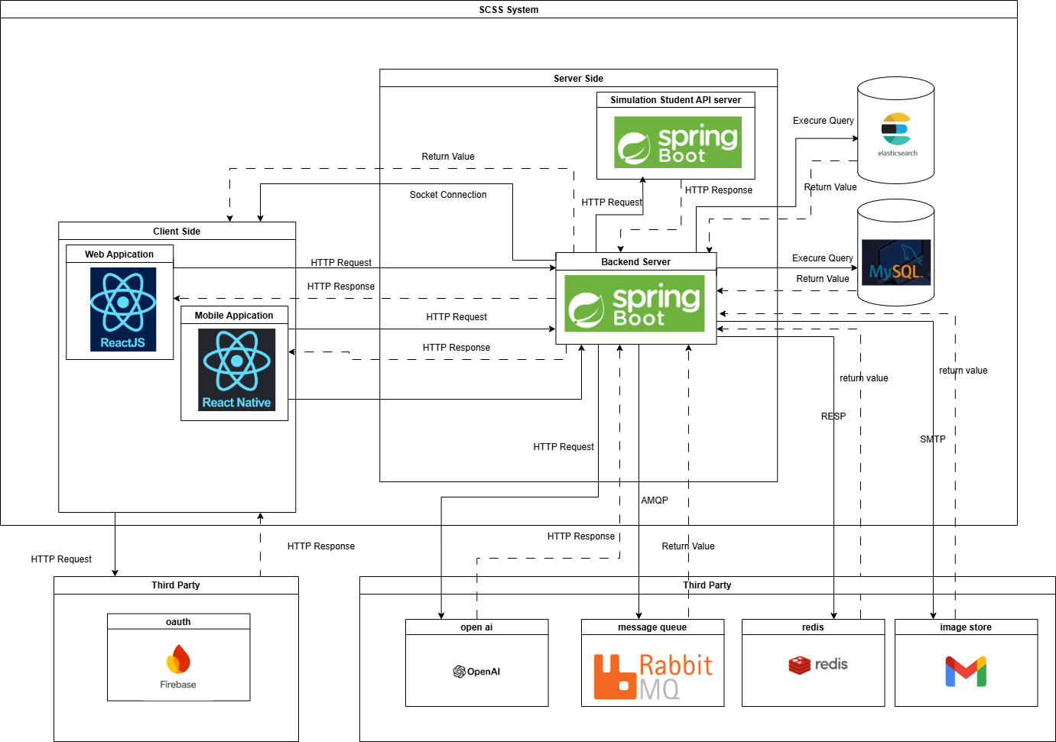

[Figure 11 - Overall System Architecture](https://drive.google.com/file/d/11YrXXkibwN2Q1mX3-ymb_7As-R9ACJlE/view?usp=drive_link)

### 1.2. Package Diagram

#### 1.2.1. Web Application Package Diagram (TBD)

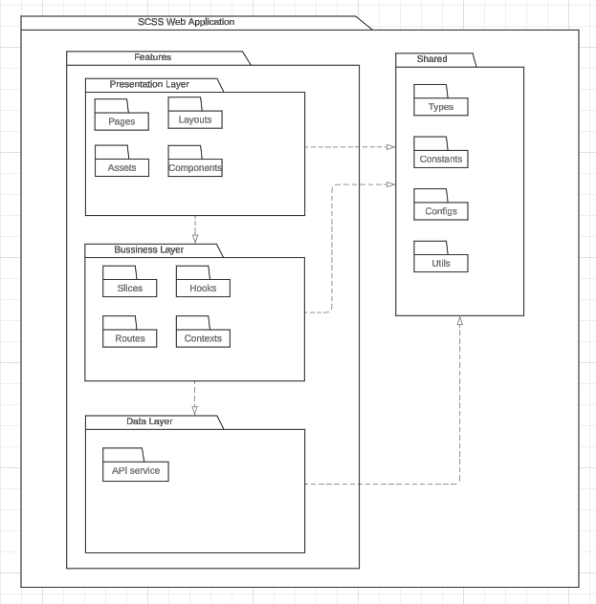

Figure 12 - Web Application Package Diagram

***Package Descriptions***

Table 37 - Web Package Descriptions

|  |  |  |
| --- | --- | --- |
| **No** | **Package** | **Description** |
| 01 | Features | This package include all the features of the application |
| 02 | Pages | The package includes page components for the application |
| 03 | Components | This package includes the detailed components of the page interface |
| 04 | Layouts | This package includes the general layouts of the interface |
| 05 | Assets | This package includes static files used by components and pages. |
| 06 | Routes | This package includes a config URL path for routing to the page component. |
| 07 | Slices | This package includes a state management pattern for a web application |
| 08 | Hooks | This  package includes the custom hooks for components used to handle logic. |
| 09 | Constants | This package includes defines constant for the entire application use |
| 10 | API Service | This package includes API service for frontend |
| 11 | Shared | This package includes all common files used by the application |
| 12 | Types | This  package includes common interfaces for the application |
| 13 | Configs | This package includes all common settings for the application. |
| 14 | Context | This packages includes provider the application |

#### 1.2.2. Mobile Application Package Diagram

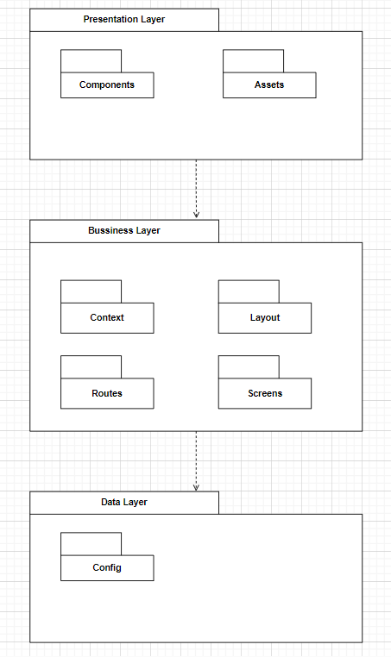

Figure 13 - Mobile Application Package Diagram

***Package Descriptions***

Table 38 - Mobile Package Descriptions

|  |  |  |
| --- | --- | --- |
| **No** | **Package** | **Description** |
| 01 | Components | It contains the reusable building blocks of the app, which are individual components that manage specific pieces of functionality or UI |
| 02 | Assets | It contains static resources such as images, fonts, and other media files used throughout the app. |
| 03 | Context | It stores context files for managing the global state throughout the application (e.g., user authentication, navigation, notifications). |
| 04 | Layout | It holds layout components responsible for structuring the visual appearance of different sections or screens |
| 05 | Routes | It contains the routing logic for the app, defining how users navigate between different screens or features. |
| 06 | Screens | It contains the major screens of the app. Each screen typically represents a full view or page (e.g., Home, Login, Profile) |
| 07 | Config | It stores configuration files, such as environment settings, API endpoints, and other app-specific constants that might be referenced globally. |

#### **1.2.3. Backend Application Package Diagram**

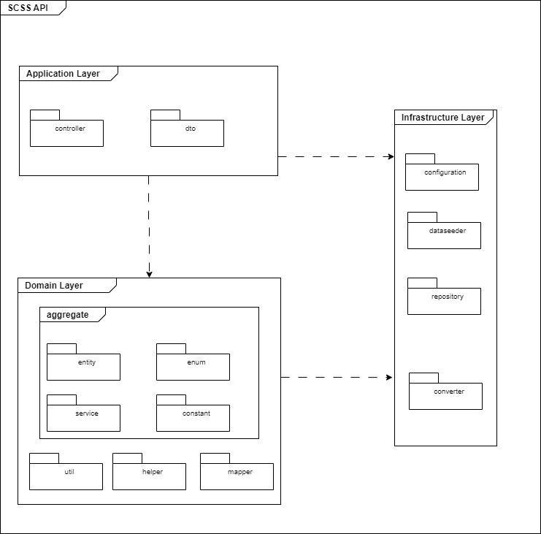

Figure 14 - Backend Application Package Diagram

***Package Descriptions***

Table 39 - Backend Package Descriptions

|  |  |  |
| --- | --- | --- |
| **No** | **Package** | **Description** |
| 01 | Controller | includes the classes that handle HTTP requests and call the relevant domain-layer business logic. They also take care of addressing errors and creating responses. |
| 02 | DTO | contains the classes that act as a bridge between the domain model and the client. They make sure that just the information that is required is visible by encapsulating data delivered to or from the client. |
| 03 | Entity | Defines the business objects and their relationships. |
| 04 | Enum | Contains enumerations that represent fixed sets of constants used across the domain. |
| 05 | Util | Contains utility classes with reusable methods that help the domain logic but do not belong to any specific entity. |
| 06 | Helper | Provides helper functions that facilitate domain-related operations. |
| 07 | Mapper | Manages the mapping between entities and DTOs, ensuring data is converted between different representations. |
| 08 | Configuration | Stores classes related to configuring application settings, such as database connections, security, or other environment-specific setups. |
| 09 | DataSeeder | Holds classes responsible for populating the database with initial or test data. |
| 10 | Repository | Contains interfaces and classes that handle communication with the data storage layer, allowing CRUD operations on domain entities. |
| 11 | Converter | Provides classes for converting data between different types, formats, or structures, such as mapping domain models to persistent data models. |

## **2. Database Design**

### **2.1. Database**

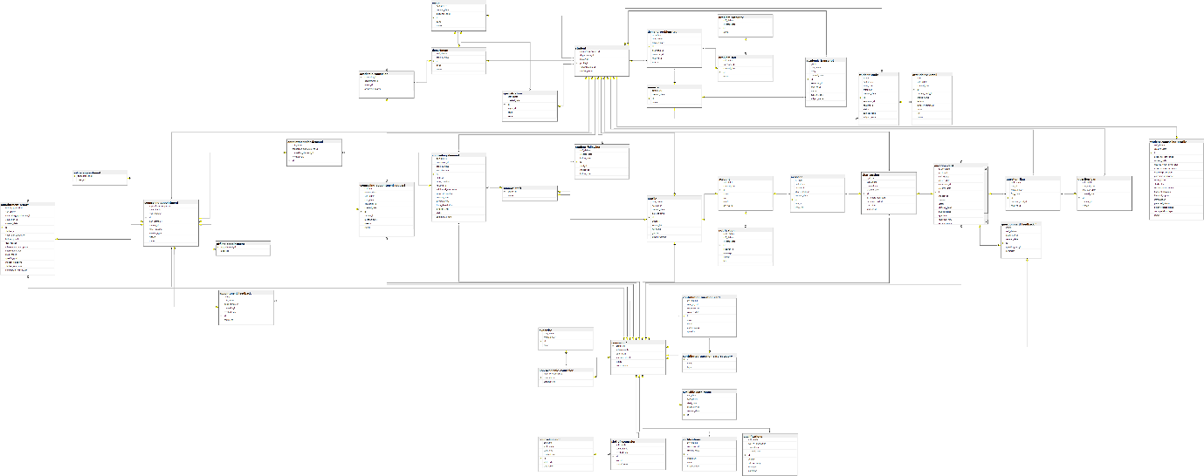

[Figure 15 - Database Diagram](https://drive.google.com/file/d/1922uFt3N7GcSsel0mpKLQZccEeXJgX8i/view?usp=drive_link)

### **2.2. Data Dictionary**

#### **2.2.1. Academic counselor table**

Table 40 - Academic counselor Table

|  |  |  |  |  |  |  |
| --- | --- | --- | --- | --- | --- | --- |
| **No** | **Field name** | **Type** | **Unique** | **Not null** | **PK/FK** | **Notes** |
| 1 | counselor_id | bigint | X | X | PK |  |
| 2 | department_id | bigint |  | X | FK |  |
| 3 | major_id | bigint |  | X | FK |  |
| 4 | academic_degree | varchar(255) |  | X | FK |  |

#### **2.2.2. Academic_transcript table**

Table 41 - Academic transcript table

|  |  |  |  |  |  |  |
| --- | --- | --- | --- | --- | --- | --- |
| No | Field name | Type | Unique | Not null | PK/FK | Notes |
| 1 | id | BIGINT | X |  | PK |  |
| 2 | grade | DECIMAL(38,2) |  | X |  |  |
| 3 | soft_delete | BIT(1) |  | X |  |  |
| 4 | term | INT |  | X |  |  |
| 5 | created_date | DATETIME(6) |  | X |  |  |
| 6 | semester_id | BIGINT |  |  |  |  |
| 7 | student_id | BIGINT |  | X |  |  |
| 8 | subject_code | VARCHAR(255) |  | X |  |  |
| 9 | subject_name | VARCHAR(255) |  | X |  |  |
| 10 | status | enum |  |  |  | Has value:   * NOT_PASSED * NOT_STARTED * PASSED * STUDYING |

#### **2.2.2. Account table**

Table 42 - Account table

|  |  |  |  |  |  |  |
| --- | --- | --- | --- | --- | --- | --- |
| **No** | **Field name** | **Type** | **Unique** | **Not null** | **PK/FK** | **Notes** |
| 1 | id | bigint | X | X | PK |  |
| 2 | soft_delete | bigint |  | X |  |  |
| 3 | created_date | bigint |  | X |  |  |
| 4 | status | varchar(20) |  | X |  |  |
| 5 | role | varchar(50) |  | X |  |  |
| 6 | email | varchar(255) | X |  |  |  |
| 7 | password | varchar(255) |  |  |  |  |

#### **2.2.3. Appointment feedback Table**

Table 43 - Appointment feedback Table

|  |  |  |  |  |  |  |
| --- | --- | --- | --- | --- | --- | --- |
| **No** | **Field name** | **Type** | **Unique** | **Not null** | **PK/FK** | **Notes** |
| 1 | id | bigint | X | X | PK |  |
| 2 | rating | decimal(38,2) |  | X |  |  |
| 3 | soft_delete | bit(1) |  | X |  |  |
| 4 | appointment_id | bigint | X | X | FK |  |
| 5 | created_date | varchar(255) |  | X |  |  |
| 6 | comment | varchar(255) |  |  |  |  |
| 7 | counselor_id | bigint | X | X | FK |  |

#### **2.2.4. Appointment_for_demand table**

Table 44 - Appointment_for_demand table

|  |  |  |  |  |  |  |
| --- | --- | --- | --- | --- | --- | --- |
| **No** | **Field name** | **Type** | **Unique** | **Not null** | **PK/FK** | **Notes** |
| 1 | id | bigint | X | X | PK |  |
| 2 | soft_delete | bit(1) |  | X |  |  |
| 3 | counseling_appointment_id | bigint | X | X | FK |  |
| 4 | created_date | bigint |  | X |  |  |
| 5 | counseling_demand_id | bigint |  | X | FK |  |

#### **2.2.5. Appointment_report  table**

Table 45 - Appointment_report table

|  |  |  |  |  |  |  |
| --- | --- | --- | --- | --- | --- | --- |
| **No** | **Field name** | **Type** | **Unique** | **Not null** | **PK/FK** | **Notes** |
| 1 | id | bigint | X | X | PK |  |
| 2 | follow_up_needed | bit(1) |  |  |  |  |
| 3 | soft_delete | bit(1) |  |  |  |  |
| 4 | counseling_appointment_id | bigint | X | X | FK |  |
| 5 | counselor_id | bigint | X | X | FK |  |
| 6 | created_date | bigint |  | X |  |  |
| 7 | student_id | bigint | X | X | FK |  |
| 8 | counselor_conclusion | text |  |  |  |  |
| 9 | follow_up_notes | text |  |  |  |  |
| 10 | goal_reason | text |  |  |  |  |
| 11 | intervention_description | varchar(255) |  | X |  |  |
| 12 | intervention_type | varchar(255) |  | X |  |  |
| 13 | main_issues | text |  |  |  |  |
| 14 | specific_goal | text |  |  |  |  |
| 15 | student_emotions | text |  |  |  |  |
| 16 | student_reactions | text |  |  |  |  |
| 17 | summary_of_discussion | text |  |  |  |  |

#### **2.2.6.** **attendance_detail table**

#### Table 46 - attendance_detail tabel

|  |  |  |  |  |  |  |
| --- | --- | --- | --- | --- | --- | --- |
| **No** | **Field name** | **Type** | **Unique** | **Not null** | **PK/FK** | **Notes** |
| 1 | id | BIGINT |  | X | PK |  |
| 2 | date | DATE |  | X |  |  |
| 3 | soft_delete | BIT(1) |  | X |  |  |
| 4 | created_date | DATETIME(6) |  | X |  |  |
| 5 | student_study_id | BIGINT |  | X | FK |  |
| 6 | group_name | VARCHAR(255) |  | X |  |  |
| 7 | lecturer | VARCHAR(255) |  | X |  |  |
| 8 | lecturer_comment | VARCHAR(255) |  |  |  |  |
| 9 | room | VARCHAR(255) |  | X |  |  |
| 10 | slot | VARCHAR(255) |  | X |  |  |
| 11 | status | ENUM |  |  |  | Has values:   * ABSENT * FUTURE * PRESENT |

#### **2.2.7. Available_date_range table**

Table 47 - Available_date_range table

|  |  |  |  |  |  |  |
| --- | --- | --- | --- | --- | --- | --- |
| **No** | **Field name** | **Type** | **Unique** | **Not null** | **PK/FK** | **Notes** |
| 1 | id | bigint | X | X | PK |  |
| 2 | end_date | date |  | X |  |  |
| 3 | soft_delete | bit(1) |  | X |  |  |
| 4 | start_date | date |  | X |  |  |
| 5 | counselor_id | bigint | X | X | FK |  |
| 6 | created_date | bigint |  | X |  |  |

#### **2.2.8. certifications table**

Table 48 – certifications table

|  |  |  |  |  |  |  |
| --- | --- | --- | --- | --- | --- | --- |
| **No** | **Field name** | **Type** | **Unique** | **Not null** | **PK/FK** | **Notes** |
| 1 | id | BIGINT |  | X | PK |  |
| 2 | soft_delete | BIT(1) |  | X |  |  |
| 3 | counselor_id | BIGINT |  | X | FK |  |
| 4 | created_date | DATETIME(6) |  | X |  |  |
| 5 | image_url | VARCHAR(255) |  |  |  |  |
| 6 | name | VARCHAR(255) |  | X |  |  |
| 7 | organization | VARCHAR(255) |  | X |  |  |

#### **2.2.9. Chat_session table**

Table 49 - Chat_session table

|  |  |  |  |  |  |  |
| --- | --- | --- | --- | --- | --- | --- |
| **No** | **Field name** | **Type** | **Unique** | **Not null** | **PK/FK** | **Notes** |
| 1 | id | bigint | X | X | PK |  |
| 2 | is_closed | bit(1) |  | X |  |  |
| 3 | soft_delete | bit(1) |  | X |  |  |
| 4 | counselor_id | bigint |  | X | FK |  |
| 5 | created_date | bigint |  | X |  |  |
| 6 | last_interaction_date | datetime(6) |  | X |  |  |
| 7 | question_card_id | bigint |  | X | FK |  |
| 8 | start_date | datetime(6) |  | X |  |  |
| 9 | student_id | bigint |  | X | FK |  |

#### **2.2.10. contributed_question_card_category table**

Table 47 - contributed_question_card_category table

|  |  |  |  |  |  |  |
| --- | --- | --- | --- | --- | --- | --- |
| **No** | **Field name** | **Type** | **Unique** | **Not null** | **PK/FK** | **Notes** |
| 1 | id | BIGINT |  | X | PK |  |
| 2 | name | VARCHAR(255) |  | X |  |  |
| 3 | type | ENUM |  | X |  | Has value:   * ACADEMIC * NON_ACADEMIC |

#### **2.2.11. contribution_question_card table**

Table 47 - contribution_question_card table

|  |  |  |  |  |  |  |
| --- | --- | --- | --- | --- | --- | --- |
| **No** | **Field name** | **Type** | **Unique** | **Not null** | **PK/FK** | **Notes** |
| 1 | id | BIGINT |  | X | PK |  |
| 2 | soft_delete | BIT(1) |  | X | FK |  |
| 3 | category_id | BIGINT |  | X | FK |  |
| 4 | counselor_id | BIGINT |  | X |  |  |
| 5 | created_date | DATETIME(6) |  | X |  |  |
| 6 | answer | TEXT |  |  |  |  |
| 7 | detail | TEXT |  |  |  |  |
| 8 | question | VARCHAR(255) |  |  |  |  |
| 9 | public_status | ENUM |  | X |  | Has value:   * HIDE * VISIBLE |

#### **2.2.12. Counseling_appointment table**

Table 48 - Counseling_appointment table

|  |  |  |  |  |  |  |
| --- | --- | --- | --- | --- | --- | --- |
| **No** | **Field name** | **Type** | **Unique** | **Not null** | **PK/FK** | **Notes** |
| 1 | id | bigint | X | X | PK |  |
| 2 | appointment_request_id | bigint | X |  | FK |  |
| 3 | counselor_id | bigint | X |  | FK |  |
| 4 | end_datetime | datetime(6) |  | X |  |  |
| 5 | start_datetime | datetime(6) |  | X |  |  |
| 6 | student_id | bigint | X |  | FK |  |
| 7 | meeting_type | enum |  |  |  | Has value:   * OFFLINE * ONLINE |
| 8 | status | enum |  |  |  | Has value:   * ABSENT * ATTEND. * CANCELED * EXPIRED * WAITING |
| 9 | cancel_reason | text |  |  |  |  |
| 10 | reason | text |  |  |  |  |

#### **2.2.9. Counseling_appointment_request**

Table 49 - Counseling_appointment_request

|  |  |  |  |  |  |  |
| --- | --- | --- | --- | --- | --- | --- |
| **No** | **Field name** | **Type** | **Unique** | **Not null** | **PK/FK** | **Notes** |
| 1 | id | bigint | X | X | PK |  |
| 2 | end_time | time(6) |  |  |  |  |
| 3 | require_date | date |  |  |  |  |
| 4 | soft_delete | bit(1) |  | X |  |  |
| 5 | start_time | time(6) |  |  |  |  |
| 6 | counselor_id | bigint | X |  | FK |  |
| 7 | created_date | bigint |  | X |  |  |
| 8 | student_id | bigint | X |  | FK |  |
| 9 | reason | varchar(255) |  |  |  |  |
| 10 | meeting_type | enum |  |  |  | Has value:   * OFFLINE * ONLINE |
| 11 | status | enum |  |  |  | Has value:   * APPROVED * DENIED * EXPIRED * WAITING |

#### **2.2.10. Counseling_demand Table**

Table 50 - Counseling_demand Table

|  |  |  |  |  |  |  |
| --- | --- | --- | --- | --- | --- | --- |
| **No** | **Field name** | **Type** | **Unique** | **Not null** | **PK/FK** | **Notes** |
| 1 | id | bigint | X | X | PK |  |
| 2 | soft_delete | bit(1) |  | X |  |  |
| 3 | counselor_id | bigint | X |  | FK |  |
| 4 | created_date | bigint |  | X |  |  |
| 5 | end_datetime | datetime(6) |  |  |  |  |
| 6 | staff_id | bigint | X | X | FK |  |
| 7 | start_datetime | datetime(6) |  |  |  |  |
| 8 | student_id | bigint | X |  | FK |  |
| 9 | contact_note | text |  |  |  |  |
| 10 | summarize_note | text |  |  |  |  |
| 11 | status | enum |  | X |  | Has value:   * PROCESSING * SOLVE * 'WAITING |
| 12 | issue_description | TEXT |  | X |  |  |
| 13 | demand_type | ENUM |  | X |  | Has values:   * ACADEMIC * NON_ACADEMIC |
| 14 | priority_level | ENUM |  |  |  | Has values:   * HIGH * LOW * MEDIUM * 'URGENT |
| 15 | additional_information | TEXT |  |  |  |  |
| 16 | cause_description | TEXT |  |  |  |  |

#### **2.2.11. Counseling_slot table**

Table 51 - Counseling_slot table

|  |  |  |  |  |  |  |
| --- | --- | --- | --- | --- | --- | --- |
| **No** | **Field name** | **Type** | **Unique** | **Not null** | **PK/FK** | **Notes** |
| 1 | id | bigint | X | X | PK |  |
| 2 | end_time | time(6) |  | X |  |  |
| 3 | soft_delete | bit(1) |  | X |  |  |
| 4 | start_time | time(6) |  | X |  |  |
| 5 | created_date | bigint |  | X |  |  |
| 6 | slot_code | varchar(255) |  | X |  |  |
| 7 | slot_name | varchar(255) |  | X |  |  |

#### **2.2.12. Counselor table**

Table 52 - Counselor table

|  |  |  |  |  |  |  |
| --- | --- | --- | --- | --- | --- | --- |
| **No** | **Field name** | **Type** | **Unique** | **Not null** | **PK/FK** | **Notes** |
| 1 | profile_id | bigint | X | X | PK |  |
| 2 | achievements | TEXT |  |  |  |  |
| 3 | other_skills | TEXT |  |  |  |  |
| 4 | specialized_skills | TEXT |  |  |  |  |
| 5 | work_history | TEXT |  |  |  |  |
| 6 | status | enum |  | X |  | Has value   * AVAILABLE * UNAVAILABLE |

#### **2.2.13. Counselor_slot table**

Table 53 - Counselor_slot table

|  |  |  |  |  |  |  |
| --- | --- | --- | --- | --- | --- | --- |
| **No** | **Field name** | **Type** | **Unique** | **Not null** | **PK/FK** | **Notes** |
| 1 | counselor_id | bigint | X | X | FK |  |
| 2 | slot_id | bigint | X | X | FK |  |

#### **2.2.14. Demand_problem_tag table**

Table 54 - Demand_problem_tag table

|  |  |  |  |  |  |  |
| --- | --- | --- | --- | --- | --- | --- |
| **No** | **Field name** | **Type** | **Unique** | **Not null** | **PK/FK** | **Notes** |
| 1 | id | bigint | X | X | PK |  |
| 2 | is_excluded | bit(1) |  | X |  |  |
| 3 | soft_delete | bit(1) |  | X |  |  |
| 4 | created_date | bigint |  | X |  |  |
| 5 | prob_tag_id | bigint | X | X | FK |  |
| 6 | semester_id | bigint | X |  | FK |  |
| 7 | student_id | bigint | X | X | FK |  |
| 8 | source | text |  | X |  |  |

#### **2.2.15. Department table**

Table 55 - Department table

|  |  |  |  |  |  |  |
| --- | --- | --- | --- | --- | --- | --- |
| **No** | **Field name** | **Type** | **Unique** | **Not null** | **PK/FK** | **Notes** |
| 1 | id | bigint | X | X | PK |  |
| 2 | soft_delete | bit(1) |  | X |  |  |
| 3 | created_date | bigint |  | X |  |  |
| 4 | code | varchar(255) | X | X |  |  |
| 5 | name | varchar(255) | X | X |  |  |

#### **2.2.16. Expertise table**

Table 56 - Expertise table

|  |  |  |  |  |  |  |
| --- | --- | --- | --- | --- | --- | --- |
| **No** | **Field name** | **Type** | **Unique** | **Not null** | **PK/FK** | **Notes** |
| 1 | id | bigint | X | X | PK |  |
| 2 | soft_delete | bit(1) |  | X |  |  |
| 3 | created_date | bigint |  | X |  |  |
| 4 | name | varchar(255) |  | X |  |  |

#### **2.2.18. Login_type table**

Table 58 - Login_type table

|  |  |  |  |  |  |  |
| --- | --- | --- | --- | --- | --- | --- |
| **No** | **Field name** | **Type** | **Unique** | **Not null** | **PK/FK** | **Notes** |
| 1 | id | bigint | X | X | PK |  |
| 2 | soft_delete | bit(1) |  | X |  |  |
| 3 | account_id | bigint |  |  | FK |  |
| 4 | created_date | bigint |  | X |  |  |
| 5 | method | varchar(20) |  | X |  |  |
| 6 | password | varchar(255) |  |  |  |  |

#### **2.2.19. Major table**

Table 59 - Major table

|  |  |  |  |  |  |  |
| --- | --- | --- | --- | --- | --- | --- |
| **No** | **Field name** | **Type** | **Unique** | **Not null** | **PK/FK** | **Notes** |
| 1 | id | bigint | X | X | PK |  |
| 2 | soft_delete | bit(1) |  | X |  |  |
| 3 | created_date | bigint |  | X |  |  |
| 4 | department_id | bigint | X |  | FK |  |
| 5 | code | varchar(255) | X | X |  |  |
| 6 | name | varchar(255) | X | X |  |  |

#### **2.2.20. Message table**

Table 60 - Message table

|  |  |  |  |  |  |  |
| --- | --- | --- | --- | --- | --- | --- |
| **No** | **Field name** | **Type** | **Unique** | **Not null** | **PK/FK** | **Notes** |
| 1 | id | bigint | X | X | PK |  |
| 2 | is_read | bit(1) |  | X |  |  |
| 3 | soft_delete | bit(1) |  | X |  |  |
| 4 | account_id | bigint | X | X | FK |  |
| 5 | chat_session_id | bigint | X | X | FK |  |
| 6 | created_date | bigint |  | X |  |  |
| 7 | sent_at | datetime(6) |  | X |  |  |
| 8 | content | text |  | X |  |  |

#### **2.2.21. Non_academic_counselor table**

Table 61 - Non_academic_counselor table

|  |  |  |  |  |  |  |
| --- | --- | --- | --- | --- | --- | --- |
| **No** | **Field name** | **Type** | **Unique** | **Not null** | **PK/FK** | **Notes** |
| 1 | counselor_id | bigint | X | X | PK, FK |  |
| 2 | industry_experience | int |  | X |  |  |
| 3 | expertise_id | bigint | X | X | FK |  |

#### **2.2.22. Notification table**

Table 62 - Notification table

|  |  |  |  |  |  |  |
| --- | --- | --- | --- | --- | --- | --- |
| **No** | **Field name** | **Type** | **Unique** | **Not null** | **PK/FK** | **Notes** |
| 1 | id | bigint | X | X | PK |  |
| 2 | read_status | bit(1) |  | X |  |  |
| 3 | soft_delete | bit(1) |  | X |  |  |
| 4 | created_date | bigint |  | X |  |  |
| 5 | receiver_id | bigint | X | X | FK |  |
| 6 | message | varchar(1000) |  | X |  |  |
| 7 | sender | varchar(255) |  | X |  |  |
| 8 | title | varchar(255) |  | X |  |  |

#### **2.2.23. Offline_appointment  table**

Table 63 - Offline_appointment table

|  |  |  |  |  |  |  |
| --- | --- | --- | --- | --- | --- | --- |
| **No** | **Field name** | **Type** | **Unique** | **Not null** | **PK/FK** | **Notes** |
| 1 | appointment_id | bigint | X | X | PK, FK |  |
| 2 | address | varchar(255) |  |  |  |  |

#### **2.2.24. Online_appointment table**

Table 64 - Online_appointment table

|  |  |  |  |  |  |  |
| --- | --- | --- | --- | --- | --- | --- |
| **No** | **Field name** | **Type** | **Unique** | **Not null** | **PK/FK** | **Notes** |
| 1 | appointment_id | bigint | X | X | PF, FK |  |
| 2 | meet_url | varchar(255) |  |  |  |  |

#### **2.2.25. Problem_category  table**

Table 65 - Problem_category table

|  |  |  |  |  |  |  |
| --- | --- | --- | --- | --- | --- | --- |
| **No** | **Field name** | **Type** | **Unique** | **Not null** | **PK/FK** | **Notes** |
| 1 | id | bigint | X | X | PK |  |
| 2 | soft_delete | bit(1) |  | X |  |  |
| 3 | created_date | bigint |  | X |  |  |
| 4 | name | text |  | X |  |  |

#### **2.2.26. Problem_tag  table**

Table 66 - Problem_tag table

|  |  |  |  |  |  |  |
| --- | --- | --- | --- | --- | --- | --- |
| **No** | **Field name** | **Type** | **Unique** | **Not null** | **PK/FK** | **Notes** |
| 1 | id | bigint | X | X | PK |  |
| 2 | soft_delete | bigint |  | X |  |  |
| 3 | category_id | bigint | X | X | FK |  |
| 4 | created_date | bigint |  | X |  |  |
| 5 | name | varchar(255) |  | X |  |  |

#### **2.2.27. Profile  table**

Table 67 - Profile table

|  |  |  |  |  |  |  |
| --- | --- | --- | --- | --- | --- | --- |
| **No** | **Field name** | **Type** | **Unique** | **Not null** | **PK/FK** | **Notes** |
| 1 | id | bigint | X | X | PK |  |
| 2 | soft_delete | bit(1) |  | X |  |  |
| 3 | account_id | bigint | X |  | FK |  |
| 4 | created_date | bigint |  | X |  |  |
| 5 | date_of_birth | bigint |  |  |  |  |
| 6 | address | varchar(255) |  |  |  |  |
| 7 | avatar_link | varchar(255) |  |  |  |  |
| 8 | full_name | varchar(255) |  | X |  |  |
| 9 | phone_numer | varchar(255) |  |  |  |  |
| 10 | gender | enum |  |  |  | Has value:   * FEMALE * MALE |

#### **2.2.27. qualifications table**

Table 67 – qualifications table

|  |  |  |  |  |  |  |
| --- | --- | --- | --- | --- | --- | --- |
| **No** | **Field name** | **Type** | **Unique** | **Not null** | **PK/FK** | **Notes** |
| 1 | id | bigint | X | X | PK |  |
| 2 | soft_delete | BIT(1) |  | X |  |  |
| 3 | year_of_graduation | INT |  |  |  |  |
| 4 | counselor_id | BIGINT |  | X | FK |  |
| 5 | created_date | DATETIME(6) |  | X |  |  |
| 6 | degree | VARCHAR(255) |  | X |  |  |
| 7 | field_of_study | VARCHAR(255) |  | X |  |  |
| 8 | image_url | VARCHAR(255) |  |  |  |  |
| 9 | institution | VARCHAR(255) |  | X |  |  |

#### **2.2.28. Question_ban table**

Table 68 - Question_ban table

|  |  |  |  |  |  |  |
| --- | --- | --- | --- | --- | --- | --- |
| **No** | **Field name** | **Type** | **Unique** | **Not null** | **PK/FK** | **Notes** |
| 1 | id | bigint | X | X | PK |  |
| 2 | soft_delete | bit(1) |  | X |  |  |
| 3 | ban_end_date | datetime(6) |  | X |  |  |
| 4 | ban_start_date | datetime(6) |  | X |  |  |
| 5 | created_date | bigint |  | X |  |  |
| 6 | student_id | bigint | X | X | FK |  |
| 7 | reason | text |  | X |  |  |

#### **2.2.29. Question_card  table**

Table 69 - Question_card table

|  |  |  |  |  |  |  |
| --- | --- | --- | --- | --- | --- | --- |
| **No** | **Field name** | **Type** | **Unique** | **Not null** | **PK/FK** | **Notes** |
| 1 | id | bigint | X | X | PK |  |
| 2 | is_accepted | bit(1) |  | X |  |  |
| 3 | is_closed | bit(1) |  | X |  |  |
| 4 | soft_delete | bit(1) |  | X |  |  |
| 5 | closed_date | datetime(6) |  |  |  |  |
| 6 | counselor_id | bigint |  |  | FK |  |
| 7 | created_date | bigint |  | X |  |  |
| 8 | student_id | bigint |  | X | FK |  |
| 9 | answer | varchar(255) |  |  |  |  |
| 10 | detail | text |  | X |  |  |
| 11 | question_type | enum |  | X |  | Has value:   * ACADEMIC * NON_ACADEMIC |
| 12 | status | enum |  | X |  | Has value:   * LAGGED * PENDING * REJECTED * VERIFIED |
| 13 | review_reason | TEXT |  |  |  |  |
| 14 | title | TEXT |  |  |  |  |
| 15 | difficulty_level | enum |  |  |  | Has value:   * Easy * Hard * Medium |
| 16 | public_status | ENUM |  | X |  | Has value:   * HIDE * PENDING * VISIBLE |

#### **2.2.30. Question_flag  table**

Table 70- Question_flag table

|  |  |  |  |  |  |  |
| --- | --- | --- | --- | --- | --- | --- |
| **No** | **Field name** | **Type** | **Unique** | **Not null** | **PK/FK** | **Notes** |
| 1 | id | bigint | X | X | PK |  |
| 2 | soft_delete | bit(1) |  | X |  |  |
| 3 | ban_id | bigint | X | X | FK |  |
| 4 | created_date | bigint |  | X |  |  |
| 5 | flag_date | datetime(6) |  | X |  |  |
| 6 | question_card_id | bigint | X | X | FK |  |
| 7 | student_id | bigint | X | X | FK |  |
| 8 | reason | text |  | X |  |  |

#### **2.2.31. Semester table**

Table 71 - Semester table

|  |  |  |  |  |  |  |
| --- | --- | --- | --- | --- | --- | --- |
| **No** | **Field name** | **Type** | **Unique** | **Not null** | **PK/FK** | **Notes** |
| 1 | id | bigint | X | X | PK |  |
| 2 | soft_delete | bit(1) |  | X |  |  |
| 3 | created_date | bigint |  | X |  |  |
| 4 | name | varchar(100) | X | X |  |  |

#### **2.2.31. slot_of_counselor table**

Table 71 - slot_of_counselor table

|  |  |  |  |  |  |  |
| --- | --- | --- | --- | --- | --- | --- |
| **No** | **Field name** | **Type** | **Unique** | **Not null** | **PK/FK** | **Notes** |
| 1 | id | bigint | X | X | PK |  |
| 2 | soft_delete | bit(1) |  | X |  |  |
| 3 | created_date | bigint |  | X |  |  |
| 4 | slot_id | varchar(100) | X | X | FK |  |
| 5 | day_of_week | enum |  | X |  | Has value:   * FRIDAY * MONDAY * SATURDAY * SUNDAY * THURSDAY * TUESDAY WEDNESDAY |
| 6 | counselor_id | bigint |  | X | FK |  |

#### **2.2.32. Specialization table**

Table 72 - Specialization table

|  |  |  |  |  |  |  |
| --- | --- | --- | --- | --- | --- | --- |
| **No** | **Field name** | **Type** | **Unique** | **Not null** | **PK/FK** | **Notes** |
| 1 | id | bigint | X | X | PK |  |
| 2 | soft_delete | bit(1) |  | X |  |  |
| 3 | created_date | bigint |  | X |  |  |
| 4 | major_id | bigint | X |  | FK |  |
| 5 | code | varchar(255) |  | X |  |  |
| 6 | name | varchar(255) |  | X |  |  |

#### **2.2.33. Student table**

Table 73 - Student table

|  |  |  |  |  |  |  |
| --- | --- | --- | --- | --- | --- | --- |
| **No** | **Field name** | **Type** | **Unique** | **Not null** | **PK/FK** | **Notes** |
| 1 | profile_id | bigint | X | X | PK |  |
| 2 | counseling_profile_id | bigint | X |  | FK |  |
| 3 | department_id | bigint | X |  | FK |  |
| 4 | major_id | bigint | X |  | FK |  |
| 5 | specialization_id | bigint |  |  | FK |  |
| 6 | student_code | varchar(255) | X | X |  |  |

#### **2.2.34. Student_counseling_profile table**

Table 74 - Student_counseling_profile table

|  |  |  |  |  |  |  |
| --- | --- | --- | --- | --- | --- | --- |
| **No** | **Field name** | **Type** | **Unique** | **Not null** | **PK/FK** | **Notes** |
| 1 | id | bigint | X | X | PK |  |
| 2 | soft_delete | bit(1) |  | X |  |  |
| 3 | created_date | bigint |  | X |  |  |
| 4 | academic_difficulties | varchar(500) |  |  |  |  |
| 5 | career_goals | varchar(500) |  |  |  |  |
| 6 | desired_counseling_fields | varchar(500) |  |  |  |  |
| 7 | extracurricular_activities | varchar(500) |  |  |  |  |
| 8 | internship_program | varchar(500) |  |  |  |  |
| 9 | part_time_experience | varchar(500) |  |  |  |  |
| 10 | stress_factors | varchar(500) |  |  |  |  |
| 11 | study_plan | varchar(500) |  |  |  |  |
| 12 | current_health_status | varchar(255) |  |  |  |  |
| 13 | financial_situation | varchar(255) |  |  |  |  |
| 14 | financial_support | varchar(255) |  |  |  |  |
| 15 | introduction | text |  |  |  |  |
| 16 | personal_interests | varchar(255) |  |  |  |  |
| 17 | psychological_status | varchar(255) |  |  |  |  |
| 18 | social_relationships | varchar(255) |  |  |  |  |
| 19 | status | enum |  | X |  | Has value:   * REJECTED * UNVERIFIED * VERIFIED |

#### **2.2.35. student_following table**

Table 75 - student_following table

|  |  |  |  |  |  |  |
| --- | --- | --- | --- | --- | --- | --- |
| **No** | **Field name** | **Type** | **Unique** | **Not null** | **PK/FK** | **Notes** |
| 1 | id | bigint | X | X | PK |  |
| 2 | soft_delete | BIT(1) |  | X |  |  |
| 3 | created_date | DATETIME(6) |  | X |  |  |
| 4 | follow_date | DATETIME(6) |  | X | PK |  |
| 5 | staff_id | BIGINT |  | X | PK |  |
| 6 | student_id | BIGINT |  | X |  |  |
| 7 | follow_note | TEXT |  |  |  |  |

#### **2.2.35. student_study table**

Table 75 - student_study table

|  |  |  |  |  |  |  |
| --- | --- | --- | --- | --- | --- | --- |
| **No** | **Field name** | **Type** | **Unique** | **Not null** | **PK/FK** | **Notes** |
| 1 | id |  |  | X | PK |  |
| 2 | grade | DECIMAL(38,2) |  |  |  |  |
| 3 | soft_delete | BIT(1) |  | X |  |  |
| 4 | soft_delete | DATE |  | X |  |  |
| 5 | total_slot | INT |  | X |  |  |
| 6 | created_date | DATETIME(6) |  | X |  |  |
| 7 | semester_id | BIGINT |  | X | FK |  |
| 8 | student_id | BIGINT |  | X | FK |  |
| 9 | subject_code | VARCHAR(255) |  | X |  |  |
| 10 | subject_name | VARCHAR(255) |  | X |  |  |
| 11 | status | ENUM |  | X |  | Has value:   * NOT_PASSED * NOT_STARTED * PASSED * STUDYING |

#### **2.2.35. Support_staff  table**

Table 75 - Support_staff table

|  |  |  |  |  |  |  |
| --- | --- | --- | --- | --- | --- | --- |
| **No** | **Field name** | **Type** | **Unique** | **Not null** | **PK/FK** | **Notes** |
| 1 | profile_id | bigint | X | X | PK |  |
| 2 | status | enum |  | X |  | Has value:   * AVAILABLE * UNAVAILABLE |

#### **2.2.36. Topic table**

Table 76 - Topic table

|  |  |  |  |  |  |  |
| --- | --- | --- | --- | --- | --- | --- |
| **No** | **Field name** | **Type** | **Unique** | **Not null** | **PK/FK** | **Notes** |
| 1 | id | bigint | X | X | PK |  |
| 2 | soft_delete | bit(1) |  | X |  |  |
| 3 | created_date | bigint |  | X | FK |  |
| 4 | name | varchar(255) |  | X |  |  |
| 5 | type | enum |  | X |  | Has value:   * ACADEMIC * NON_ACADEMIC |

#### **2.2.37. Certifications table**

Table 77 - Certifications table

|  |  |  |  |  |  |  |
| --- | --- | --- | --- | --- | --- | --- |
| **No** | **Field name** | **Type** | **Unique** | **Not null** | **PK/FK** | **Notes** |
| 1 | id | bigint | X | X | PK |  |
| 2 | soft_delete | bit(1) |  | X |  |  |
| 3 | counselor_id | bigint |  | X | FK |  |
| 4 | created_date | DATETIME(6) |  | X |  |  |
| 5 | image_url | varchar(255) |  |  |  |  |
| 6 | name | varchar(255) |  | X |  |  |
| 7 | organization | varchar(255) |  | X |  |  |

#### 2.2.38. Contributed_question_card_category table

Table 78 - Contributed_question_card_category table

|  |  |  |  |  |  |  |
| --- | --- | --- | --- | --- | --- | --- |
| **No** | **Field name** | **Type** | **Unique** | **Not null** | **PK/FK** | **Notes** |
| 1 | id | bigint | X | X | PK |  |
| 2 | name | varchar (255) |  | X |  |  |
| 3 | type | ENUM |  | X | FK | Has values:   * ACADEMIC * NON_ACADEMIC |

#### **2.2.39. contribution_question_card table**

Table 79 - contribution_question_card table

|  |  |  |  |  |  |  |
| --- | --- | --- | --- | --- | --- | --- |
| **No** | **Field name** | **Type** | **Unique** | **Not null** | **PK/FK** | **Notes** |
| 1 | id | bigint | X | X | PK |  |
| 2 | soft_delete | BIT(1) |  | X |  |  |
| 3 | category_id | BIGINT |  | X | FK |  |
| 4 | counselor_id | BIGINT |  | X | FK |  |
| 5 | created_date | DATETIME(6) |  | X |  |  |
| 6 | answer | VARCHAR(255) |  |  |  |  |
| 7 | question | VARCHAR(255) |  |  |  |  |
| 8 | title | VARCHAR(255) |  |  |  |  |
| 9 | status | ENUM |  | X |  | Has values:   * REJECTED * VERIFIED |

#### **2.2.40. qualifications table**

Table 80 - qualifications table

|  |  |  |  |  |  |  |
| --- | --- | --- | --- | --- | --- | --- |
| **No** | **Field name** | **Type** | **Unique** | **Not null** | **PK/FK** | **Notes** |
| 1 | id | bigint | X | X | PK |  |
| 2 | soft_delete | BIT(1) |  | X |  |  |
| 3 | year_of_graduation | INT |  |  |  |  |
| 4 | counselor_id | BIGINT |  | X | FK |  |
| 5 | created_date | DATETIME(6) |  | X |  |  |
| 6 | degree | VARCHAR(255) |  | X |  |  |
| 7 | field_of_study | VARCHAR(255) |  | X |  |  |
| 8 | image_url | VARCHAR(255) |  |  |  |  |
| 9 | institution | VARCHAR(255) |  | X |  |  |

## **3. Detailed Design**

### **3.1 Booking, handling, and tracking counseling appointments:**

#### **3.1.1. Class Diagram**

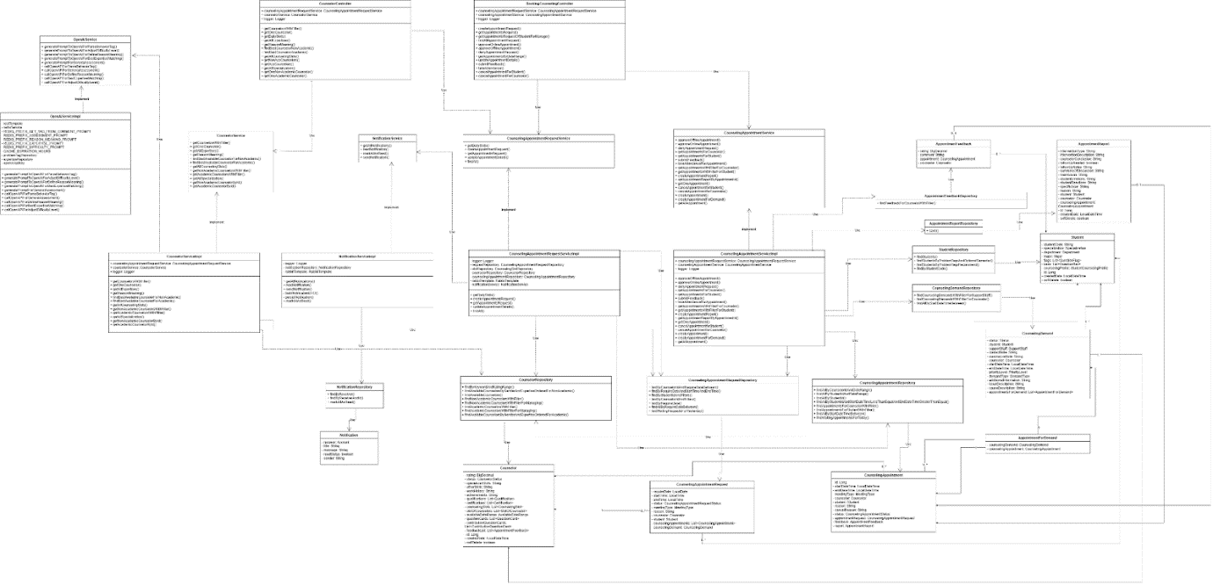

Figure 16 - Booking, handling, and tracking counseling appointments class diagram

##### **3.1.1.1. Class Specification**

###### **3.1.1.1.1. CounselorController class**

Table 81 - CounselorController class

|  |  |  |  |  |
| --- | --- | --- | --- | --- |
| **No** | **Attribute** | **Data Type** | **Visibility** | **Description** |
| 1 | counselingAppointmentRequestService | CounselingAppointmentRequestService | Public |  |
| 2 | counselorService | CounselorService | Public |  |
| 3 | logger | Logger | Public |  |

Table 82 - CounselorController method class

|  |  |  |  |
| --- | --- | --- | --- |
| **No** | **Method** | **Visibility** | **Description** |
| 1 | createAppointmentRequest() | Public |  |
| 2 | getAppointmentsRequest() | Public |  |
| 3 | getAppointmentsRequestOfStudentForManage() | Public |  |
| 4 | findAllAppointmentRequest() | Public |  |
| 5 | approveOnlineAppointment() | Public |  |
| 6 | approveOfflineAppointment() | Public |  |
| 7 | denyAppointmentRequest() | Public |  |
| 8 | getAppointmentsByDateRange() | Public |  |
| 9 | updateAppointmentDetails() | Public |  |
| 10 | submitFeedback() | Public |  |
| 11 | takeAttendance() | Public |  |
| 12 | cancelAppointmentForStudent() | Public |  |
| 13 | cancelAppointmentForCounselor() | Public |  |

###### **3.1.1.1.2. CounselorService class**

Table 83 - CounselorService method class

|  |  |  |  |
| --- | --- | --- | --- |
| **No** | **Method** | **Visibility** | **Description** |
| 1 | getCounselorsWithFilter() | Public |  |
| 2 | getOneCounselor() | Public |  |
| 3 | getAllExpertises() | Public |  |
| 4 | getReasonMeaning() | Public |  |
| 5 | findBestAvailableCounselorForNonAcademic() | Public |  |
| 6 | findBestAvailableCounselorForAcademic() | Public |  |
| 7 | getAllCounselingSlots() | Public |  |
| 8 | getNonAcademicCounselorsWithFilter() | Public |  |
| 9 | getAcademicCounselorsWithFilter() | Public |  |
| 10 | getAllSpecialization() | Public |  |
| 11 | getNonAcademicCounselorById() | Public |  |
| 12 | getAcademicCounselorById() | Public |  |

###### **3.1.1.1.3. CounselorServiceImpl class**

Table 84 - CounselorServiceImpl class

|  |  |  |  |  |
| --- | --- | --- | --- | --- |
| **No** | **Attribute** | **Data Type** | **Visibility** | **Description** |
| 1 | counselingAppointmentRequestService | CounselingAppointmentRequestService | Public |  |
| 2 | logger | Logger | Public |  |

Table 85 - CounselorServiceImpl method class

|  |  |  |  |
| --- | --- | --- | --- |
| **No** | **Method** | **Visibility** | **Description** |
| 1 | getCounselorsWithFilter() | Public |  |
| 2 | getOneCounselor() | Public |  |
| 3 | getAllExpertises() | Public |  |
| 4 | getReasonMeaning() | Public |  |
| 5 | findBestAvailableCounselorForNonAcademic() | Public |  |
| 6 | findBestAvailableCounselorForAcademic() | Public |  |
| 7 | getAllCounselingSlots() | Public |  |
| 8 | getNonAcademicCounselorsWithFilter() | Public |  |
| 9 | getAcademicCounselorsWithFilter() | Public |  |
| 10 | getAllSpecialization() | Public |  |
| 11 | getAllSpecialization() | Public |  |
| 12 | getNonAcademicCounselorById() | Public |  |
| 13 | getAcademicCounselorById() | Public |  |

###### **3.1.1.1.4. NotificationServiceImpl class**

Table 86 - NotificationServiceImpl class

|  |  |  |  |  |
| --- | --- | --- | --- | --- |
| **No** | **Attribute** | **Data Type** | **Visibility** | **Description** |
| 1 | logger | Logger | Private |  |
| 2 | notificationRepository | NotificationRepository | Private |  |
| 3 | rabbitTemplate | RabbitTemplate | Private |  |

Table 87 - NotificationServiceImp method class

|  |  |  |  |
| --- | --- | --- | --- |
| **No** | **Method** | **Visibility** | **Description** |
| 1 | getAllNotifications() | Public |  |
| 2 | readNotification() | Public |  |
| 3 | sendNotification() | Public |  |
| 4 | buildNotificationDTO() | Private |  |
| 5 | persistNotification() | Private |  |
| 6 | markAllAsRead() | Public |  |

###### **3.1.1.1.5. CounselingAppointmentRequestServiceImpl class**

Table 88 – CounselingAppointmentRequestServiceImpl class

|  |  |  |  |  |
| --- | --- | --- | --- | --- |
| **No** | **Attribute** | **Data Type** | **Visibility** | **Description** |
| 1 | logger | Logger | Private |  |
| 2 | requestRepository | CounselingAppointmentRequestRepository | Private |  |
| 3 | slotRepository | CounselingSlotRepository | Private |  |
| 4 | counselorRepository | CounselorRepository | Private |  |
| 5 | counselingAppointmentRepository | CounselingAppointmentRepository | Private |  |
| 6 | rabbitTemplate | RabbitTemplate | Private |  |
| 7 | notificationService | NotificationService | Private |  |

Table 89- CounselingAppointmentRequestServiceImpl method class

|  |  |  |  |
| --- | --- | --- | --- |
| **No** | **Method** | **Visibility** | **Description** |
| 1 | getDailySlots() | Public |  |
| 2 | createAppointmentRequest() | Public |  |
| 3 | getAppointmentsRequest() | Public |  |
| 4 | updateAppointmentDetails() | Public |  |
| 5 | findAll() | Public |  |

###### **3.1.1.1.6. BookingCounselingController class**

Table 90 - BookingCounselingController class

|  |  |  |  |  |
| --- | --- | --- | --- | --- |
| **No** | **Attribute** | **Data Type** | **Visibility** | **Description** |
| 1 | counselingAppointmentRequestService | CounselingAppointmentRequestService | Public |  |
| 2 | counselingAppointmentService | CounselingAppointmentService | Public |  |
| 3 | logger | Logger | Public |  |

Table 91 - BookingCounselingController method class

|  |  |  |  |
| --- | --- | --- | --- |
| **No** | **Method** | **Visibility** | **Description** |
| 1 | createAppointmentRequest() | Public |  |
| 2 | getAppointmentsRequest() | Public |  |
| 3 | getAppointmentsRequestOfStudentForManage() | Public |  |
| 4 | findAllAppointmentRequest() | Public |  |
| 5 | approveOnlineAppointment() | Public |  |
| 6 | approveOfflineAppointment() | Public |  |
| 7 | denyAppointmentRequest() | Public |  |
| 8 | getAppointmentsByDateRange() | Public |  |
| 9 | updateAppointmentDetails() | Public |  |
| 10 | submitFeedback() | Public |  |
| 11 | takeAttendance() | Public |  |
| 12 | cancelAppointmentForStudent() | Public |  |
| 13 | cancelAppointmentForCounselor() | Public |  |

###### **3.1.1.1.7. CounselorRepository class**

Table 92 - CounselorRepository class

|  |  |  |  |
| --- | --- | --- | --- |
| **No** | **Method** | **Visibility** | **Description** |
| 1 | findByKeywordAndRatingRange() | Public |  |
| 2 | findAvailableCounselorsByGenderAndExpertiseOrderedForNonAcademic() | Public |  |
| 3 | findAvailableCounselors() | Public |  |
| 4 | findNonAcademicCounselorsWithFilter() | Public |  |
| 5 | findNonAcademicCounselorsWithFilterForManaging() | Public |  |
| 6 | findAcademicCounselorsWithFilter() | Public |  |
| 7 | findAcademicCounselorsWithFilterForManaging() | Public |  |
| 8 | findAvailableCounselorsByGenderAndExpertiseOrderedForAcademic() | Public |  |

###### **3.1.1.1.8. CounselingAppointmentRequestService class**

Table 93 – CounselingAppointmentRequestService method class

|  |  |  |  |
| --- | --- | --- | --- |
| **No** | **Method** | **Visibility** | **Description** |
| 1 | getDailySlots() | Public |  |
| 2 | createAppointmentRequest() | Public |  |
| 3 | getAppointmentsRequest() | Public |  |
| 4 | updateAppointmentDetails() | Public |  |
| 5 | findAll() | Public |  |

###### **3.1.1.1.9 . OpenAIServiceImpl class**

Table 94 - OpenAIServiceImpl class

|  |  |  |  |  |
| --- | --- | --- | --- | --- |
| **No** | **Attribute** | **Data Type** | **Visibility** | **Description** |
| 1 | restTemplate |  | Private |  |
| 2 | redisService |  | Private |  |
| 3 | REDIS_PREFIX_GET_TAG_FROM_COMMENT_PROMPT |  | Private |  |
| 4 | REDIS_PREFIX_ASSESSMENT_PROMPT |  | Private |  |
| 5 | REDIS_PREFIX_REASON_MEANING_PROMPT |  | Private |  |
| 6 | REDIS_PREFIX_EXPERTISE_PROMPT |  | Private |  |
| 7 | REDIS_PREFIX_DIFFICULTY_PROMPT |  | Private |  |
| 8 | CACHE_EXPIRATION_HOURS |  | Private |  |
| 9 | problemTagRepository |  | Private |  |
| 10 | expertiseRepository |  | Private |  |
| 11 | openAiApiKey |  | Private |  |

Table 95 - OpenAIServiceImpl method class

|  |  |  |  |
| --- | --- | --- | --- |
| **No** | **Method** | **Visibility** | **Description** |
| 1 | generatePromptToOpenAIForParseBehaviorTag() | Public |  |
| 2 | generatePromptToOpenAIForAdjustDifficultyLevel() | Public |  |
| 3 | generatePromptToOpenAIForDefineReasonMeaning() | Public |  |
| 4 | generatePromptToOpenAIForBestExpertiseMatching() | Public |  |
| 5 | generatePromptForGeneralAssessment() | Public |  |
| 6 | callOpenAPIForParseBehaviorTag() | Public |  |
| 7 | callOpenAPIForGeneralAssessment() | Public |  |
| 8 | callOpenAPIForDefineReasonMeaning() | Public |  |
| 9 | callOpenAPIForBestExpertiseMatching() | Public |  |
| 10 | callOpenAPIForAdjustDifficultyLevel() | Public |  |

###### **3.1.1.1.10 . OpenAIServiceImpl class**

Table 96 – OpenAIServiceImpl method class

|  |  |  |  |
| --- | --- | --- | --- |
| **No** | **Method** | **Visibility** | **Description** |
| 1 | generatePromptToOpenAIForParseBehaviorTag() | Public |  |
| 2 | generatePromptToOpenAIForAdjustDifficultyLevel() | Public |  |
| 3 | generatePromptToOpenAIForDefineReasonMeaning() | Public |  |
| 4 | generatePromptToOpenAIForBestExpertiseMatching() | Public |  |
| 5 | generatePromptForGeneralAssessment() | Public |  |
| 6 | callOpenAPIForParseBehaviorTag() | Public |  |
| 7 | callOpenAPIForGeneralAssessment() | Public |  |
| 8 | callOpenAPIForDefineReasonMeaning() | Public |  |
| 9 | callOpenAPIForBestExpertiseMatching() | Public |  |
| 10 | callOpenAPIForAdjustDifficultyLevel() | Public |  |

###### **3.1.1.1.11. NotificationService class**

Table 97 - NotificationService class

|  |  |  |  |
| --- | --- | --- | --- |
| **No** | **Method** | **Visibility** | **Description** |
| 1 | getAllNotifications() |  |  |
| 2 | readNotification() |  |  |
| 3 | markAllAsRead() |  |  |
| 4 | sendNotification() |  |  |

###### **3.1.1.1.12 . OpenAIService class**

Table 98 - OpenAIService class

|  |  |  |  |  |
| --- | --- | --- | --- | --- |
| **No** | **Attribute** | **Data Type** | **Visibility** | **Description** |
| 1 | restTemplate |  | Private |  |
| 2 | redisService |  | Private |  |
| 3 | REDIS_PREFIX_GET_TAG_FROM_COMMENT_PROMPT |  | Private |  |
| 4 | REDIS_PREFIX_ASSESSMENT_PROMPT |  | Private |  |
| 5 | REDIS_PREFIX_REASON_MEANING_PROMPT |  | Private |  |
| 6 | REDIS_PREFIX_EXPERTISE_PROMPT |  | Private |  |
| 7 | REDIS_PREFIX_DIFFICULTY_PROMPT |  | Private |  |
| 8 | CACHE_EXPIRATION_HOURS |  | Private |  |
| 9 | problemTagRepository |  | Private |  |
| 10 | expertiseRepository |  | Private |  |
| 11 | openAiApiKey |  | Private |  |

Table 99 - OpenAIService method class

|  |  |  |  |
| --- | --- | --- | --- |
| **No** | **Method** | **Visibility** | **Description** |
| 1 | generatePromptToOpenAIForParseBehaviorTag() | Public |  |
| 2 | generatePromptToOpenAIForAdjustDifficultyLevel() | Public |  |
| 3 | generatePromptToOpenAIForDefineReasonMeaning() | Public |  |
| 4 | generatePromptToOpenAIForBestExpertiseMatching() | Public |  |
| 5 | generatePromptForGeneralAssessment() | Public |  |
| 6 | callOpenAPIForParseBehaviorTag() | Public |  |
| 7 | callOpenAPIForGeneralAssessment() | Public |  |
| 8 | callOpenAPIForDefineReasonMeaning() | Public |  |
| 9 | callOpenAPIForBestExpertiseMatching() | Public |  |
| 10 | callOpenAPIForAdjustDifficultyLevel() | Public |  |

###### **3.1.1.1.13 . NotificationRepository class**

Table 100 - NotificationRepository class

|  |  |  |  |
| --- | --- | --- | --- |
| **No** | **Method** | **Visibility** | **Description** |
| 1 | findByReceiver() | Public |  |
| 2 | findByReceiverAndId() | Public |  |
| 3 | markAllAsRead() | Public |  |

###### **3.1.1.1.14 . Notification class**

Table 101 - Notification class

|  |  |  |  |  |
| --- | --- | --- | --- | --- |
| **No** | **Attribute** | **Data Type** | **Visibility** | **Description** |
| 1 | receiver | Account | Private |  |
| 2 | title | String | Private |  |
| 3 | message | String | Private |  |
| 4 | readStatus | boolean | Private |  |
| 5 | sender | String | Private |  |

###### **3.1.1.1.15 . CounselingAppointmentService class**

Table 102 - CounselingAppointmentService method class

|  |  |  |  |
| --- | --- | --- | --- |
| **No** | **Method** | **Visibility** | **Description** |
| 1 | approveOfflineAppointment() | Public |  |
| 2 | approveOnlineAppointment() | Public |  |
| 3 | denyAppointmentRequest() | Public |  |
| 4 | getAppointmentsForCounselor() | Public |  |
| 5 | getAppointmentsForStudent() | Public |  |
| 6 | submitFeedback() | Public |  |
| 7 | takeAttendanceForAppointment() | Public |  |
| 8 | getAppointmentsWithFilterForCounselor() | Public |  |
| 9 | getAppointmentsWithFilterForStudent() | Public |  |
| 10 | createAppointmentReport() | Public |  |
| 11 | getAppointmentReportByAppointmentId() | Public |  |
| 12 | getOneAppointment() | Public |  |
| 13 | cancelAppointmentforStudent() | Public |  |
| 14 | cancelAppointmentforCounselor() | Public |  |
| 15 | createAppointment() | Public |  |
| 16 | createAppointmentForDemand() | Public |  |
| 17 | getAllAppointment() | Public |  |

###### **3.1.1.1.16 . CounselingAppointmentServiceImpl class**

Table 103 - CounselingAppointmentServiceImpl class

|  |  |  |  |  |
| --- | --- | --- | --- | --- |
| **No** | **Attribute** | **Data Type** | **Visibility** | **Description** |
| 1 | counselingAppointmentRequestService | CounselingAppointmentRequestService | Public |  |
| 2 | counselingAppointmentService | CounselingAppointmentService | Public |  |
| 3 | logger | Logger | Public |  |

Table 104 - CounselingAppointmentServiceImpl method class

|  |  |  |  |
| --- | --- | --- | --- |
| **No** | **Method** | **Visibility** | **Description** |
| 1 | approveOfflineAppointment() | Public |  |
| 2 | approveOnlineAppointment() | Public |  |
| 3 | denyAppointmentRequest() | Public |  |
| 4 | createAppointmentReport() | Public |  |
| 5 | getAppointmentsForCounselor() | Public |  |
| 6 | getAppointmentsForStudent() | Public |  |
| 7 | submitFeedback() | Public |  |
| 8 | takeAttendanceForAppointment() | Public |  |
| 9 | getAppointmentsWithFilterForCounselor() | Public |  |
| 10 | getAppointmentsWithFilterForStudent() | Public |  |
| 11 | getAppointmentReportByAppointmentId() | Public |  |
| 12 | getOneAppointment() | Public |  |
| 13 | cancelAppointmentforStudent() | Public |  |
| 14 | cancelAppointmentforCounselor() | Public |  |
| 15 | createAppointment() | Public |  |
| 16 | createAppointmentForDemand() | Public |  |
| 17 | getAllAppointment() | Public |  |

###### **3.1.1.1.17 . AppointmentFeedback class**

Table 105 - AppointmentFeedback class

|  |  |  |  |  |
| --- | --- | --- | --- | --- |
| **No** | **Attribute** | **Data Type** | **Visibility** | **Description** |
| 1 | rating | BigDecimal | Private |  |
| 2 | comment | String | Private |  |
| 3 | appointment | CounselingAppointment | Private |  |
| 4 | counselor | Counselor | Private |  |

###### **3.1.1.1.18 . AppointmentFeedbackRepository class**

Table 106 - AppointmentFeedbackRepository method class

|  |  |  |  |
| --- | --- | --- | --- |
| **No** | **Method** | **Visibility** | **Description** |
| 1 | findFeedbackForCounselorWithFilter() | Public |  |

###### **3.1.1.1.19 . AppointmentReportRepository class**

Table 107 - AppointmentReportRepository method class

|  |  |  |  |
| --- | --- | --- | --- |
| **No** | **Method** | **Visibility** | **Description** |
| 1 | save() | Public |  |

###### **3.1.1.1.20 . AppointmentReport class**

Table 108 - AppointmentReport class

|  |  |  |  |  |
| --- | --- | --- | --- | --- |
| **No** | **Attribute** | **Data Type** | **Visibility** | **Description** |
| 1 | interventionType | String | Private |  |
| 2 | interventionDescription | String | Private |  |
| 3 | counselorConclusion | String | Private |  |
| 4 | followUpNeeded | boolean | Private |  |
| 5 | followUpNotes | String | Private |  |
| 6 | summaryOfDiscussion | String | Private |  |
| 7 | mainIssues | String | Private |  |
| 8 | studentEmotions | String | Private |  |
| 9 | studentReactions | String | Private |  |
| 10 | specificGoal | String | Private |  |
| 11 | reason | String | Private |  |
| 12 | student | Student | Private |  |
| 13 | counselor | Counselor | Private |  |
| 14 | counselingAppointment | List<CounselingAppointment> | Private |  |
| 15 | id | Long | Private |  |
| 16 | createdDate | LocalDateTime | Private |  |
| 17 | softDelete | boolean | Private |  |

###### **3.1.1.1.21 . CounselingAppointmentRequestRepository class**

Table 109 - CounselingAppointmentRequestRepository method class

|  |  |  |  |
| --- | --- | --- | --- |
| **No** | **Method** | **Visibility** | **Description** |
| 1 | findByCounselorIdAndRequireDateBetween() | Public |  |
| 2 | findByRequireDateAndStartTimeAndEndTime() | Public |  |
| 3 | findByStudentIdAndFilters() | Public |  |
| 4 | findByCounselorIdAndFilters() | Public |  |
| 5 | findByRequireDate() | Public |  |
| 6 | findAllByRequireDateBetween() | Public |  |
| 7 | findWaitingRequestsForYesterday() | Public |  |

###### **3.1.1.1.22 . Counselor class**

Table 110 - Counselor class

|  |  |  |  |  |
| --- | --- | --- | --- | --- |
| **No** | **Attribute** | **Data Type** | **Visibility** | **Description** |
| 1 | rating | BigDecimal | Private |  |
| 2 | status | CounselorStatus | Private |  |
| 3 | specializedSkills | String | Private |  |
| 4 | otherSkills | String | Private |  |
| 5 | workHistory | String | Private |  |
| 6 | achievements | String | Private |  |
| 7 | qualifications | List<Qualification> | Private |  |
| 8 | certifications | List<Certification> | Private |  |
| 9 | counselingSlots | List<CounselingSlot> | Private |  |
| 10 | slotOfCounselors | List<SlotOfCounselor> | Private |  |
| 11 | availableDateRange | AvailableDateRange | Private |  |
| 12 | questionCards | List<QuestionCard> | Private |  |
| 13 | contributionQuestionCards | List<ContributionQuestionCard> | Private |  |
| 14 | feedbackList | List<AppointmentFeedback> | Private |  |
| 15 | id | Long | Private |  |
| 16 | createdDate | LocalDateTime | Private |  |
| 17 | softDelete | boolean | Private |  |

###### **3.1.1.1.23 . CounselingAppointmentRequest class**

Table 111 - CounselingAppointmentRequest class

|  |  |  |  |  |
| --- | --- | --- | --- | --- |
| **No** | **Attribute** | **Data Type** | **Visibility** | **Description** |
| 1 | requireDate | LocalDate | Private |  |
| 2 | startTime | LocalTime | Private |  |
| 3 | endTime | LocalTime | Private |  |
| 4 | status | CounselingAppointmentRequestStatus | Private |  |
| 5 | meetingType | MeetingType | Private |  |
| 6 | reason | String | Private |  |
| 7 | counselor | Counselor | Private |  |
| 8 | student | Student | Private |  |
| 9 | counselingAppointments | List<CounselingAppointment> | Private |  |
| 10 | counselingDemand | CounselingDemand | Private |  |

###### **3.1.1.1.24 . CounselingAppointment class**

Table 112 - CounselingAppointment class

|  |  |  |  |  |
| --- | --- | --- | --- | --- |
| **No** | **Attribute** | **Data Type** | **Visibility** | **Description** |
| 1 | id | Long | Private |  |
| 2 | startDateTime | LocalDateTime | Private |  |
| 3 | endDateTime | LocalDateTime | Private |  |
| 4 | meetingType | MeetingType | Private |  |
| 5 | counselor | Counselor | Private |  |
| 6 | student | Student | Private |  |
| 7 | reason | String | Private |  |
| 8 | cancelReason | String | Private |  |
| 9 | status | CounselingAppointmentStatus | Private |  |
| 10 | appointmentRequest | CounselingAppointmentRequest | Private |  |
| 11 | feedback | AppointmentFeedback | Private |  |
| 12 | report | AppointmentReport | Private |  |

###### **3.1.1.1.25. AppointmentForDemand class**

Table 113 - AppointmentForDemand class

|  |  |  |  |  |
| --- | --- | --- | --- | --- |
| **No** | **Attribute** | **Data Type** | **Visibility** | **Description** |
| 1 | counselingDemand: | CounselingDemand | Private |  |
| 2 | counselingAppointment | CounselingAppointment | Private |  |

###### **3.1.1.1.26 . StudentRepository class**

Table 114 - StudentRepository method class

|  |  |  |  |
| --- | --- | --- | --- |
| **No** | **Method** | **Visibility** | **Description** |
| 1 | findStudents() | Public |  |
| 2 | findStudentsByProblemTagsAndOptionalSemester() | Public |  |
| 3 | findStudentsByProblemTagsRecommend() | Public |  |
| 4 | findByStudentCode() | Public |  |

###### **3.1.1.1.27. CounselingDemandRepository class**

Table 115 - CounselingDemandRepository method class

|  |  |  |  |
| --- | --- | --- | --- |
| **No** | **Method** | **Visibility** | **Description** |
| 1 | findCounselingDemandsWithFilterForSupportStaff() | Public |  |
| 2 | findCounselingDemandsWithFilterForCounselor() | Public |  |
| 3 | findAllByStartDateTimeBetween() | Public |  |

###### **3.1.1.1.28. CounselingAppointmentRepository class**

Table 116 - CounselingAppointmentRepository method class

|  |  |  |  |
| --- | --- | --- | --- |
| **No** | **Method** | **Visibility** | **Description** |
| 1 | findAllByCounselorIdAndDateRange() | Public |  |
| 2 | findAllByStudentIdAndDateRange() | Public |  |
| 3 | findAllByStudentId() | Public |  |
| 4 | findAllByStudentIdAndStartDateTimeLessThanEqualAndEndDateTimeGreaterThanEqual() | Public |  |
| 5 | findAppointmentsForCounselorWithFilter() | Public |  |
| 6 | findAppointmentsForStudentWithFilter() | Public |  |
| 7 | findAllByStartDateTimeBetween() | Public |  |
| 8 | findWaitingAppointmentsForToday() | Public |  |

###### **3.1.1.1.29 . Student class**

Table 117 - Student class

|  |  |  |  |  |
| --- | --- | --- | --- | --- |
| **No** | **Attribute** | **Data Type** | **Visibility** | **Description** |
| 1 | studentCode | String | Private |  |
| 2 | specialization | Specialization | Private |  |
| 3 | department | Department | Private |  |
| 4 | major | Major | Private |  |
| 5 | flags | List<QuestionFlag> | Private |  |
| 6 | bans | List<QuestionBan> | Private |  |
| 7 | counselingProfile | StudentCounselingProfile | Private |  |
| 8 | id | Long | Private |  |
| 9 | createdDate | LocalDateTime | Private |  |
| 10 | softDelete | boolean | Private |  |

###### **3.1.1.1.30 . CounselingDemand class**

Table 118 - CounselingDemand class

|  |  |  |  |  |
| --- | --- | --- | --- | --- |
| **No** | **Attribute** | **Data Type** | **Visibility** | **Description** |
| 1 | status | Status | Private |  |
| 2 | student | Student | Private |  |
| 3 | supportStaff | SupportStaff | Private |  |
| 4 | contactNote | String | Private |  |
| 5 | summarizeNote | String | Private |  |
| 6 | counselor | Counselor | Private |  |
| 7 | startDateTime | LocalDateTime | Private |  |
| 8 | endDateTime | LocalDateTime | Private |  |
| 9 | priorityLevel | PriorityLevel | Private |  |
| 10 | demandType | DemandType | Private |  |
| 11 | additionalInformation | String | Private |  |
| 12 | issueDescription | String | Private |  |
| 13 | causeDescription | String | Private |  |
| 14 | appointmentsForDemand | List<AppointmentForDemand> | Private |  |

#### 3.1.2. Sequence Diagram

##### **3.1.2.1. Sequence Diagram**

###### **3.1.2.1.1. Student quick matching counselor**

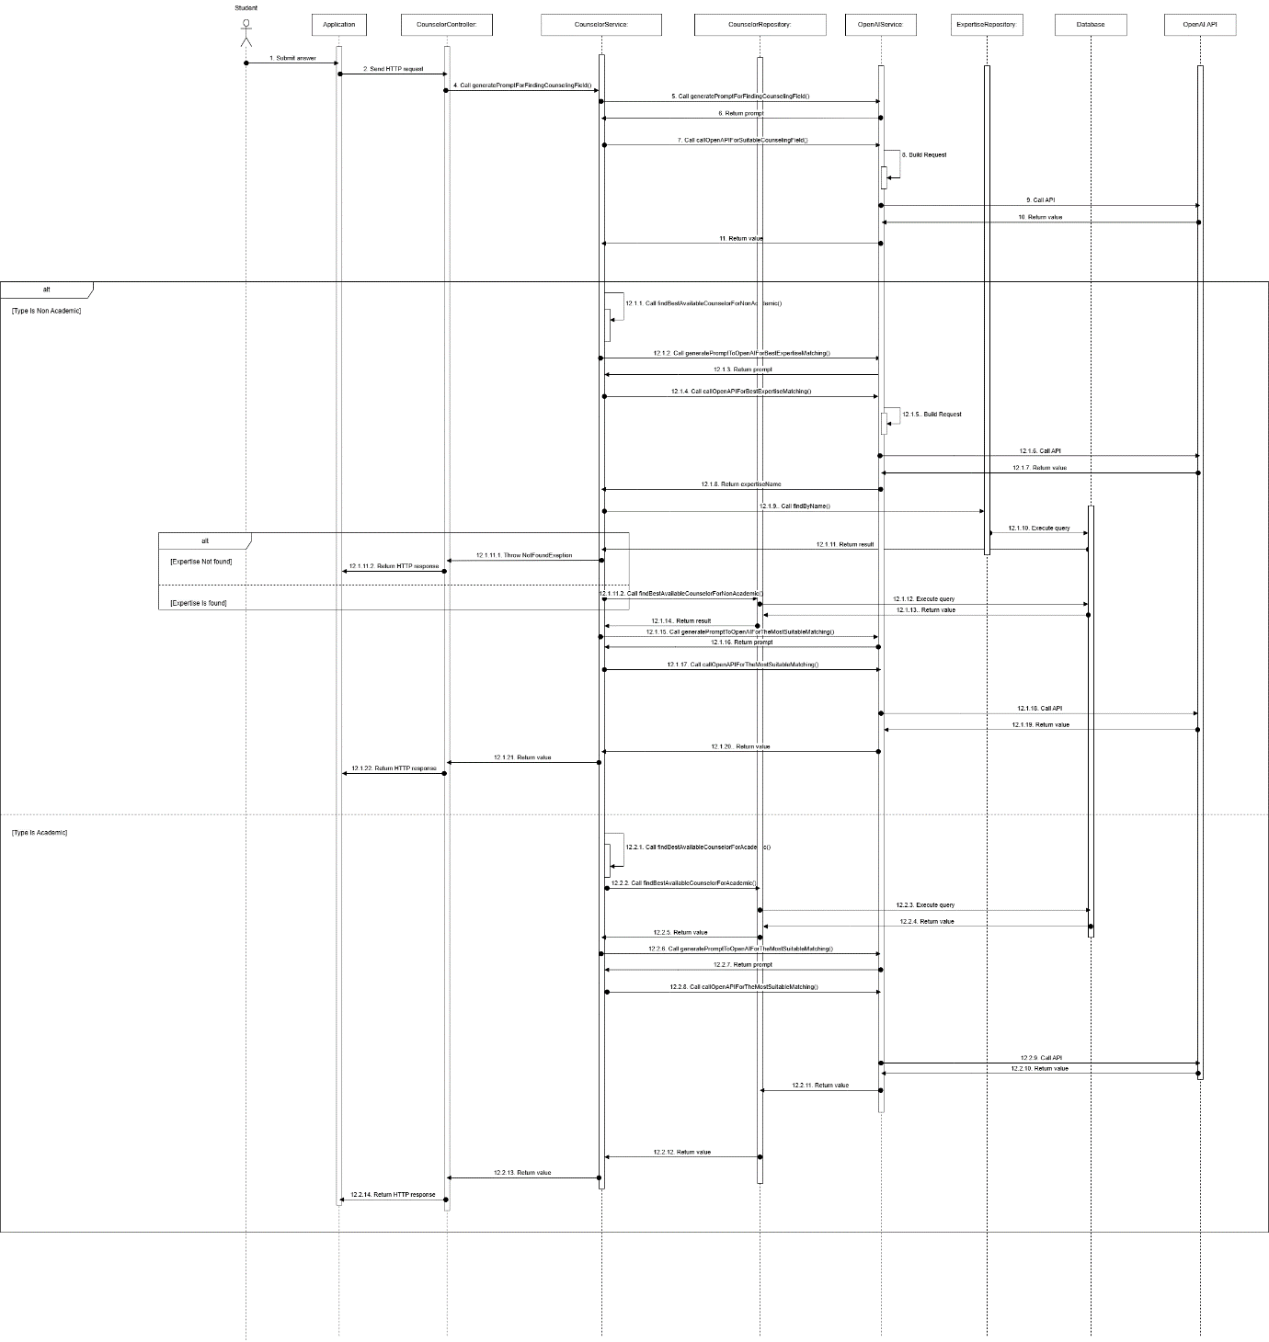

Figure 17- Student quick matching counselor sequence diagram

**3.1.2.1.2. Student creates appointment request** 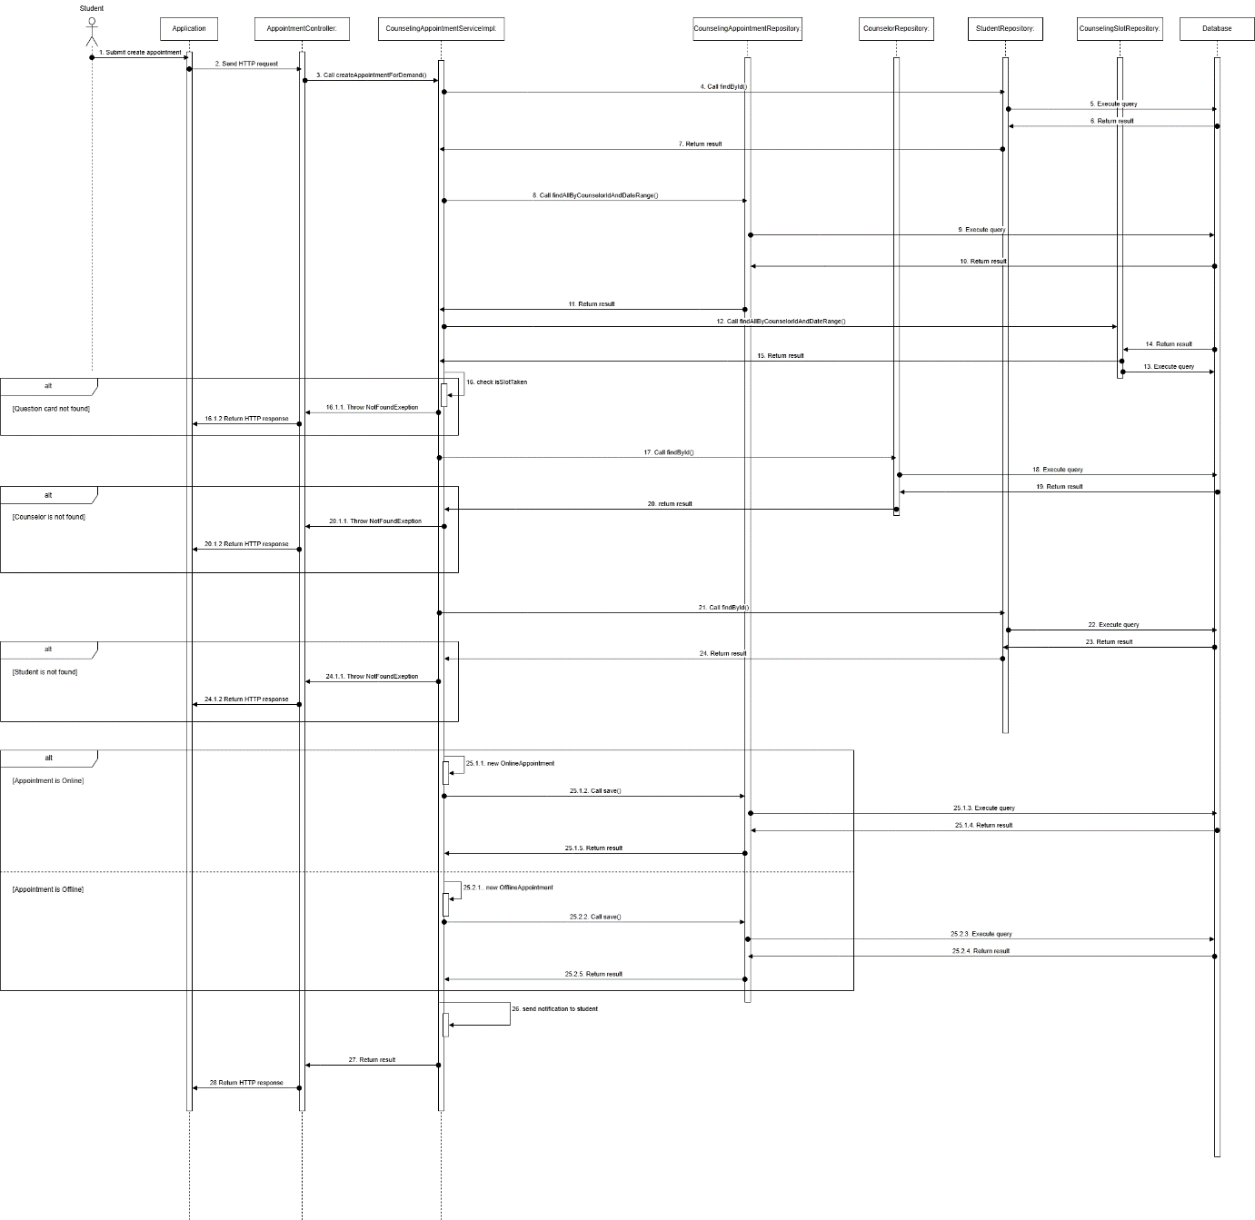

Figure 18 - Student creates appointment request sequence diagram

###### **3.1.2.1.3. Counselor Approves appointment request**

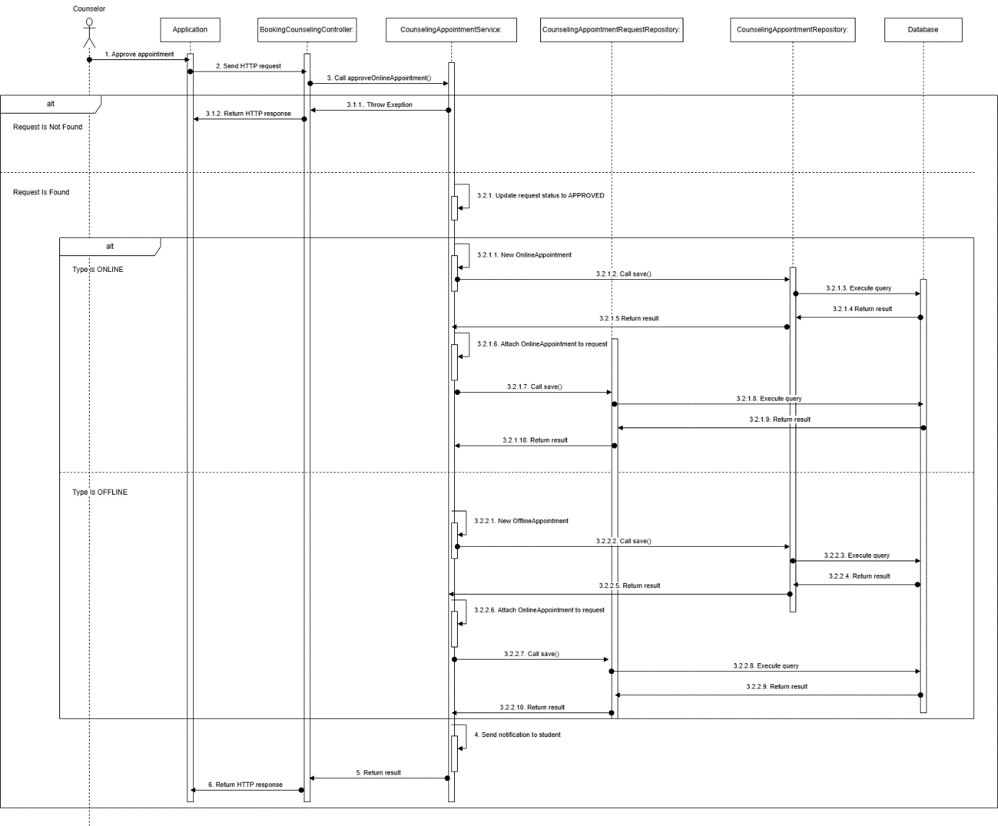

Figure 19 - Counselor Approves appointment request sequence diagram

###### **3.1.2.1.4. Take attendance**

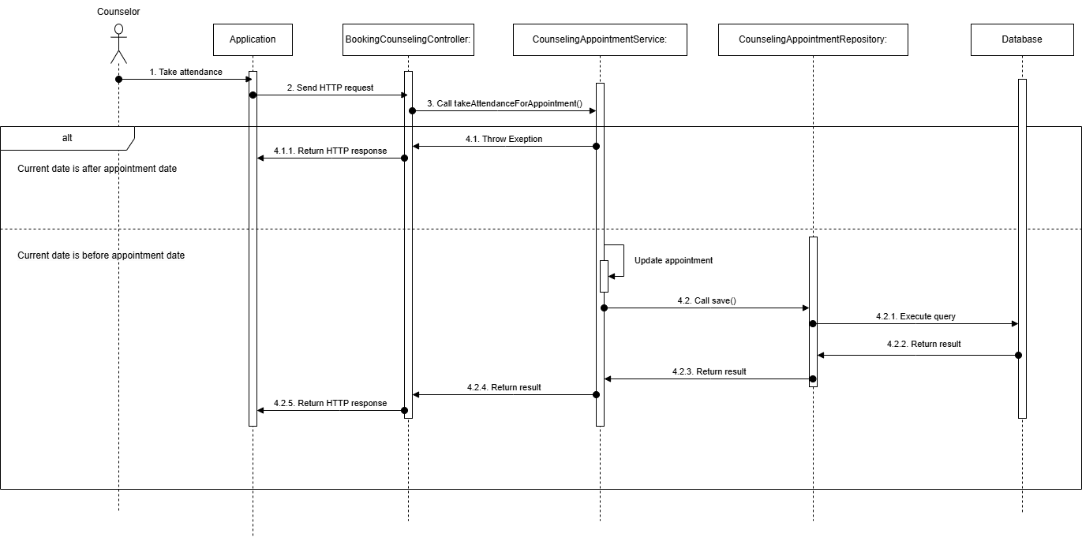

Figure 20 - Take attendance sequence diagram

###### **3.1.2.1.5. Student provide feedback**

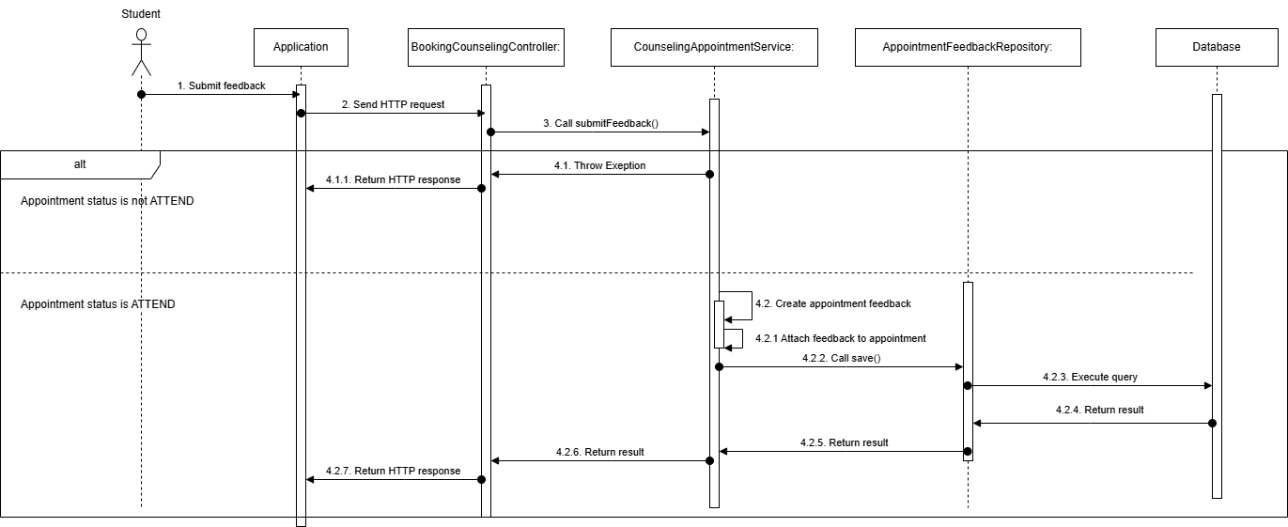

Figure 21 - Student provide feedback sequence diagram

###### **3.1.2.1.6. Counselor cancel appointment**

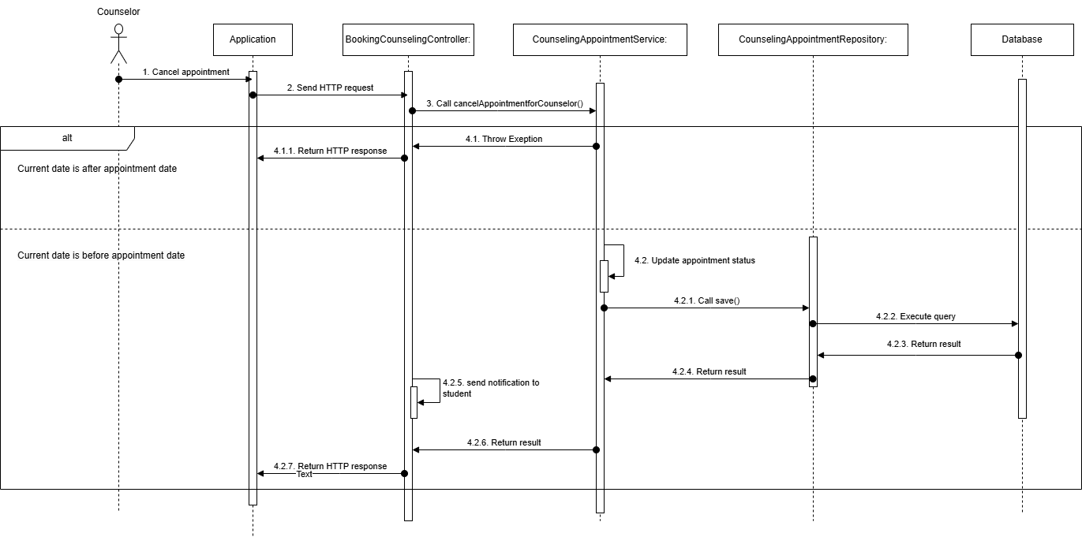

Figure 22 – Counselor cancel appointment sequence diagram

###### **3.1.2.1.7. Student cancel appointment**

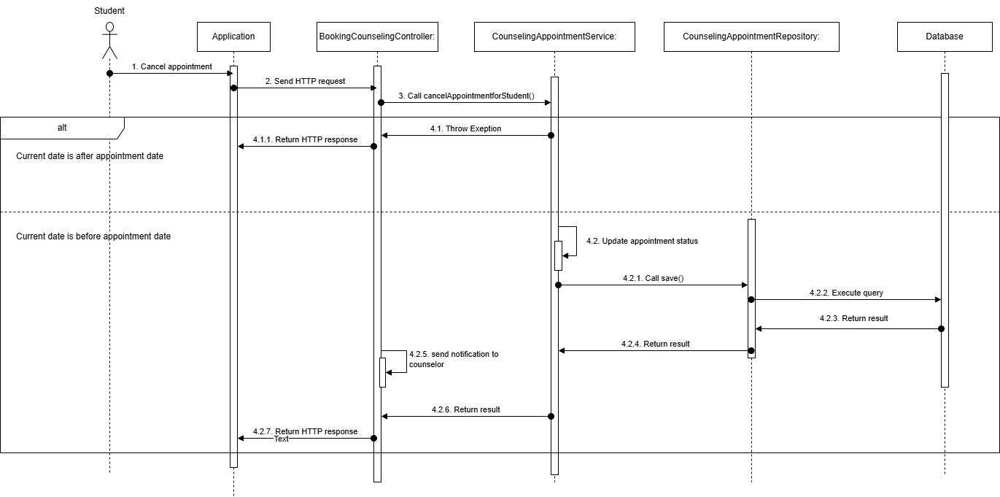

Figure 23 - Student cancel appointment sequence diagram

#### **3.1.3. Activity Diagram**

**3.1.3.1. Create Booking request with quick booking**  
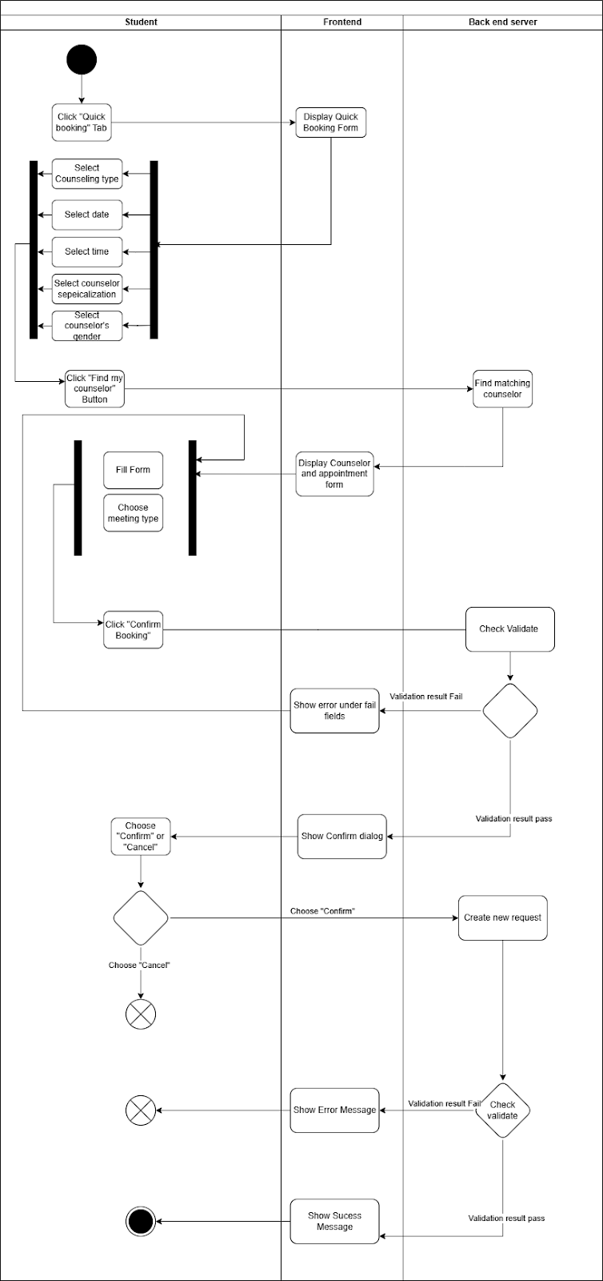

Figure 24 - Create Booking request with quick booking activity diagram

##### **3.1.3.2. Create booking request with choosing a specific counselor**

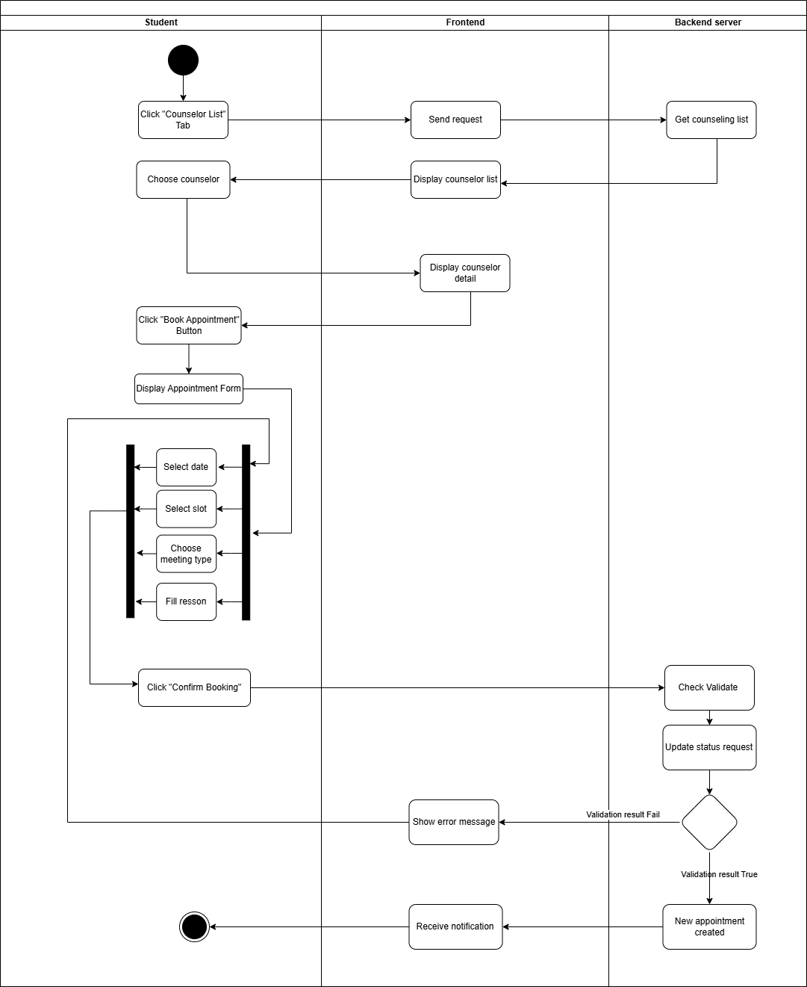

Figure 25 - Create booking request with choosing a specific counselor activity diagram

##### **3.1.3.3. Take attendance**

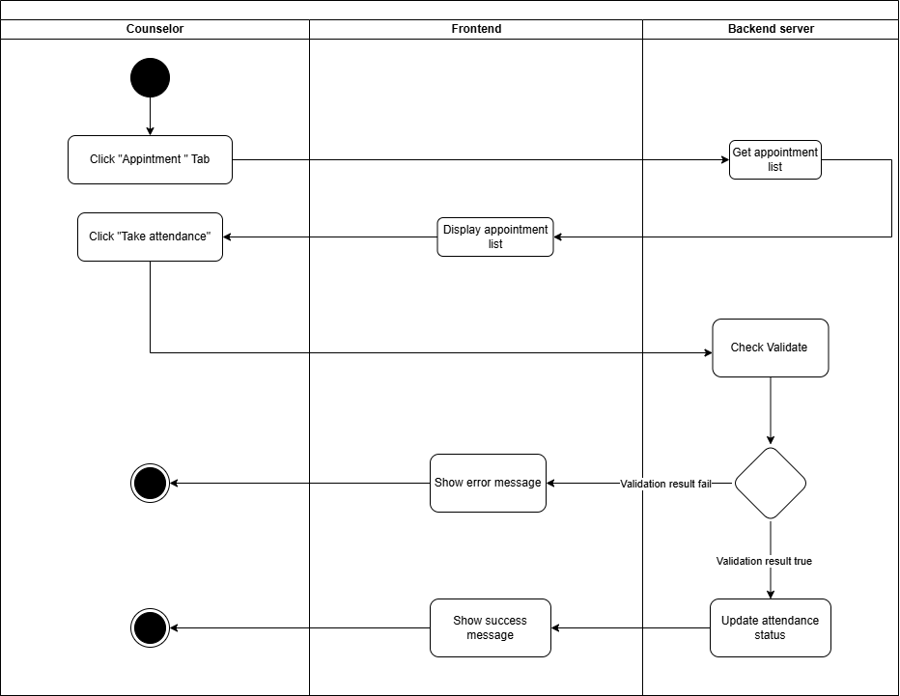

Figure 26 - Take attendance activity diagram

##### **3.1.3.4. Provide Feedback**

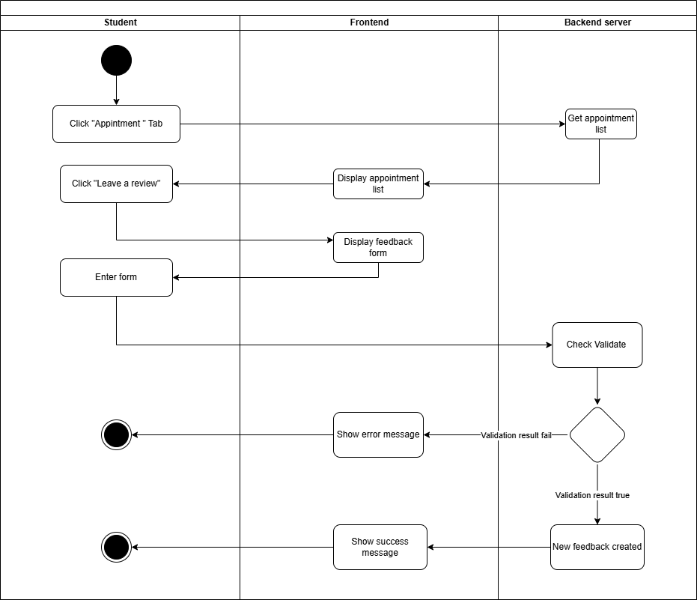

Figure 27 - Provide Feedback activity diagram

##### **3.1.3.5. Cancel Appointment**

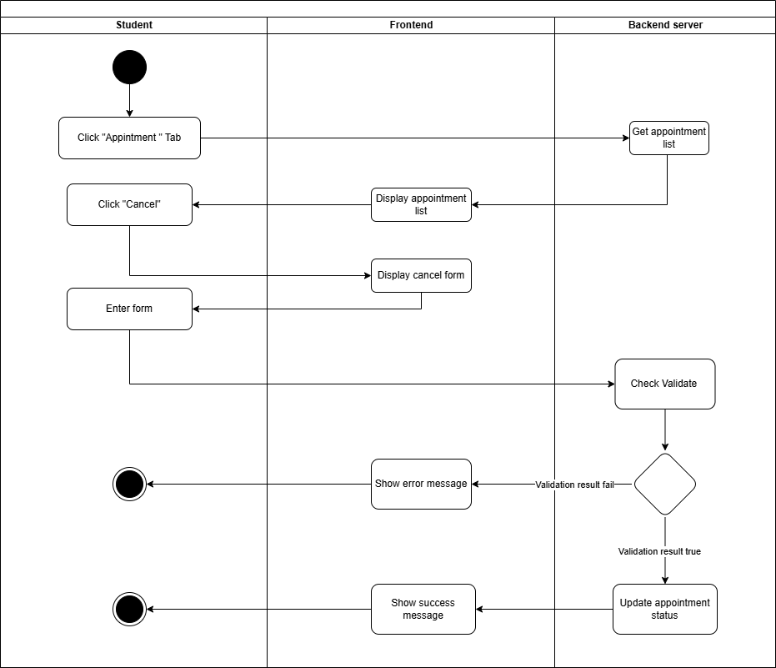

Figure 28 - Cancel Appointment activity diagram

**3.1.3.6. Approve appointment request**

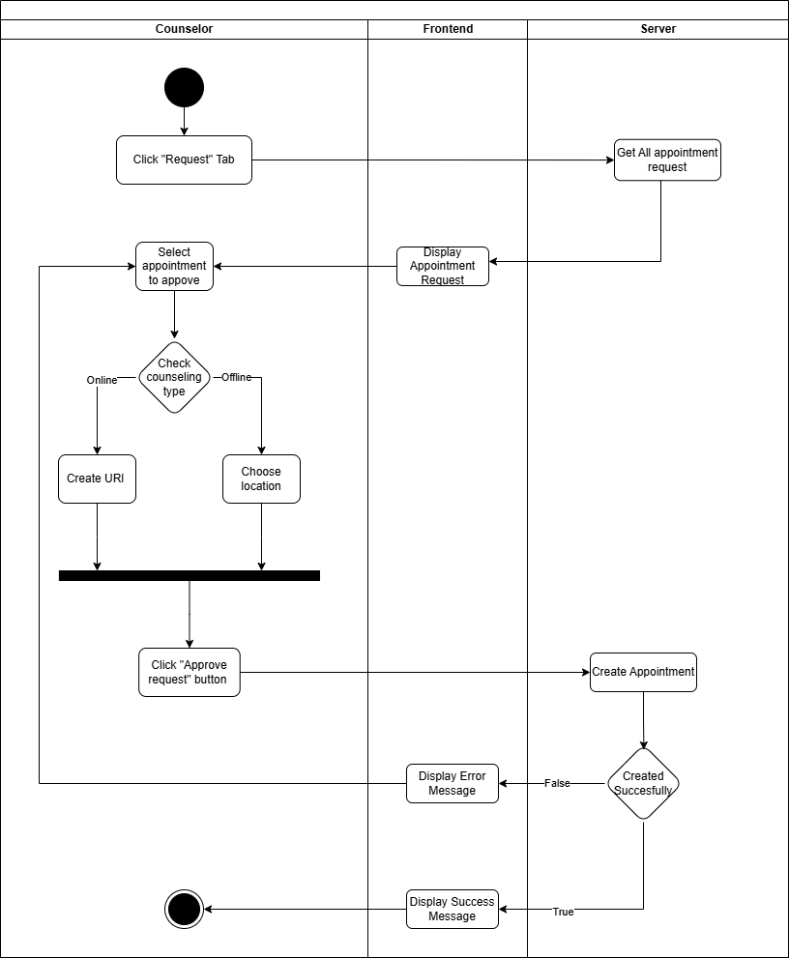

Figure 29 - Approve appointment request activity diagram

**3.1.3.7. Create report**

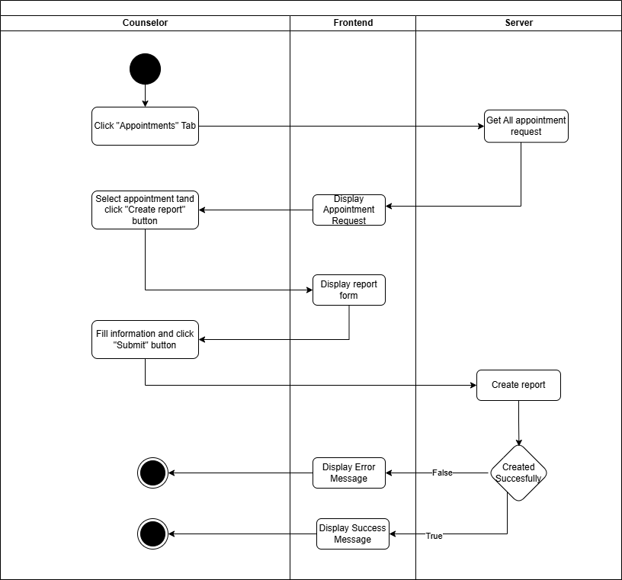

Figure 30 - Create report activity diagram

#### 3.1.4. State Machine Diagram

##### 3.1.4.1. Booking Appointment State Machine Diagram

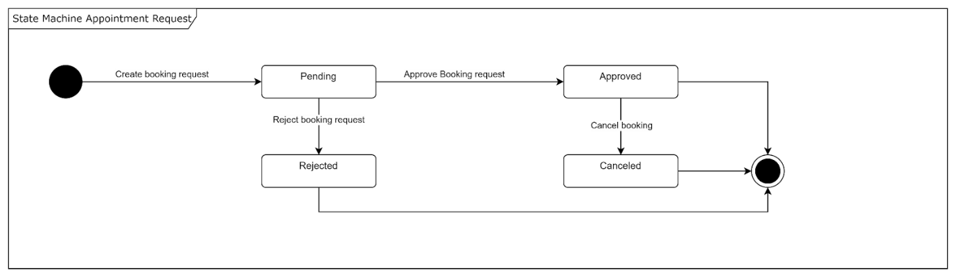

Figure 31 - Booking Appointment State Machine Diagram

##### 3.1.4.2. Taking Appointment State Machine Diagram

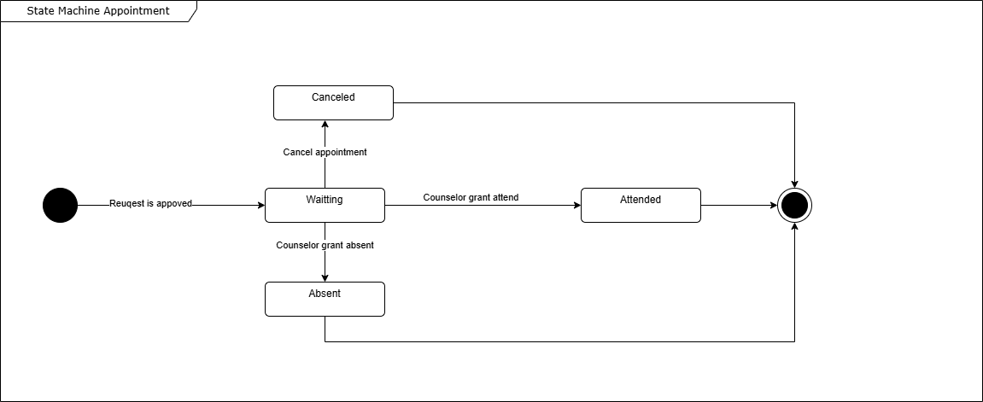

### **3.2. Student Questions and Counselor Support**

#### **3.2.1. Class Diagram**

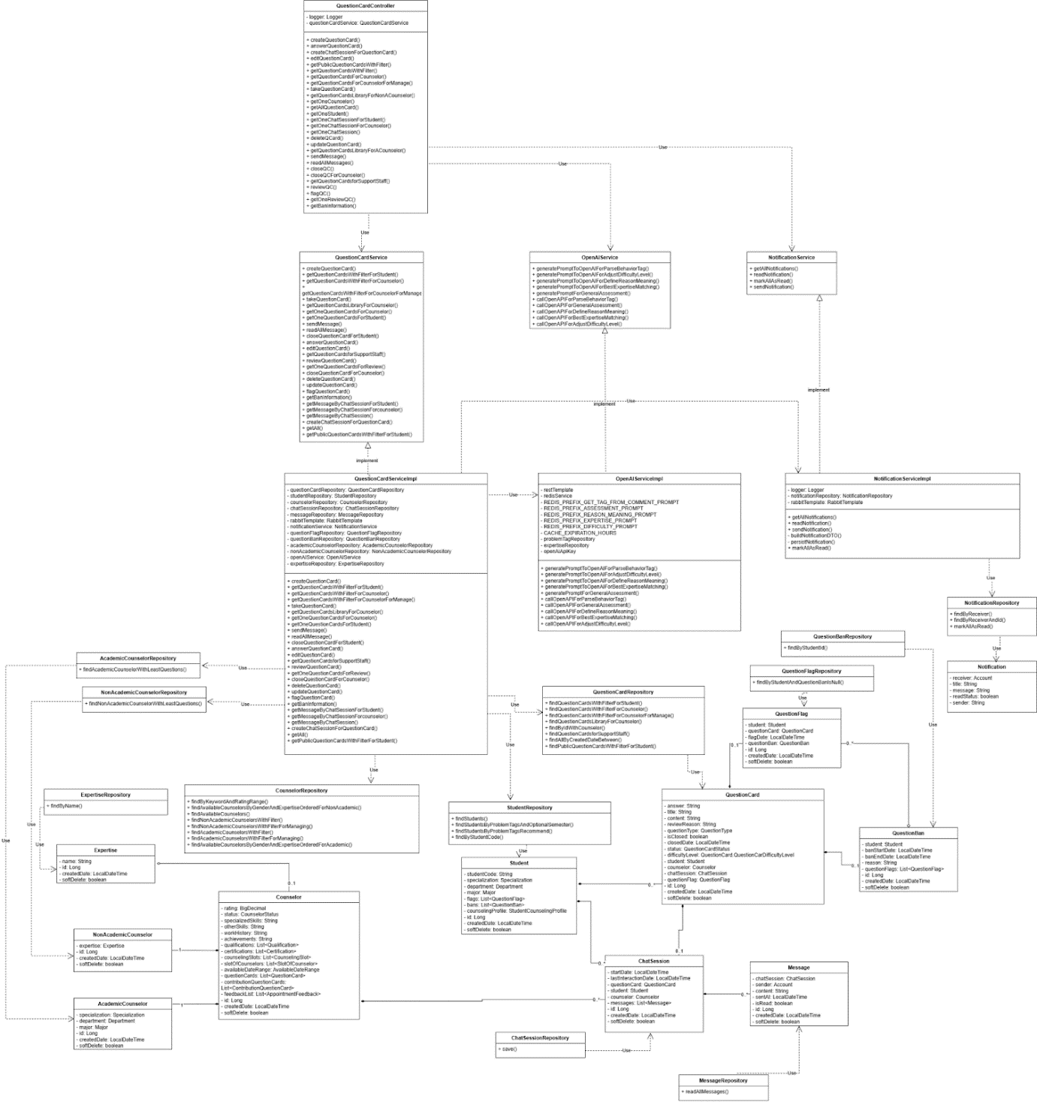

Figure 32 - Student Questions and Counselor Support class diagram

##### **3.2.1.1. Class Specification**

###### **3.2.1.1.1. Counselor class**

Table 119 - Counselor class

|  |  |  |  |  |
| --- | --- | --- | --- | --- |
| **No** | **Attribute** | **Data Type** | **Visibility** | **Description** |
| 1 | rating | BigDecimal | Private |  |
| 2 | status | CounselorStatus | Private |  |
| 3 | specializedSkills | String | Private |  |
| 4 | otherSkills | String | Private |  |
| 5 | workHistory | String | Private |  |
| 6 | achievements | String | Private |  |
| 7 | qualifications | List<Qualification> | Private |  |
| 8 | certifications | List<Certification> | Private |  |
| 9 | counselingSlots | List<CounselingSlot> | Private |  |
| 10 | slotOfCounselors | List<SlotOfCounselor> | Private |  |
| 11 | availableDateRange | AvailableDateRange | Private |  |
| 12 | questionCards | List<QuestionCard> | Private |  |
| 13 | contributionQuestionCards | List<ContributionQuestionCard> | Private |  |
| 14 | feedbackList | List<AppointmentFeedback> | Private |  |
| 15 | id | Long | Private |  |
| 16 | createdDate | LocalDateTime | Private |  |
| 17 | softDelete | boolean | Private |  |

###### **3.2.1.1.2 . StudentRepository class**

Table 120 – StudentRepository method class

|  |  |  |  |
| --- | --- | --- | --- |
| **No** | **Method** | **Visibility** | **Description** |
| 1 | findStudents() | Public |  |
| 2 | findStudentsByProblemTagsAndOptionalSemester() | Public |  |
| 3 | findStudentsByProblemTagsRecommend() | Public |  |
| 4 | findByStudentCode() | Public |  |

###### **3.2.1.1.3. CounselorRepository class**

Table 121 – CounselorRepository method class

|  |  |  |  |
| --- | --- | --- | --- |
| **No** | **Method** | **Visibility** | **Description** |
| 1 | findByKeywordAndRatingRange() | Public |  |
| 2 | findAvailableCounselorsByGenderAndExpertiseOrderedForNonAcademic() | Public |  |
| 3 | findAvailableCounselors() | Public |  |
| 4 | findNonAcademicCounselorsWithFilter() | Public |  |
| 5 | findNonAcademicCounselorsWithFilterForManaging() | Public |  |
| 6 | findAcademicCounselorsWithFilter() | Public |  |
| 7 | findAcademicCounselorsWithFilterForManaging() | Public |  |
| 8 | findAvailableCounselorsByGenderAndExpertiseOrderedForAcademic() | Public |  |

###### **3.2.1.1.4. Student class**

Table 122 - Student class

|  |  |  |  |  |
| --- | --- | --- | --- | --- |
| **No** | **Attribute** | **Data Type** | **Visibility** | **Description** |
| 1 | studentCode | String | Private |  |
| 2 | specialization | Specialization | Private |  |
| 3 | department | Department | Private |  |
| 4 | major | Major | Private |  |
| 5 | flags | List<QuestionFlag> | Private |  |
| 6 | bans | List<QuestionBan> | Private |  |
| 7 | counselingProfile | StudentCounselingProfile | Private |  |
| 8 | id | Long | Private |  |
| 9 | createdDate | LocalDateTime | Private |  |
| 10 | softDelete | boolean | Private |  |

###### **3.2.1.1.5. QuestionCard class**

Table 123 - QuestionCard class

|  |  |  |  |  |
| --- | --- | --- | --- | --- |
| **No** | **Attribute** | **Data Type** | **Visibility** | **Description** |
| 1 | answer | String | Private |  |
| 2 | title | String | Private |  |
| 3 | content | String | Private |  |
| 4 | reviewReason | String | Private |  |
| 5 | questionType | QuestionType | Private |  |
| 6 | isClosed | boolean | Private |  |
| 7 | closedDate | LocalDateTime | Private |  |
| 8 | status | QuestionCardStatus | Private |  |
| 9 | difficultyLevel: | LocalDateTime | Private |  |
| 10 | QuestionCard | QuestionCarDifficultyLevel | Private |  |
| 11 | student | Student | Private |  |
| 12 | counselor | Counselor | Private |  |
| 13 | chatSession | ChatSession | Private |  |
| 14 | questionFlag | QuestionFlag | Private |  |
| 15 | id | Long | Private |  |
| 16 | createdDate | LocalDateTime | Private |  |
| 17 | softDelete | boolean | Private |  |

###### **3.2.1.1.6. QuestionBan class**

Table 124 - QuestionBan class

|  |  |  |  |  |
| --- | --- | --- | --- | --- |
| **No** | **Attribute** | **Data Type** | **Visibility** | **Description** |
| 1 | student: | Student | Private |  |
| 2 | banStartDate | LocalDateTime | Private |  |
| 3 | banEndDate | LocalDateTime | Private |  |
| 4 | reason | String | Private |  |
| 5 | questionFlags | List<QuestionFlag> | Private |  |
| 6 | id | Long | Private |  |
| 7 | createdDate: | LocalDateTime | Private |  |
| 8 | softDelete: | boolean | Private |  |

###### **3.2.1.1.7. NotificationService class**

Table 125 – NotificationService method class

|  |  |  |  |
| --- | --- | --- | --- |
| **No** | **Method** | **Visibility** | **Description** |
| 1 | getAllNotifications() | Public |  |
| 2 | readNotification() | Public |  |
| 3 | markAllAsRead() | Public |  |
| 4 | sendNotification() | Public |  |

###### **3.2.1.1.8. NotificationServiceImpl class**

Table 126 - NotificationServiceImpl class

|  |  |  |  |  |
| --- | --- | --- | --- | --- |
| **No** | **Attribute** | **Data Type** | **Visibility** | **Description** |
| 1 | logger | Logger | Private |  |
| 2 | notificationRepository | NotificationRepository | Private |  |
| 3 | rabbitTemplate | RabbitTemplate | Private |  |

Table 127 - NotificationServiceImpl method class

|  |  |  |  |
| --- | --- | --- | --- |
| **No** | **Method** | **Visibility** | **Description** |
| 1 | getAllNotifications() | Public |  |
| 2 | readNotification() | Public |  |
| 3 | sendNotification() | Public |  |
| 4 | buildNotificationDTO() | Private |  |
| 5 | persistNotification() | Private |  |
| 6 | markAllAsRead() | Public |  |

###### **3.2.1.1.9 . NotificationRepository class**

Table 128 - NotificationRepository method class

|  |  |  |  |
| --- | --- | --- | --- |
| **No** | **Method** | **Visibility** | **Description** |
| 1 | findByReceiver() | Public |  |
| 2 | findByReceiverAndId() | Public |  |
| 3 | markAllAsRead() | Public |  |

###### **3.2.1.1.10. Notification class**

Table 129 - Notification class

|  |  |  |  |  |
| --- | --- | --- | --- | --- |
| **No** | **Attribute** | **Data Type** | **Visibility** | **Description** |
| 1 | receiver | Account | Private |  |
| 2 | title | String | Private |  |
| 3 | message | String | Private |  |
| 4 | readStatus | boolean | Private |  |
| 5 | sender | String | Private |  |

###### **3.2.1.1.11. ChatSession class**

Table 130 - ChatSession class

|  |  |  |  |  |
| --- | --- | --- | --- | --- |
| **No** | **Attribute** | **Data Type** | **Visibility** | **Description** |
| 1 | startDate | LocalDateTime | Private |  |
| 2 | startDate | LocalDateTime | Private |  |
| 3 | questionCard | QuestionCard | Private |  |
| 4 | student | Student | Private |  |
| 5 | counselor | Counselor | Private |  |
| 6 | messages | List<Message> | Private |  |
| 7 | id | Long | Private |  |
| 8 | createdDate | LocalDateTime | Private |  |
| 9 | softDelete | boolean | Private |  |

###### **3.2.1.1.12. Message class**

Table 131 - Message class

|  |  |  |  |  |
| --- | --- | --- | --- | --- |
| **No** | **Attribute** | **Data Type** | **Visibility** | **Description** |
| 1 | chatSession | ChatSession | Private |  |
| 2 | sender | Account | Private |  |
| 3 | content | String | Private |  |
| 4 | sentAt | LocalDateTime | Private |  |
| 6 | isRead | boolean | Private |  |
| 7 | id | Long | Private |  |
| 8 | createdDate | LocalDateTime | Private |  |
| 9 | softDelete | boolean | Private |  |

###### **3.2.1.1.13. MessageRepository class**

Table 132 - MessageRepository method class

|  |  |  |  |
| --- | --- | --- | --- |
| **No** | **Method** | **Visibility** | **Description** |
| 1 | readAllMessages() | Public |  |

###### **3.2.1.1.14. MessageRepository class**

Table 133 - MessageRepository method class

|  |  |  |  |
| --- | --- | --- | --- |
| **No** | **Method** | **Visibility** | **Description** |
| 1 | save() | Public |  |

###### **3.2.1.1.15. QuestionFlag class**

Table 134 - QuestionFlag class

|  |  |  |  |  |
| --- | --- | --- | --- | --- |
| **No** | **Attribute** | **Data Type** | **Visibility** | **Description** |
| 1 | student | Student | Private |  |
| 2 | questionCard | QuestionCard | Private |  |
| 3 | flagDate | LocalDateTime | Private |  |
| 4 | questionBan | QuestionBan | Private |  |
| 6 | isRead | boolean | Private |  |
| 7 | id | Long | Private |  |
| 8 | createdDate | LocalDateTime | Private |  |
| 9 | softDelete | boolean | Private |  |

###### **3.2.1.1.16. QuestionFlagRepository class**

Table 135 - QuestionFlagRepository class

|  |  |  |  |
| --- | --- | --- | --- |
| **No** | **Method** | **Visibility** | **Description** |
| 1 | findByStudentAndQuestionBanIsNull() | Public |  |

###### **3.2.1.1.17. QuestionBanRepository class**

Table 136 - QuestionBanRepository method class

|  |  |  |  |
| --- | --- | --- | --- |
| **No** | **Method** | **Visibility** | **Description** |
| 1 | findByStudentId() | Public |  |

###### **3.2.1.1.18. QuestionCardServiceImpl class**

Table 137 - QuestionCardServiceImpl class

|  |  |  |  |  |
| --- | --- | --- | --- | --- |
| **No** | **Attribute** | **Data Type** | **Visibility** | **Description** |
| 1 | questionCardRepository | QuestionCardRepository | Private |  |
| 2 | studentRepository | StudentRepository | Private |  |
| 3 | counselorRepository | CounselorRepository | Private |  |
| 4 | chatSessionRepository | ChatSessionRepository | Private |  |
| 5 | messageRepository | MessageRepository | Private |  |
| 6 | rabbitTemplate | RabbitTemplate | Private |  |
| 7 | notificationService | NotificationService | Private |  |
| 8 | questionFlagRepository | QuestionFlagRepository | Private |  |
| 9 | questionBanRepository | QuestionBanRepository | Private |  |
| 10 | academicCounselorRepository | AcademicCounselorRepository | Private |  |
| 11 | nonAcademicCounselorRepository | NonAcademicCounselorRepository | Private |  |
| 12 | openAIService | OpenAIService | Private |  |
| 13 | expertiseRepository | ExpertiseRepository | Private |  |

Table 138 - QuestionCardServiceImpl method class

|  |  |  |  |
| --- | --- | --- | --- |
| **No** | **Method** | **Visibility** | **Description** |
| 1 | createQuestionCard() | Public |  |
| 2 | getQuestionCardsWithFilterForStudent() | Public |  |
| 3 | getQuestionCardsWithFilterForCounselor() | Public |  |
| 4 | getQuestionCardsWithFilterForCounselorForManage() | Public |  |
| 5 | takeQuestionCard() | Public |  |
| 6 | getQuestionCardsLibraryForCounselor() | Public |  |
| 7 | getOneQuestionCardsForCounselor() | Public |  |
| 8 | getOneQuestionCardsForStudent() | Public |  |
| 9 | sendMessage() | Public |  |
| 10 | readAllMessage() | Public |  |
| 11 | closeQuestionCardForStudent() | Public |  |
| 12 | answerQuestionCard() | Public |  |
| 13 | editQuestionCard() | Public |  |
| 14 | getQuestionCardsforSupportStaff() | Public |  |
| 15 | reviewQuestionCard() | Public |  |
| 16 | getOneQuestionCardsForReview() | Public |  |
| 17 | closeQuestionCardForCounselor() | Public |  |
| 18 | deleteQuestionCard() | Public |  |
| 19 | updateQuestionCard() | Public |  |
| 20 | flagQuestionCard() | Public |  |
| 21 | getBanInformation() | Public |  |
| 22 | getMessageByChatSessionForStudent() | Public |  |
| 23 | getMessageByChatSessionForCounselor() | Public |  |
| 24 | getMessageByChatSession() | Public |  |
| 25 | createChatSessionForQuestionCard() | Public |  |
| 26 | getAll() | Public |  |
| 27 | getPublicQuestionCardsWithFilterForStudent() | Public |  |

###### **3.2.1.1.19. QuestionCardController class**

Table 139 - QuestionCardController class

|  |  |  |  |  |
| --- | --- | --- | --- | --- |
| **No** | **Attribute** | **Data Type** | **Visibility** | **Description** |
| 1 | logger | Logger | Private |  |
| 2 | questionCardService | QuestionCardService | Private |  |

Table 140 - QuestionCardController method class

|  |  |  |  |
| --- | --- | --- | --- |
| **No** | **Method** | **Visibility** | **Description** |
| 1 | createQuestionCard() | Public |  |
| 2 | answerQuestionCard() | Public |  |
| 3 | createChatSessionForQuestionCard() | Public |  |
| 4 | editQuestionCard() | Public |  |
| 5 | getPublicQuestionCardsWithFilter() | Public |  |
| 6 | getQuestionCardsWithFilter() | Public |  |
| 7 | getQuestionCardsForCounselor() | Public |  |
| 8 | getQuestionCardsForCounselorForManage() | Public |  |
| 9 | takeQuestionCard() | Public |  |
| 10 | getQuestionCardsLibraryForNonACounselor() | Public |  |
| 11 | getOneCounselor() | Public |  |
| 12 | getAllQuestionCard() | Public |  |
| 13 | getOneStudent() | Public |  |
| 14 | getOneChatSessionForStudent() | Public |  |
| 15 | getOneChatSessionForCounselor() | Public |  |
| 16 | getOneChatSession() | Public |  |
| 17 | deleteQCard() | Public |  |
| 18 | updateQuestionCard() | Public |  |
| 19 | getQuestionCardsLibraryForACounselor() | Public |  |
| 20 | sendMessage() | Public |  |
| 21 | readAllMessages() | Public |  |
| 22 | closeQC() | Public |  |
| 23 | closeQCForCounselor() | Public |  |
| 24 | getQuestionCardsforSupportStaff() | Public |  |
| 25 | reviewQC() | Public |  |
| 26 | flagQC() | Public |  |
| 27 | getOneReviewQC() | Public |  |
| 28 | getBanInformation() | Public |  |

###### **3.2.1.1.20. QuestionCardController class**

Table 141 - QuestionCardController method class

|  |  |  |  |
| --- | --- | --- | --- |
| **No** | **Method** | **Visibility** | **Description** |
| 1 | createQuestionCard() | Public |  |
| 2 | getQuestionCardsWithFilterForStudent() | Public |  |
| 3 | getQuestionCardsWithFilterForCounselor() | Public |  |
| 4 | getQuestionCardsWithFilterForCounselorForManage() | Public |  |
| 5 | takeQuestionCard() | Public |  |
| 6 | getQuestionCardsLibraryForCounselor() | Public |  |
| 7 | getOneQuestionCardsForCounselor() | Public |  |
| 8 | getOneQuestionCardsForStudent() | Public |  |
| 9 | sendMessage() | Public |  |
| 10 | readAllMessage() | Public |  |
| 11 | closeQuestionCardForStudent() | Public |  |
| 12 | answerQuestionCard() | Public |  |
| 13 | editQuestionCard() | Public |  |
| 14 | getQuestionCardsforSupportStaff() | Public |  |
| 15 | reviewQuestionCard() | Public |  |
| 16 | getOneQuestionCardsForReview() | Public |  |
| 17 | closeQuestionCardForCounselor() | Public |  |
| 18 | deleteQuestionCard() | Public |  |
| 19 | updateQuestionCard() | Public |  |
| 20 | flagQuestionCard() | Public |  |
| 21 | getBanInformation() | Public |  |
| 22 | getMessageByChatSessionForStudent() | Public |  |
| 23 | getMessageByChatSessionForcounselor() | Public |  |
| 24 | getMessageByChatSession() | Public |  |
| 25 | createChatSessionForQuestionCard() | Public |  |
| 26 | getAll() | Public |  |
| 27 | getPublicQuestionCardsWithFilterForStudent() | Public |  |

###### **3.2.1.1.21. OpenAIService class**

Table 142 - OpenAIService method class

|  |  |  |  |
| --- | --- | --- | --- |
| **No** | **Method** | **Visibility** | **Description** |
| 1 | generatePromptToOpenAIForParseBehaviorTag() | Public |  |
| 2 | generatePromptToOpenAIForAdjustDifficultyLevel() | Public |  |
| 3 | generatePromptToOpenAIForDefineReasonMeaning() | Public |  |
| 4 | generatePromptToOpenAIForBestExpertiseMatching() | Public |  |
| 5 | generatePromptForGeneralAssessment() | Public |  |
| 6 | callOpenAPIForParseBehaviorTag() | Public |  |
| 7 | callOpenAPIForGeneralAssessment() | Public |  |
| 8 | callOpenAPIForDefineReasonMeaning() | Public |  |
| 9 | callOpenAPIForBestExpertiseMatching() | Public |  |
| 10 | callOpenAPIForAdjustDifficultyLevel() | Public |  |

###### **3.2.1.1.22. QuestionCardRepository class**

Table 143 - QuestionCardRepository method class

|  |  |  |  |
| --- | --- | --- | --- |
| **No** | **Method** | **Visibility** | **Description** |
| 1 | findQuestionCardsWithFilterForStudent() | Public |  |
| 2 | findQuestionCardsWithFilterForCounselor() | Public |  |
| 3 | findQuestionCardsWithFilterForCounselorForManage() | Public |  |
| 4 | findQuestionCardsLibraryForCounselor() | Public |  |
| 5 | findByIdWithCounselor() | Public |  |
| 6 | findQuestionCardsforSupportStaff() | Public |  |
| 7 | findAllByCreatedDateBetween() | Public |  |
| 8 | findPublicQuestionCardsWithFilterForStudent() | Public |  |

###### **3.2.1.1.23. OpenAIService class**

Table 144 - OpenAIService class

|  |  |  |  |  |
| --- | --- | --- | --- | --- |
| **No** | **Attribute** | **Data Type** | **Visibility** | **Description** |
| 1 | restTemplate |  | Private |  |
| 2 | redisService |  | Private |  |
| 3 | REDIS_PREFIX_GET_TAG_FROM_COMMENT_PROMPT |  | Private |  |
| 4 | REDIS_PREFIX_ASSESSMENT_PROMPT |  | Private |  |
| 5 | REDIS_PREFIX_REASON_MEANING_PROMPT |  | Private |  |
| 6 | REDIS_PREFIX_EXPERTISE_PROMPT |  | Private |  |
| 7 | REDIS_PREFIX_DIFFICULTY_PROMPT |  | Private |  |
| 8 | CACHE_EXPIRATION_HOURS |  | Private |  |
| 9 | problemTagRepository |  | Private |  |
| 10 | expertiseRepository |  | Private |  |
| 11 | openAiApiKey |  | Private |  |

Table 145 - OpenAIService method class

|  |  |  |  |
| --- | --- | --- | --- |
| **No** | **Method** | **Visibility** | **Description** |
| 1 | generatePromptToOpenAIForParseBehaviorTag() | Public |  |
| 2 | generatePromptToOpenAIForAdjustDifficultyLevel() | Public |  |
| 3 | generatePromptToOpenAIForDefineReasonMeaning() | Public |  |
| 4 | generatePromptToOpenAIForBestExpertiseMatching() | Public |  |
| 5 | generatePromptForGeneralAssessment() | Public |  |
| 6 | callOpenAPIForParseBehaviorTag() | Public |  |
| 7 | callOpenAPIForGeneralAssessment() | Public |  |
| 8 | callOpenAPIForDefineReasonMeaning() | Public |  |
| 9 | callOpenAPIForBestExpertiseMatching() | Public |  |
| 10 | callOpenAPIForAdjustDifficultyLevel() | Public |  |

###### **3.2.1.1.24. NonAcademicCounselor class**

Table 146 - NonAcademicCounselor class

|  |  |  |  |  |
| --- | --- | --- | --- | --- |
| **No** | **Attribute** | **Data Type** | **Visibility** | **Description** |
| 1 | expertise | Expertise | Private |  |
| 2 | id | Long | Private |  |
| 3 | createdDate | LocalDateTime | Private |  |
| 4 | softDelete | boolean | Private |  |

###### **3.2.1.1.25. AcademicCounselor class**

Table 147 - AcademicCounselor class

|  |  |  |  |  |
| --- | --- | --- | --- | --- |
| **No** | **Attribute** | **Data Type** | **Visibility** | **Description** |
| 1 | specialization | Specialization | Private |  |
| 2 | department | Department | Private |  |
| 3 | major | Major | Private |  |
| 4 | id | Long | Private |  |
| 5 | createdDate | LocalDateTime | Private |  |
| 6 | softDelete | boolean | Private |  |

###### **3.2.1.1.26. ExpertiseRepository class**

Table 148 - ExpertiseRepository method class

|  |  |  |  |
| --- | --- | --- | --- |
| **No** | **Method** | **Visibility** | **Description** |
| 1 | findByName() | Public |  |

###### **3.2.1.1.27. AcademicCounselorRepository class**

Table 149 - AcademicCounselorRepository method class

|  |  |  |  |
| --- | --- | --- | --- |
| **No** | **Method** | **Visibility** | **Description** |
| 1 | findAcademicCounselorWithLeastQuestions() | Public |  |

###### **3.2.1.1.28. NonAcademicCounselorRepository class**

Table 150 - NonAcademicCounselorRepository method class

|  |  |  |  |
| --- | --- | --- | --- |
| **No** | **Method** | **Visibility** | **Description** |
| 1 | findNonAcademicCounselorWithLeastQuestions() | Public |  |

###### **3.2.1.1.29. Expertise class**

Table 151 - Expertise class

|  |  |  |  |  |
| --- | --- | --- | --- | --- |
| **No** | **Attribute** | **Data Type** | **Visibility** | **Description** |
| 1 | name | String | Private |  |
| 2 | id | Long | Private |  |
| 3 | createdDate | LocalDateTime | Private |  |
| 4 | softDelete | boolean | Private |  |

#### **3.2.2. Sequence Diagram**

##### **3.2.2.1. Student create question card**

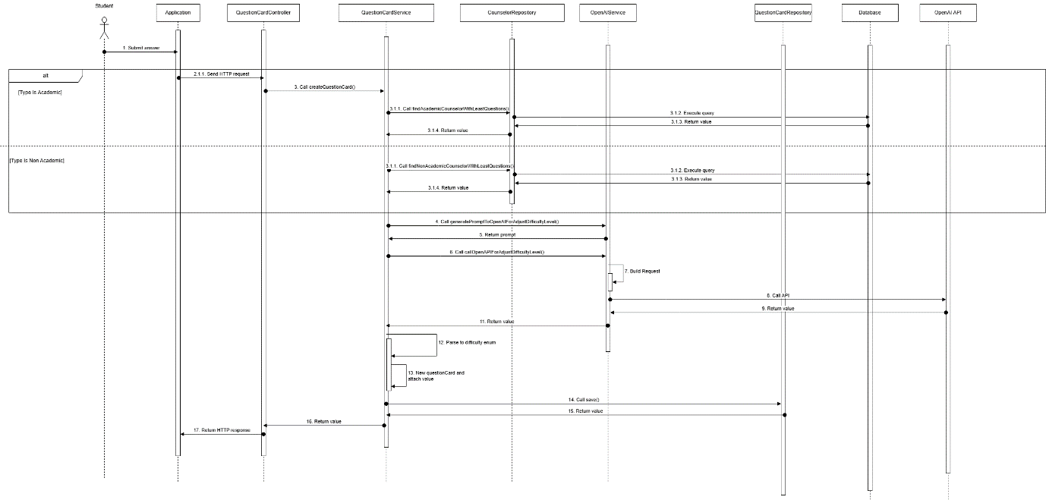

Figure 33 - Student create question card sequence diagram

##### **3.2.2.2. Counselor answer question sequence diagram**

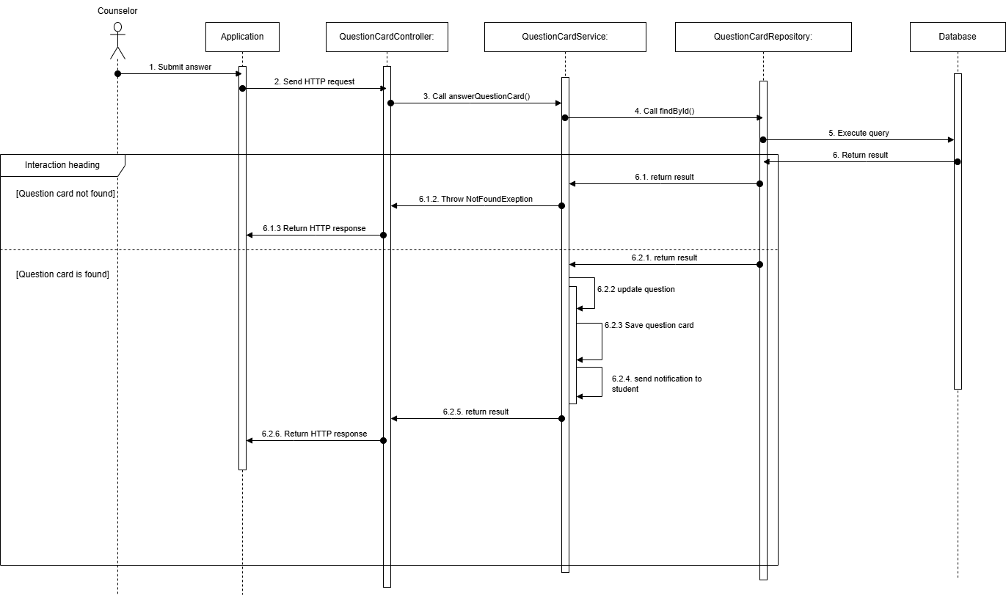

Figure 34 – Counselor answer question sequence diagram

##### **3.2.2.3. Counselor closes question sequence diagram**

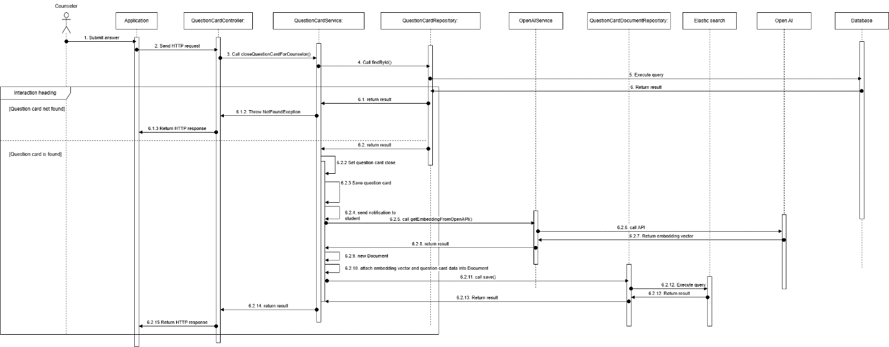

Figure 35 - Counselor closes question sequence diagram

##### **3.2.2.4. Student accepts question sequence diagram**

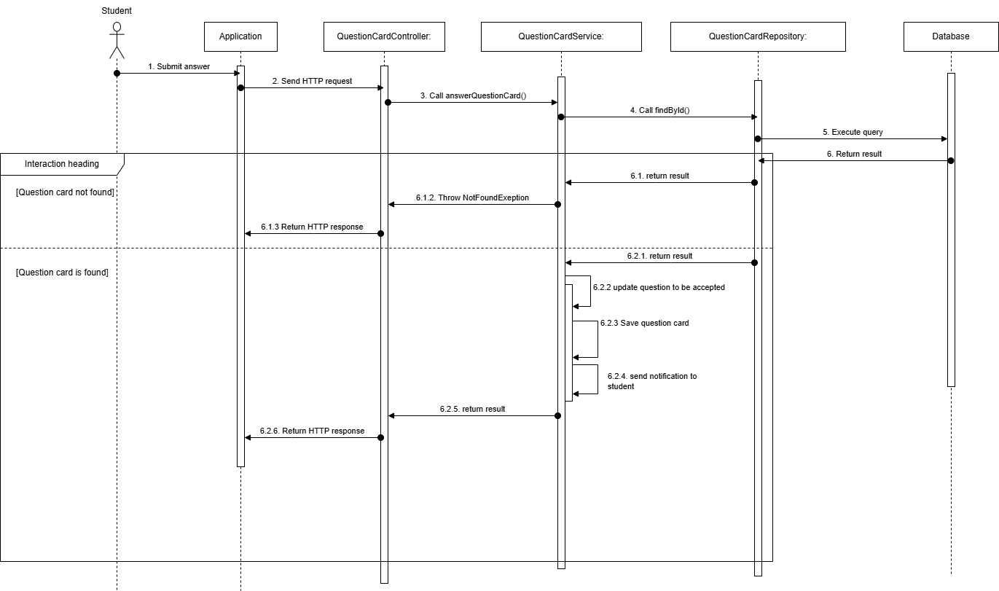

Figure 36 - Student accepts question sequence diagram

##### **3.2.2.5 Student initiate chat sequence diagram**

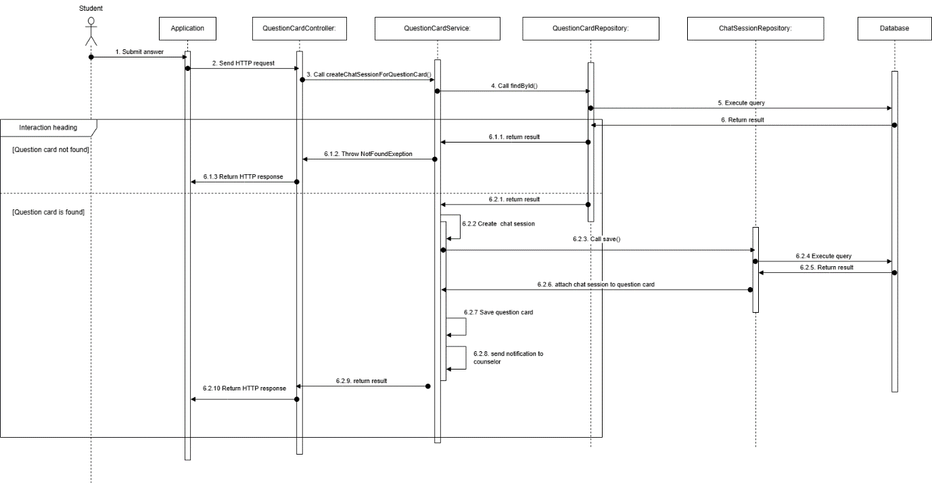

Figure 37 - Student initiate chat sequence diagram

#### **3.2.3. Activity Diagram**

##### **3.2.3.1. Create question activity diagram**

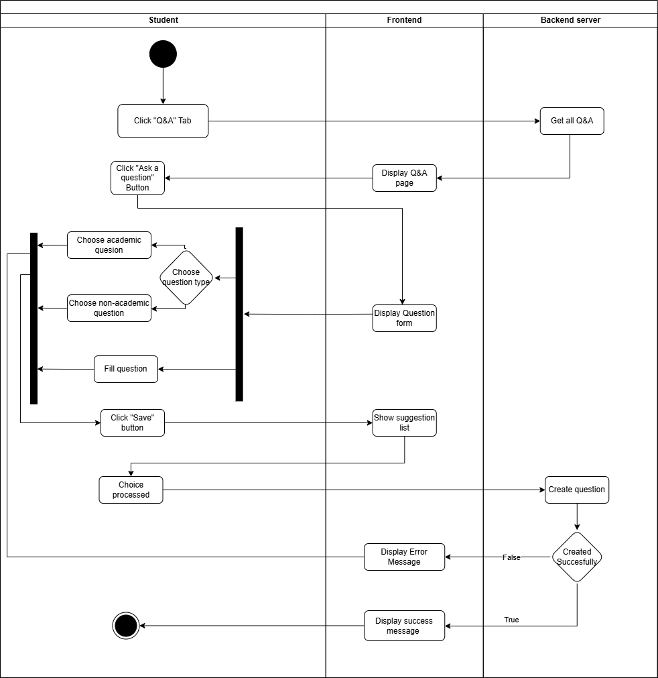

Figure 38 - Create question activity diagram

##### **3.2.3.2. Answer question activity diagram**

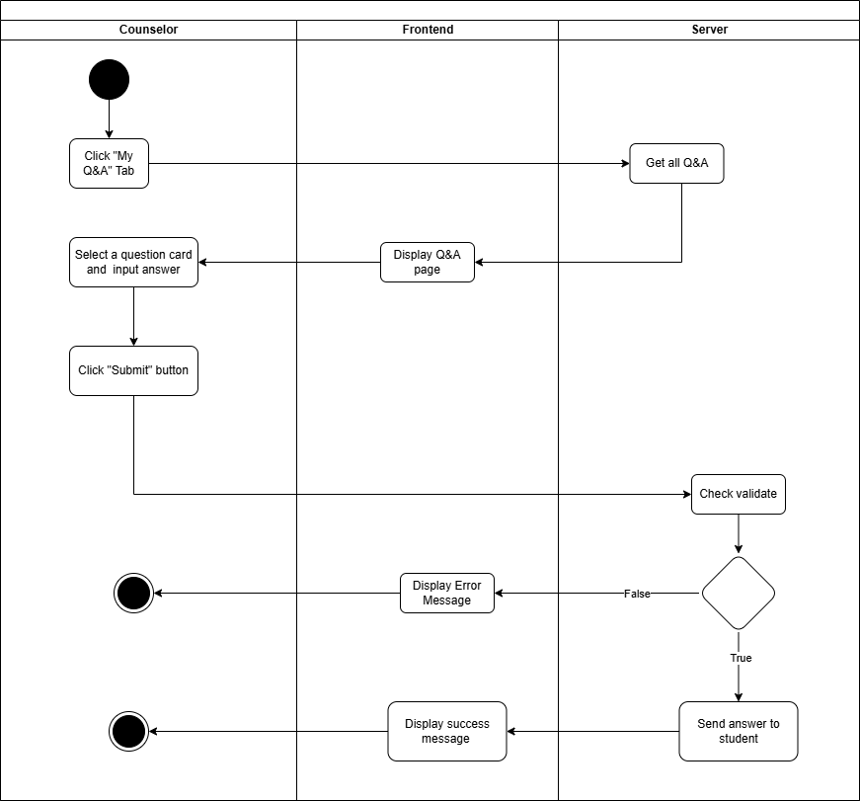

Figure 39 - Answer question activity diagram

##### **3.2.3.3. Flag question activity diagram**

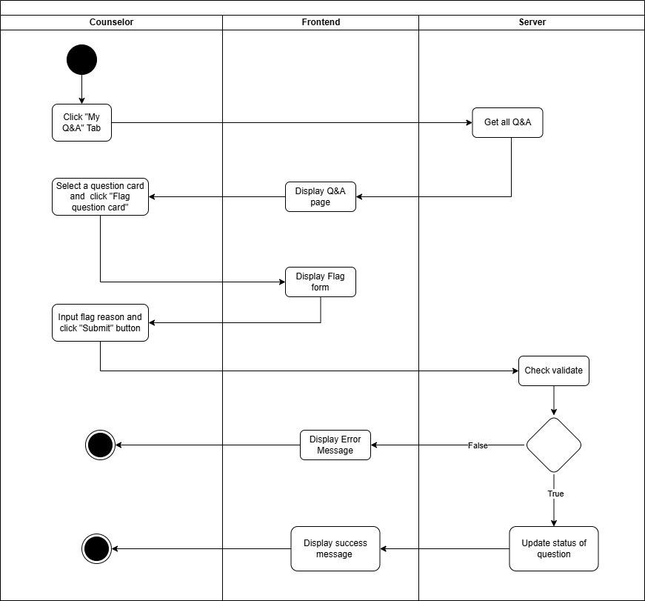

Figure 40 - 3.2.3.3. Flag question activity diagram

##### **3.2.3.4. Close question activity diagram**

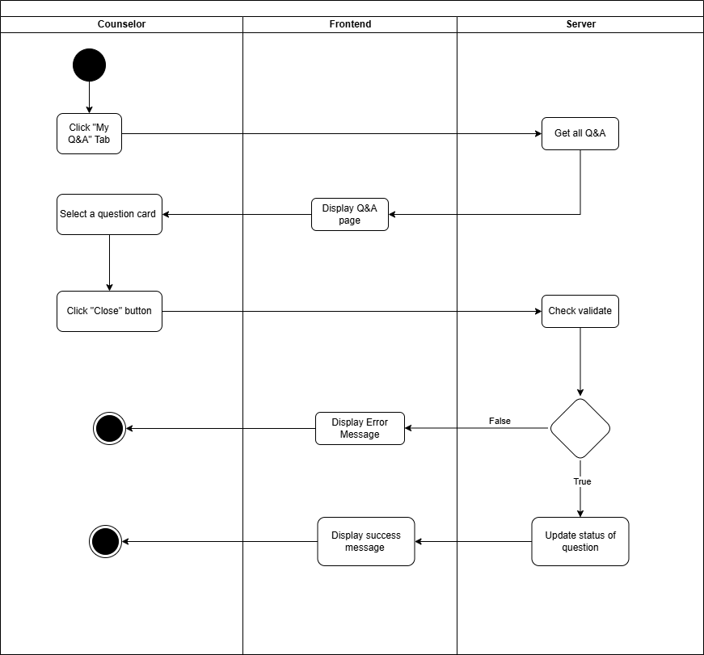

Figure 41 - Close question activity diagram

##### **3.2.3.5. Chat in session activity diagram**

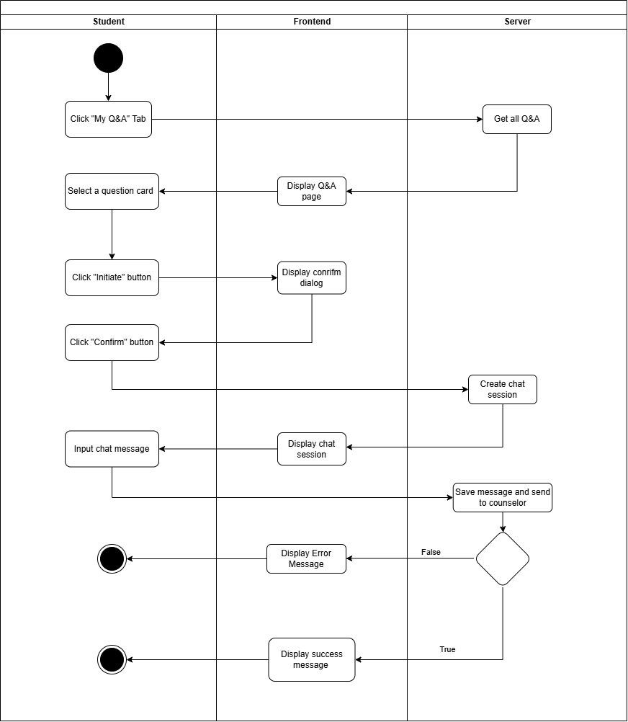

Figure 42 - Chat in session activity diagram

#### **3.2.4. State Machine Diagram**

##### **3.2.4.1. Q&A State Machine Diagram**

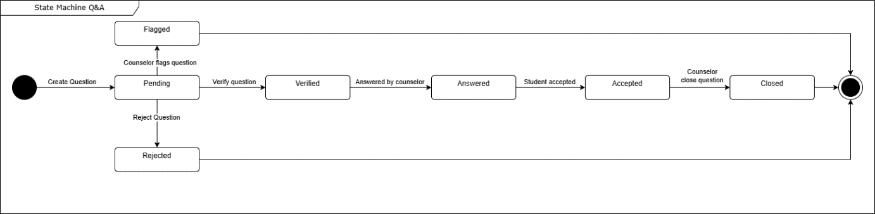

Figure 43 - Q&A State Machine Diagram

### **3.3. Staff-Driven Student Support and Counselor Matching for student’s demand**

#### **3.3.1. Class Diagram**

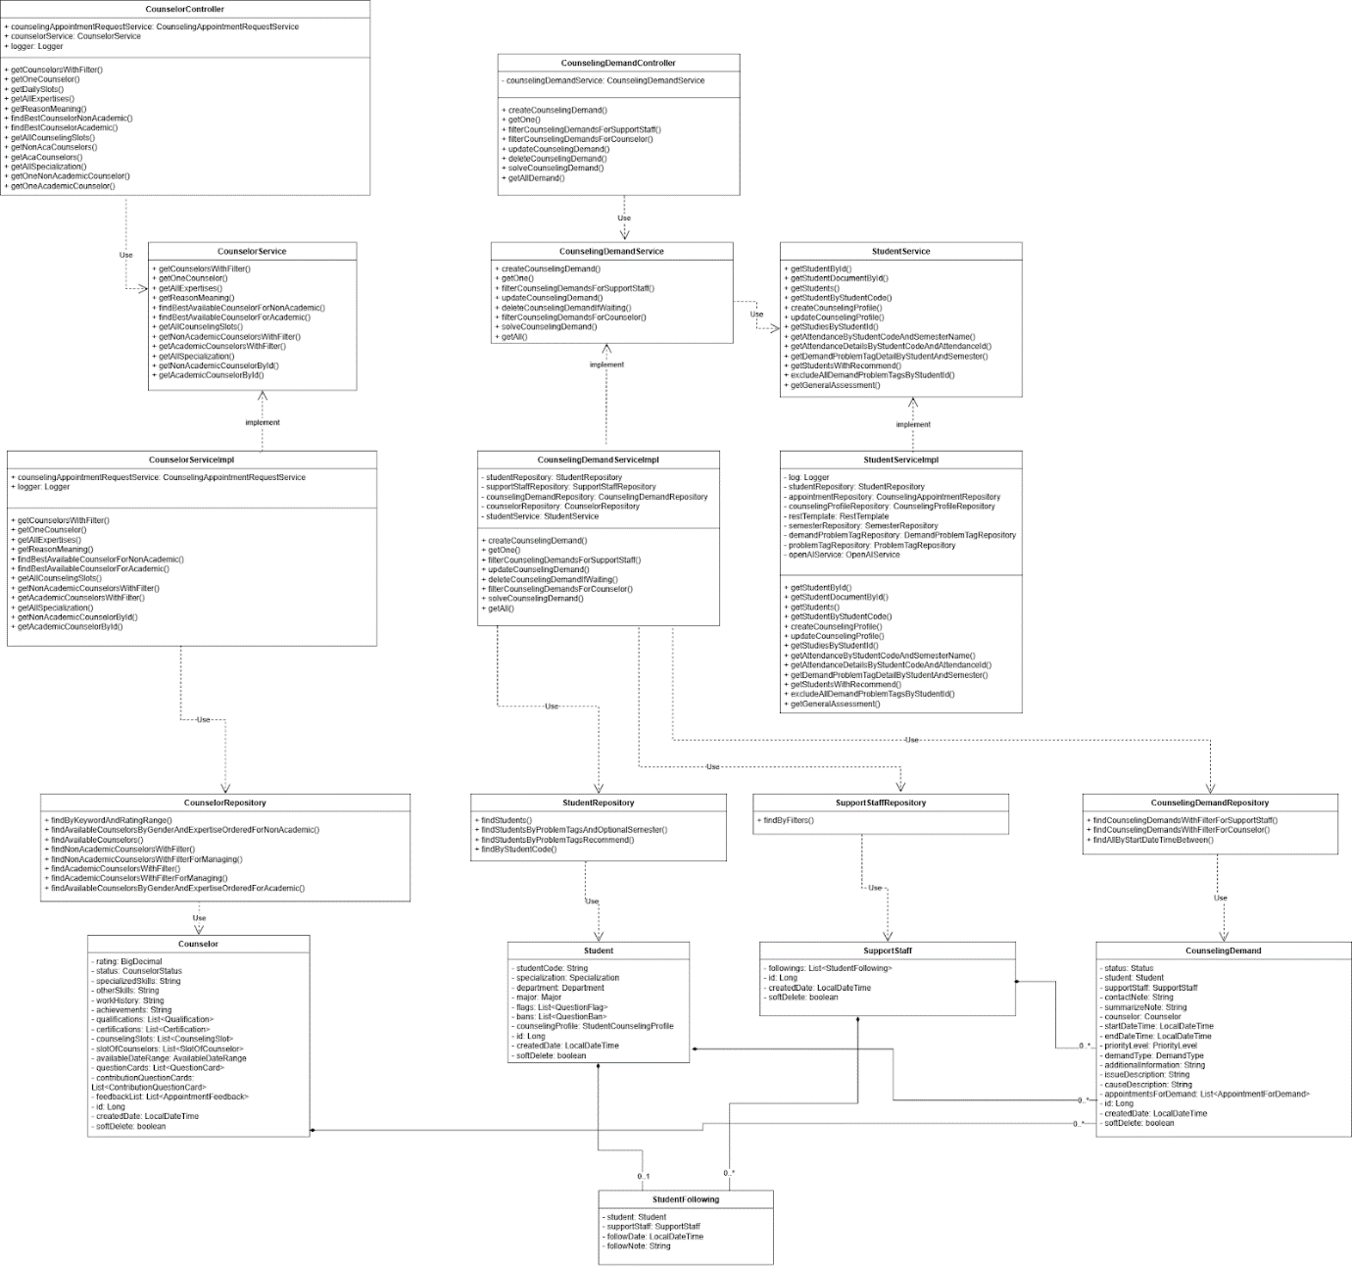

Figure 44 - Staff-Driven Student Support and Counselor Matching for student’s demand class diagram

##### **3.3.1.1. Class Specification**

###### **3.3.1.1.1. CounselorController class**

Table 152 - CounselorController class

|  |  |  |  |  |
| --- | --- | --- | --- | --- |
| **No** | **Attribute** | **Data Type** | **Visibility** | **Description** |
| 1 | counselingAppointmentRequestService | CounselingAppointmentRequestService | Public |  |
| 2 | counselorService | CounselorService | Public |  |
| 3 | logger | Logger | Public |  |

Table 153 - CounselorController method class

|  |  |  |  |
| --- | --- | --- | --- |
| **No** | **Method** | **Visibility** | **Description** |
| 1 | createAppointmentRequest() | Public |  |
| 2 | getAppointmentsRequest() | Public |  |
| 3 | getAppointmentsRequestOfStudentForManage() | Public |  |
| 4 | findAllAppointmentRequest() | Public |  |
| 5 | approveOnlineAppointment() | Public |  |
| 6 | approveOfflineAppointment() | Public |  |
| 7 | denyAppointmentRequest() | Public |  |
| 8 | getAppointmentsByDateRange() | Public |  |
| 9 | updateAppointmentDetails() | Public |  |
| 10 | submitFeedback() | Public |  |
| 11 | takeAttendance() | Public |  |
| 12 | cancelAppointmentForStudent() | Public |  |
| 13 | cancelAppointmentForCounselor() | Public |  |

###### **3.3.1.1.2. CounselorService class**

Table 154 – CounselorService method class

|  |  |  |  |
| --- | --- | --- | --- |
| **No** | **Method** | **Visibility** | **Description** |
| 1 | getCounselorsWithFilter() | Public |  |
| 2 | getOneCounselor() | Public |  |
| 3 | getAllExpertises() | Public |  |
| 4 | getReasonMeaning() | Public |  |
| 5 | findBestAvailableCounselorForNonAcademic() | Public |  |
| 6 | findBestAvailableCounselorForAcademic() | Public |  |
| 7 | getAllCounselingSlots() | Public |  |
| 8 | getNonAcademicCounselorsWithFilter() | Public |  |
| 9 | getAcademicCounselorsWithFilter() | Public |  |
| 10 | getAllSpecialization() | Public |  |
| 11 | getNonAcademicCounselorById() | Public |  |
| 12 | getAcademicCounselorById() | Public |  |

###### **3.3.1.1.3. CounselorServiceImpl class**

Table 155 - CounselorServiceImpl class

|  |  |  |  |  |
| --- | --- | --- | --- | --- |
| **No** | **Attribute** | **Data Type** | **Visibility** | **Description** |
| 1 | counselingAppointmentRequestService | CounselingAppointmentRequestService | Public |  |
| 2 | logger | Logger | Public |  |

Table 156 - CounselorServiceImpl method class

|  |  |  |  |
| --- | --- | --- | --- |
| **No** | **Method** | **Visibility** | **Description** |
| 1 | getCounselorsWithFilter() | Public |  |
| 2 | getOneCounselor() | Public |  |
| 3 | getAllExpertises() | Public |  |
| 4 | getReasonMeaning() | Public |  |
| 5 | findBestAvailableCounselorForNonAcademic() | Public |  |
| 6 | findBestAvailableCounselorForAcademic() | Public |  |
| 7 | getAllCounselingSlots() | Public |  |
| 8 | getNonAcademicCounselorsWithFilter() | Public |  |
| 9 | getAcademicCounselorsWithFilter() | Public |  |
| 10 | getAllSpecialization() | Public |  |
| 11 | getAllSpecialization() | Public |  |
| 12 | getNonAcademicCounselorById() | Public |  |
| 13 | getAcademicCounselorById() | Public |  |

###### **3.3.1.1.4. CounselorRepository class**

Table 157 - CounselorRepository method class

|  |  |  |  |
| --- | --- | --- | --- |
| **No** | **Method** | **Visibility** | **Description** |
| 1 | findByKeywordAndRatingRange() | Public |  |
| 2 | findAvailableCounselorsByGenderAndExpertiseOrderedForNonAcademic() | Public |  |
| 3 | findAvailableCounselors() | Public |  |
| 4 | findNonAcademicCounselorsWithFilter() | Public |  |
| 5 | findNonAcademicCounselorsWithFilterForManaging() | Public |  |
| 6 | findAcademicCounselorsWithFilter() | Public |  |
| 7 | findAcademicCounselorsWithFilterForManaging() | Public |  |
| 8 | findAvailableCounselorsByGenderAndExpertiseOrderedForAcademic() | Public |  |

###### **3.3.1.1.5. Counselor class**

Table 158 - Counselor class

|  |  |  |  |  |
| --- | --- | --- | --- | --- |
| **No** | **Attribute** | **Data Type** | **Visibility** | **Description** |
| 1 | rating | BigDecimal | Private |  |
| 2 | status | CounselorStatus | Private |  |
| 3 | specializedSkills | String | Private |  |
| 4 | otherSkills | String | Private |  |
| 5 | workHistory | String | Private |  |
| 6 | achievements | String | Private |  |
| 7 | qualifications | List<Qualification> | Private |  |
| 8 | certifications | List<Certification> | Private |  |
| 9 | counselingSlots | List<CounselingSlot> | Private |  |
| 10 | slotOfCounselors | List<SlotOfCounselor> | Private |  |
| 11 | availableDateRange | AvailableDateRange | Private |  |
| 12 | questionCards | List<QuestionCard> | Private |  |
| 13 | contributionQuestionCards | List<ContributionQuestionCard> | Private |  |
| 14 | feedbackList | List<AppointmentFeedback> | Private |  |
| 15 | id | Long | Private |  |
| 16 | createdDate | LocalDateTime | Private |  |
| 17 | softDelete | boolean | Private |  |

###### **3.3.1.1.6. Student class**

Table 159 - Student class

|  |  |  |  |  |
| --- | --- | --- | --- | --- |
| **No** | **Attribute** | **Data Type** | **Visibility** | **Description** |
| 1 | studentCode | String | Private |  |
| 2 | specialization | Specialization | Private |  |
| 3 | department | Department | Private |  |
| 4 | major | Major | Private |  |
| 5 | flags | List<QuestionFlag> | Private |  |
| 6 | bans | List<QuestionBan> | Private |  |
| 7 | counselingProfile | StudentCounselingProfile | Private |  |
| 8 | id | Long | Private |  |
| 9 | createdDate | LocalDateTime | Private |  |
| 10 | softDelete | boolean | Private |  |

###### **3.3.1.1.7. CounselingDemand class**

Table 160 - CounselingDemand class

|  |  |  |  |  |
| --- | --- | --- | --- | --- |
| **No** | **Attribute** | **Data Type** | **Visibility** | **Description** |
| 1 | status | Status | Private |  |
| 2 | student | Student | Private |  |
| 3 | supportStaff | SupportStaff | Private |  |
| 4 | contactNote | String | Private |  |
| 5 | summarizeNote | String | Private |  |
| 6 | counselor | Counselor | Private |  |
| 7 | startDateTime | LocalDateTime | Private |  |
| 8 | endDateTime | LocalDateTime | Private |  |
| 9 | priorityLevel | PriorityLevel | Private |  |
| 10 | demandType | DemandType | Private |  |
| 11 | additionalInformation | String | Private |  |
| 12 | issueDescription | String | Private |  |
| 13 | causeDescription | String | Private |  |
| 14 | appointmentsForDemand | List<AppointmentForDemand> | Private |  |
| 15 | id | Long | Private |  |
| 16 | createdDate | LocalDateTime | Private |  |
| 17 | softDelete | boolean | Private |  |

###### **3.3.1.1.8. StudentFollowing class**

Table 161 - StudentFollowing class

|  |  |  |  |  |
| --- | --- | --- | --- | --- |
| **No** | **Attribute** | **Data Type** | **Visibility** | **Description** |
| 1 | student | Student | Private |  |
| 2 | supportStaff | SupportStaff | Private |  |
| 3 | followDate | LocalDateTime | Private |  |
| 4 | followNote | String | Private |  |

###### **3.3.1.1.9. StudentRepository class**

Table 162 – StudentRepository method class

|  |  |  |  |
| --- | --- | --- | --- |
| **No** | **Method** | **Visibility** | **Description** |
| 1 | findStudents() | Public |  |
| 2 | findStudentsByProblemTagsAndOptionalSemester() | Public |  |
| 3 | findStudentsByProblemTagsRecommend() | Public |  |
| 4 | findByStudentCode() | Public |  |

###### **3.3.1.1.10. SupportStaffRepository class**

Table 163 - SupportStaffRepository method class

|  |  |  |  |
| --- | --- | --- | --- |
| **No** | **Method** | **Visibility** | **Description** |
| 1 | findByFilters() | Public |  |

###### **3.3.1.1.11. CounselingDemandController class**

Table 164 - CounselingDemandController class

|  |  |  |  |  |
| --- | --- | --- | --- | --- |
| **No** | **Attribute** | **Data Type** | **Visibility** | **Description** |
| 1 | counselingDemandService | CounselingDemandService | Private |  |

Table 165 - CounselingDemandController method class

|  |  |  |  |
| --- | --- | --- | --- |
| **No** | **Method** | **Visibility** | **Description** |
| 1 | createCounselingDemand() | Public |  |
| 2 | getOne() | Public |  |
| 3 | filterCounselingDemandsForSupportStaff() | Public |  |
| 4 | filterCounselingDemandsForCounselor() | Public |  |
| 5 | updateCounselingDemand() | Public |  |
| 6 | deleteCounselingDemand() | Public |  |
| 7 | solveCounselingDemand() | Public |  |
| 8 | getAllDemand() | Public |  |

###### **3.3.1.1.12. CounselingDemandRepository class**

Table 166 - CounselingDemandRepository method class

|  |  |  |  |
| --- | --- | --- | --- |
| **No** | **Method** | **Visibility** | **Description** |
| 1 | findCounselingDemandsWithFilterForSupportStaff() | Public |  |
| 2 | findCounselingDemandsWithFilterForCounselor() | Public |  |
| 3 | findAllByStartDateTimeBetween() | Public |  |

###### **3.3.1.1.13. SupportStaff class**

Table 167 - SupportStaff class

|  |  |  |  |  |
| --- | --- | --- | --- | --- |
| **No** | **Attribute** | **Data Type** | **Visibility** | **Description** |
| 1 | following: | List<StudentFollowing> | Private |  |
| 2 | id | SupportStaLongff | Private |  |
| 3 | createdDate | LocalDateTime | Private |  |
| 4 | softDelete | boolean | Private |  |

###### **3.3.1.1.14. CounselingDemandService class**

Table 168 - CounselingDemandService method class

|  |  |  |  |
| --- | --- | --- | --- |
| **No** | **Method** | **Visibility** | **Description** |
| 1 | createCounselingDemand() | Public |  |
| 2 | getOne() | Public |  |
| 3 | filterCounselingDemandsForSupportStaff() | Public |  |
| 4 | updateCounselingDemand() | Public |  |
| 5 | deleteCounselingDemandIfWaiting() | Public |  |
| 6 | filterCounselingDemandsForCounselor() | Public |  |
| 7 | solveCounselingDemand() | Public |  |
| 8 | getAll() | Public |  |

###### **3.3.1.1.15. CounselingDemandService class**

Table 169 - CounselingDemandService method class

|  |  |  |  |
| --- | --- | --- | --- |
| **No** | **Method** | **Visibility** | **Description** |
| 1 | getStudentById() | Public |  |
| 2 | getStudentDocumentById() | Public |  |
| 3 | getStudents() | Public |  |
| 4 | getStudentByStudentCode() | Public |  |
| 5 | createCounselingProfile() | Public |  |
| 6 | updateCounselingProfile() | Public |  |
| 7 | getStudiesByStudentId() | Public |  |
| 8 | getAttendanceByStudentCodeAndSemesterName() | Public |  |
| 9 | getAttendanceDetailsByStudentCodeAndAttendanceId() | Public |  |
| 10 | getDemandProblemTagDetailByStudentAndSemester() | Public |  |
| 11 | getStudentsWithRecommend() | Public |  |
| 12 | excludeAllDemandProblemTagsByStudentId() | Public |  |
| 13 | getGeneralAssessment() | Public |  |

###### **3.3.1.1.16. CounselingDemandServiceImpl class**

Table 170 - CounselingDemandServiceImpl class

|  |  |  |  |  |
| --- | --- | --- | --- | --- |
| **No** | **Attribute** | **Data Type** | **Visibility** | **Description** |
| 1 | studentRepository | CounselingAppointmentRequestService | Public |  |
| 2 | counselingDemandRepository | CounselingDemandRepository | Public |  |
| 3 | counselorRepository | CounselorRepository | Public |  |
| 4 | studentService: | StudentService |  |  |

Table 171 - CounselingDemandServiceImpl method class

|  |  |  |  |
| --- | --- | --- | --- |
| **No** | **Method** | **Visibility** | **Description** |
| 1 | createCounselingDemand() | Public |  |
| 2 | getOne() | Public |  |
| 3 | filterCounselingDemandsForSupportStaff() | Public |  |
| 4 | updateCounselingDemand() | Public |  |
| 5 | deleteCounselingDemandIfWaiting() | Public |  |
| 6 | filterCounselingDemandsForCounselor() | Public |  |
| 7 | solveCounselingDemand() | Public |  |
| 8 | getAll() | Public |  |

###### **3.3.1.1.17. CounselingDemandService class**

Table 172 - CounselingDemandService method class

|  |  |  |  |
| --- | --- | --- | --- |
| **No** | **Method** | **Visibility** | **Description** |
| 1 | getStudentById() | Public |  |
| 2 | getStudentDocumentById() | Public |  |
| 3 | getStudents() | Public |  |
| 4 | getStudentByStudentCode() | Public |  |
| 5 | createCounselingProfile() | Public |  |
| 6 | updateCounselingProfile() | Public |  |
| 7 | getStudiesByStudentId() | Public |  |
| 8 | getAttendanceByStudentCodeAndSemesterName() | Public |  |
| 9 | getAttendanceDetailsByStudentCodeAndAttendanceId() | Public |  |
| 10 | getDemandProblemTagDetailByStudentAndSemester() | Public |  |
| 11 | getStudentsWithRecommend() | Public |  |
| 12 | excludeAllDemandProblemTagsByStudentId() | Public |  |
| 13 | getGeneralAssessment() | Public |  |

###### **3.3.1.1.18. StudentServiceImpl class**

Table 173 - StudentServiceImpl class

|  |  |  |  |  |
| --- | --- | --- | --- | --- |
| **No** | **Attribute** | **Data Type** | **Visibility** | **Description** |
| 1 | log: Logger | CounselingAppointmentRequestService | Public |  |
| 2 | studentRepository | CounselingDemandRepository | Public |  |
| 3 | appointmentRepository | CounselingAppointmentRepository | Public |  |
| 4 | counselingProfileRepository | CounselingProfileRepository | Public |  |
| 5 | restTemplate | RestTemplate | Public |  |
| 6 | semesterRepository | SemesterRepository | Public |  |
| 7 | demandProblemTagRepositor | DemandProblemTagRepository | Public |  |
| 8 | openAIService | OpenAIService | Public |  |
| 9 | problemTagRepository | ProblemTagRepository | Public |  |

Table 174 - StudentServiceImpl method class

|  |  |  |  |
| --- | --- | --- | --- |
| **No** | **Method** | **Visibility** | **Description** |
| 1 | getStudentById() | Public |  |
| 2 | getStudentDocumentById() | Public |  |
| 3 | getStudents() | Public |  |
| 4 | getStudentByStudentCode() | Public |  |
| 5 | createCounselingProfile() | Public |  |
| 6 | updateCounselingProfile() | Public |  |
| 7 | getStudiesByStudentId() | Public |  |
| 8 | getAttendanceByStudentCodeAndSemesterName() | Public |  |
| 9 | getAttendanceDetailsByStudentCodeAndAttendanceId() | Public |  |
| 10 | getDemandProblemTagDetailByStudentAndSemester() | Public |  |
| 11 | + getStudentsWithRecommend() | Public |  |
| 12 | excludeAllDemandProblemTagsByStudentId() | Public |  |
| 13 | getGeneralAssessment() | Public |  |

#### **3.3.2. Sequence Diagram**

##### **3.3.2.1. Support staff follows student sequence diagram**

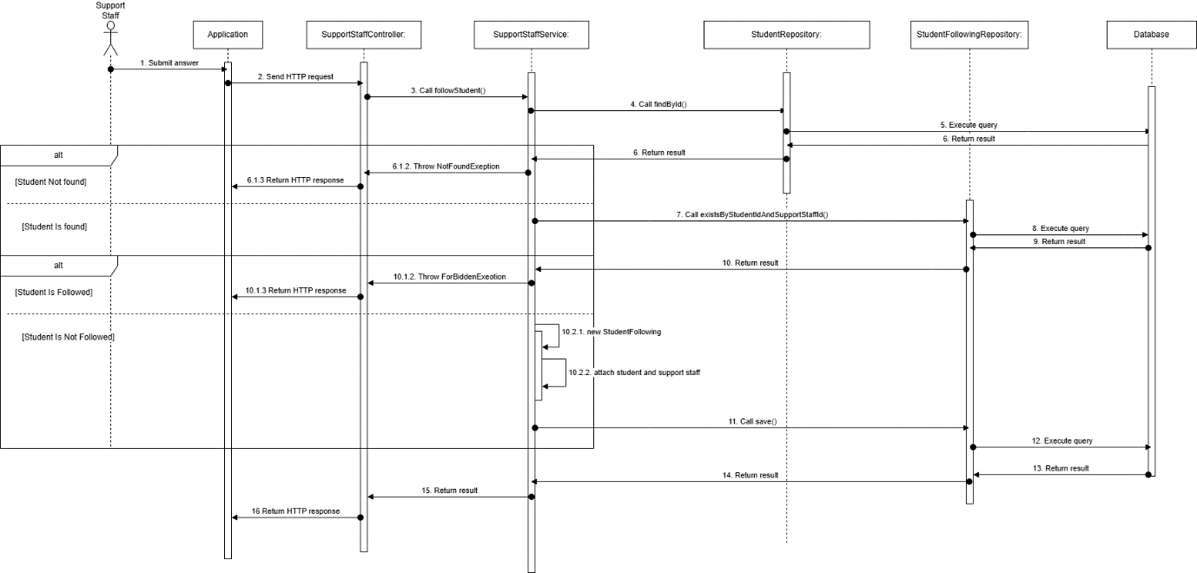

Figure 45 - Support staff follows student sequence diagram

##### **3.3.2.2. Support staff create demand card sequence diagram**



Figure 46 – Support staff create demand card sequence diagram

##### **3.3.2.3. Counselor creates appointment and attach to demand card sequence diagram**

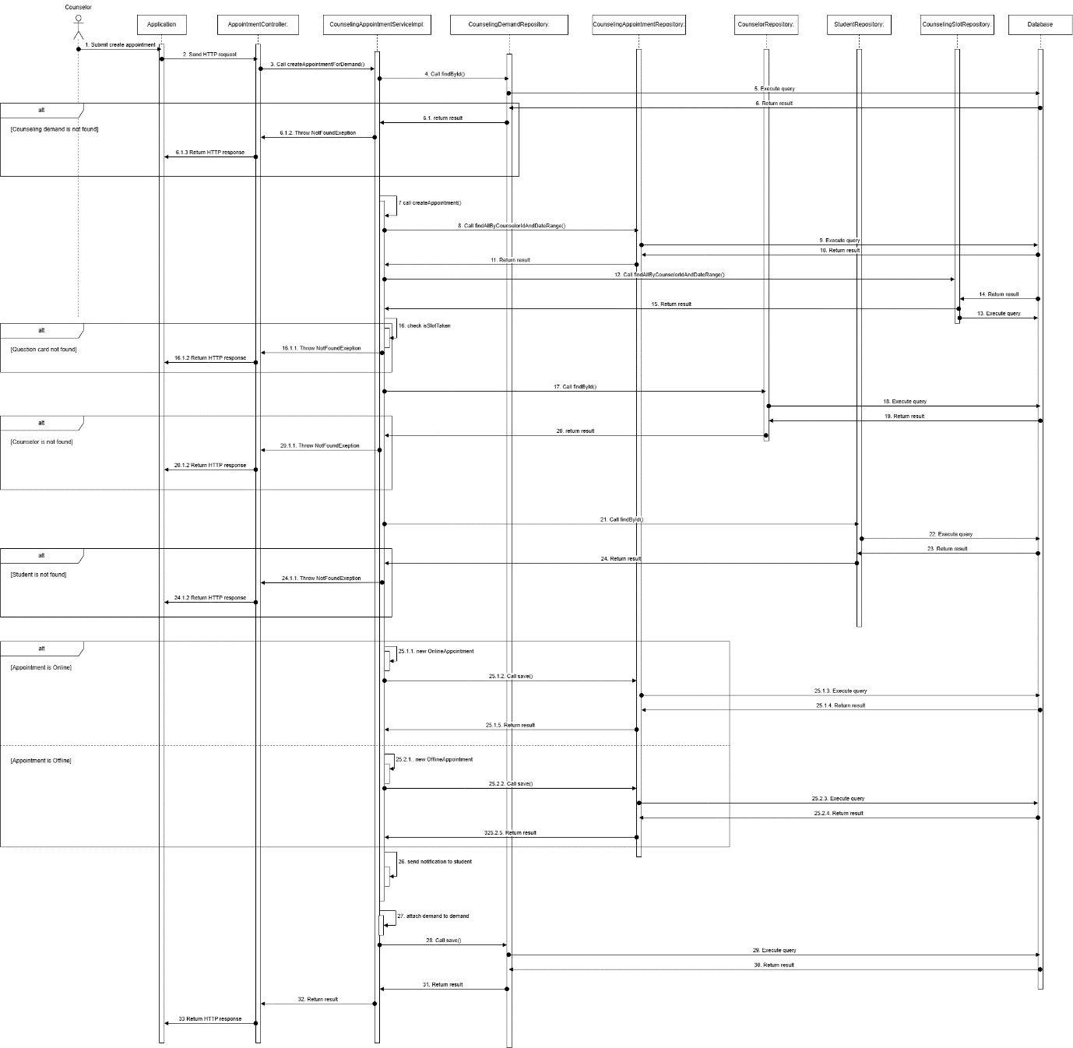

Figure 47 - Counselor creates appointment and attach to demand cardsequence diagram

##### **3.3.2.4. Counselor solves demand card sequence diagram**

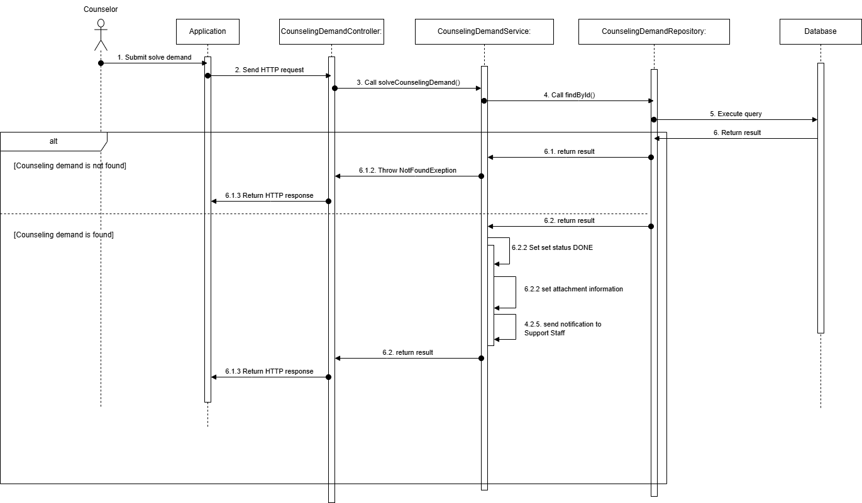

Figure 47 – Counselor solves demand card student sequence diagram

#### **3.3.3. Activity Diagram**

##### **3.3.3.1. Staff Create demand card for mapping counselor with student activity diagram**

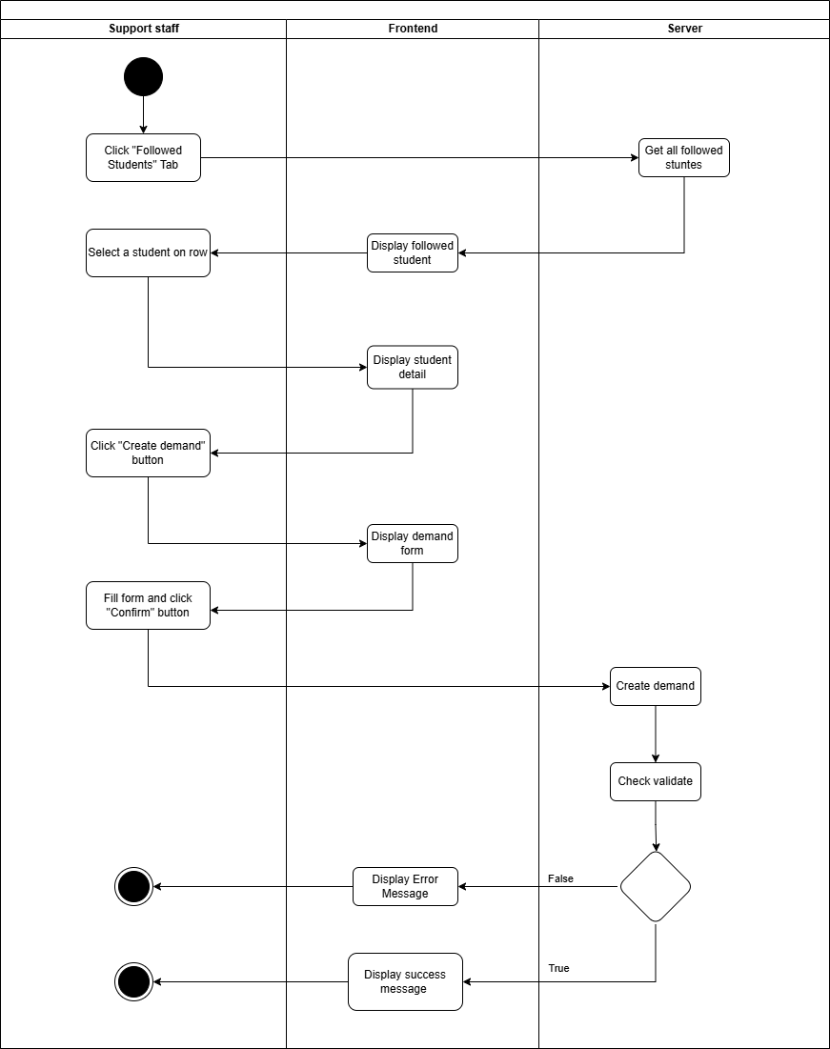

Figure 47 - Staff Create demand card for mapping counselor with student activity diagram

##### **3.3.3.1. Counselor Create appointment for demand if student need activity diagram**

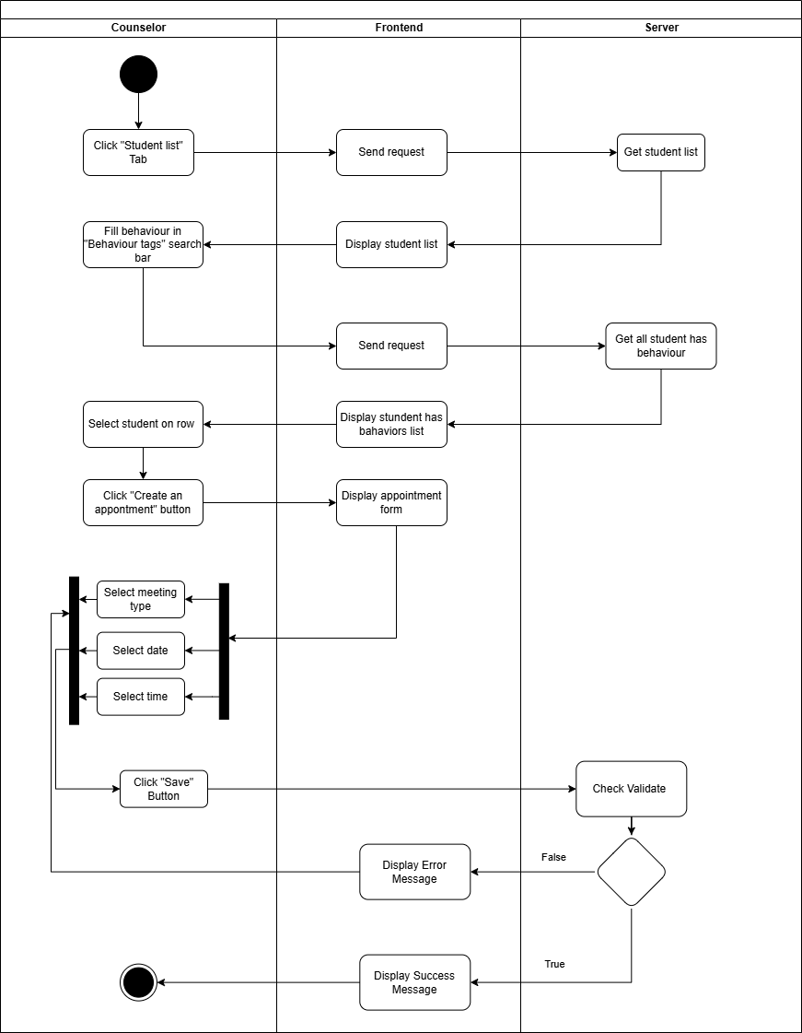

Figure 48 - Counselor Create appointment for demand if student need activity diagram

##### **3.3.3.2. Staff Follow student activity diagram**

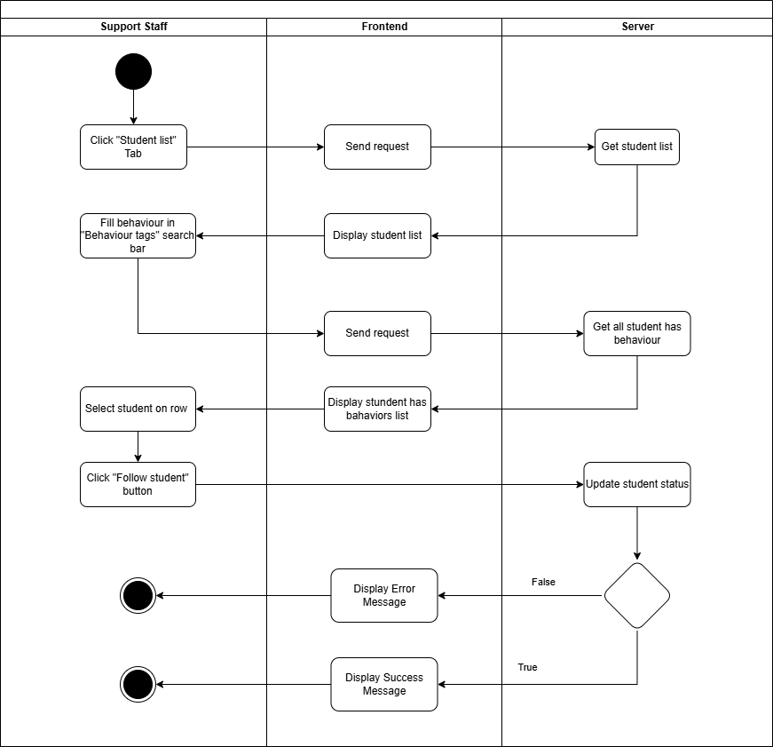

Figure 49 - Staff Follow student activity diagram

##### **3.3.3.3. Staff Unfollow student activity diagram**

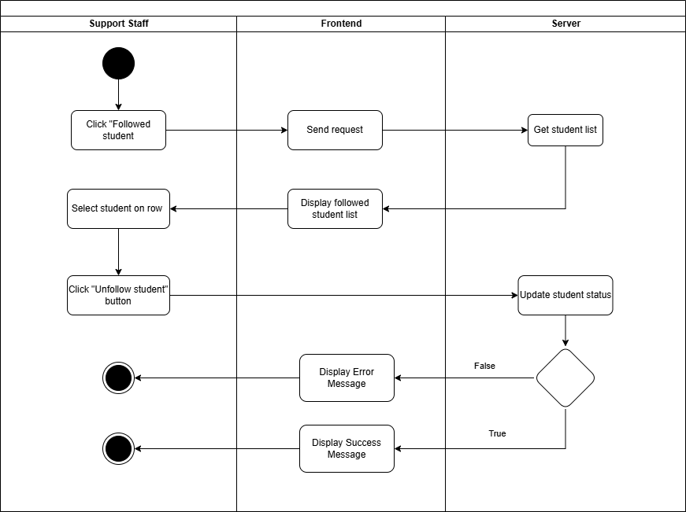

Figure 50 - Staff Unfollow student activity diagram

##### **3.3.3.4. Solve demand activity diagram**

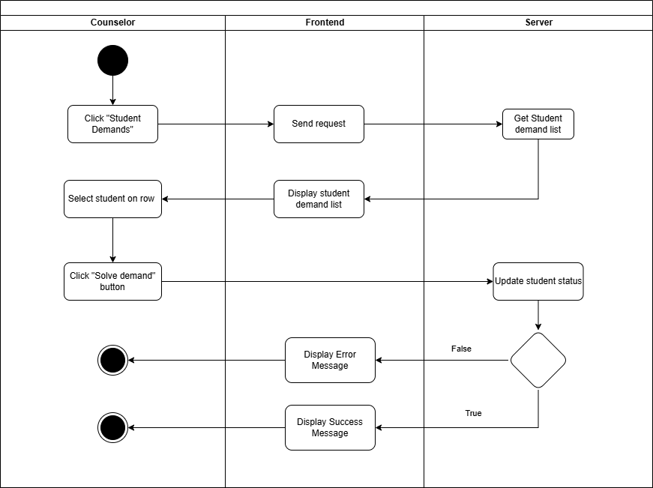

Figure 51 - Solve demand activity diagram

#### **3.3.4. State Machine Diagram**

##### **3.3.4.1. Demand Mapping State Machine Diagram**

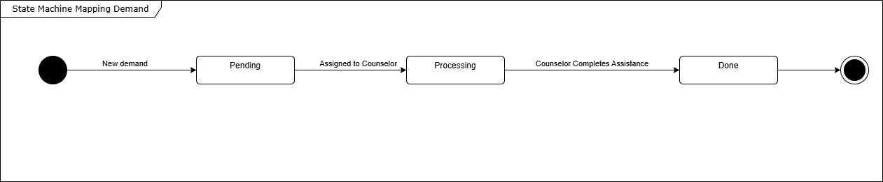

Figure 52 -Demand Mapping State Machine Diagram

# **V. Software Testing Documentation**

## 1. Overall Description

1.1. Test Model In the SCSS Project, we apply Agile testing for the following purposes:  Quickly adapt to projects that changed rapidly and continuously.  Test cases are ready for execution when finishing the implementation.  Detecting errors in the system early allows for quick correction.

1.2. Test Levels  Integration testing: Ensure every module works appropriately together in the system.  System testing: Ensure that the SCSS system meets the design specification and other requirements.

1.3. Testing Types

Functional test: Ensure that all functions in the system meet its requirements.

 API test: Ensure that all APIs in the system process and return required data correctly.

 User Interface test: Ensure that all elements of the UI are correctly presented.

## **2. Test Strategy**

### **2.1. Testing Types**

Functional test: Ensure that all functions in the system meet its requirements.

API test: Ensure that all APIs in the system process and return required data correctly.

User Interface test: Ensure that all elements of the UI are correctly presented.

### **2.2. Test** **Levels**

Table 175 - Test Levels

|  |  |  |  |
| --- | --- | --- | --- |
| **Type of Tests** | **Test Level** | | |
| **Integration** | **System** | **Acceptance** |
| Function test | X | X | X |
| User interface test | X | X | X |

### **2.3. Supporting Tools**

Table 176 - Supporting Tools

|  |  |  |  |
| --- | --- | --- | --- |
| Purpose | Tool | Vendor/In-house | Version |
| User interface testing on web application | Google Chrome | Vendor (Google) | 124.0.6367.60 |
| User interface testing on mobile application | Android Emulator | Vendor (Android Studio) | 9.0 |
| User interface testing on mobile application | Physical mobile device | Vendor (Android Device) | 9.0 |
| API test, Integration test | Postman | Vendor (Postman) | 11.18 |

## **3. Test Plan**

### **3.1. Human Resources**

Table 177 - Human Resources

|  |  |  |
| --- | --- | --- |
| **Worker/Doer** | **Role** | **Specific Responsibilities/Comments** |
| Trình Vĩnh Phát | Leader | Planning, assigning test functions to members and verifying test results. |
| Vũ Ngọc Hải Đăng | Member | Execute test and report |
| Đoàn Tiến Phát | Member | Execute test and report |
| Phạm Trần Sơn Nguyên | Member | Execute test and report |
| Nguyễn An Khánh | Member | Execute test and report |

### **3.2. Test Environment**

Table 178 - Test Environment

|  |  |  |  |
| --- | --- | --- | --- |
| **Purpose** | **Tool** | **Provider** | **Version** |
| User interface testing on web application | Google Chrome | Google Chrome | 119.0.6045.200 |
| User interface testing on mobile application | Android Emulator  Physical mobile device | Android studio Android Device | 9.0 |
| API test, Integration test | Postman | Postman | 11.18 |

### **3.3. Test Milestones**

Table 179 - Test Milestones

|  |  |  |
| --- | --- | --- |
| **Milestone Task** | **Start Date** | **End Date** |
| Create test plan | 15/10/2024 | 21/10/2024 |
| Create test cases for Web application | 21/10/2024 | 20/11/2024 |
| Create test cases for APIs | 20/11/2024 | 29/11/2024 |
| Create test cases for Mobile application | 29/11/2024 | 05/12/2024 |
| Create report for testing | 05/12/2024 | 10/12/2024 |

## 4. Test Cases & Test Reports

Test Cases & test reports:[GFA24SE27-Test-Report](https://docs.google.com/spreadsheets/d/1hvsthMjcUTw9Bgdl9XRwjIgiAAiwfSyVjGNcgt06Gzo/edit?usp=sharing)

# **VI. Release Package & User Guides**

## **1. Deliverable Package**

Table 180 - Deliverable Package

|  |  |  |
| --- | --- | --- |
| **No.** | **Deliverable Item** | **Description** |
| 1 | Source Codes |  |
| 2 | Database Script(s) |  |
| 3 | Final Report Document | A document file that summarizes the project information. |
| 4 | Test Cases Document |  |
| 5 | Defects List |  |
| 6 | Slide |  |

## **2. Installation Guides**

**2.1 System Requirements**

**2.1.1 Hardware requirements**

**2.1.1.1 Website application**

Table 181 - Website application

|  |  |  |
| --- | --- | --- |
| **PC** | **Minimum** | **Recommended** |
| Internet connection | Cable, Wi-fi | Cable, Wi-fi |
| Processor | Intel Core i5 | Intel Core i7 |
| Memory | 8GB RAM | 16GB RAM |
| Storage | HDD 256GB | SSD 256GB |
| Web Browser | Google Chrome  Internet Explorer | Google Chrome v.124.0.6367.60  Internet Explorer IE.11 |

***2.1.1.2 Mobile application***

Table 182 - Mobile application

|  |  |  |
| --- | --- | --- |
| **Mobile** | **Minimum** | **Recommended** |
| Internet connection | Cable, Wi-fi | Cable, Wi-fi |
| Processor | Qualcomm SM4250 | Qualcomm Snapdragon 680 |
| Memory | 8GB | 32GB |
| Storage | 105.46MB | 120.00MB |
| Operating System | Android 12 | Android 14 |

***2.1.2 Software requirements***

Table 183 - Software requirements

|  |  |  |
| --- | --- | --- |
| **Component** | **Name and Version** | **Description** |
| Operating System | Windows 10 | Operating system for building production |
| DBMS | MySQL | Used to manage database |
| Java spring boot | Java spring boot 3.3.2 | Use to run back-end server |
| ReactJS | ReactJS 18.3.1 | Use to run front-end server |
| ReactNative | ReactNative 0.74.3 | Use to run mobile application |
| IDE | Visual Studio, Intellij, Android Studio | Use to write, edit and run code |

### **2.2. Installation Instruction**

#### **2.2.1. Environment Setup**

##### **2.2.1.1. Mobile Application Development**

Step1: Download Visual Studio Code:

* Go to the [Visual Studio Code download page](https://code.visualstudio.com/download).
* Download the latest stable version of Visual Studio Code (version 1.95 or newer).

Step2: Install Visual Studio Code:

* Follow the on-screen instructions to install Visual Studio Code on your machine.

Step 3: Setup for React Native Development:

* Open Visual Studio Code after installation.
* Install the **React Native CLI** if you haven't already by opening a terminal and running:  
  Npx create-expo-app scss-mobile
* Install **Node.js** (required for React Native) from [Node.js website](https://nodejs.org/).

Step 4: Install Required Extensions in Visual Studio Code:

* Open Visual Studio Code.
* Go to the **Extensions** view by clicking on the Extensions icon in the Activity Bar.
* Search for and install the **React Native Tools** extension to enhance support for React Native development.

##### 2.2.1.2. Web application

Step 1: Install Visual Studio Code:

* Download the [Visual Studio Code setup file.](https://code.visualstudio.com/Download)
* After the download is complete, run the VSCodeUserSetup.exe file.
* Click Next to proceed with the installation. Then, agree to the terms of use.
* Choose the installation location (it's recommended to keep the default) and click Next.
* In the subsequent steps, continue clicking Next until the installation is complete.

Step 2: Install npm through Visual Studio Code or you can install npm via NodeJS: [Link.](https://nodejs.org/en/)

##### **2.2.1.3. Back-end Server**

###### **2.2.1.3.1. Install Intellij**

Step 1: Go to the JetBrains Website

1. Open your web browser and navigate to the JetBrains IntelliJ IDEA homepage at<https://www.jetbrains.com/idea/>.

Step 2: Choose the IntelliJ IDEA Edition

1. On the IntelliJ IDEA homepage, click the Download button.
2. You’ll see two editions:
   * Ultimate: A paid edition with full features for professional development.
   * Community: A free edition suitable for learning and open-source projects.
3. Select the edition that fits your needs, then click Download.

Step 3: Download IntelliJ IDEA for Your Operating System

1. The download page will detect your operating system (Windows, macOS, or Linux) automatically.
2. Click the Download button for your operating system.

Step 4: Run the Installation File

1. Once the download completes, open the installation file (.exe on Windows, .dmg on macOS, or .tar.gz on Linux).
2. On Windows:
   * Double-click the .exe file and follow the installation instructions.
3. On macOS:
   * Open the .dmg file, then drag and drop the IntelliJ IDEA icon into the Applications folder.
4. On Linux:
   * Extract the .tar.gz file and move the folder to a suitable location. You can add an alias or shortcut to open IntelliJ from the terminal.

Step 5: Launch IntelliJ IDEA and Initial Setup

1. Open IntelliJ IDEA for the first time.
2. Choose Do not import settings if this is your first installation.
3. IntelliJ will prompt you to configure initial settings such as theme (Light or Dark), plugins, and other options. Choose your preferred settings.
4. Once done, click Start using IntelliJ IDEA to begin.

###### **2.2.1.3.2. Install Environment**

Step 1: Install Java 21 or Higher

1. Download Java: Visit the [Oracle JDK](https://www.oracle.com/java/technologies/downloads/) or [OpenJDK](https://openjdk.org/) website and download Java 21 or higher.
2. Install:
   * Windows/macOS: Follow the installer’s instructions.
   * Linux: Use a package manager (e.g., sudo apt install openjdk-21-jdk on Ubuntu).
3. Set JAVA_HOME Environment Variable (if needed): Point JAVA_HOME to your Java installation path.
4. Verify: Run java -version to ensure Java is correctly installed.

Step 2: Install Maven 3.9.8 or Higher

1. Download Maven: Go to the [Maven download page](https://maven.apache.org/download.cgi) and download version 3.9.8 or higher.
2. Install:
   * Windows/macOS: Extract and move the folder to a suitable location (e.g., C:\Program Files\Apache\Maven).
   * Linux: Extract and move to a system directory (e.g., /usr/local/apache-maven).
3. Add to PATH: Ensure the Maven bin directory is in your PATH.
4. Verify: Run mvn -version to check the Maven installation.

Step 3: Install Git

1. Download and Install Git: Go to [Git’s official website](https://git-scm.com/downloads) and download the appropriate version for your OS.
2. Clone the Project: Run the following command in your terminal or command prompt:  
   git clone <project-repo-url>

###### **2.2.1.3.3. SCSS Server**

Step 1: Clone source code from github

1. Access source code online through link: <https://github.com/Capstone-FA24SE111-GFA24SE27/scss-backend>
2. Copy source code URL 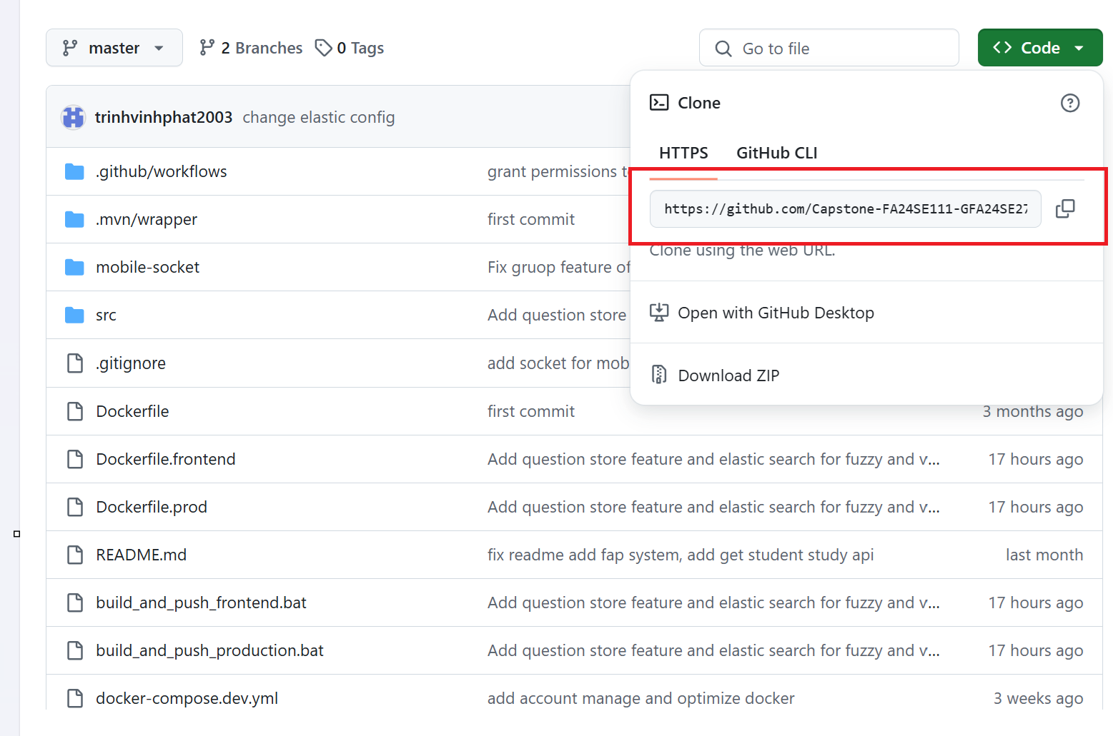
3. Open terminal and run 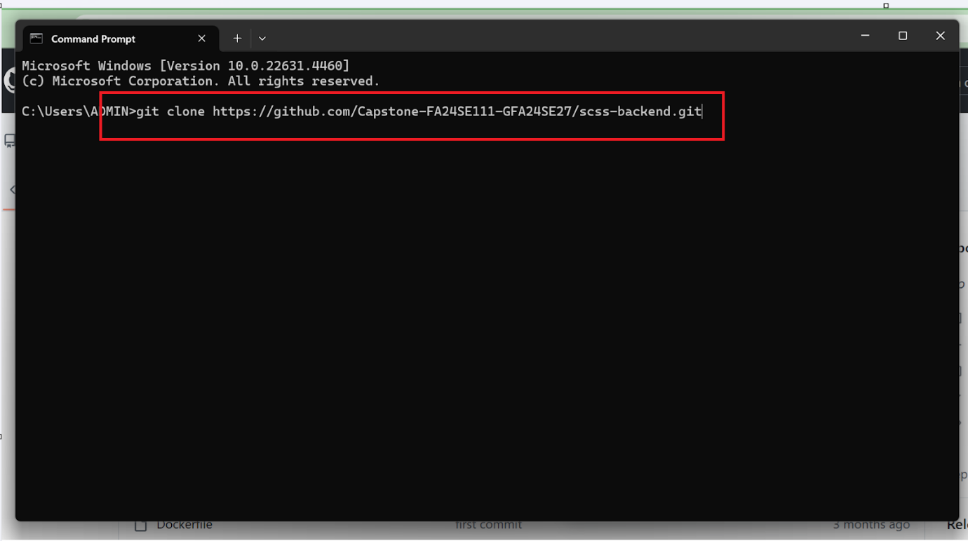
4. After clown project, you will get folder with source code 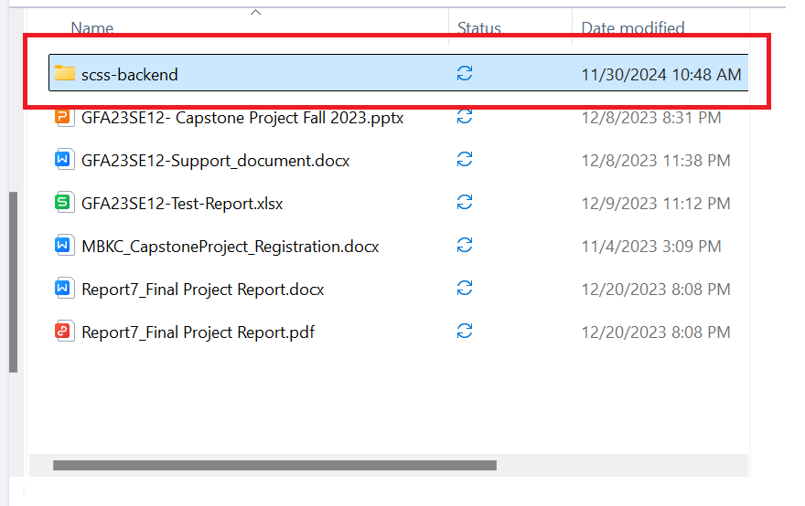

Step 2: Set up service using by system

1. Open Docker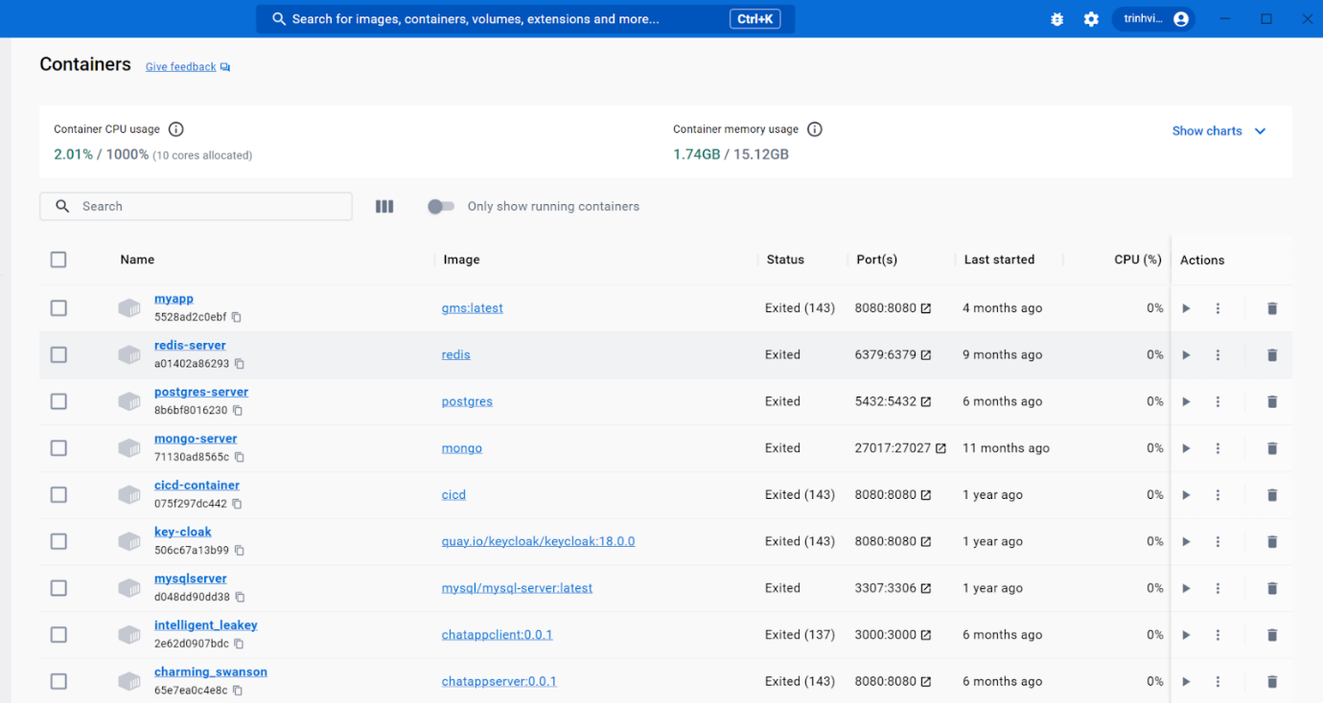
2. Run CMD command at root of project 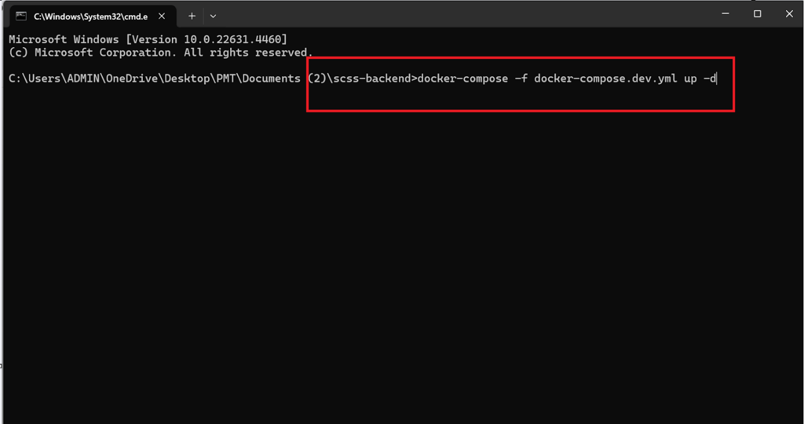
3. After waiting for service to up, some necessary container will up 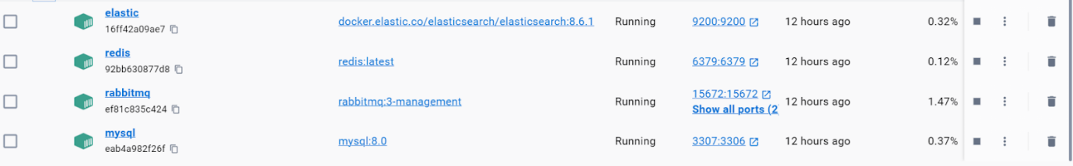

Step 3: Open source code with coding editor

1. Open intellj, click file -> open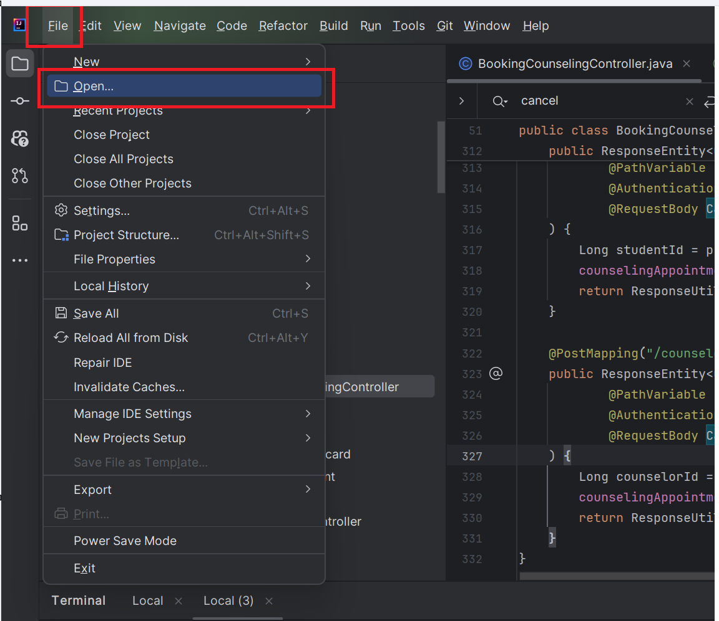
2. Select folder containing source code and click OK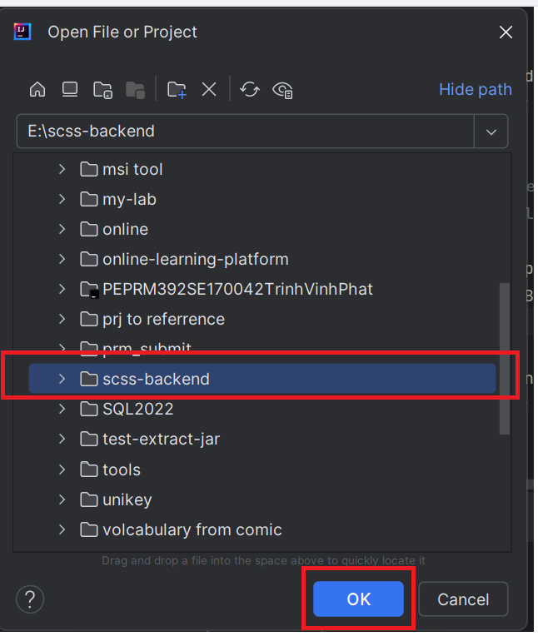
3. Folder will be opened in intellj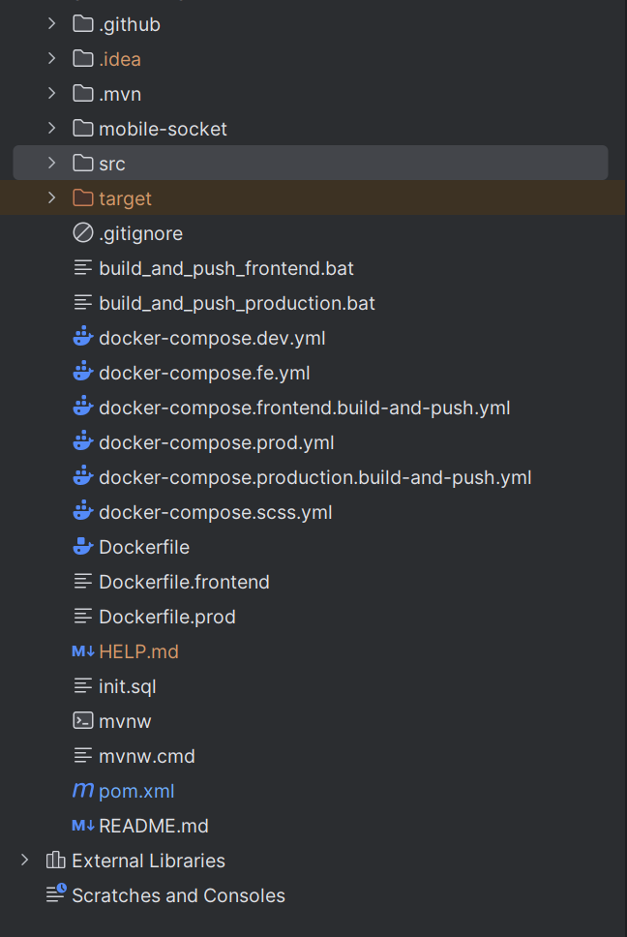

Step 4: Run application

1. In intellj, click icon terminal at the left corner to open terminal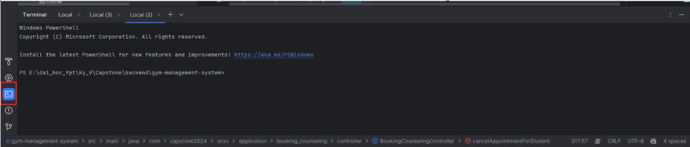
2. Run command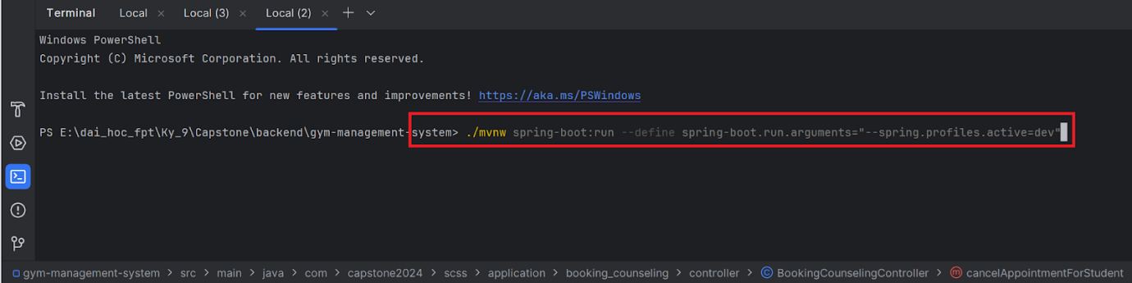
3. Waiting for application to finish building and up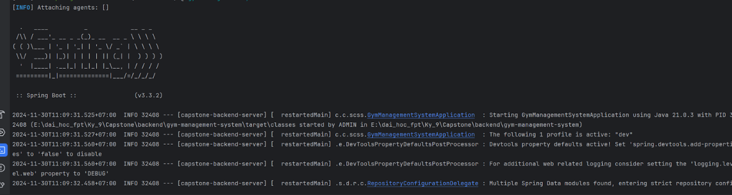

**2.2.2. Run Frontend web application**

Step 1: Clone the repository or extract “SCSS_WebApplication.zip” and open folder with Visual Studio Code.

Step 2: Create .env file at root of the project with content: *VITE_SERVER_BASE_URL=http://scss-server.southafricanorth.cloudapp.azure.com*

Step 3: Open the terminal and enter npm install:

Open terminal and enter npm install:

* npm i
* npm run dev

**2.2.4. Run Frontend mobile application**

Step 1: Access source code online through link: <https://github.com/Capstone-FA24SE111-GFA24SE27/scss-mobile>

Step 2: Copy the source code URL:

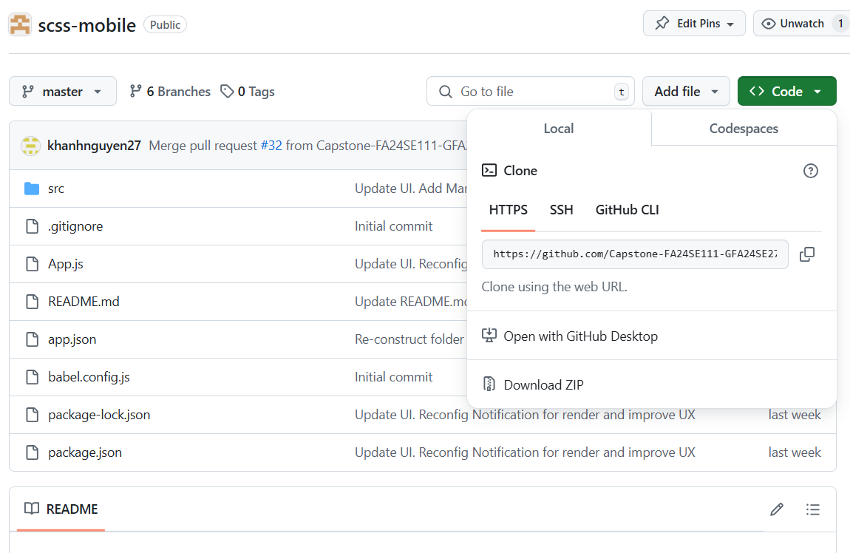

Step 3 : Clone this repository by opening terminal, input this command and press Enter: .

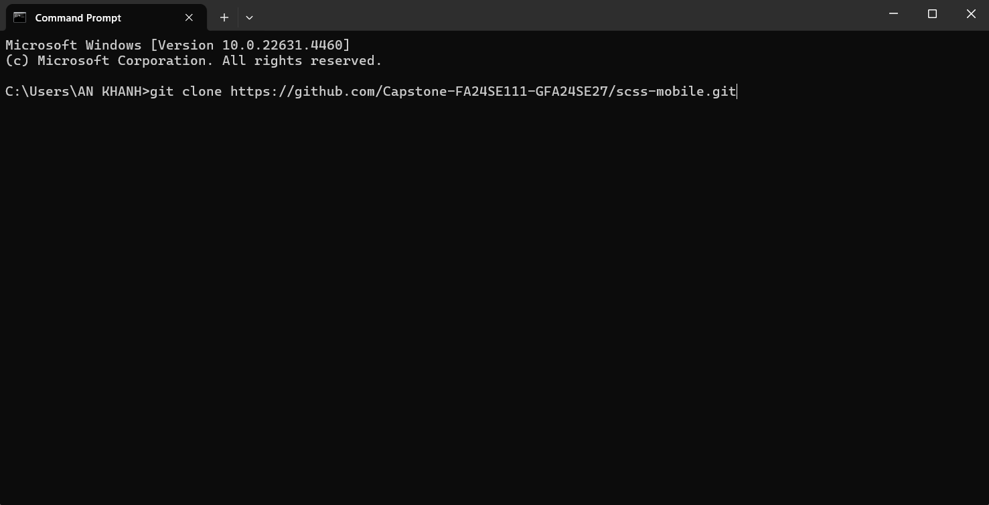

Step 4: Open the code folder with Visual Studio Code.

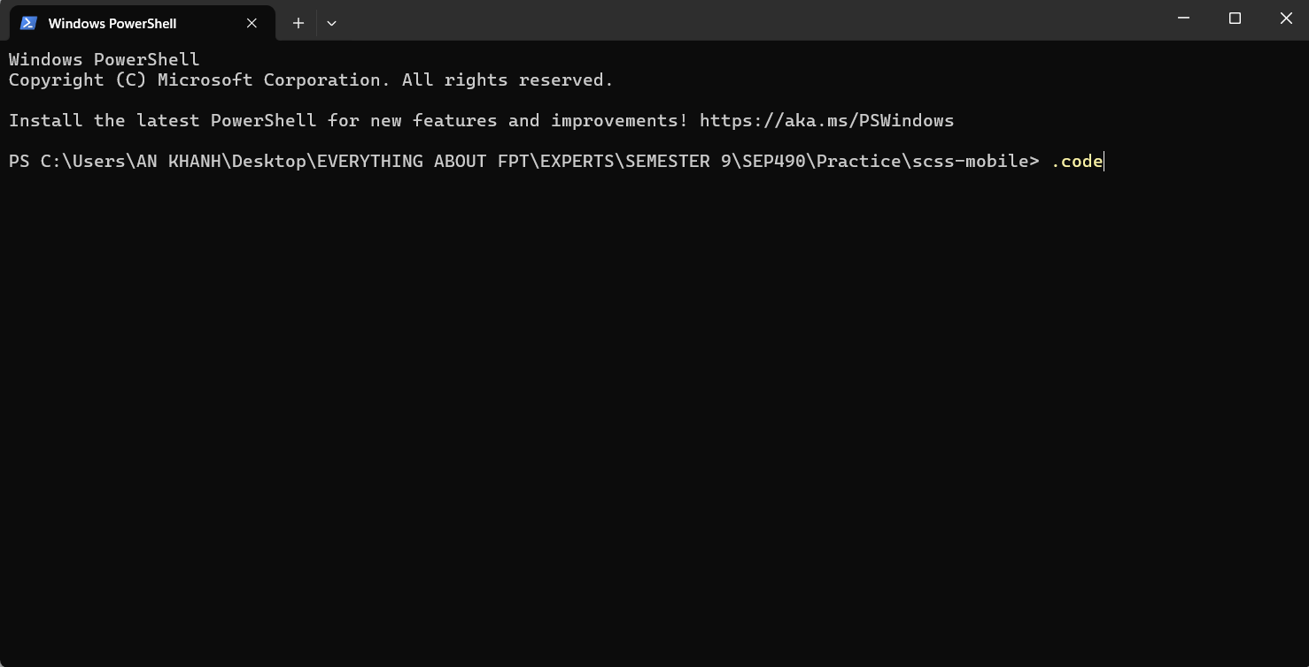

Step 5: After VS Code open with scss- folder, open VS Code terminal, input 2 commands in sequence: “npm install” and press Enter to install “node_modules” folder, then “npm run android” and press Enter to start mobile application





## **3. User Manual**

### **3.1. Overview**

### **3.2. Web Application**

#### **3.2.1. Authentication**

##### **3.2.1.1. Login**

**3.2.1.1.1. Description**

Use this guideline to login into SCSS with an email account. This web application supports login with email account that has been added as a admin, manager, counselor, support staff, student.

**3.2.1.1.2. Guide Steps**

Step 1: Access SCSS at http://scss-fe.azurewebsites.net/ **.** Then fill in “Email” and  “Password”

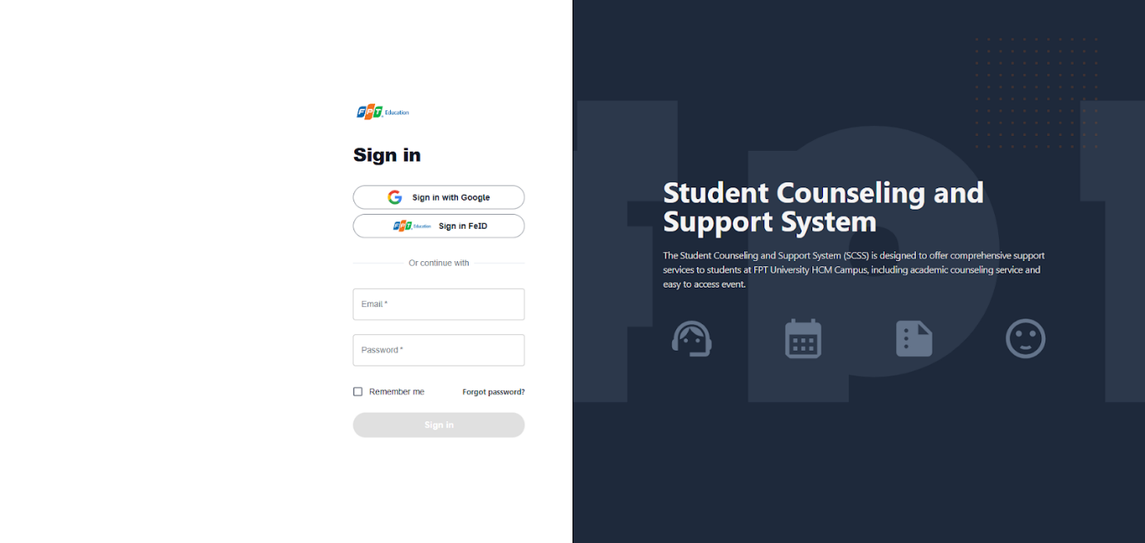

Figure 53 – Login page

**Step 2:** Click “Sign in” Button

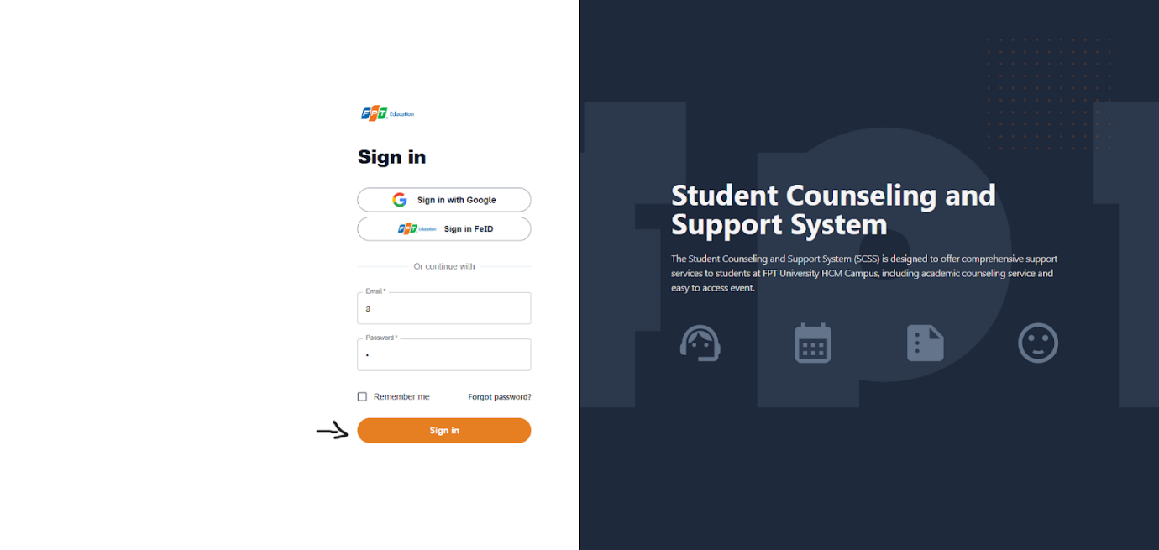

Figure 54 - Sign in

After logging in successfully, user is directed to the Dashboard Page with account authenticated.

##### **3.2.1.2. Reset Password**

Use this guide so users can reset their email account password when they forget their password.

3.2.1.2.1. Description Use this guide so users can reset their email account password when they forget their password.

**Step 1:** Access SCSS at http://scss-fe.azurewebsites.net/. Then press “Forgot password”.

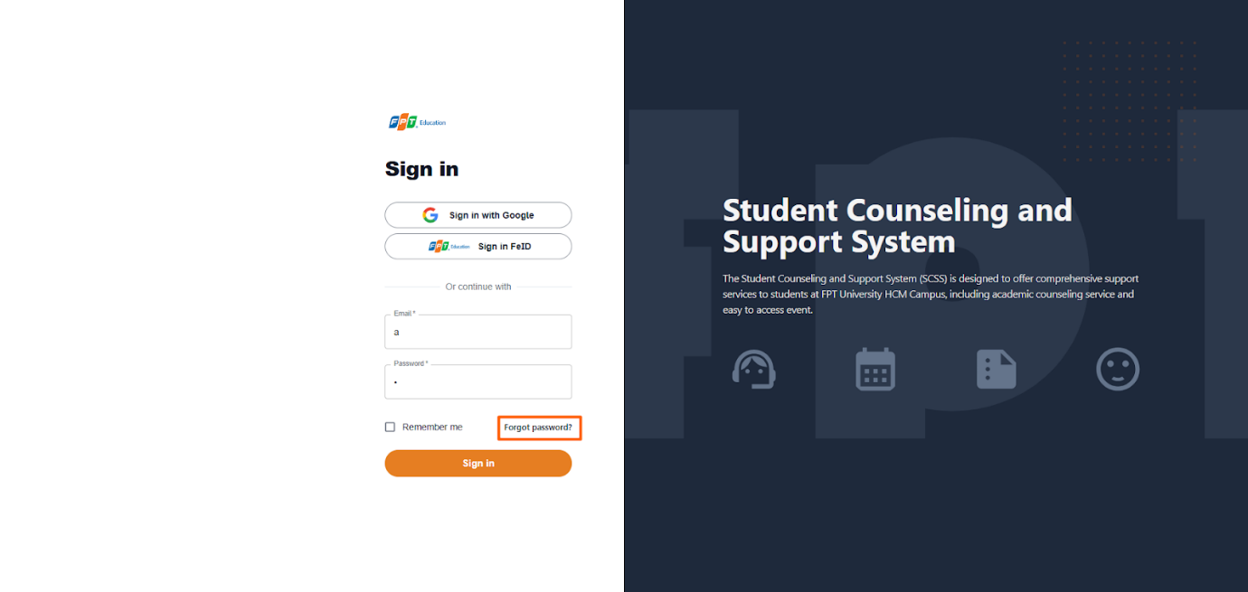

Figure 55 - Resset Password

3.2.1.2.2. Guide Steps

**Step 2:** Then fill in “Email”

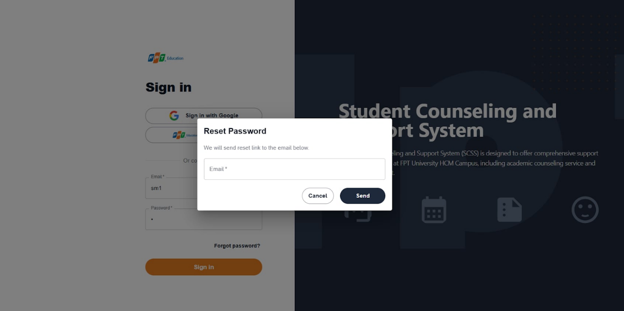

Figure 56 - Send email ro resset password

**Step 3:** Click “Send Email” button

After sending the email successfully, the user is redirected to the Verify OTP Page with the email that sent the OTP authentication code.

##### **3.2.1.3. Edit Password**

**3.2.1.3.1. Description**

Use this guide so users can update their email account password when they want to edit their password.

This web application supports updating passwords for actors: Admin, manager, counselor, support staff, student.

3.2.1.4.2. Guide Steps

Step 1: Access SCSS at http://scss-fe.azurewebsites.net/. After logging in successfully, click the box avatar on the header and click “Settings” menu item.

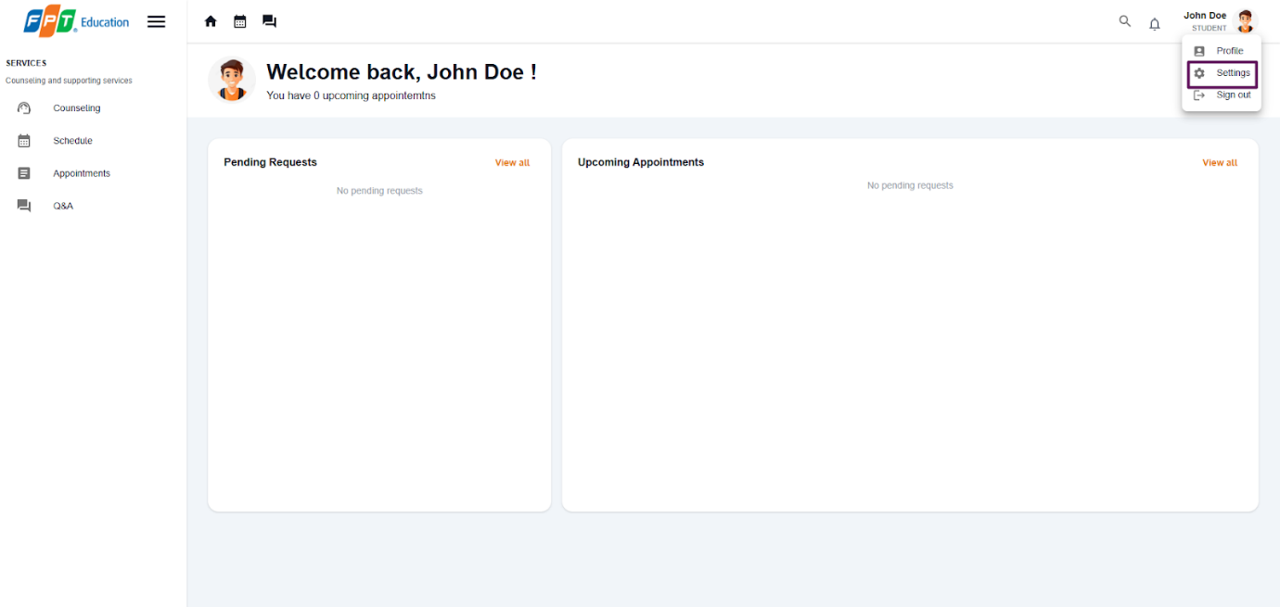

Figure 57 - View student's homepage

After click “Settings” menu item, the user is redirected to the Settings Page.

**Step 2:** Click menu icon button and click “Edit” button.

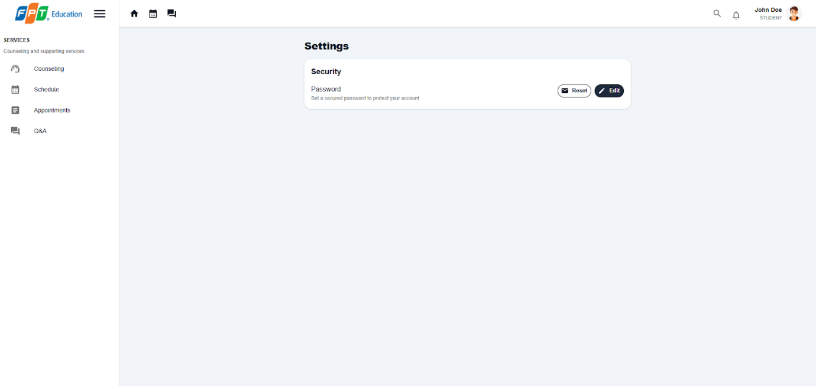

Figure 58 - View Setting

**Step 3:** Fill in “Current password”, “New password” and “Confirm new password”, then click “Save” button

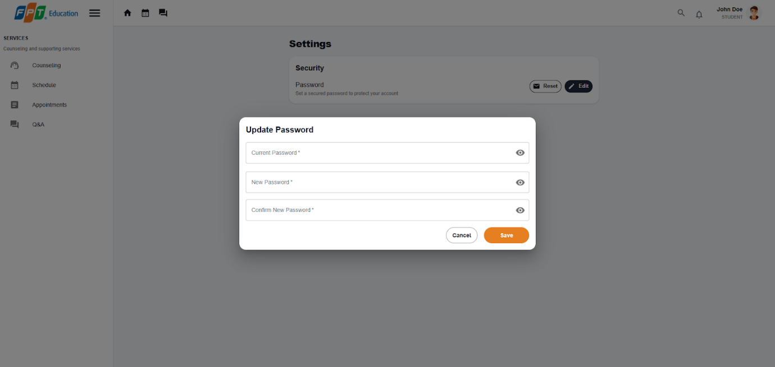

Figure 59 - Edit password

#### **3.2.2.  Booking counseling appointment**

##### **3.2.2.1. Quick booking a counselor**

**3.2.2.1.1. Description**

Use this guideline to login into SCSS student account to quick booking counseling appointments.

Step 1: Access SCSS at http://scss-fe.azurewebsites.net/. Then fill in “Email” and “Password” of the student account.

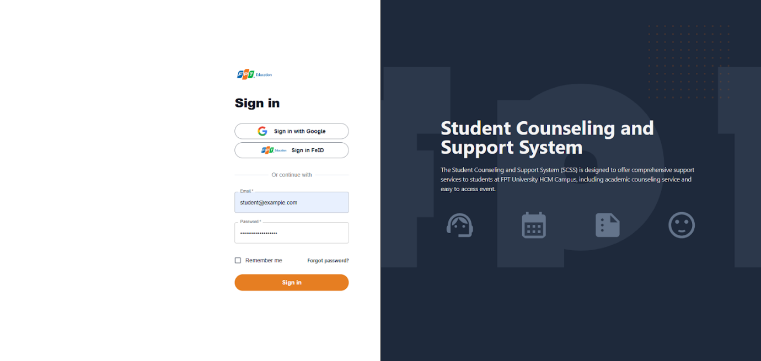

**Step 2:** Click “Sign in ” button.

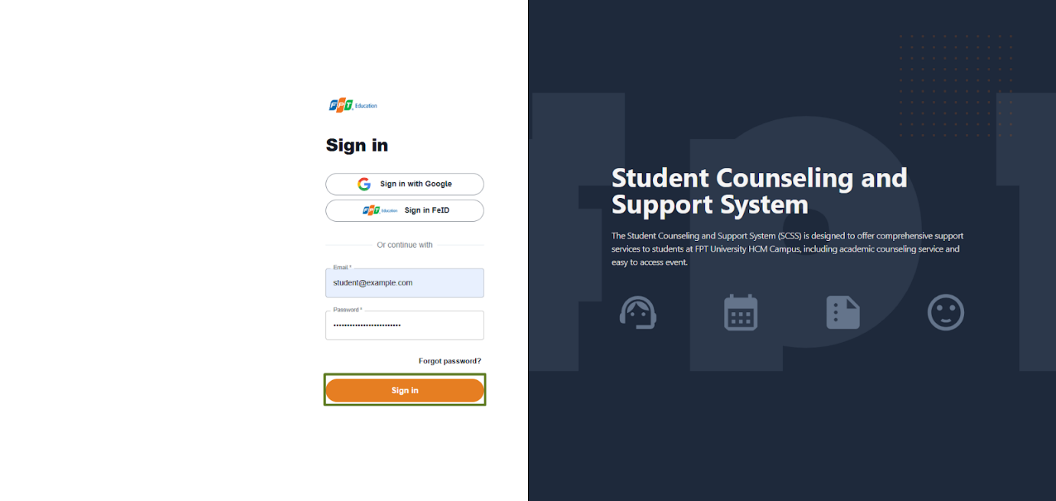

**Step 3:** From the homepage, choose “Counseling” from the left sidebar.

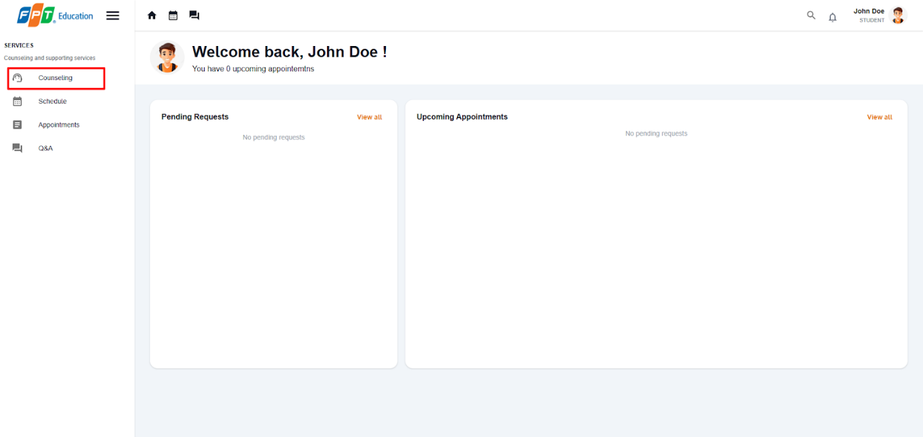

**Step 4:** Enter all the the required information to booking counseling appointment including:

Counseling Type, gender (optional), department (optional for academic counseling), major (optional for academic counseling), and reason.

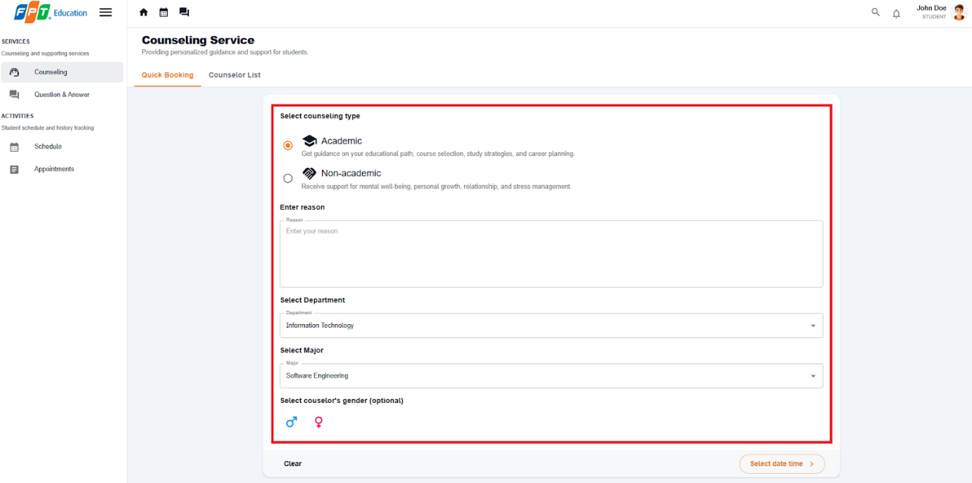

**Step 5:** After selecting all required fields and entering reason, choose 'Select date time' and the system will validate your reason.

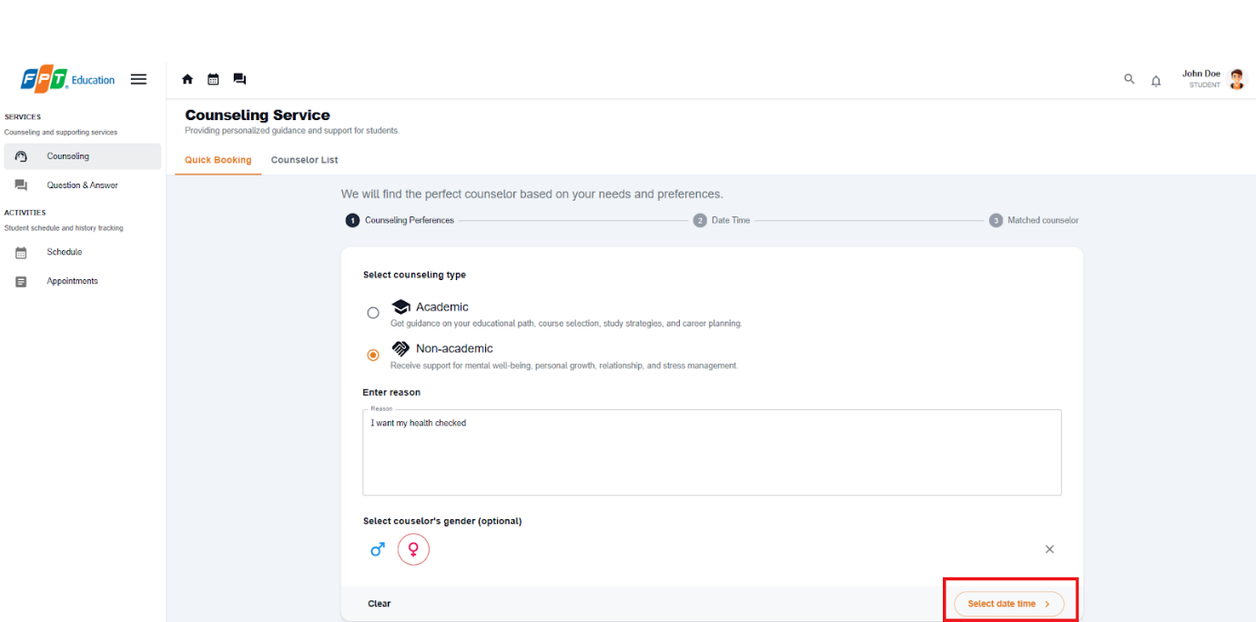

**Step 6:** If you give a valid reason, continue to select date and time.

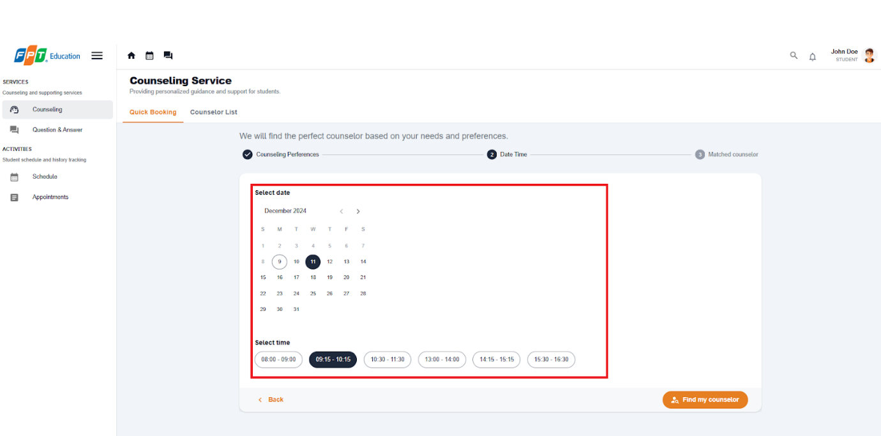

**Step 7:** After selecting date time, select 'Find my counselor' button and the system will find the counselor that matched your preferences.

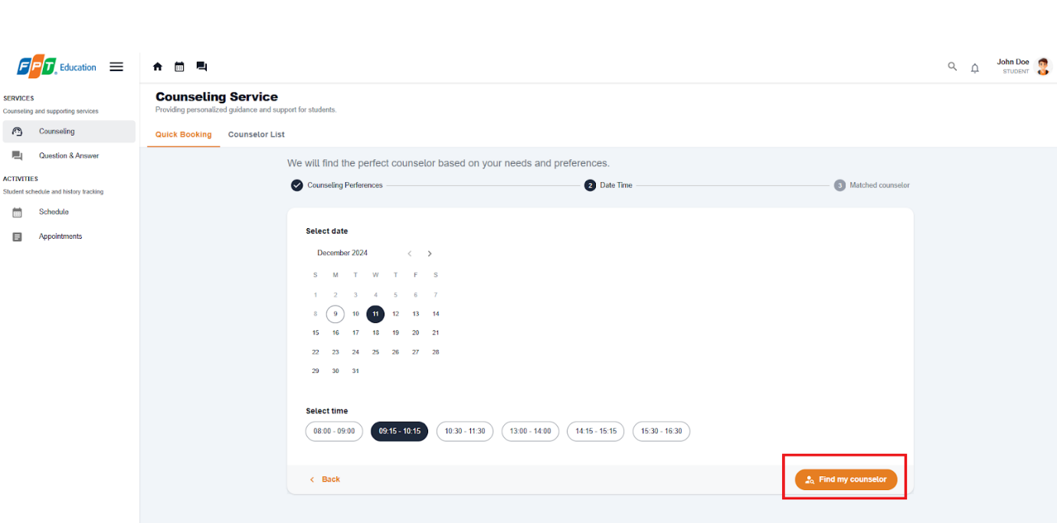

**Step 8:** If there is a matched counselor, continue to select meeting type between offline and online.

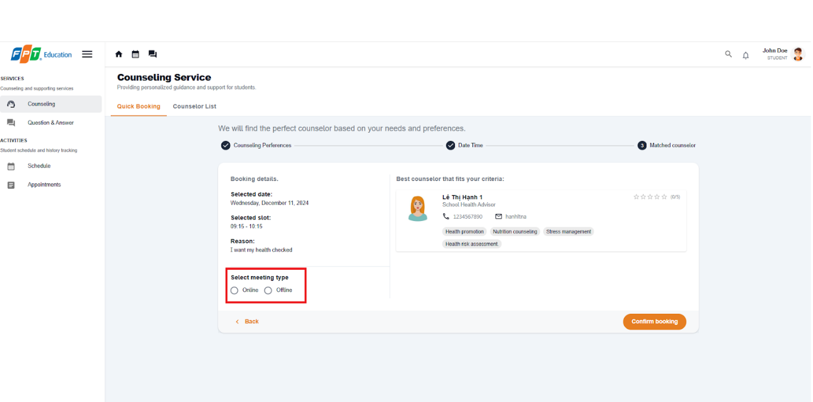

**Step 9:**  Choose the 'Confirm booking' button, there will be an success dialog and you book successfully.

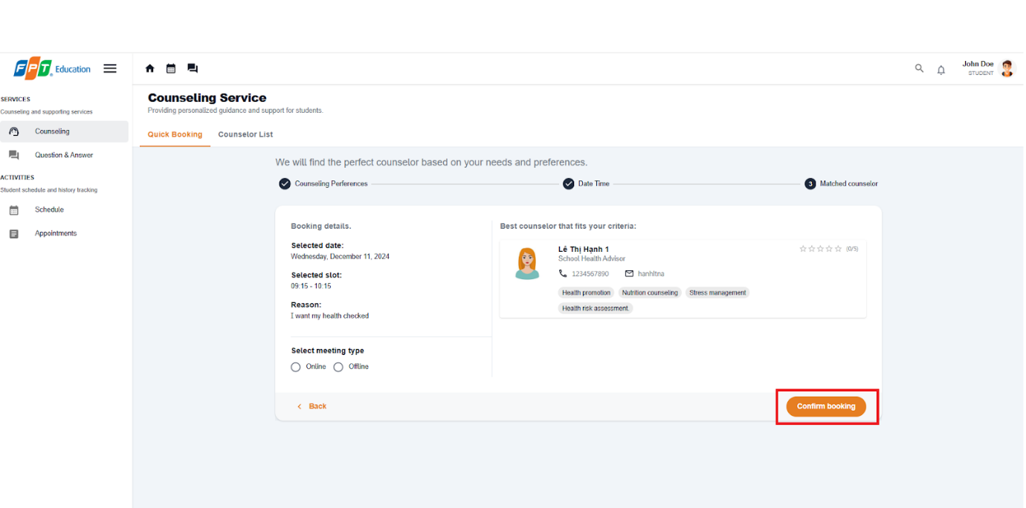

##### 3.2.2.2. Booking a specific counselor

3.2.2.2.1. Description

Use this guideline to login into the SCSS student account to book a specific counselor.

**Step 1:** Access SCSS at http://scss-fe.azurewebsites.net/. Then fill in “Email” and “Password” of the student account.



**Step 2:** Click “Sign in ” button.



**Step 3:** From the homepage, choose “Counseling” from the left sidebar.



**Step 4:** Select ”Counselor List” tab,

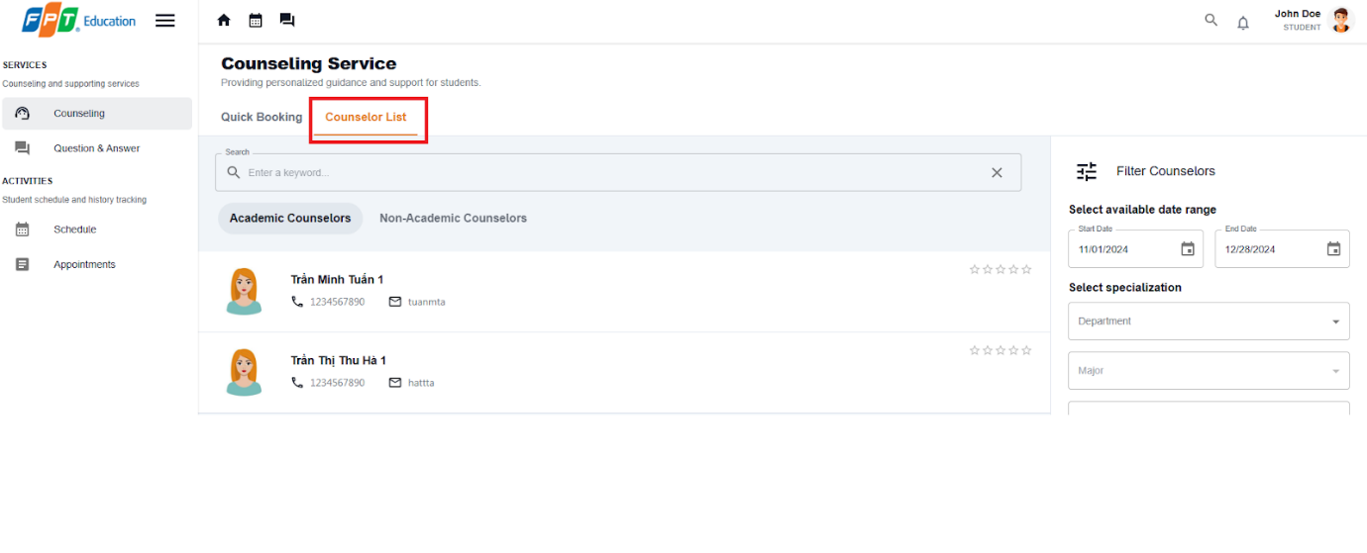

**Step 5:** Choose filter options to narrow down counselors based on preferences of students, including: availability, specialization/expertise, rating, counseling type, gender or search by keyword.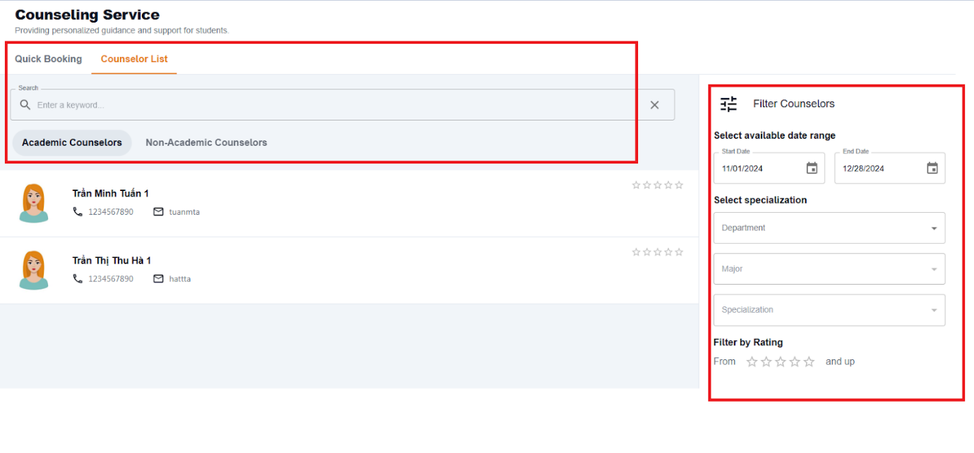

**Step 6:** Select a counselor and click the button “Book counselor”

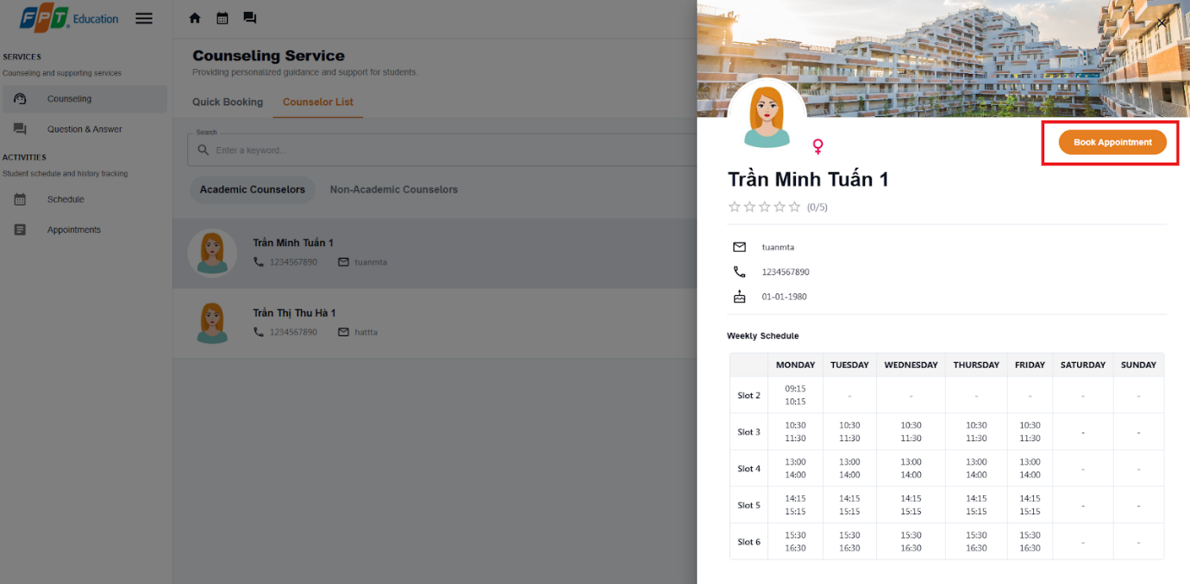

**Step 7:**  Select all the required information to book an appointment including: “Select date”, “Select slot”, “Select meeting type“, Fill “Reason“:

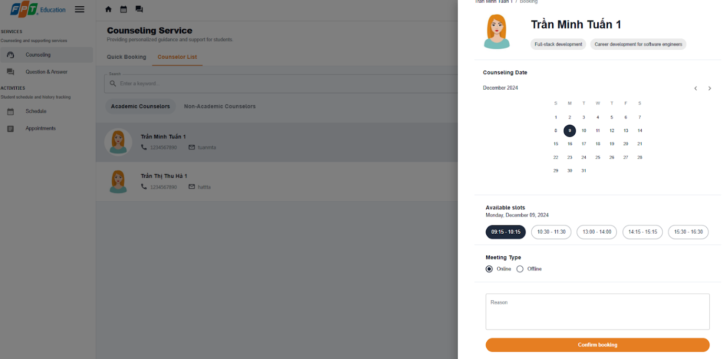

**Step 8:** Select confirm booking and confirm

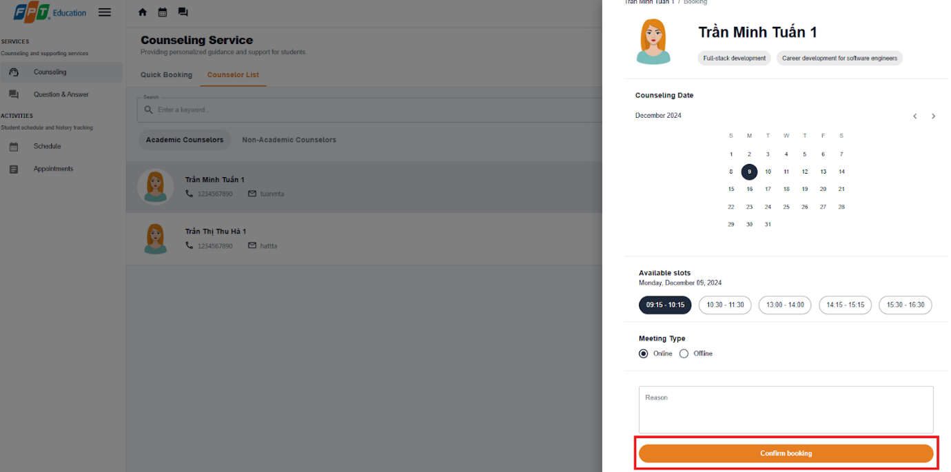

##### 3.2.2.3. Approve an appointment request

3.2.2.3.1. Description

Use this guideline to log into the SCSS counselor account to approve a student appointment request.

**Step 1:** Access SCSS at http://scss-fe.azurewebsites.net/. Then fill in “Email” and “Password” of the counselor account.



**Step 2:** Click “Sign in ” button.



**Step 3:** From the homepage, choose “Requests” from the left sidebar.

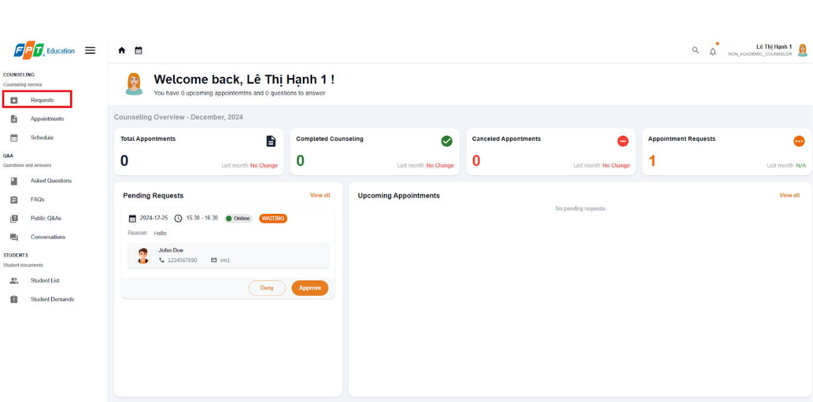

**Step 3:** In “Requests” page, select the ”Approve” button.

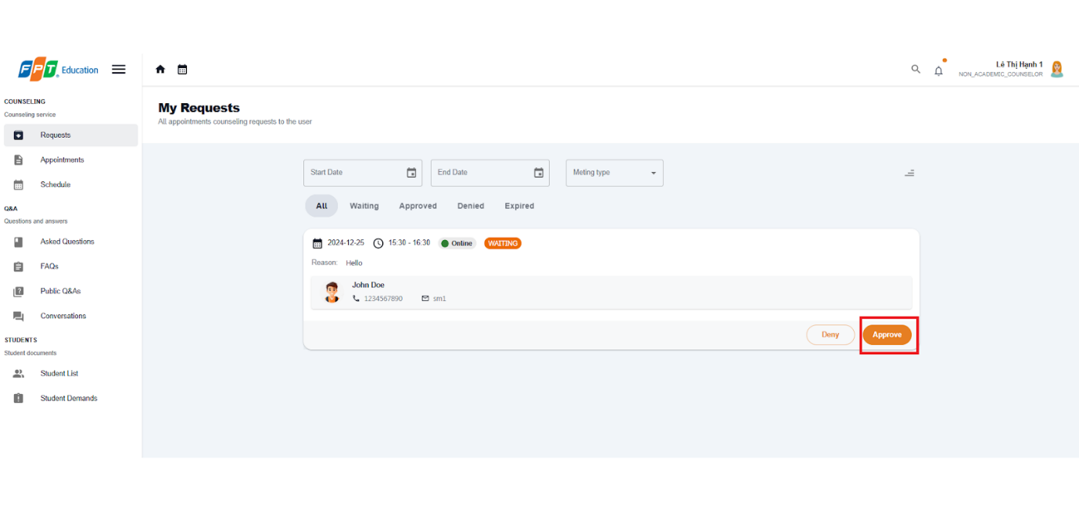

**Step 4:** There is a dialog displayed, if the appointment request meeting type is ”Online”, fill in the meeting URL, if it is ”Offline”, fill in the address. After fill required field, press “Confirm” Button to approve the request.

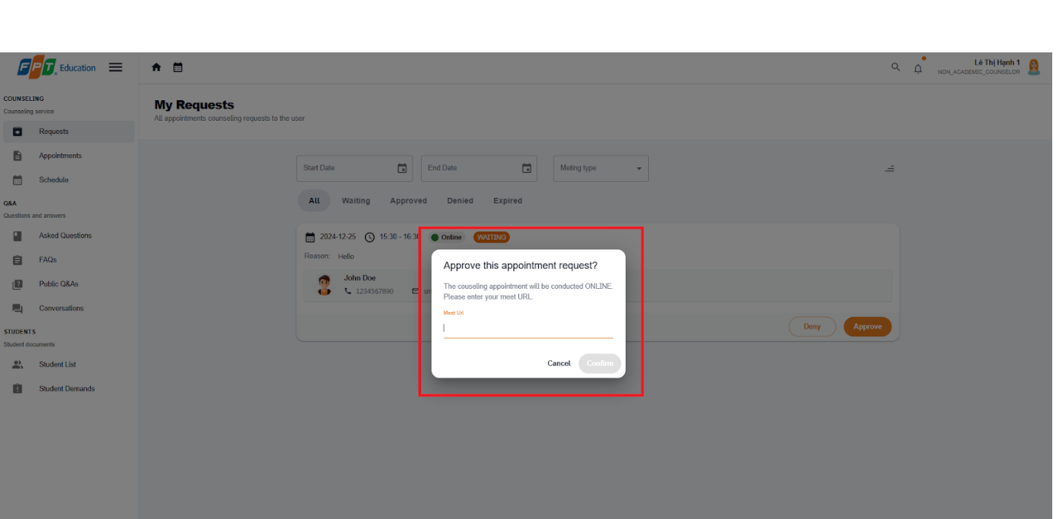

##### 3.2.2.4. Deny an appointment request

3.2.2.4.1. Description

Use this guideline to log into the SCSS counselor account to deny a student appointment request.

**Step 1:** Access SCSS at http://scss-fe.azurewebsites.net/. Then fill in “Email” and “Password” of the counselor account.



**Step 2:** Click “Sign in ” button.



**Step 3:** From the homepage, choose “Requests” from the left sidebar.



**Step 3:** In “Requests” page, select the ”Deny” button.

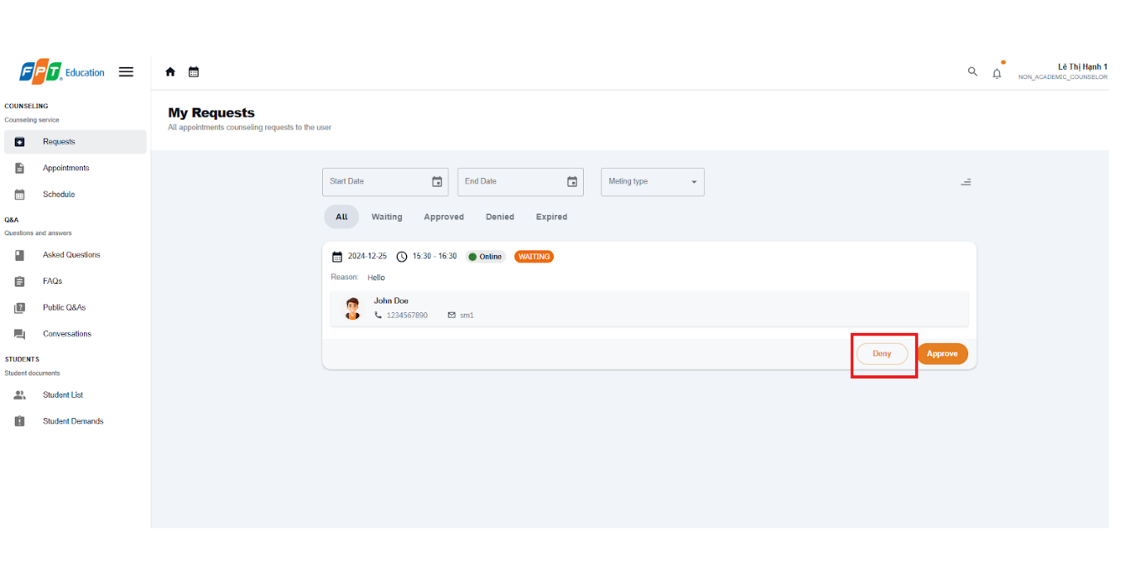

**Step 4:** There is a confirmation dialog displayed, press “Confirm” Button to deny the request.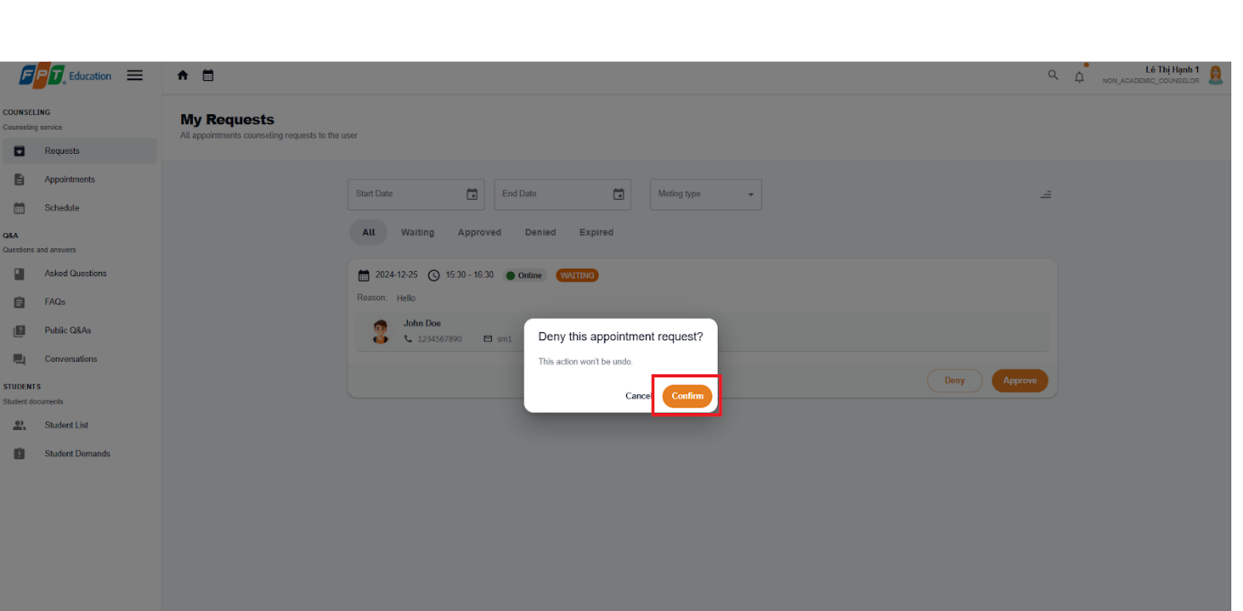

##### 3.2.2.5. Take Attendance for Appointment

3.2.2.5.1. Description

Use this guideline to log into the SCSS counselor account to take attendance for appointment

**Step 1:** Access SCSS at http://scss-fe.azurewebsites.net/. Then fill in “Email” and “Password” of the counselor account.



**Step 2:** Click “Sign in ” button.



**Step 3:** From the homepage, choose “Appointments” from the left sidebar.

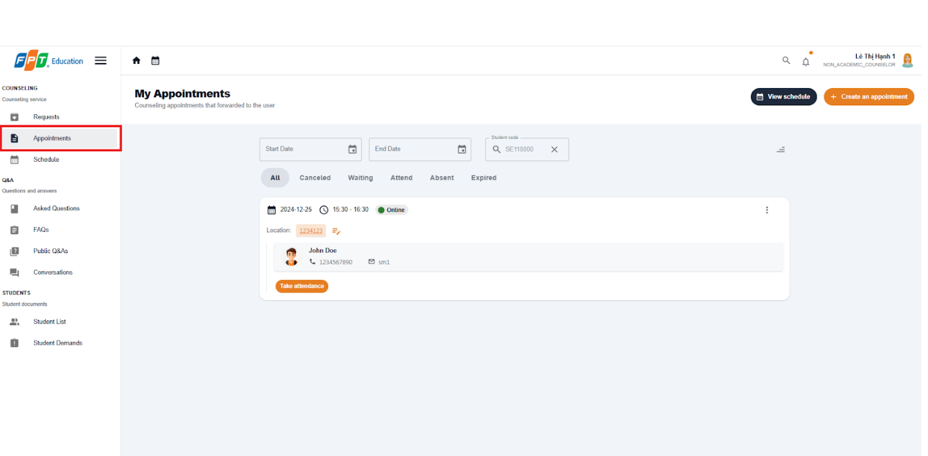

**Step 4:** In “Appointments” page, find an appointment using filter section by meeting date, and status. After finding an appointment, press “Take attendance” button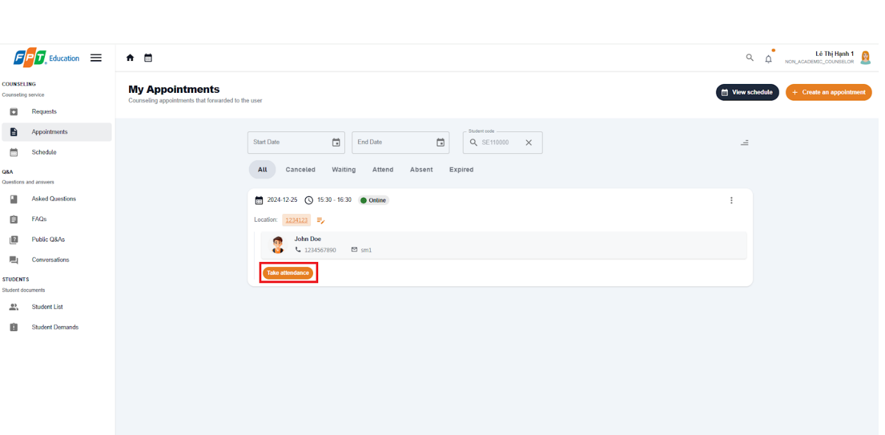

**Step 5:** There will be Take Attendance dialog, a take attendance confirmation will open. Press “ATTEND” or “ABSENT” to change the status of the chosen appointment.

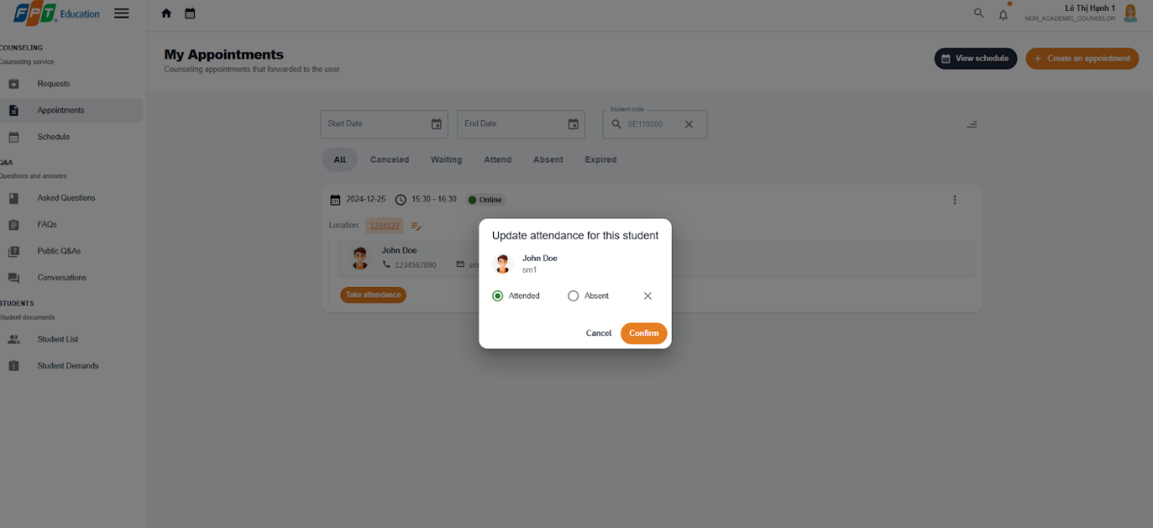

**Step 6:** After taking attendance, the status of appointment will change to “ATTEND” or “ABSENT”

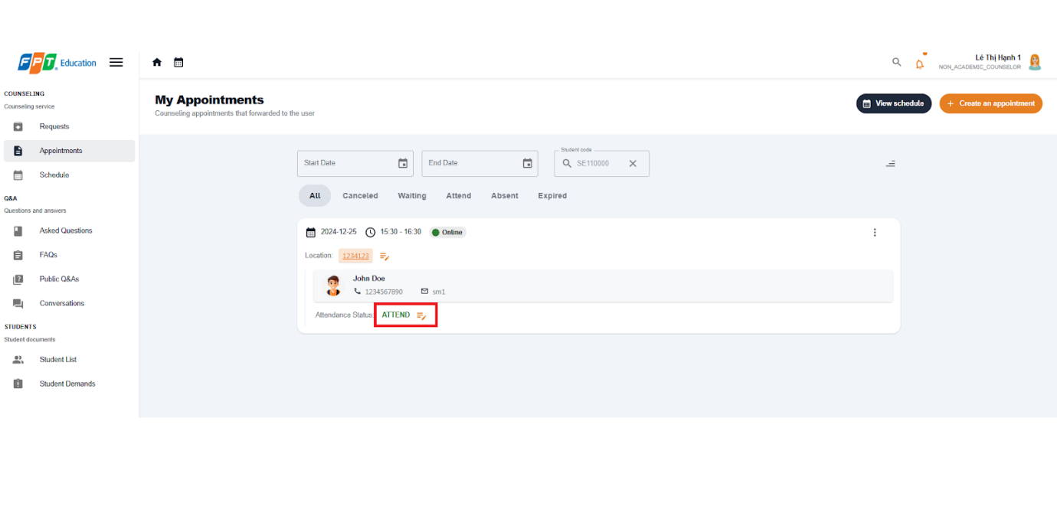

##### 3.2.2.6. Give Feedback for Appointment

3.2.2.6.1. Description

Use this guideline to log into the SCSS student account to write feedback for appointment

**Step 1:** Access SCSS at http://scss-fe.azurewebsites.net/. Then fill in “Email” and “Password” of the student account.



**Step 2:** Click “Sign in ” button.



**Step 3:** From the homepage, choose “Appointments” from the left sidebar.

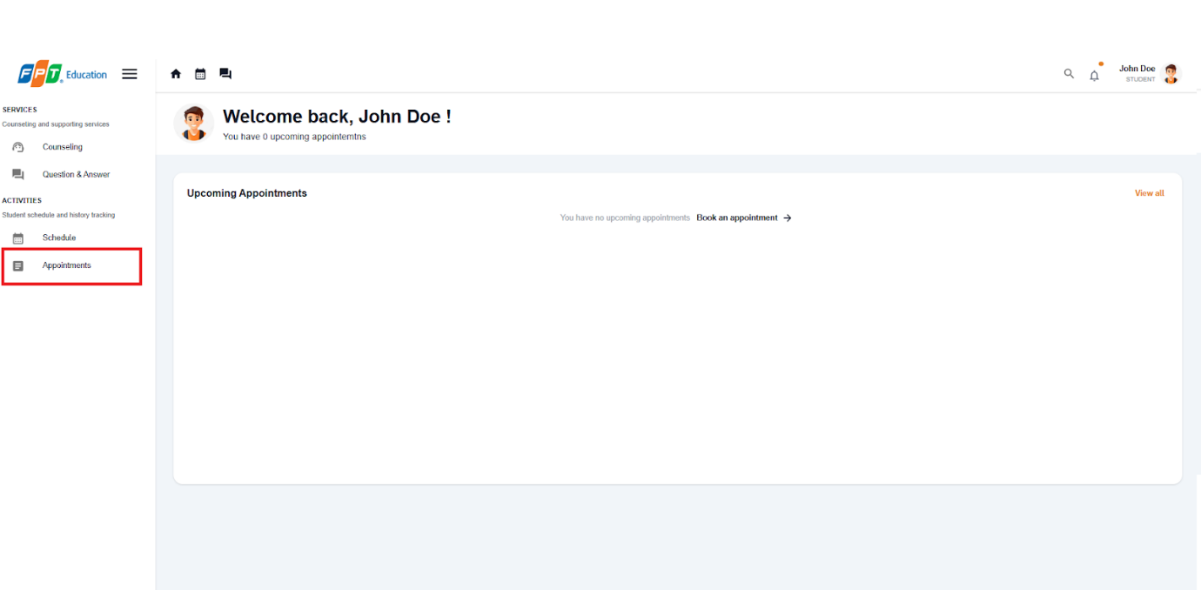

**Step 4:** In Appointment page, find an appointment using filter section by meeting date, and status. After finding a appointment (which status is “ATTEND”), press “Leave a review” button.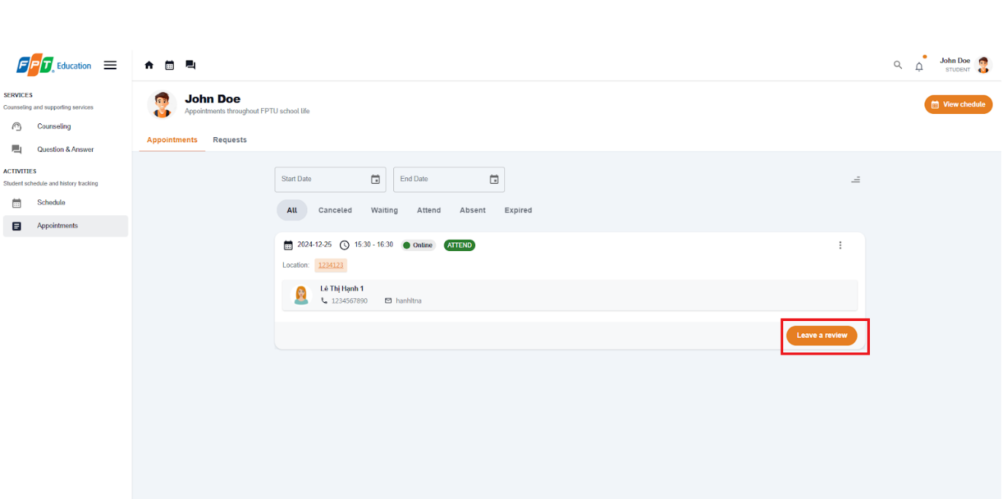

**Step 5:** Fill in feedback content including message and rating. Then submit it by pressing “Save” Button, or cancel by pressing “Cancel” Button

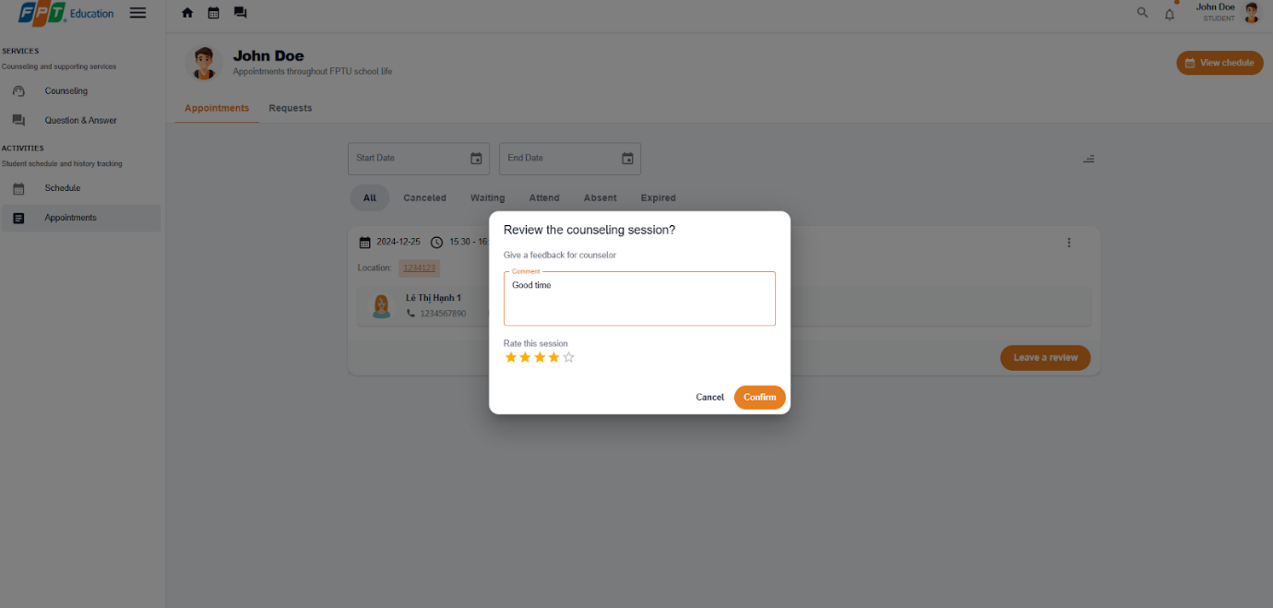

**Step 8:** View feedback after submitting in the appointments page.

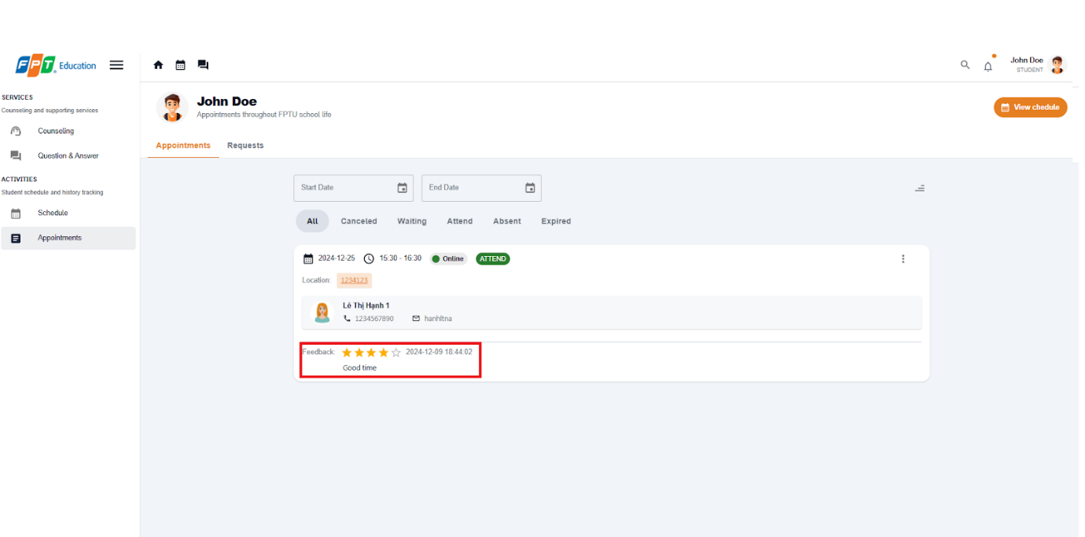

##### 3.2.2.7. Create report for an appointment

3.2.2.7.1. Description

Use this guideline to log into the SCSS student account to write report for appointment

**Step 1:** Access SCSS at http://scss-fe.azurewebsites.net/. Then fill in “Email” and “Password” of the counselor account.



**Step 2:** Click “Sign in ” button.



**Step 3:** From the homepage, choose “Appointments” from the left sidebar.

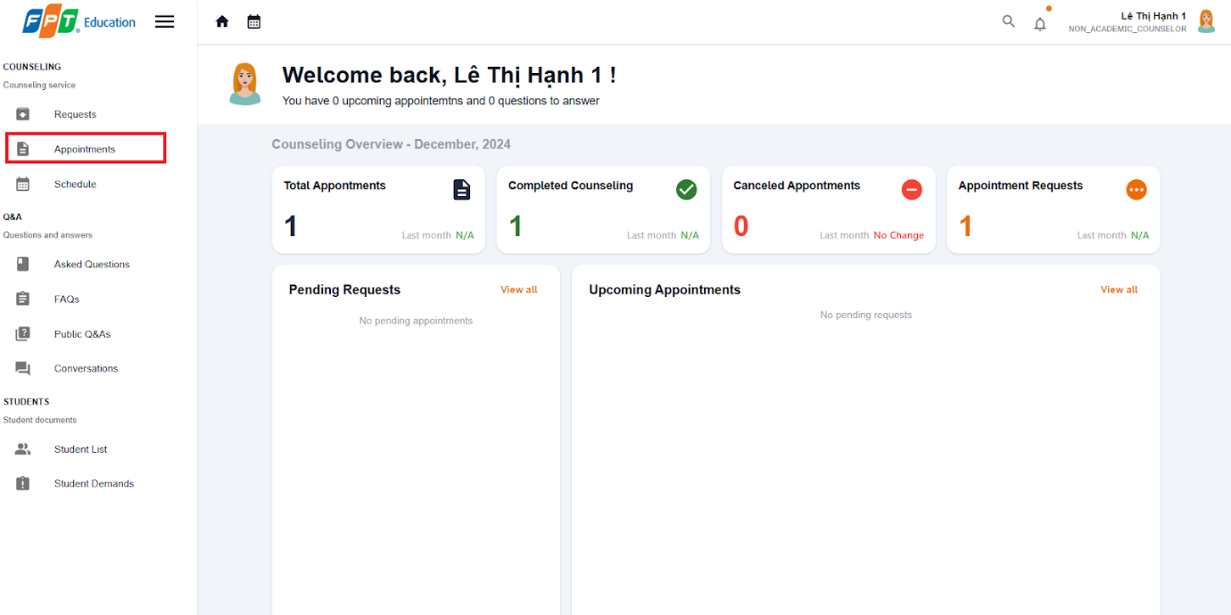

**Step 4:** In the Appointment page, find an appointment using the filter section by meeting date, and status. After finding an appointment (which status is “ATTEND”), press the more vert icon button, then choose the “Create Report” option.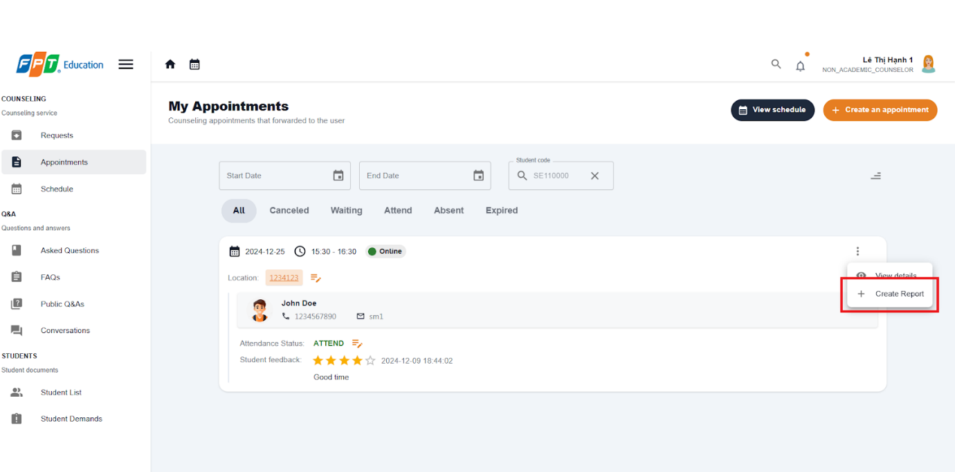

**Step 5:** Fill in the report form which requires 4 steps, including Goal, Content, Conclusion, Intervention. You can select Preview button before submitting to check full report.

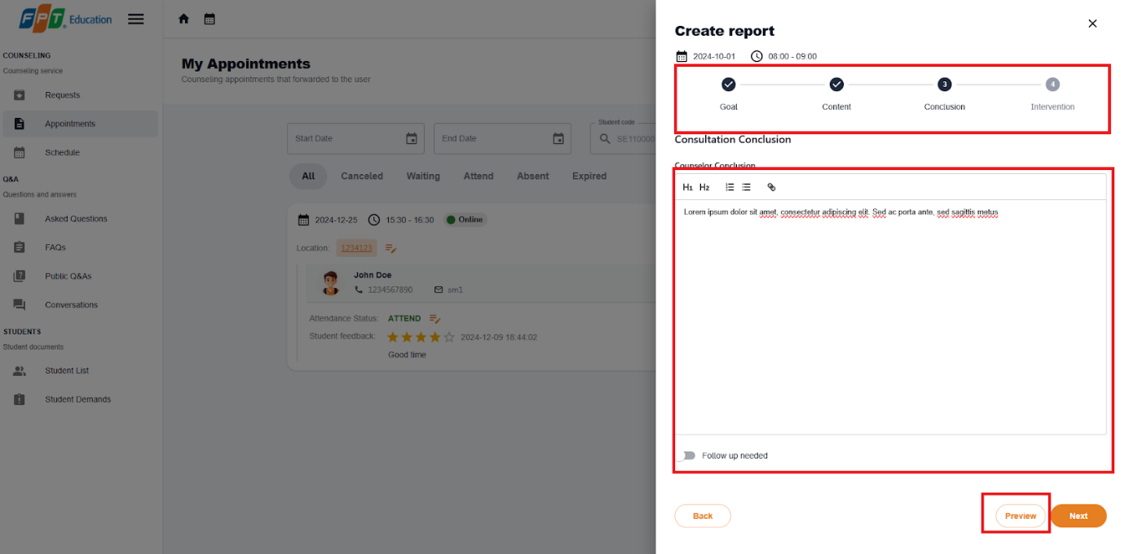

**Step 6:**.Select submit button. After confirmation, report will be created, then select more vert icon button again select View report option.

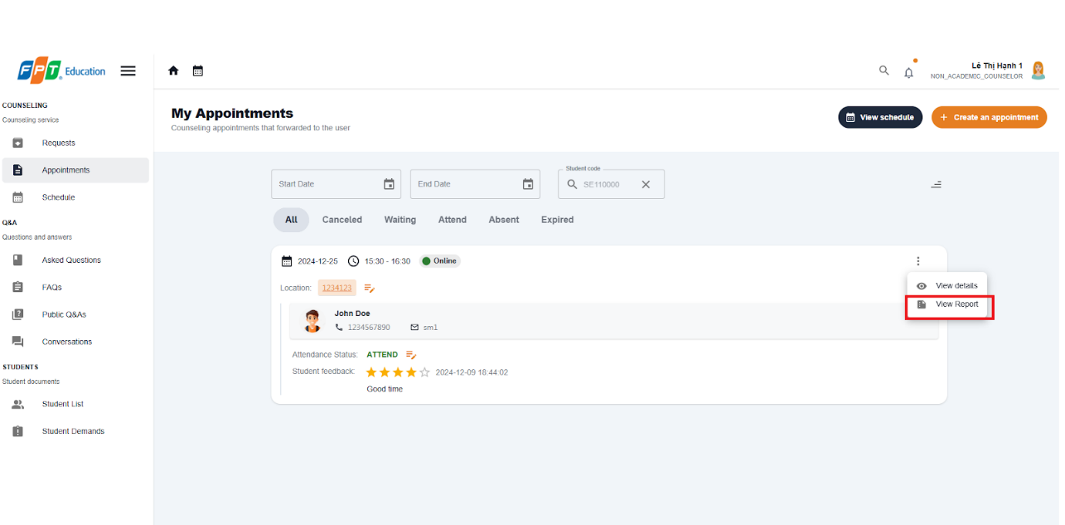

**Step 7:**.Check on newly created report.

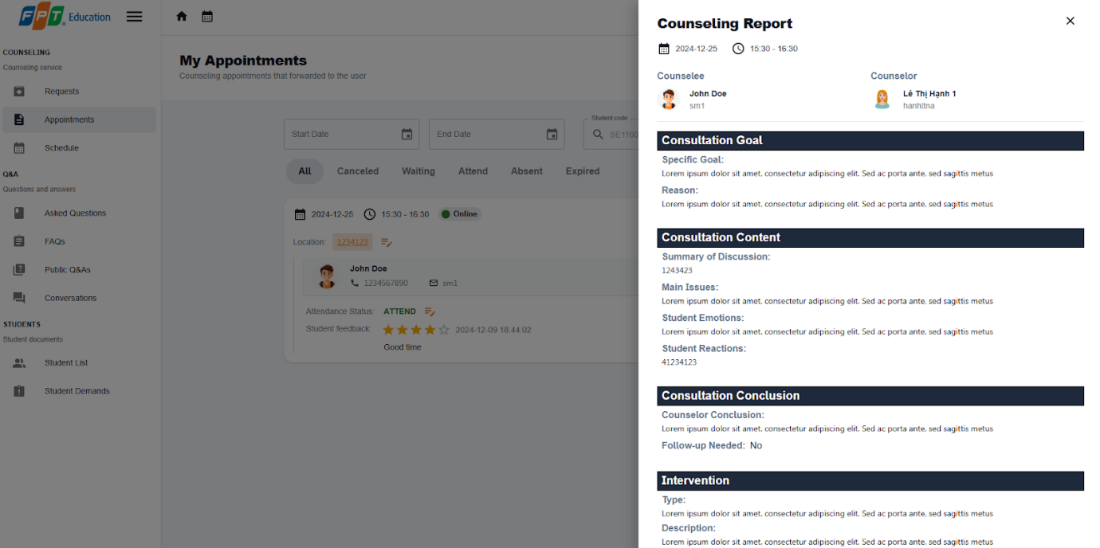

#### 3.2.3. Question and answer

##### 3.2.3.1. Ask a question

3.2.3.1.1 Description

Use this guideline to create a question for counselor

3.2.3.1.2. Guide Steps:

**Step 1**: Access SCSS at http://scss-fe.azurewebsites.net/. Then fill in “Email” and “Password” of the student account.



**Step 2:** Click the “Sign in ” button.



**Step 3:** From the homepage, choose “Question & Answer” from the left sidebar.

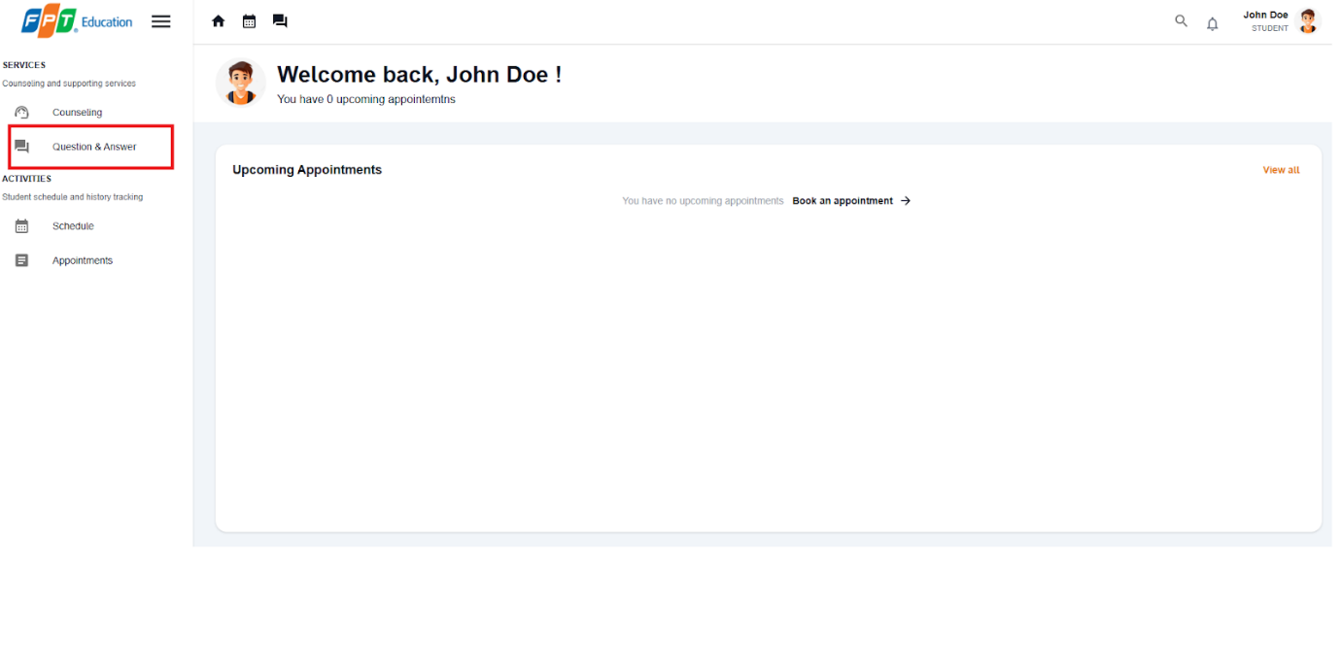

**Step 4:** In Q&A page, choose “Ask a button” at top right

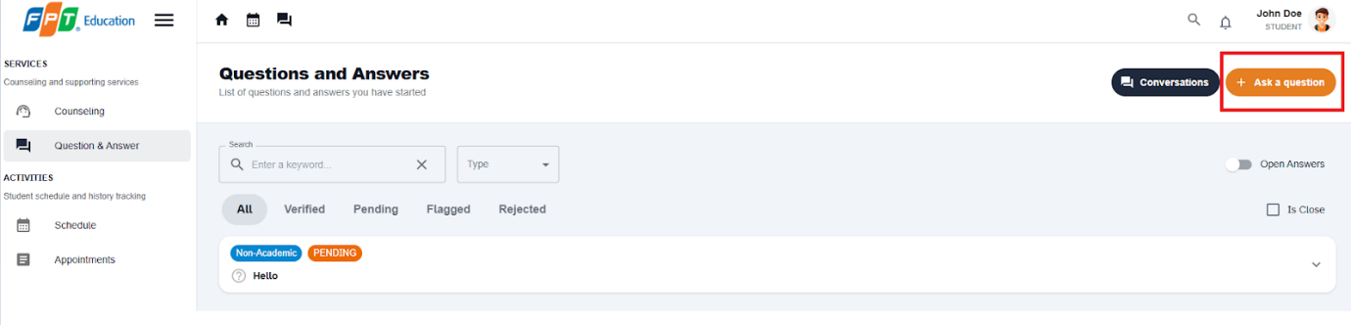

**Step 5:** Choose the question type and fill in the question content, if there are similar questions, it will be suggested to students before submitting in case there are duplicate questions. Then confirm submitting questions and it will be forwarded to suitable counselors.

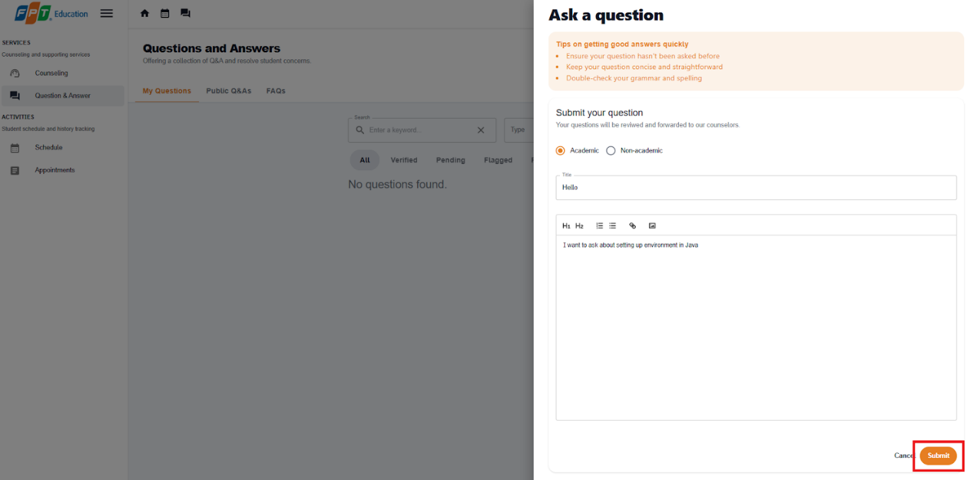

##### 3.2.3.2. Edit a question

3.2.3.1.1 Description

Use this guideline to create a question for counselor

3.2.3.1.2. Guide Steps:

**Step 1**: Access SCSS at http://scss-fe.azurewebsites.net/. Then fill in “Email” and “Password” of the student account.



**Step 2:** Click the “Sign in ” button.



**Step 3:** From the homepage, choose “Question & Answer” from the left sidebar.



**Step 4:** Select  “edit question“ button if the question is not answered yet.

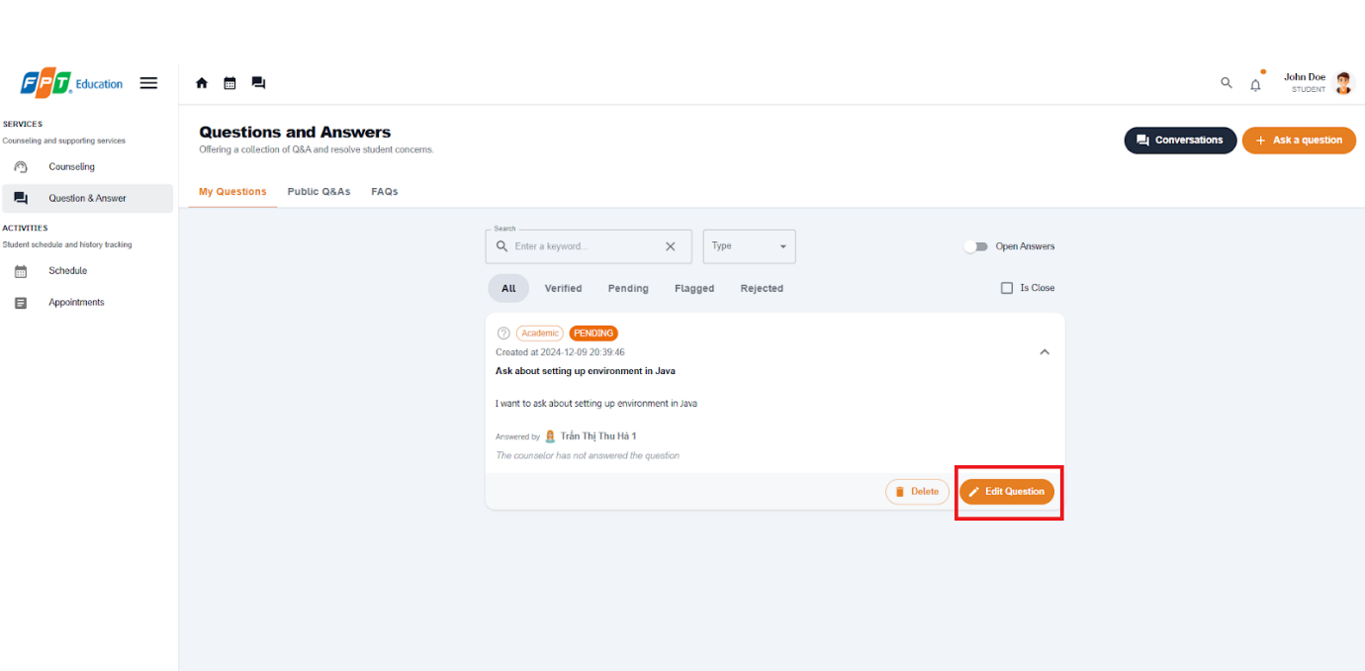

**Step 5:** Update title and content of question then select Save button.

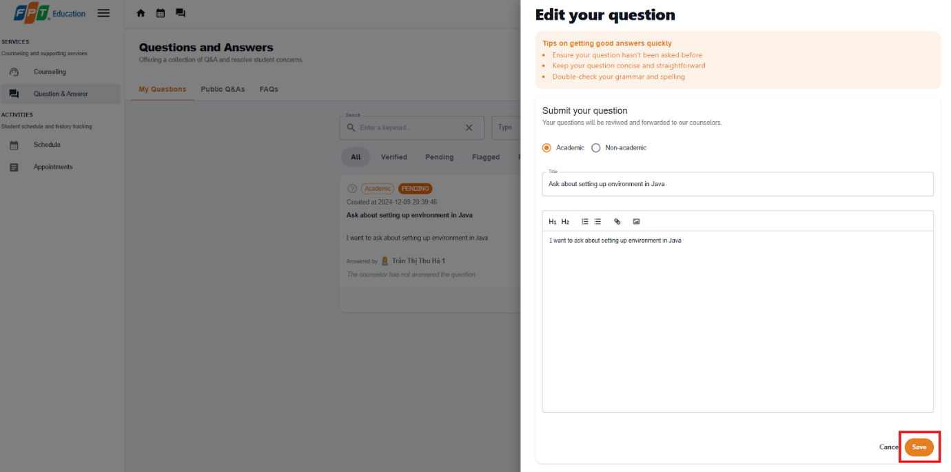

##### 3.2.3.3. Answer a question

3.2.3.3.1 Description

Use this guideline to create a question for counselor

3.2.3.3.2. Guide Steps:

**Step 1**: Access SCSS at http://scss-fe.azurewebsites.net/. Then fill in “Email” and “Password” of the counselor account.



**Step 2:** Click the “Sign in ” button.



**Step 3:** From the homepage, choose “Asked Questions” from the left sidebar.

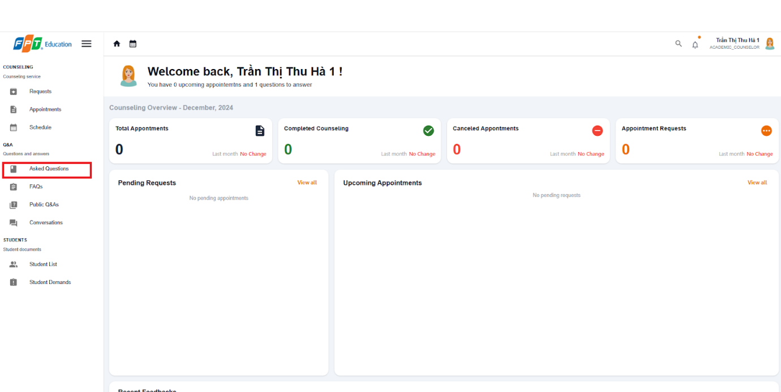

**Step 4:** Select  “Answer“ button and a Answer dialog will show up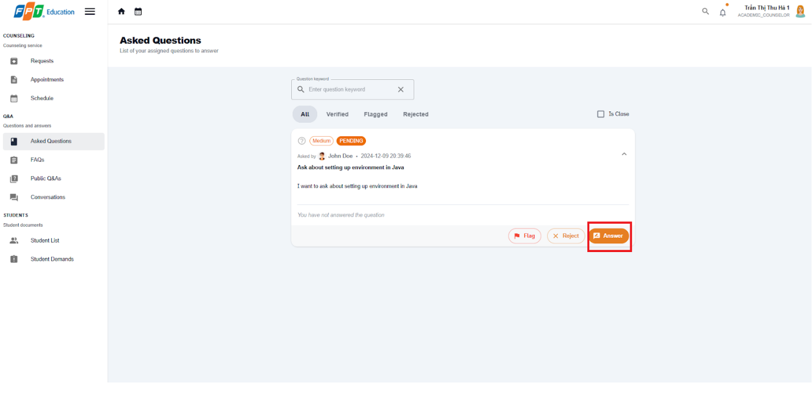

**Step 5:** Fill in the answer for the question then select the Submit Answer button.

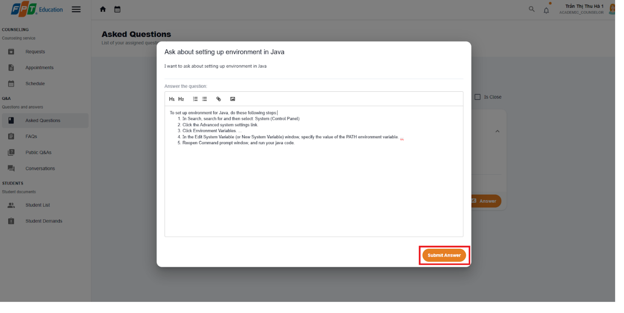

##### 3.2.3.4. Edit your answer

3.2.3.4.1 Description

Use this guideline to create a question for counselor

3.2.3.4.2. Guide Steps:

**Step 1**: Access SCSS at http://scss-fe.azurewebsites.net/. Then fill in “Email” and “Password” of the counselor account.



**Step 2:** Click the “Sign in ” button.



**Step 3:** From the homepage, choose “Asked Questions” from the left sidebar.



**Step 4:** Select  “Answer“ button and a Answer dialog will show up

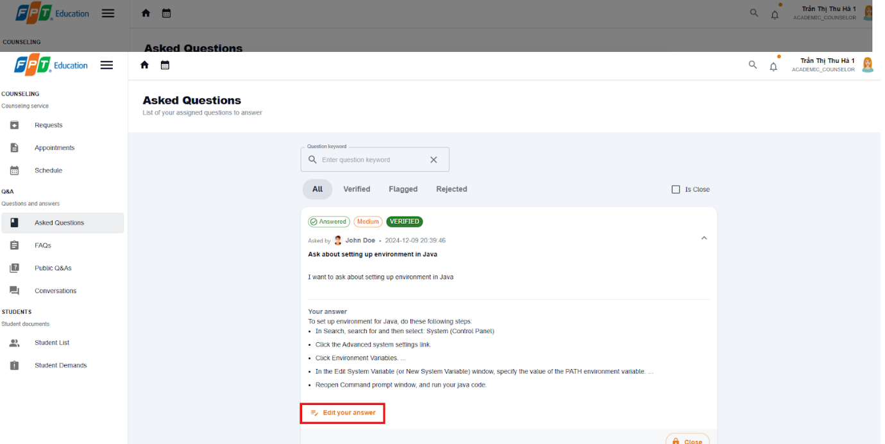

**Step 5:** Fill in the answer for the question then select the Submit Answer button.



##### 3.2.3.5. Chat about a question

3.2.3.5.1 Description

Use this guideline to create a question for counselor

3.2.3.5.2. Guide Steps:

**Step 1**: Access SCSS at http://scss-fe.azurewebsites.net/. Then fill in “Email” and “Password” of the student account.



**Step 2:** Click the “Sign in ” button.



**Step 3:** From the homepage, choose “Question & Answer” from the left sidebar.



**Step 4:** In Q&A page, select the question which has already been answered, and select Start to chat button

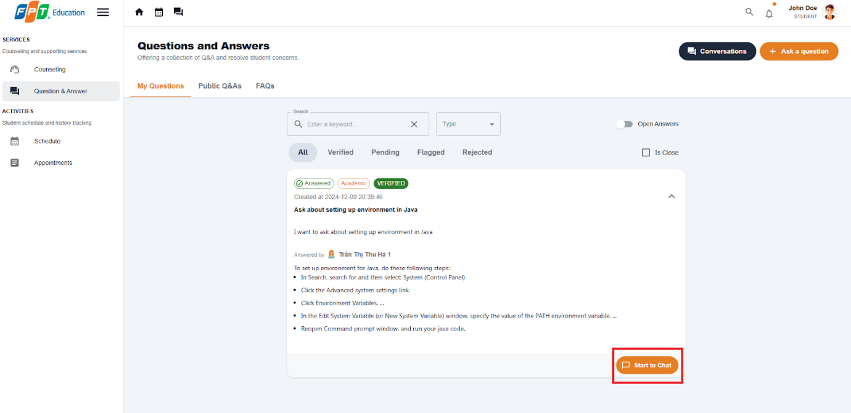

**Step 5:** A chat session will show up and you can chat with the counselor for the question is closed.

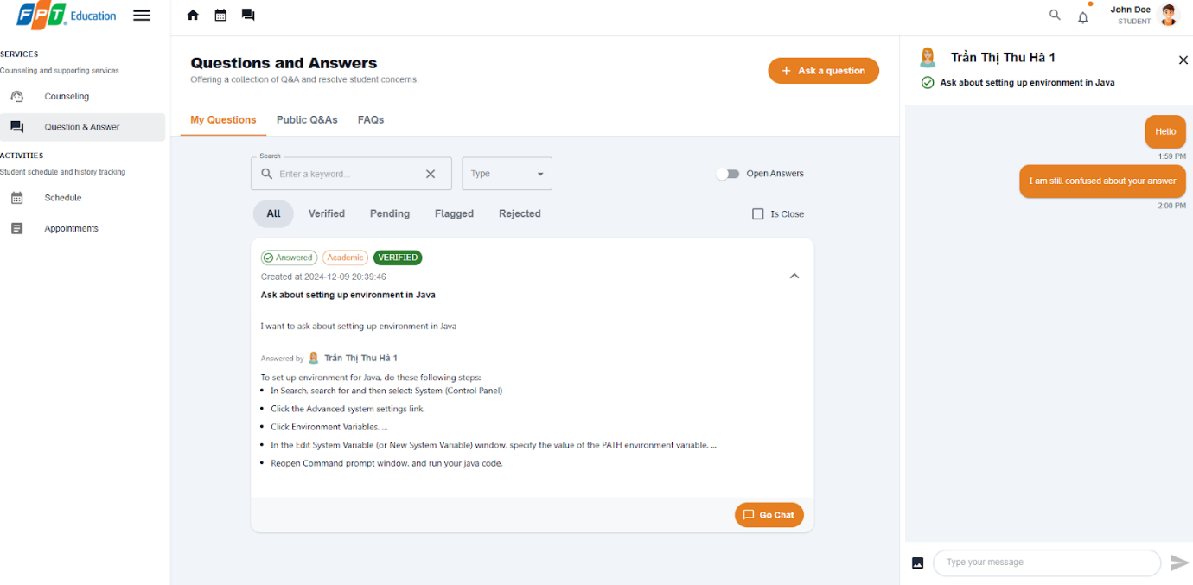

##### 3.2.3.6. Close a question

3.2.3.6.1 Description

Use this guideline to create a question for counselor

3.2.3.6.2. Guide Steps:

**Step 1**: Access SCSS at http://scss-fe.azurewebsites.net/. Then fill in “Email” and “Password” of the student account.



**Step 2:** Click the “Sign in ” button.



**Step 3:** From the homepage, choose “Asked Questions” from the left sidebar.



**Step 4:** Select  “Close“ button and a confirmation dialog will show up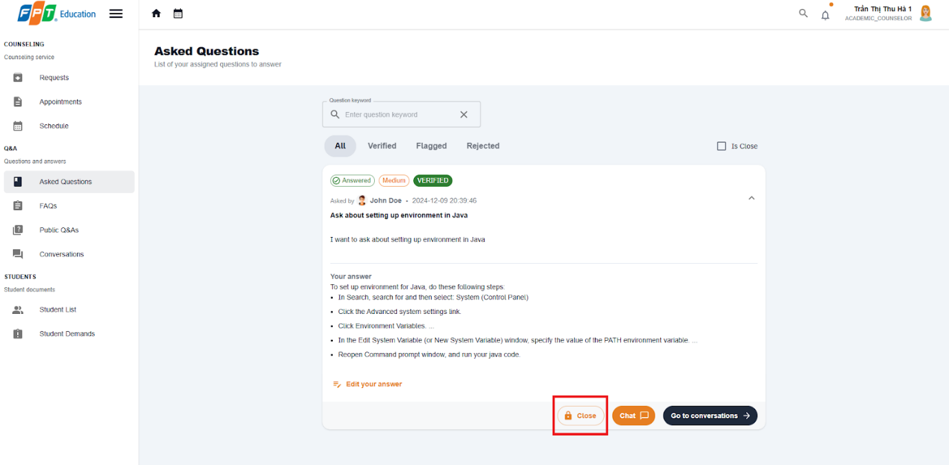

**Step 5:** After confirming, the question will be closed and the asked student will no longer be able to chat.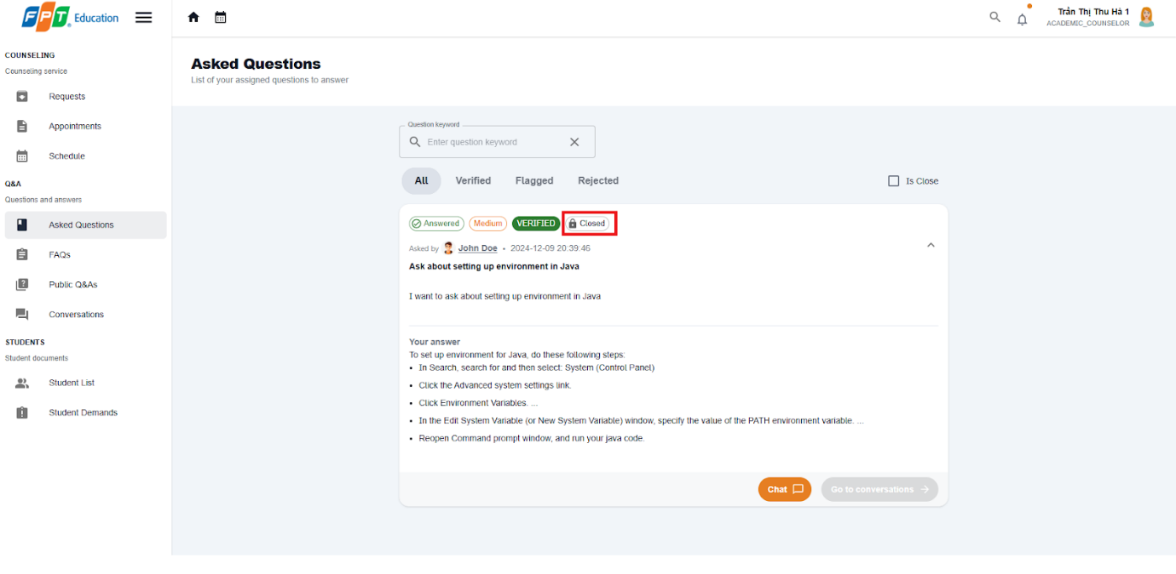

##### 3.2.3.7. Contribute to FAQ

3.2.3.3.7 Description

Use this guideline to create a question for counselor

3.2.3.3.7. Guide Steps:

**Step 1**: Access SCSS at http://scss-fe.azurewebsites.net/. Then fill in “Email” and “Password” of the counselor account.



**Step 2:** Click the “Sign in ” button.



**Step 3:** From the homepage, choose “FAQ” from the left sidebar.

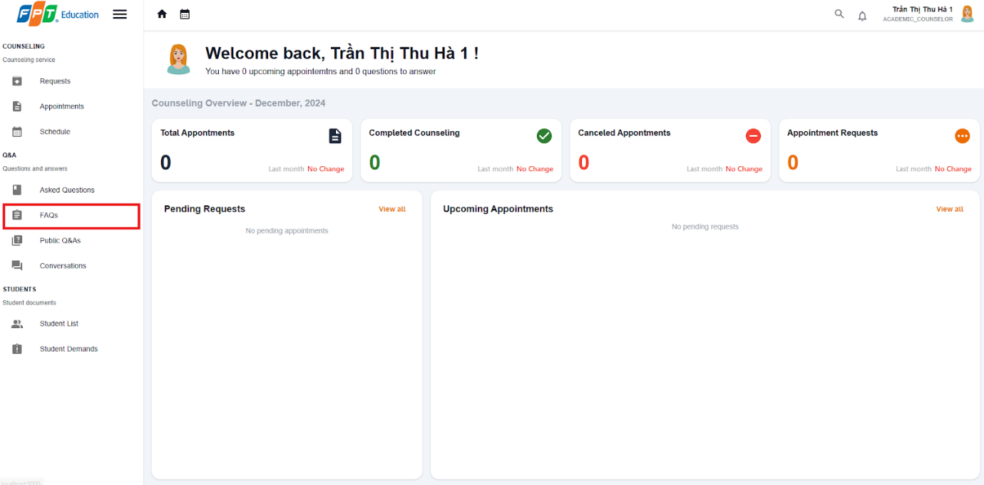

**Step 4:** Select  “Contribute to FAQ“ button in FAQ page 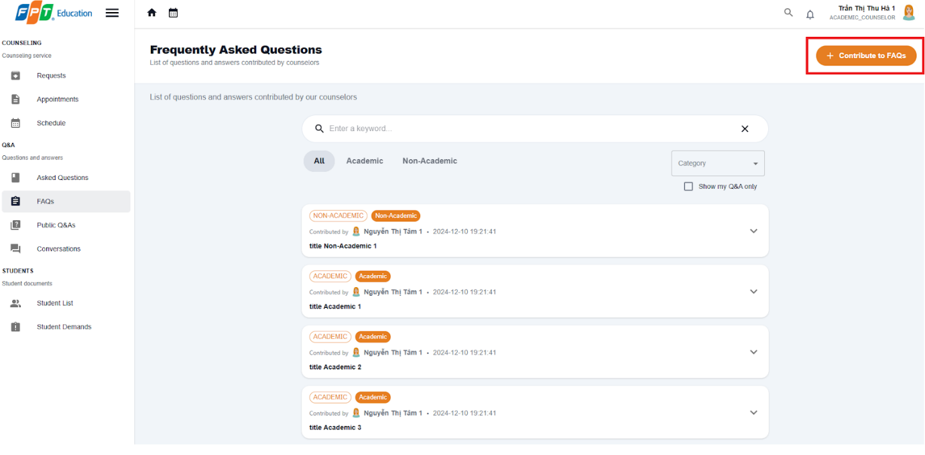

**Step 5:** Enter category, title, question content, answer. Then select “Submit“  button

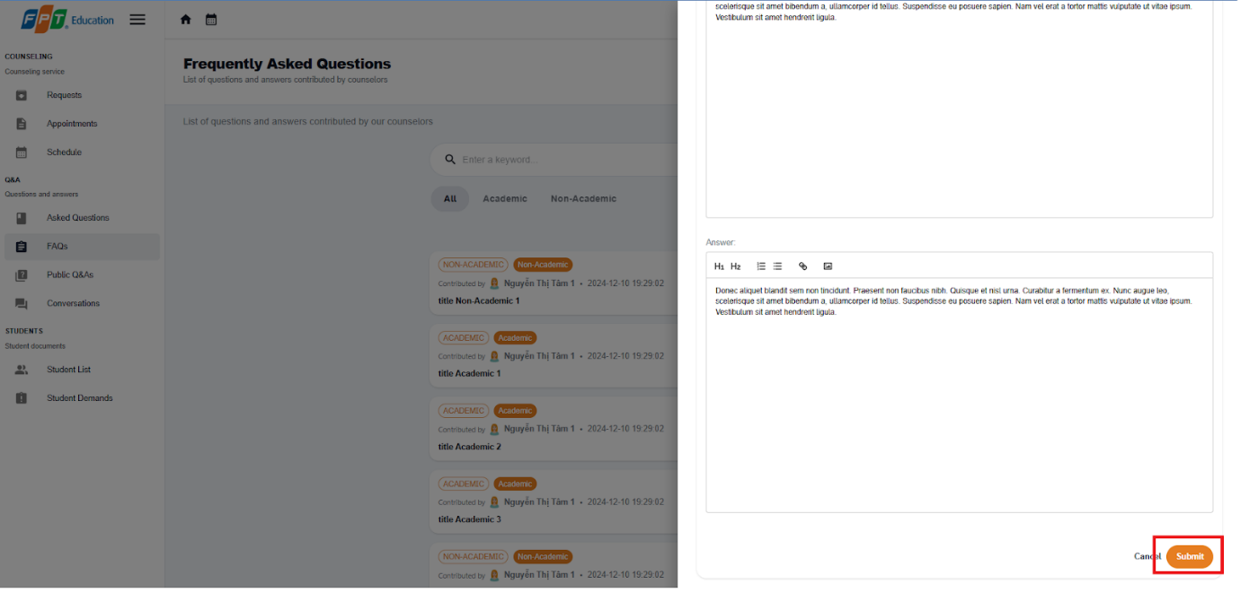

**Step 6:** In the FAQ page, you can select the  “Show my Q&A only“ button to view your created Q&A.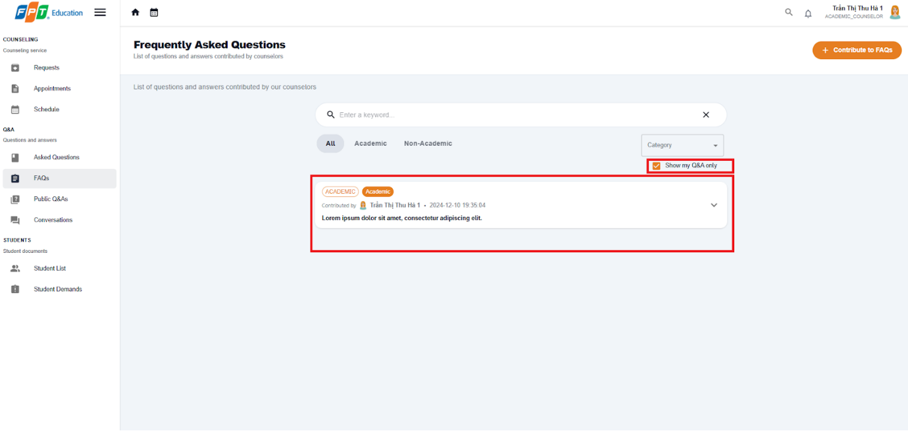

##### 3.2.3.8. Edit contributed FAQ

3.2.3.3.8 Description

Use this guideline to create a question for counselor

3.2.3.3.8. Guide Steps:

**Step 1**: Access SCSS at http://scss-fe.azurewebsites.net/. Then fill in “Email” and “Password” of the counselor account.



**Step 2:** Click the “Sign in ” button.



**Step 3:** From the homepage, choose “FAQ” from the left sidebar.



**Step 4:** Select  “Edit“ button in FAQ page 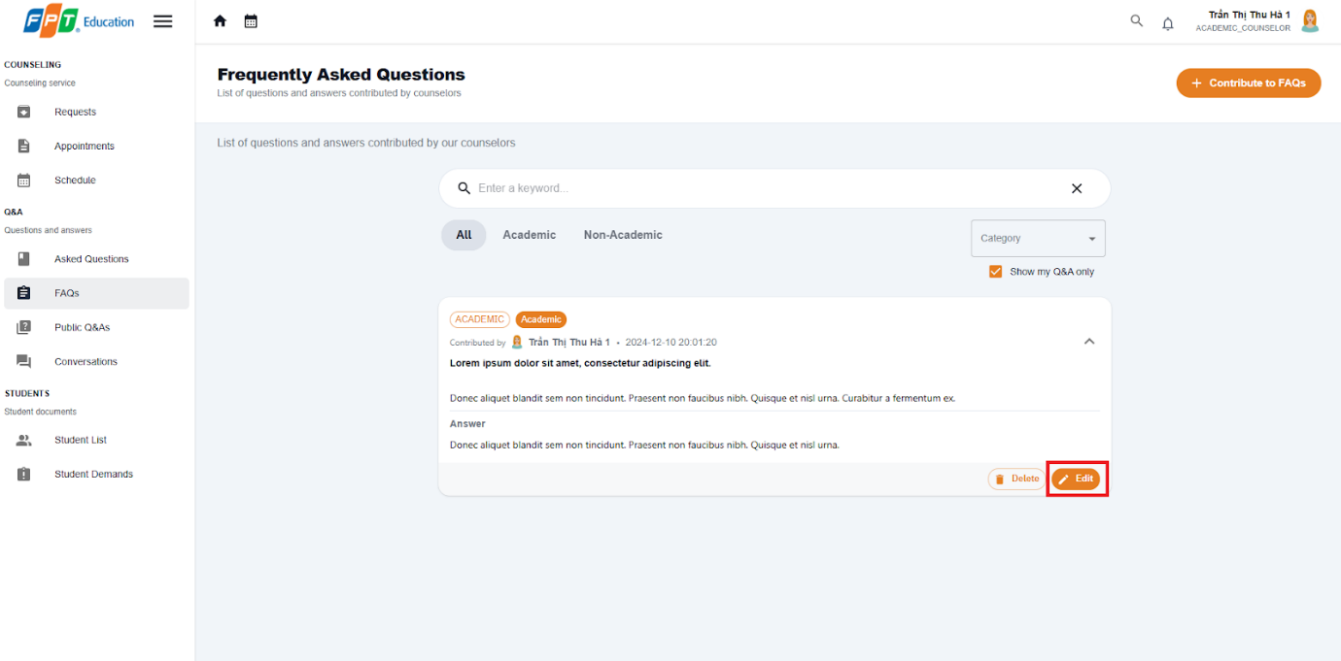

**Step 5:** Enter new category, title, question content, answer. Then select “Submit“  button



**Step 6:** In the FAQ page, you can select the  “Show my Q&A only“ button to view your Q&A.

#### 3.2.4. Counseling demand

##### 3.3.4.1. Create counseling demand

3.3.3.3.1 Description

Use this guideline to create a counseling for a student

3.3.3.3.2. Guide Steps:

**Step 1**: Access SCSS at http://scss-fe.azurewebsites.net/. Then fill in “Email” and “Password” of the support staff account.



**Step 2:** Click the “Sign in ” button.



**Step 3:** From the homepage, choose “Recommended Students” new problematic students or ”Student List” for all students  from the left sidebar.

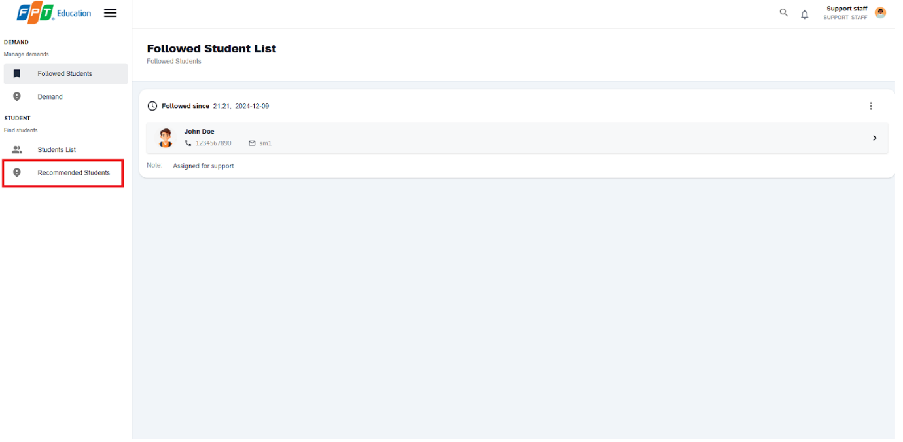

**Step 4:** Select a student, in student detail, select  “Follow Student“ button to the added the student to the Followed List for further actions.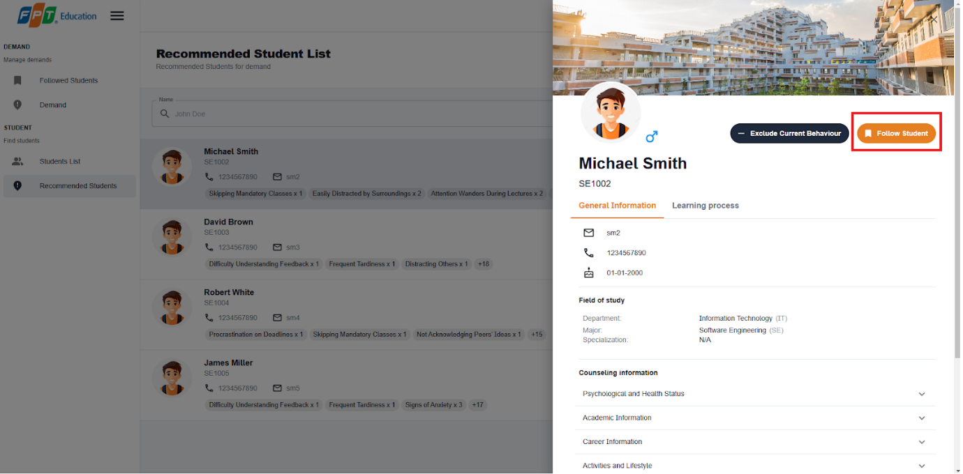

**Step 5:** Choose “Student List” from the left sidebar.

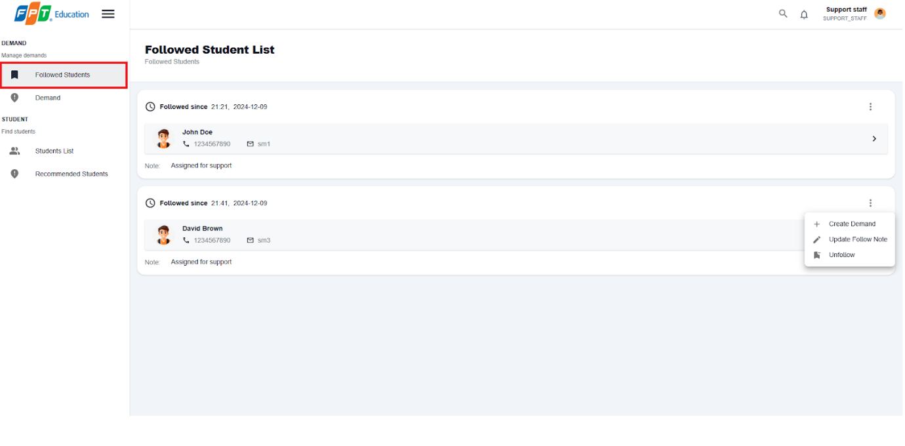

**Step 6:** Select more vert icon button from a student, then select Create Demand option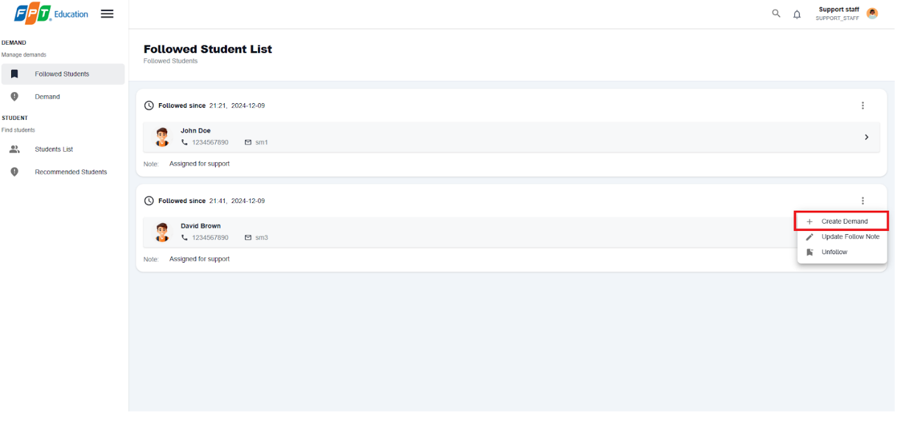

**Step 6:** Select a suitable counselor and fill in counseling demand form

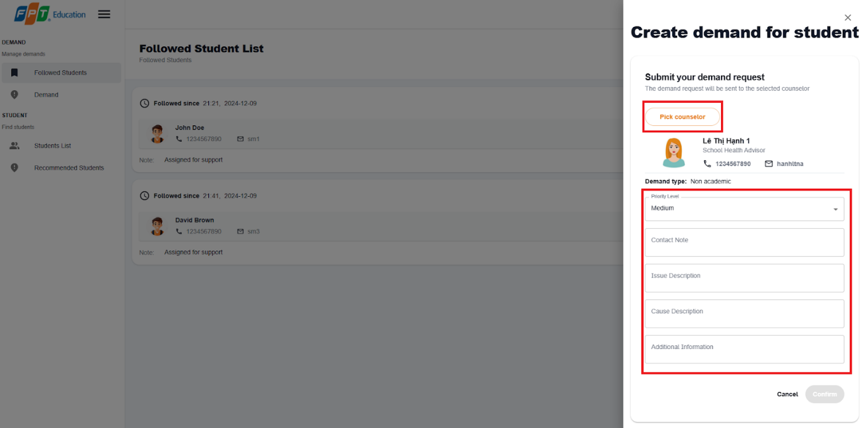

**Step 7:** Select confirm button and new demand will be created

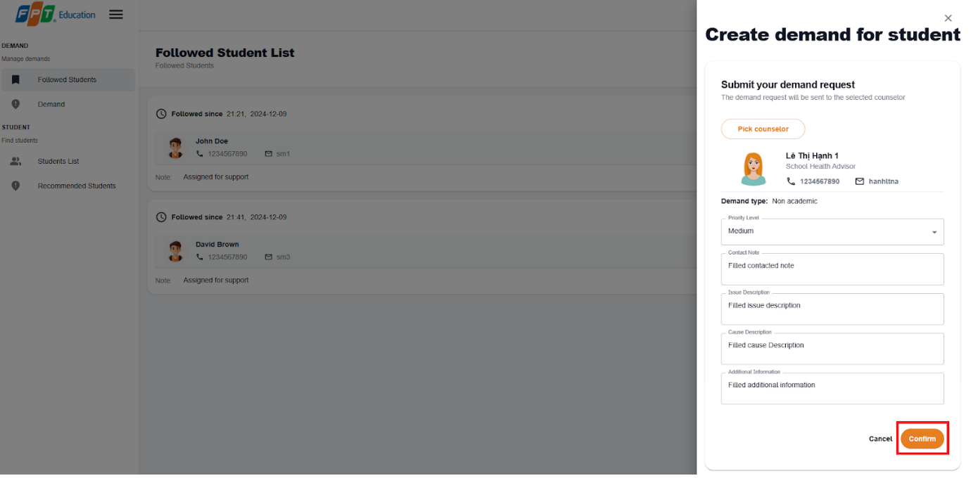

**Step 8:** Choose ” Demand”  from the left sidebar and view your newly created demand

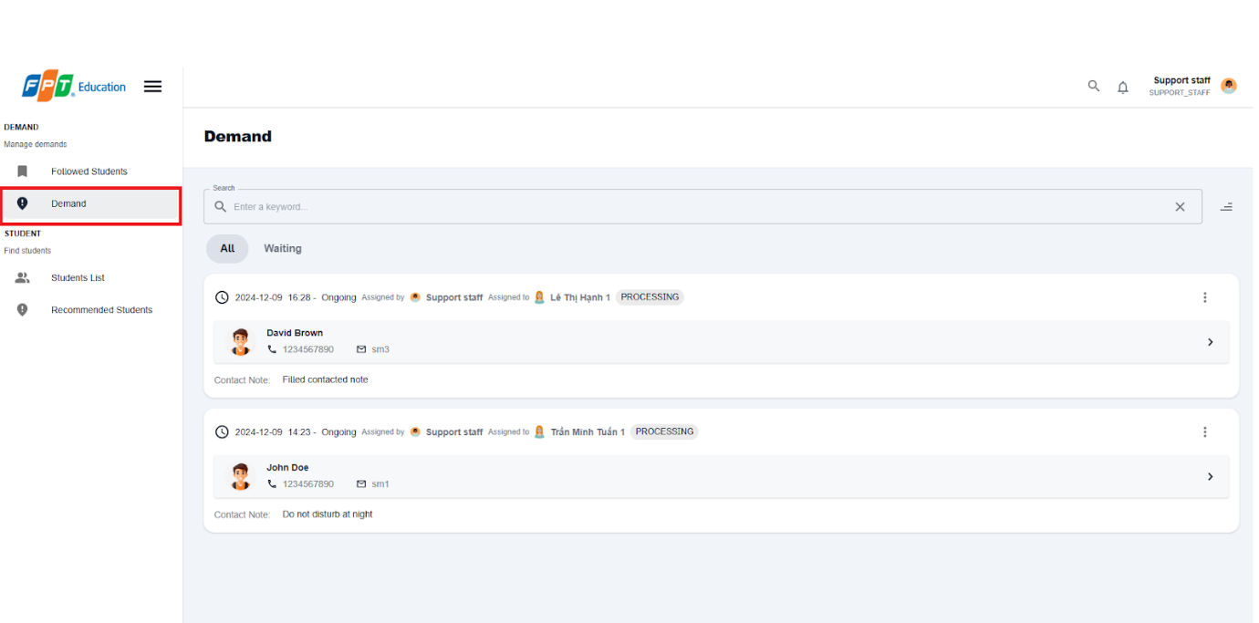

##### 3.3.4.2. Create an appointment from demand

3.3.3.3.1 Description

Use this guideline to create a counseling for a student

3.3.3.3.2. Guide Steps:

**Step 1**: Access SCSS at http://scss-fe.azurewebsites.net/. Then fill in “Email” and “Password” of the counselor account.



**Step 2:** Click the “Sign in ” button.



**Step 3:** From the homepage, choose “Student Demands” from the left sidebar.

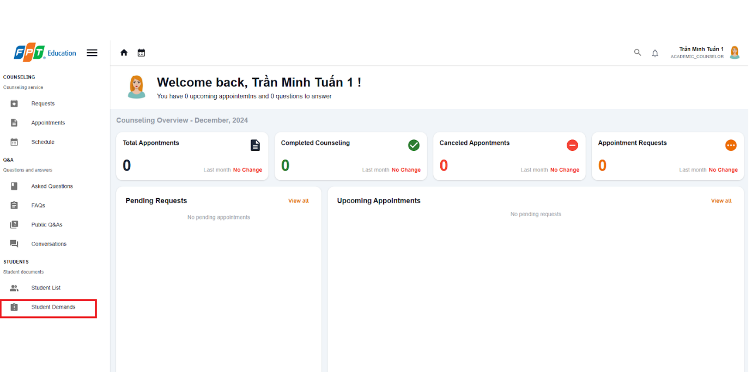

**Step 4:** IN Student Demand page, select more vert icon button form a student, then choose “Create an appointment“ option

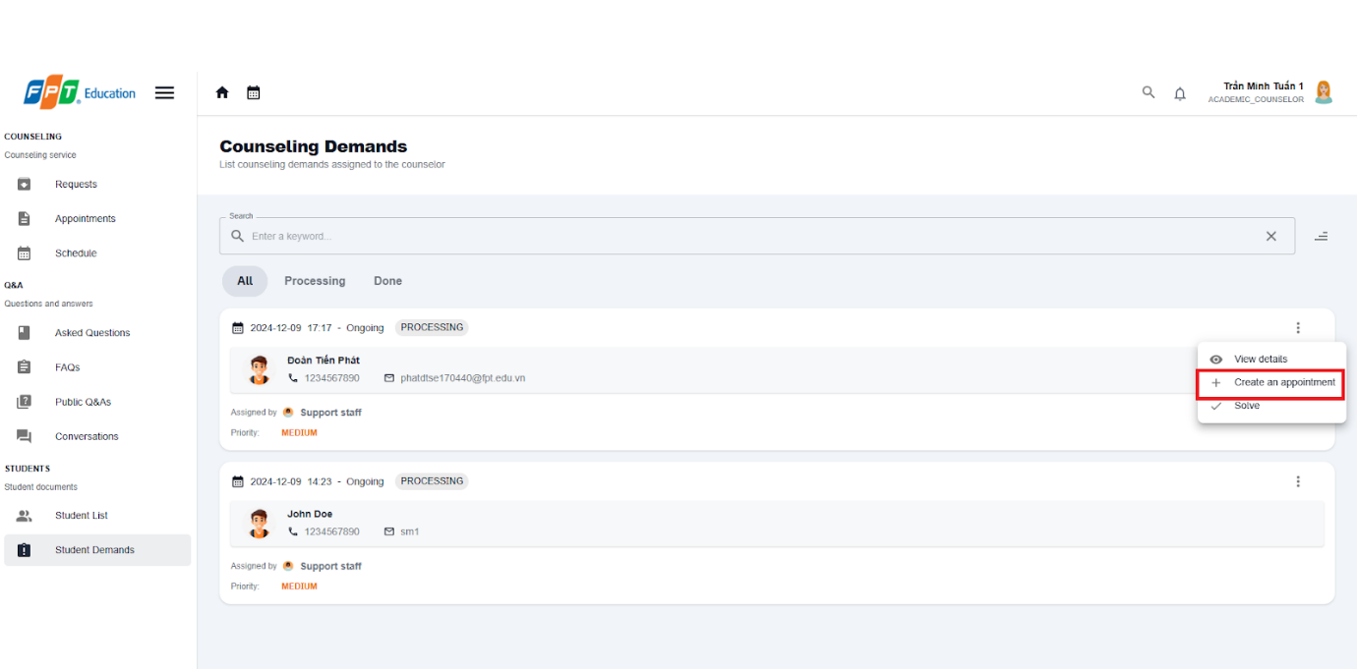

**Step 5:** After filling in counseling fields, then select confirm booking and new appointment with the student will be created.

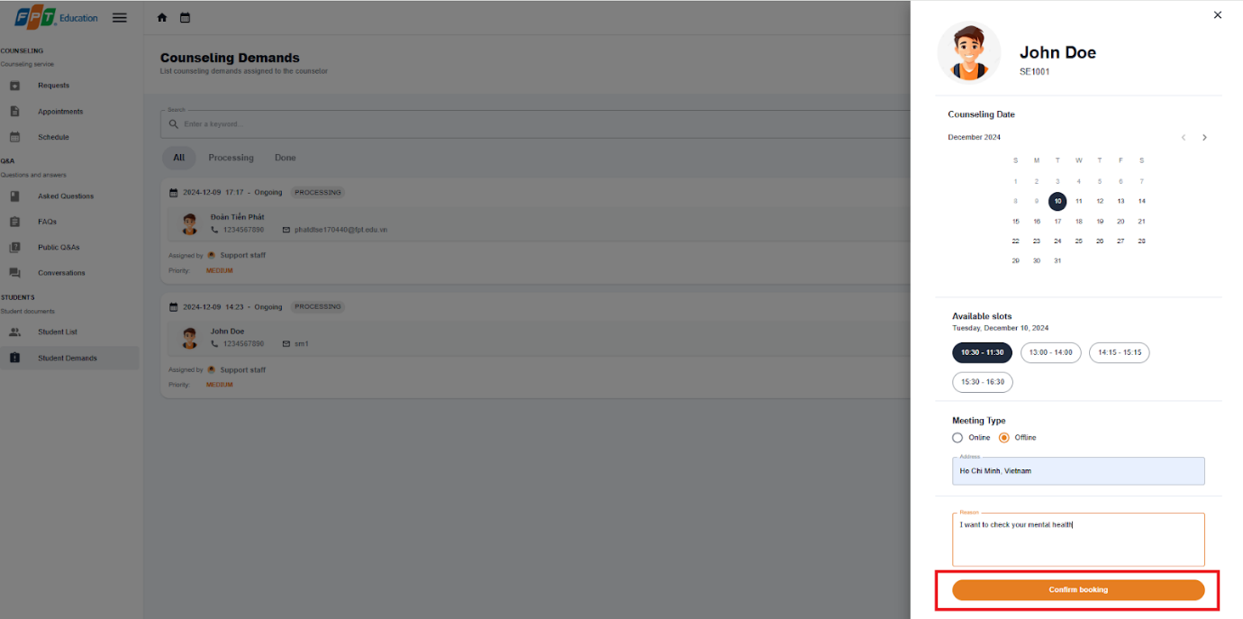

##### 3.3.4.3. Solve a counseling demand

3.3.3.3.1 Description

Use this guideline to create a counseling for a student

3.3.3.3.2. Guide Steps:

**Step 1**: Access SCSS at http://scss-fe.azurewebsites.net/. Then fill in “Email” and “Password” of the counselor account.



**Step 2:** Click the “Sign in ” button.



**Step 3:** From the homepage, choose “Student Demands” from the left sidebar.



**Step 4:** In Student Demand page, select more vert icon button form a student, then choose “Solve“ option

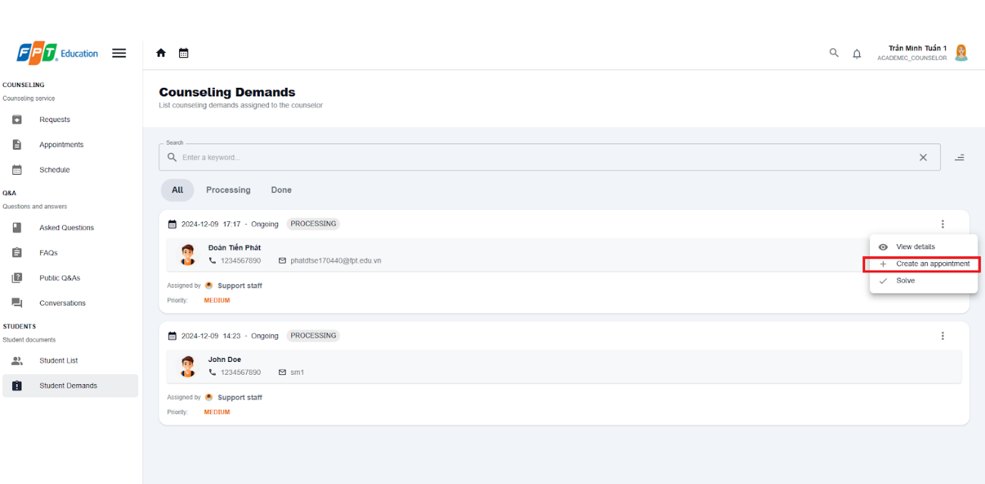

**Step 5:** After filling in the summary field, then select confirm button to solve the demand.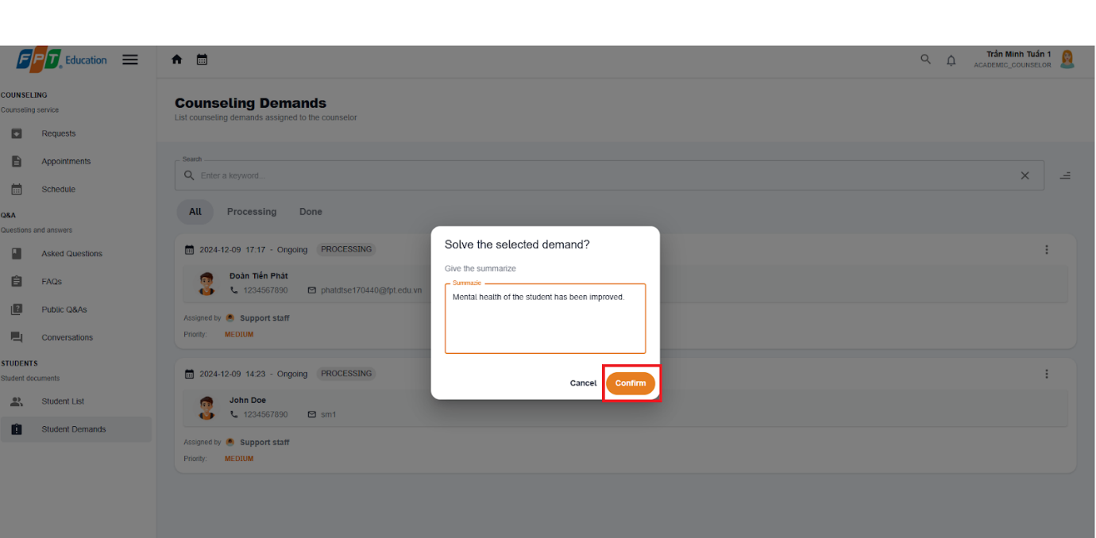

**Step 6:** Solved demand will be marked with DONE status

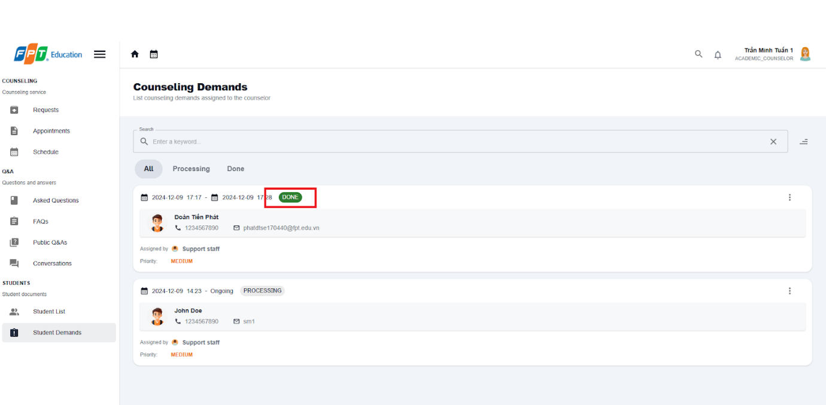

#### 3.2.5. Counselor Management

##### 3.3.5.1. Update counselor availability

3.3.5.1.1 Description

Use this guideline to update counselor availability

3.3.5.1.2 . Guide Steps:

**Step 1**: Access SCSS at http://scss-fe.azurewebsites.net/. Then fill in “Email” and “Password” of the manager account.



**Step 2:** Click the “Sign in ” button.



**Step 3:** From the homepage, choose “Counselors Table” from the left sidebar.

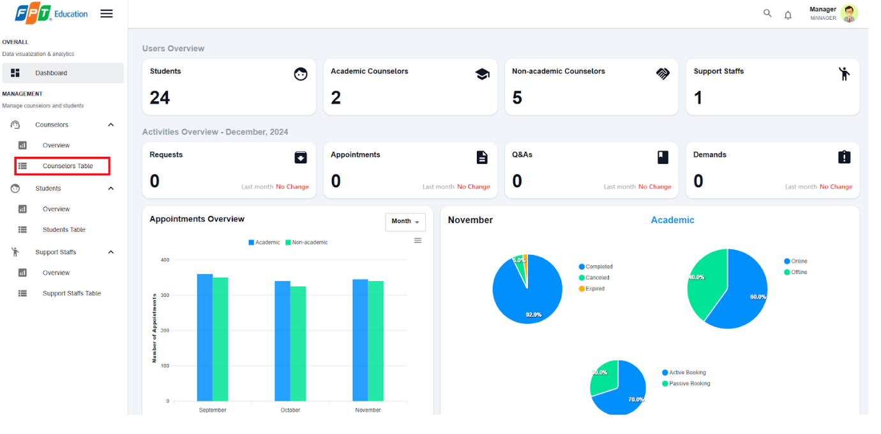

**Step 4:** In Counselor Table page, select a counselor at Full name field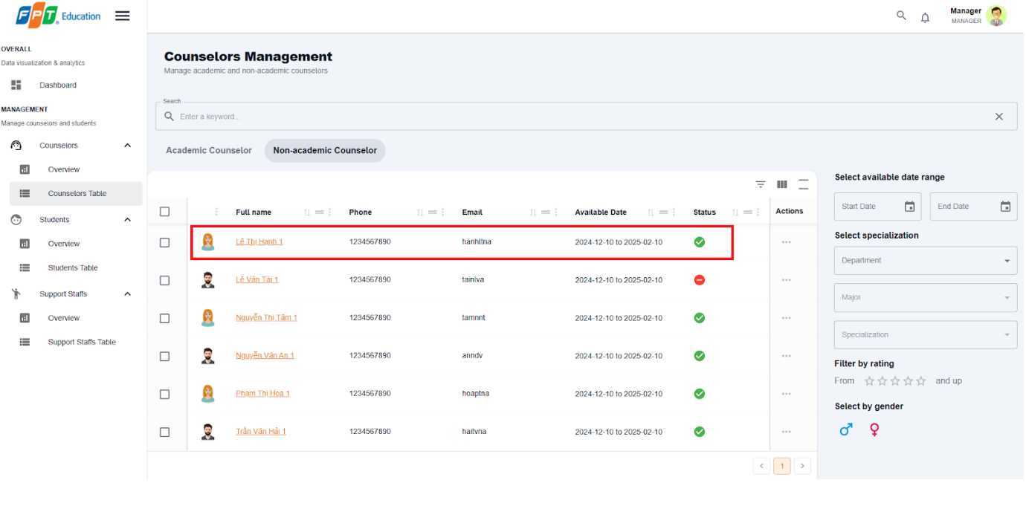

**Step 5:** In Counselor detail management page, select between  “Availability ” and “Unavailability ”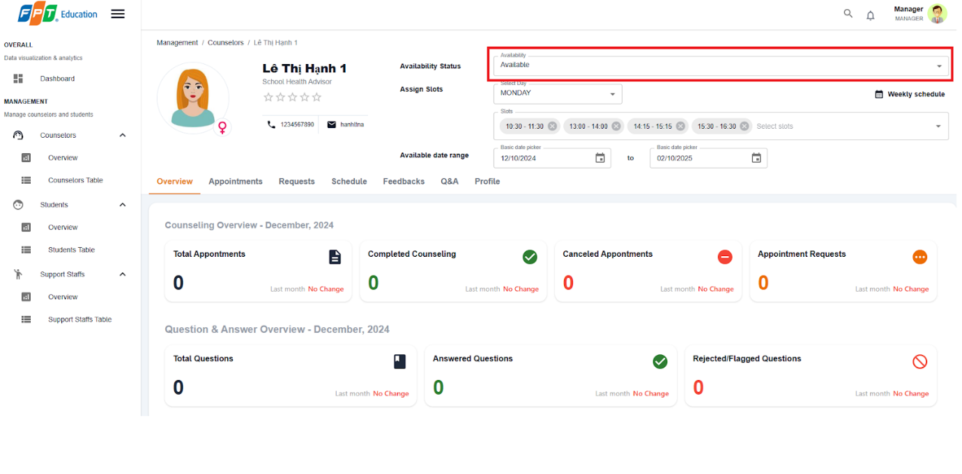

##### 3.3.5.2. Update counselor weekly schedule

3.3.5.2.1 Description

Use this guideline to update counselor availability

3.3.5.2.2 . Guide Steps:

**Step 1**: Access SCSS at http://scss-fe.azurewebsites.net/. Then fill in “Email” and “Password” of the manager account.



**Step 2:** Click the “Sign in ” button.



**Step 3:** From the homepage, choose “Counselors Table” from the left sidebar.



**Step 4:** In Counselor Table page, select a counselor at Full name field

**Step 5:** In Counselor detail management page, select from “Select Days” and select slots from “Select slots”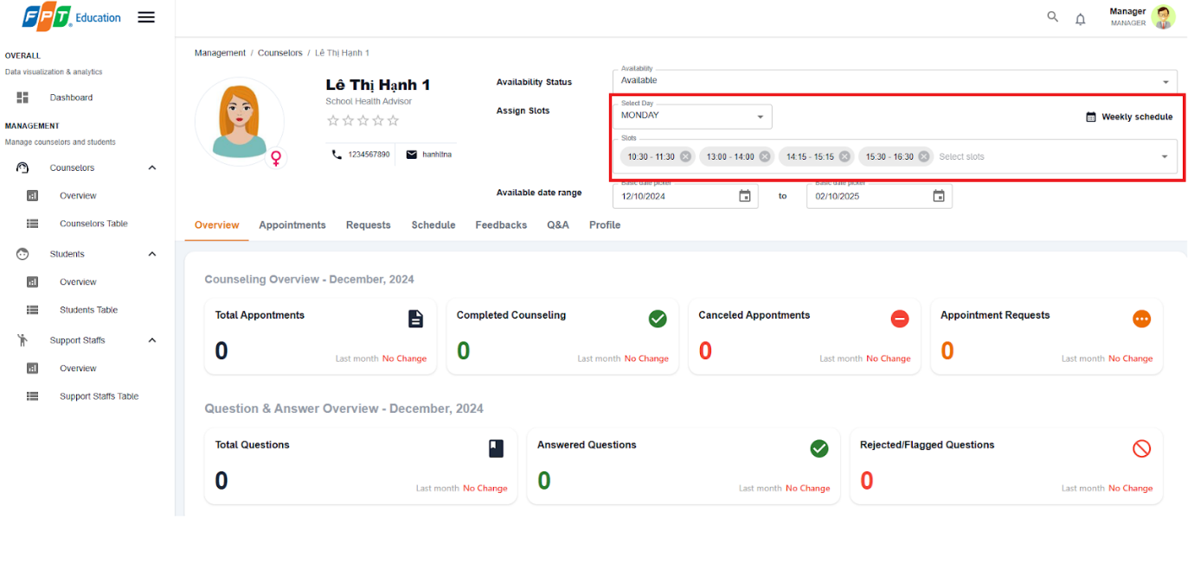

**Step 6:** In Counselor detail management page, select “Weekly Schedule” to view full schedule of the counselor for a week.

##### 3.3.5.3. Update counselor date range

3.3.5.1.1 Description

Use this guideline to update counselor availability

3.3.5.1.2 . Guide Steps:

**Step 1**: Access SCSS at http://scss-fe.azurewebsites.net/. Then fill in “Email” and “Password” of the manager account.



**Step 2:** Click the “Sign in ” button.



**Step 3:** From the homepage, choose “Counselors Table” from the left sidebar.



**Step 4:** In Counselor Table page, select a counselor at Full name field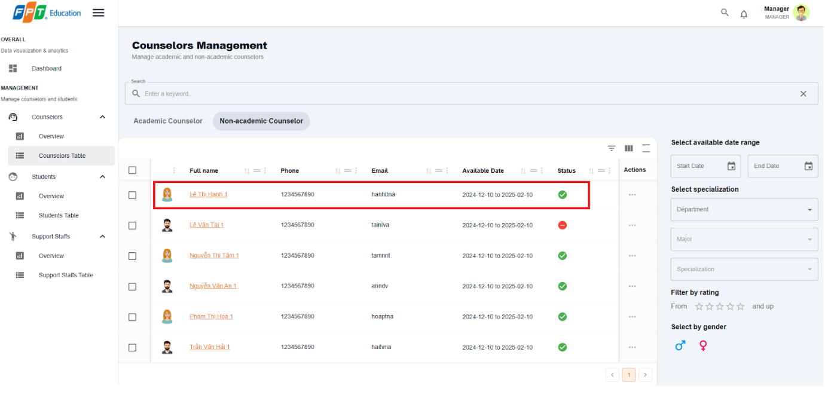

**Step 5:** In Counselor detail management page, pick “Start date” and “End date”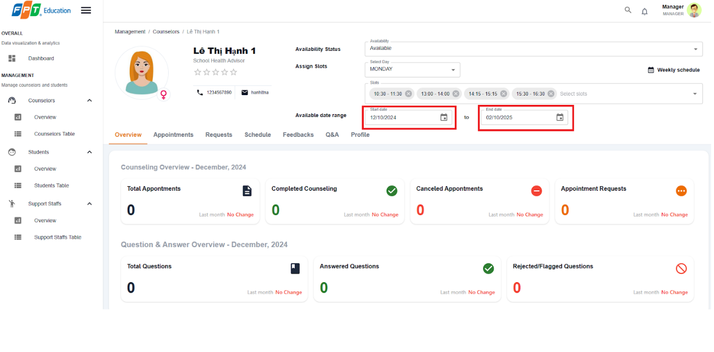

#### 3.2.6. Account Management

##### 3.3.6.1. Create non-academic/academic counselor  account

3.3.6.1.1. Description

Use this guide so administrators can create non-academic or academic counselor account.

3.3.6.1.2. Guide Steps

**Step 1**: Access SCSS at http://scss-fe.azurewebsites.net/. Then fill in “Email” and “Password” of the administrator account.

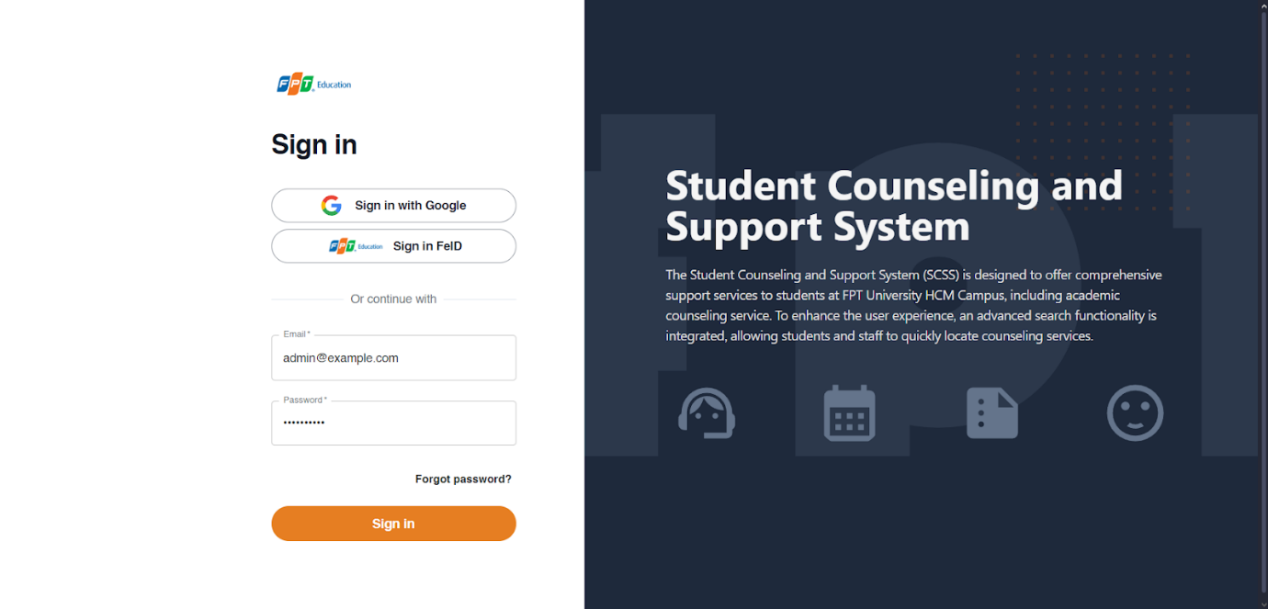

**Step 2:** Click the “Sign in ” button.

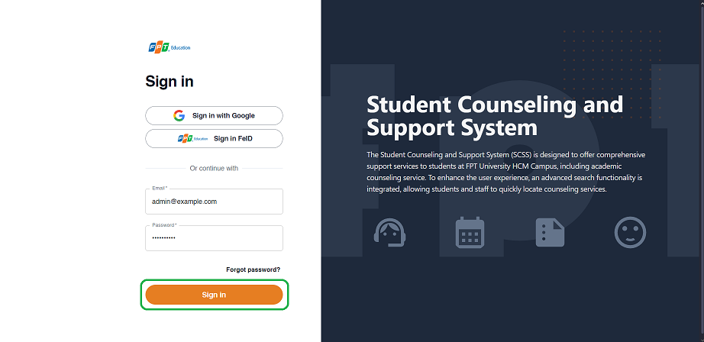

**Step 3:** From the homepage, choose “Create Account” from the left sidebar.

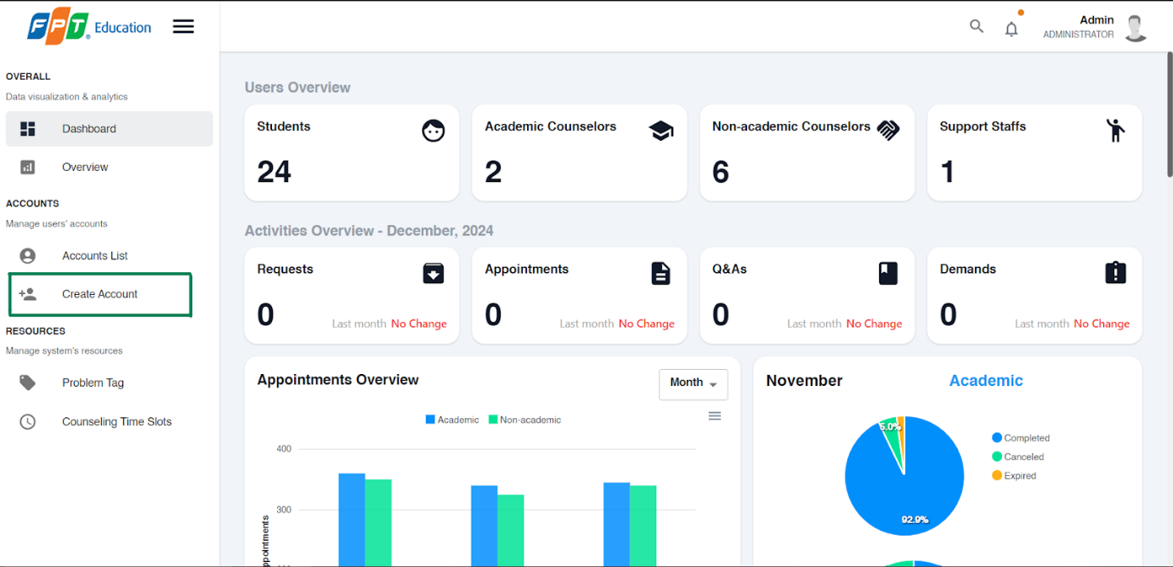

**Step 4:** Select “Academic Counselor” or “Non-academic Counselor” tab accordingly.

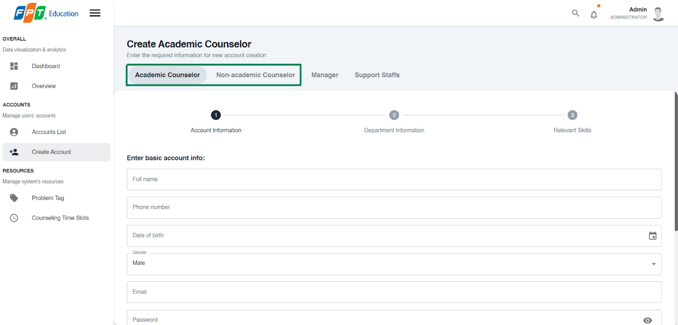

**Step 5:** Fill out “Full name”, “Phone number”, “Email”, “Gender”, “Date of birth”, “Email”, “Password”, and “Avatar” field and press the “Next” button at the bottom of the form when all the fields shown have been filled.

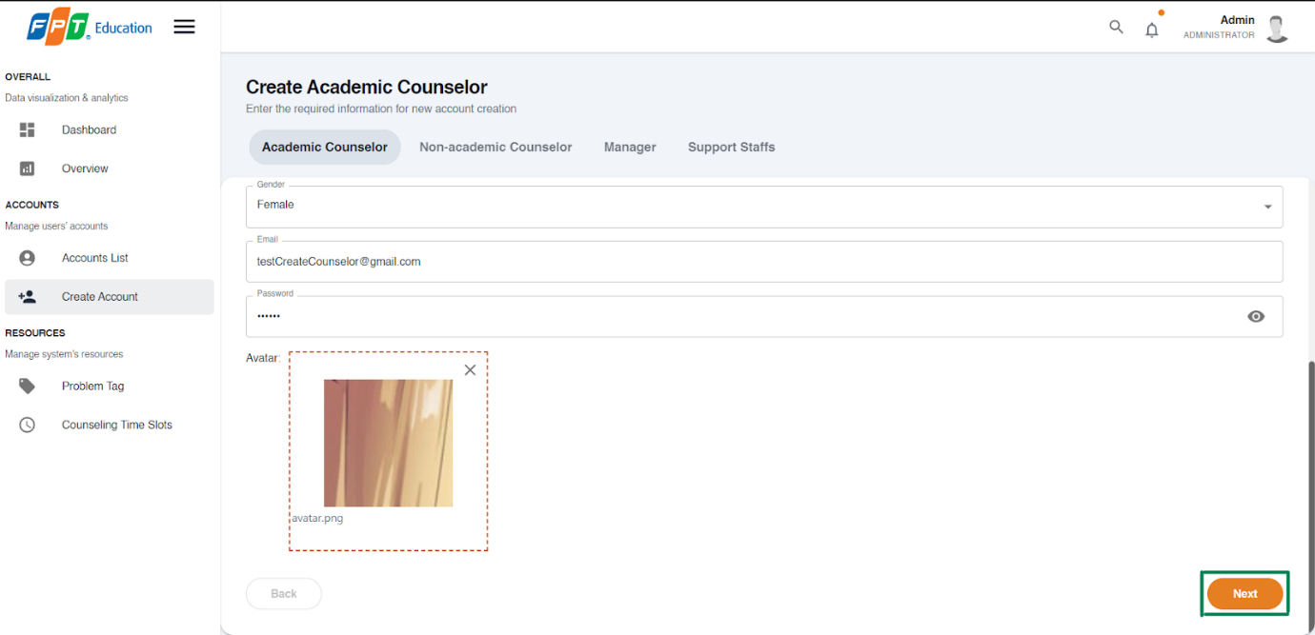

**Step 6.1:** Fill out “Department”, and “Major” field if creating an academic counselor account and press the “Next” button at the bottom of the form when all the fields shown have been filled.

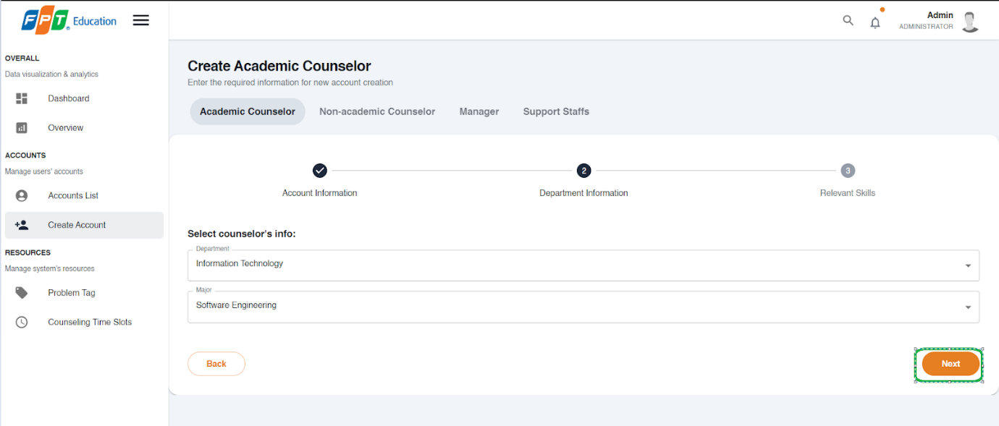

**Step 6.2:** Fill out the “Expertise” field if creating a non-academic counselor account and press the “Next” button at the bottom of the form when all the fields shown have been filled.

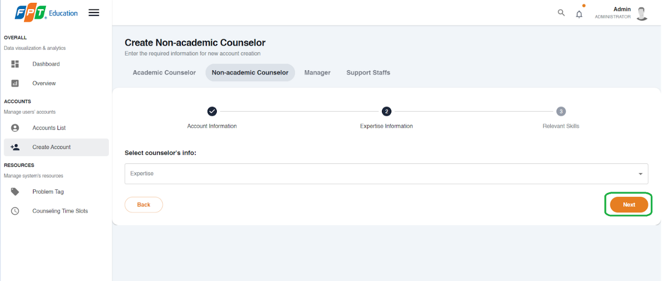

**Step 7:** Fill out the “Specialized skill”, “Other skills”, “Achievements”, and “Work History” fields.

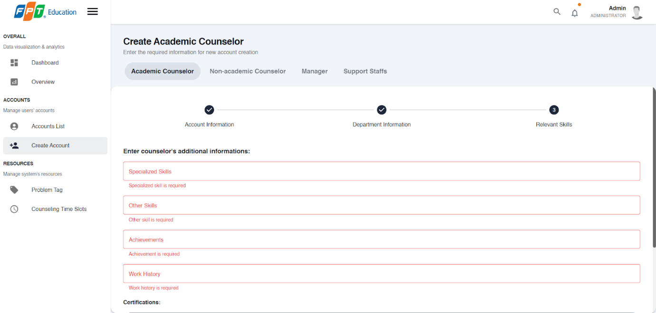

**Step 8:** Add “certification” by pressing the “Add certification” button and fill out “Certification’s name”, “Certification’s organization” and “Certification’s Image”, then press the “Add” button.

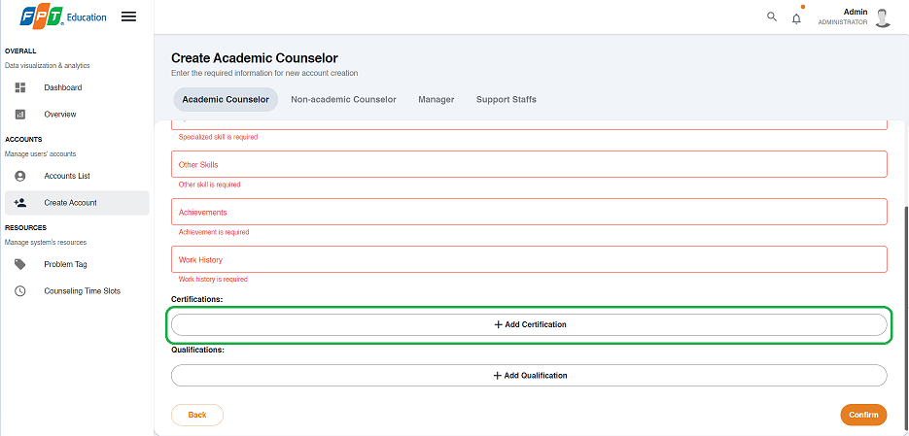

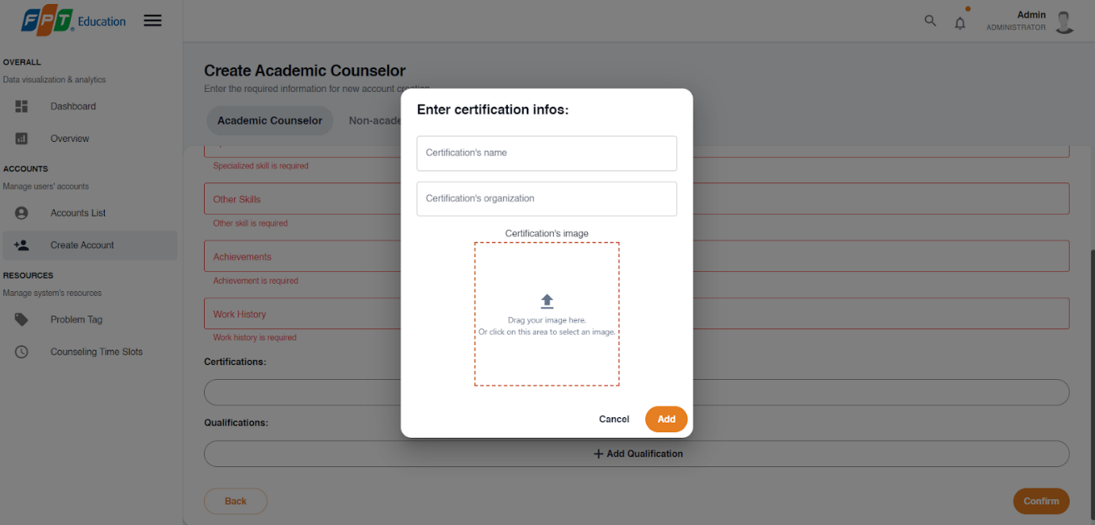

**Step 9:** Add “qualification” by pressing the “Add qualification” button and fill out “Degree”, “Institution”, “Field of study”, “Year of graduation”, and “Qualification’s image” then press the “Add” button.

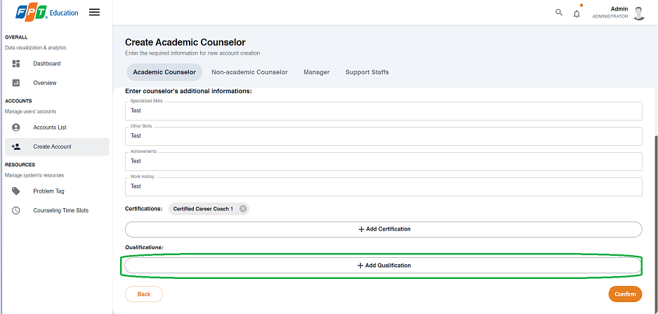

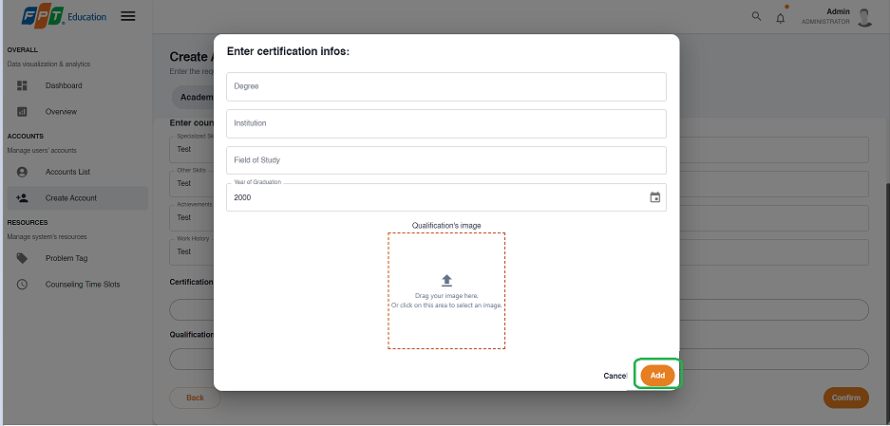

**Step 10:** Press the “Confirm” button after all the required fields have been filled out.

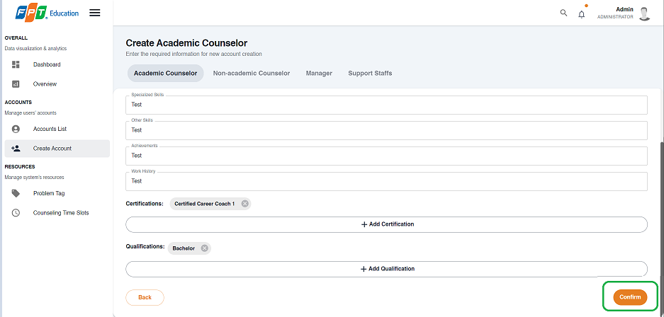

**Step 11:** Press the “OK” button after a success dialog is shown to complete creating a counselor.

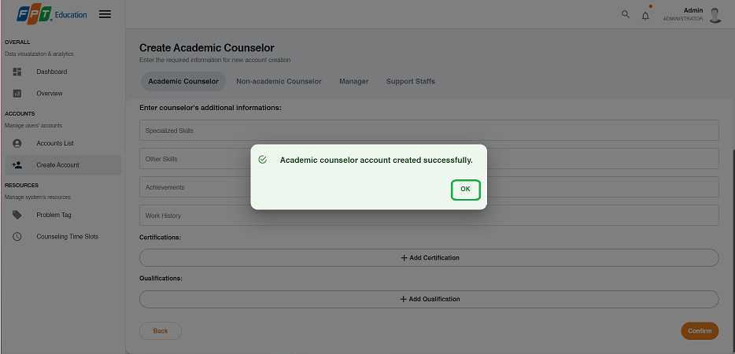

##### 3.3.6.2. Create manager/support staff account

3.3.6.2.1. Description

Use this guide so administrators can create manager or support staff accounts.

3.3.6.2.2. Guide Steps

**Step 1**: Access SCSS at http://scss-fe.azurewebsites.net/. Then fill in “Email” and “Password” of the administrator account.



**Step 2:** Click the “Sign in ” button.



**Step 3:** From the homepage, choose “Create Account” from the left sidebar.



**Step 4:** Select “Manager” or “Support staff” tab accordingly.

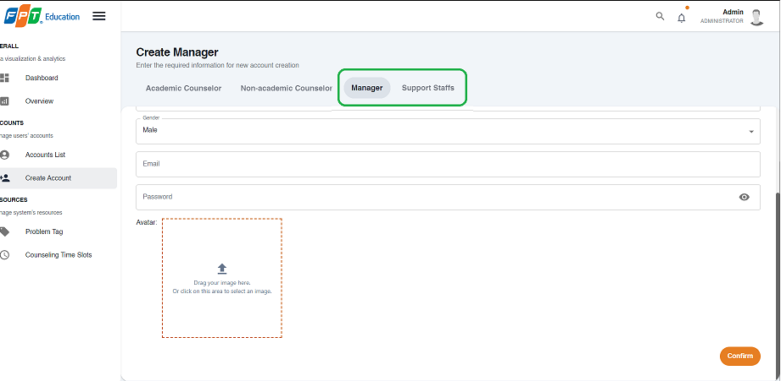

**Step 5:** Fill out “Full name”, “Phone number”, “Email”, “Gender”, “Date of birth”, “Email”, “Password”, and “Avatar” field and press the “Next” button at the bottom of the form when all the fields shown have been filled.

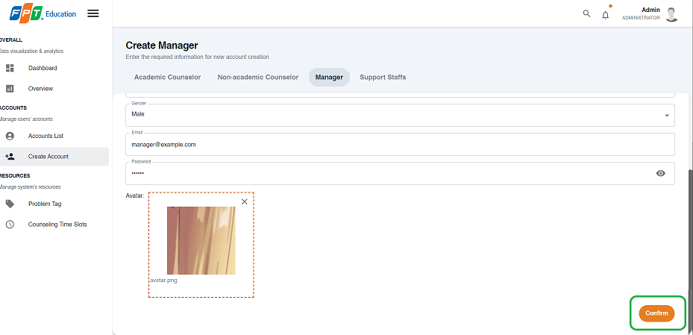

**Step 6:** Press the “OK” button after a success dialog is shown to complete creating an account.

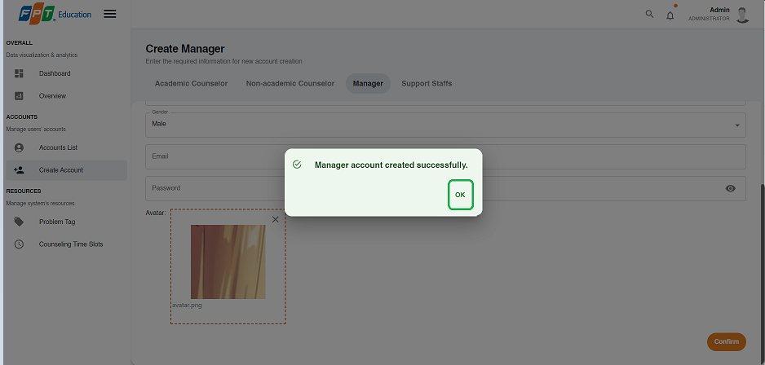

#### 3.2.7. Resource Management

##### 3.3.7.1. Create problem tag

3.3.1.1.1. Description

Use this guideline to create a problem tag using an administrator account.

3.3.1.1.2. Guide Steps

**Step 1**: Access SCSS at http://scss-fe.azurewebsites.net/. Then fill in “Email” and “Password” of the administrator account.



**Step 2:** Click the “Sign in ” button.



**Step 3:** From the homepage, choose “Problem Tag” from the left sidebar.

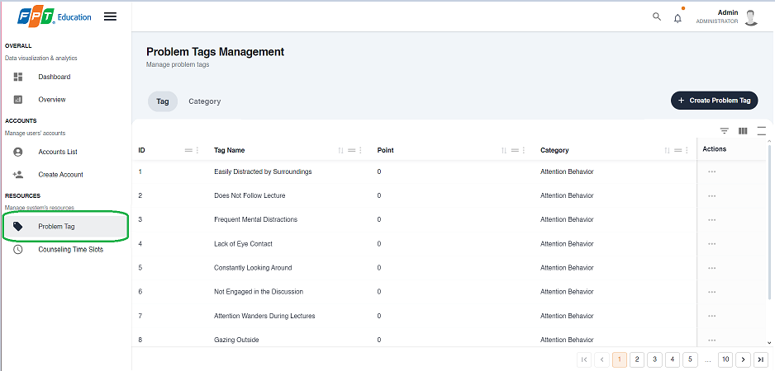

**Step 4:** Select “Tag” tab.

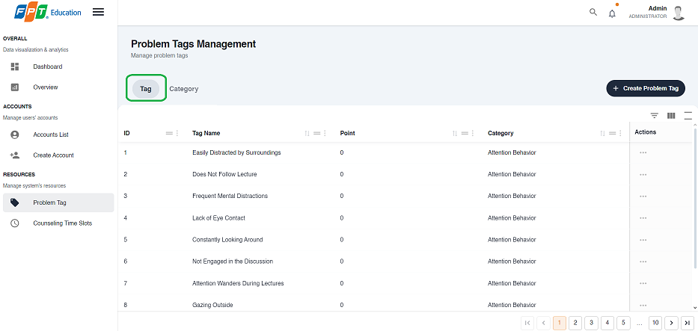

**Step 5:** Press the “Create Problem Tag” button.

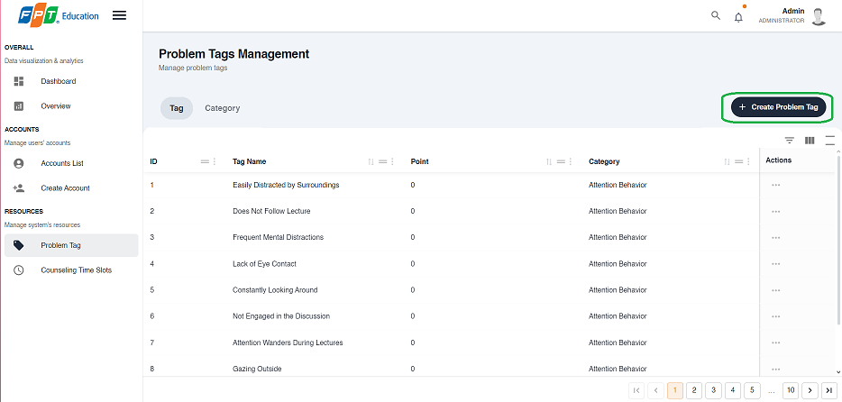

**Step 6:** Fill out the “Problem tag name”, “Point”, and select a “Category”, then press the “Confirm” button.

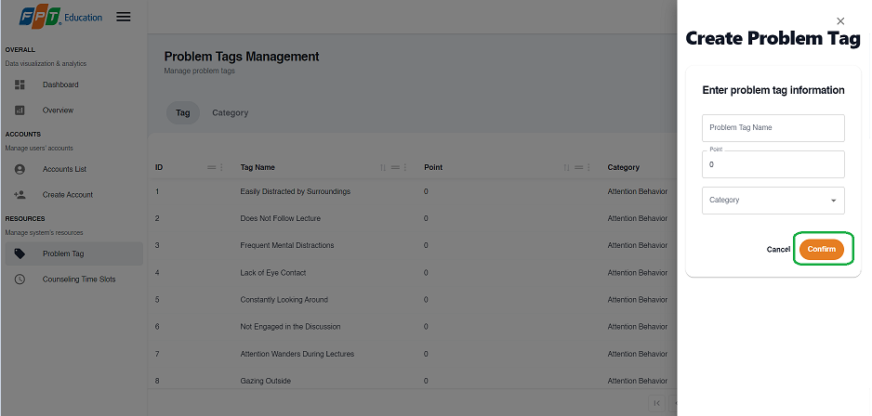

**Step 7:** Press the “OK” button after a success dialog is shown to complete creating a problem tag.

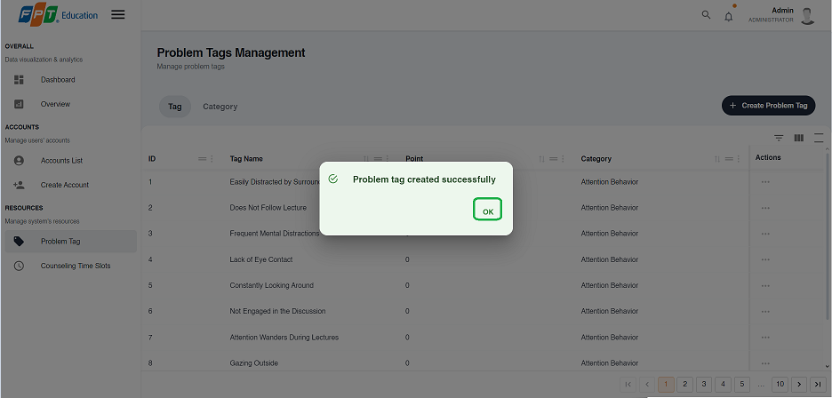

##### 3.3.7.2. Create problem tag’s category

3.3.1.2.1. Description

Use this guideline to create a problem tag’s category using an administrator account.

3.3.1.2.2. Guide Steps

**Step 1**: Access SCSS at http://scss-fe.azurewebsites.net/. Then fill in “Email” and “Password” of the administrator account.



**Step 2:** Click the “Sign in ” button.



**Step 3:** From the homepage, choose “Problem Tag” from the left sidebar.



**Step 4:** Select “Category” tab.

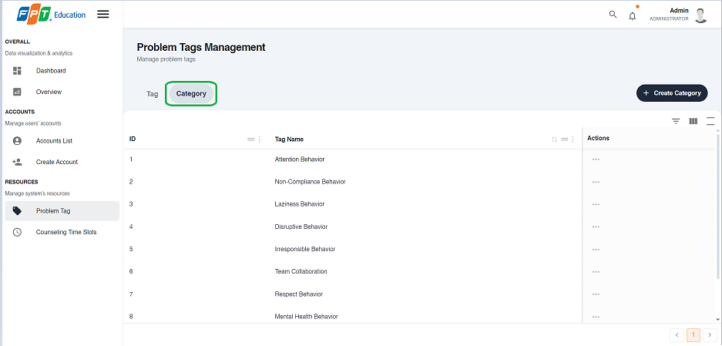

**Step 5:** Press the “Create Category” button.

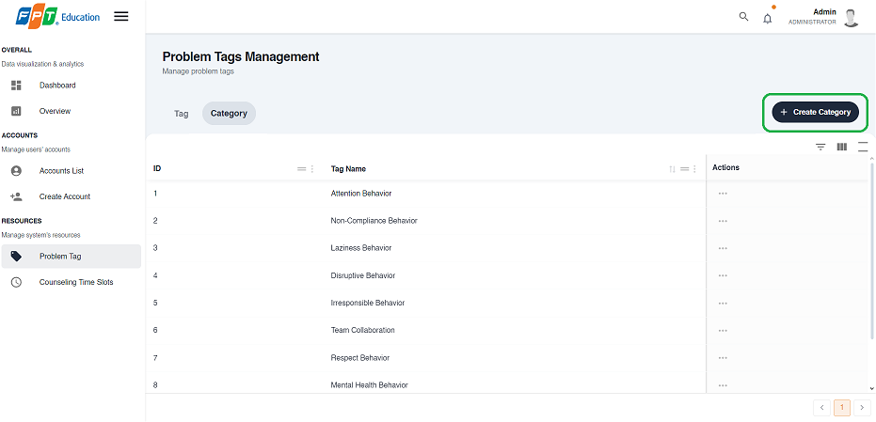

**Step 6:** Fill out the “Category name” field, then press the “Confirm” button.

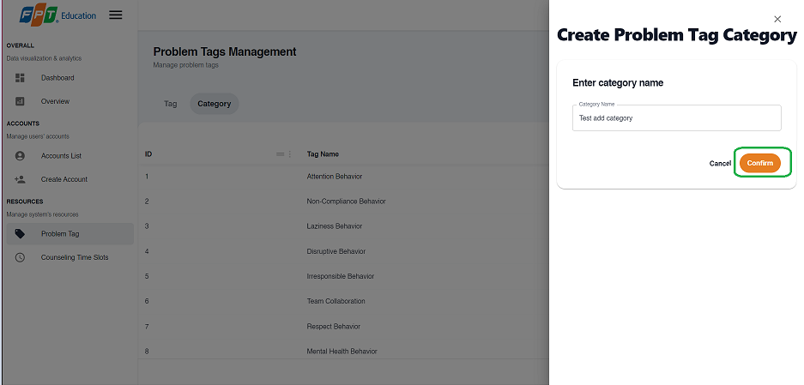

**Step 7:** Press the “OK” button after a success dialog is shown to complete creating a problem tag’s category

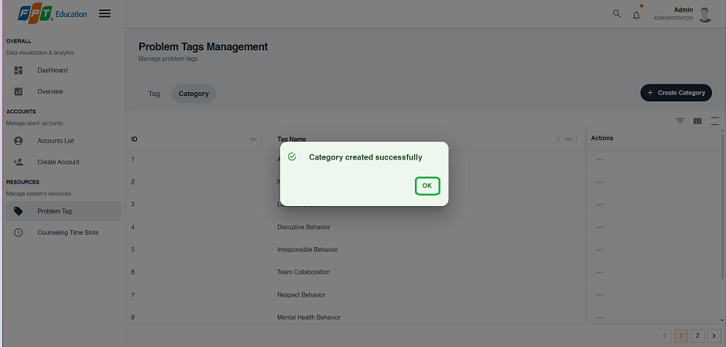.

##### 3.3.7.3. Create counseling time slot

3.3.1.3.1. Description

Use this guideline to create a counseling time slot using an administrator account.

3.3.1.3.2. Guide Steps

**Step 1**: Access SCSS at http://scss-fe.azurewebsites.net/. Then fill in “Email” and “Password” of the administrator account.



**Step 2:** Click the “Sign in ” button.



**Step 3:** From the homepage, choose “Counseling Time Slots” from the left sidebar.

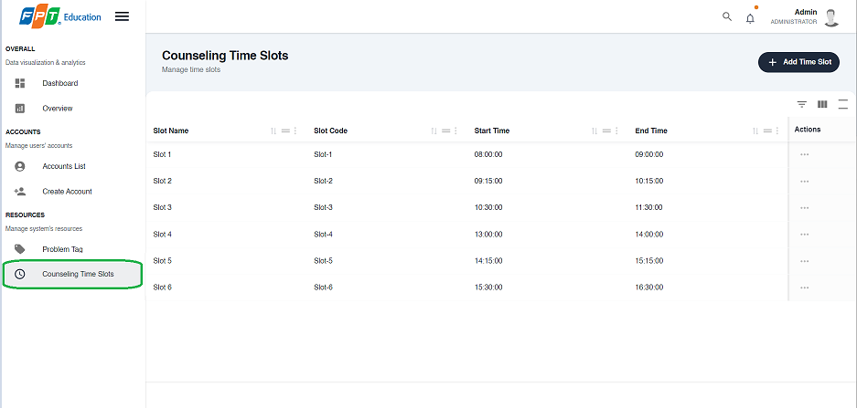

**Step 4:** Press the “Add Time Slot” button.

.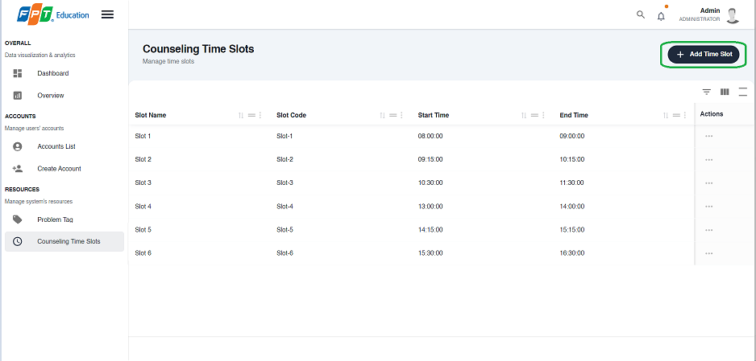

**Step 5:** Fill out the “Slot name”, “Slot code”, “Start time”, and “End time” fields, then press the “Confirm” button.

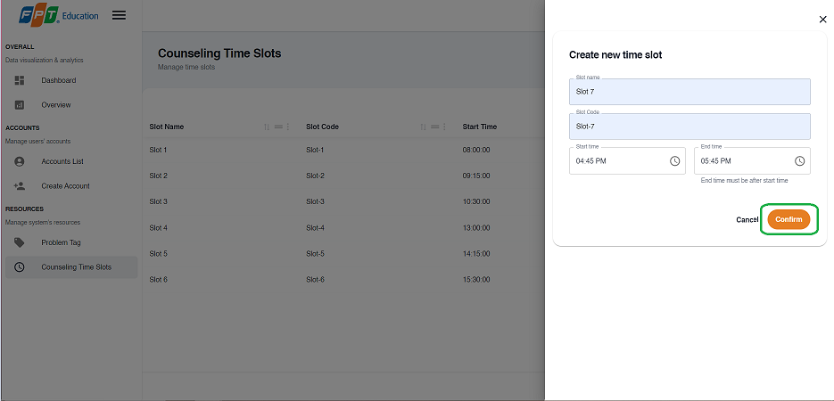

**Step 6:** Press the “OK” button after a success dialog is shown to complete creating a counseling time slot.

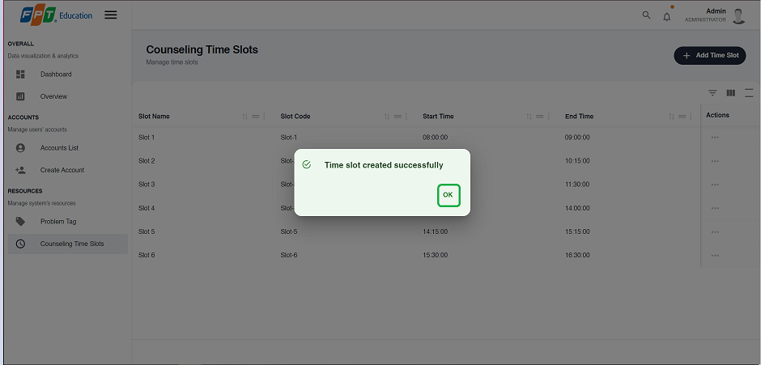

##### 3.3.7.4. Remove problem tag’s category

3.3.1.4.1. Description

Use this guideline to remove a problem tag’s category using an administrator account.

3.3.1.4.2. Guide Steps

**Step 1**: Access SCSS at http://scss-fe.azurewebsites.net/. Then fill in “Email” and “Password” of the administrator account.



**Step 2:** Click the “Sign in ” button.



**Step 3:** From the homepage, choose “Problem Tag” from the left sidebar.



**Step 4:** Select “Category” tab.



**Step 5:** Press the “...” button under the actions column, in the row of the selected category.

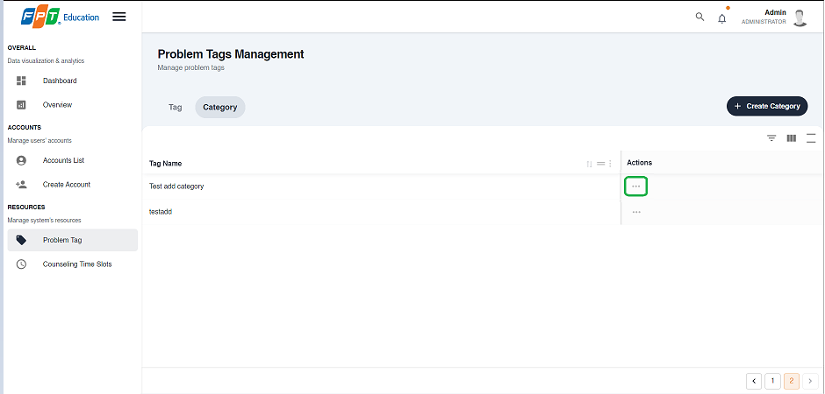

**Step 6:** Press the “Delete” button.

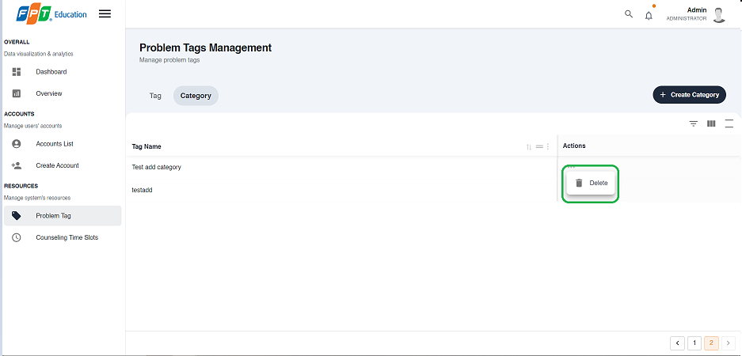

**Step 7:** Press the “Confirm” button.

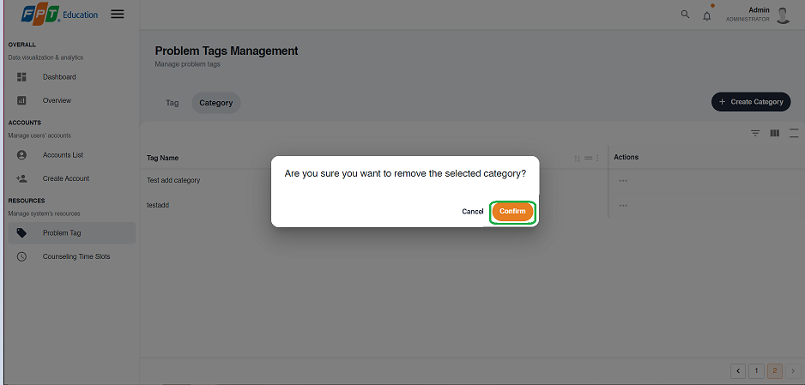

**Step 8:** Press the “Ok” button to complete removing a category.

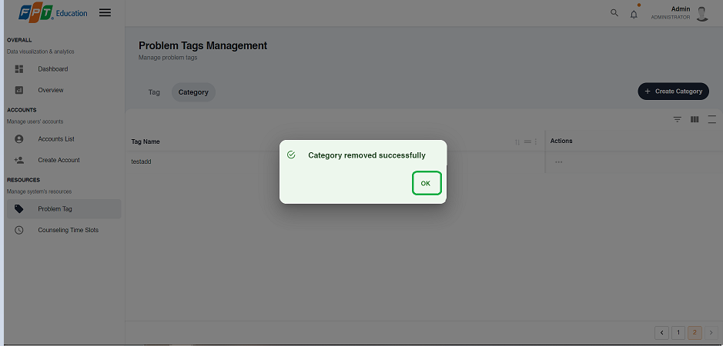

##### 3.3.7.5. Remove problem tag

3.3.1.5.1. Description

Use this guideline to remove a problem tag’s category using an administrator account.

3.3.1.5.2. Guide Steps

**Step 1**: Access SCSS at http://scss-fe.azurewebsites.net/. Then fill in “Email” and “Password” of the administrator account.



**Step 2:** Click the “Sign in ” button.



**Step 3:** From the homepage, choose “Problem Tag” from the left sidebar.



**Step 4:** Select “Tag” tab.



**Step 5:** Press the “...” button under the actions column, in the row of the selected problem tag.

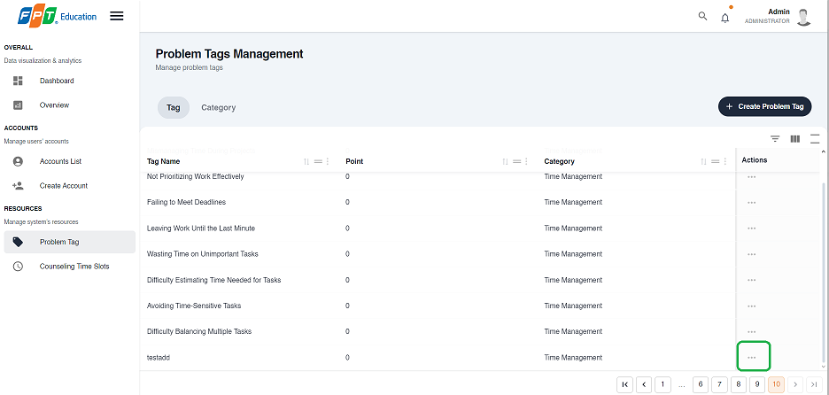**Step 6:** Press the “Delete” button.

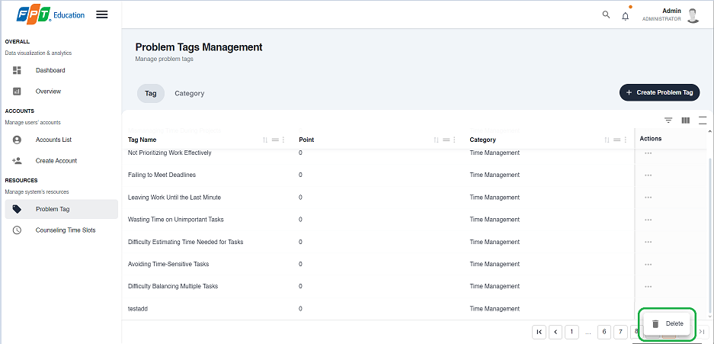

**Step 7:** Press the “Confirm” button.

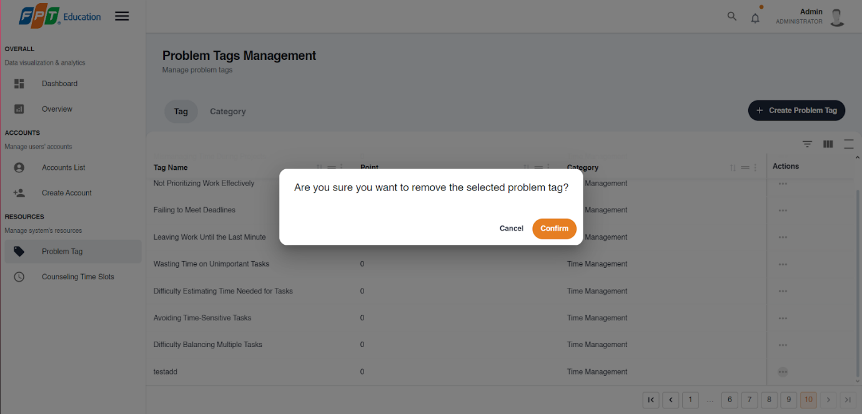

**Step 8:** Press the “Ok” button to complete removing a problem tag.

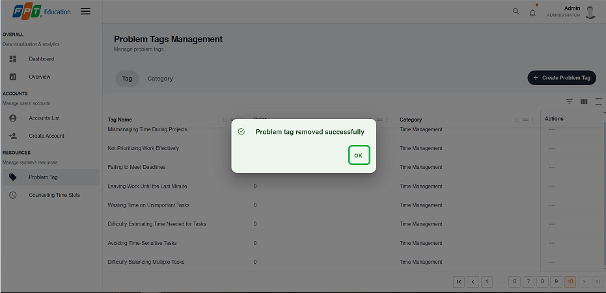

##### 3.3.7.6. Remove problem tag

3.3.1.6.1. Description

Use this guideline to remove a problem tag’s category using an administrator account.

3.3.1.6.2. Guide Steps

**Step 1**: Access SCSS at http://scss-fe.azurewebsites.net/. Then fill in “Email” and “Password” of the administrator account.



**Step 2:** Click the “Sign in ” button.



**Step 3:** From the homepage, choose “Counseling Time Slots” from the left sidebar.



**Step 4:** Press the “...” button under the actions column, in the row of the selected problem tag.

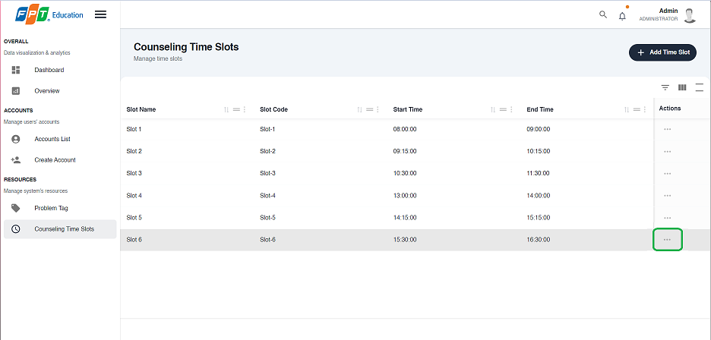**Step 5:** Press the “Delete” button.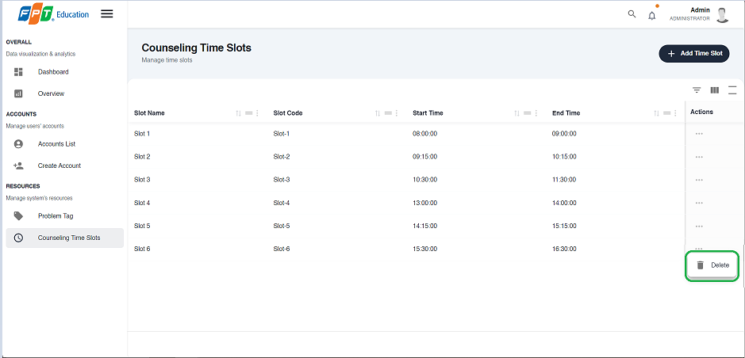

**Step 6:** Press the “Confirm” button.

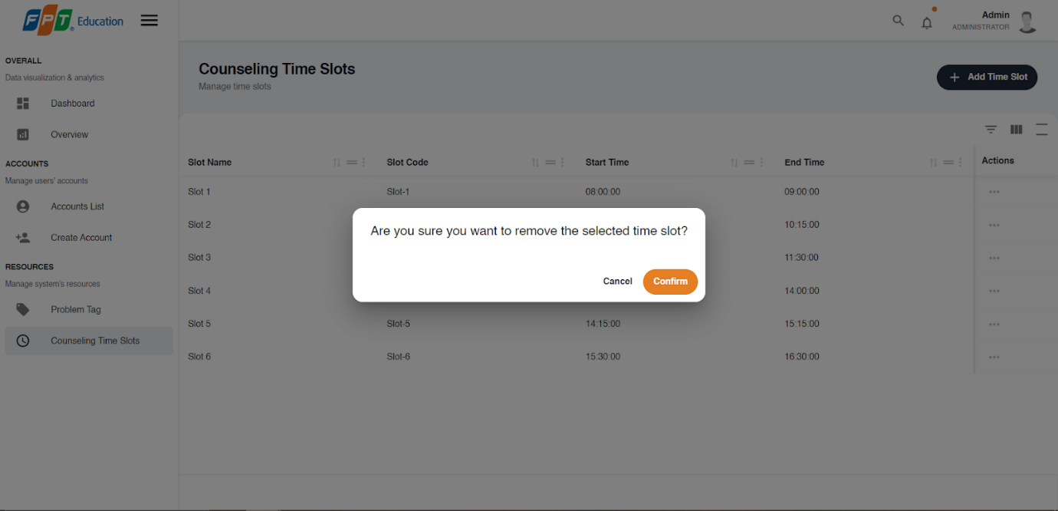

**Step 7:** Press the “Ok” button to complete removing a time slot.

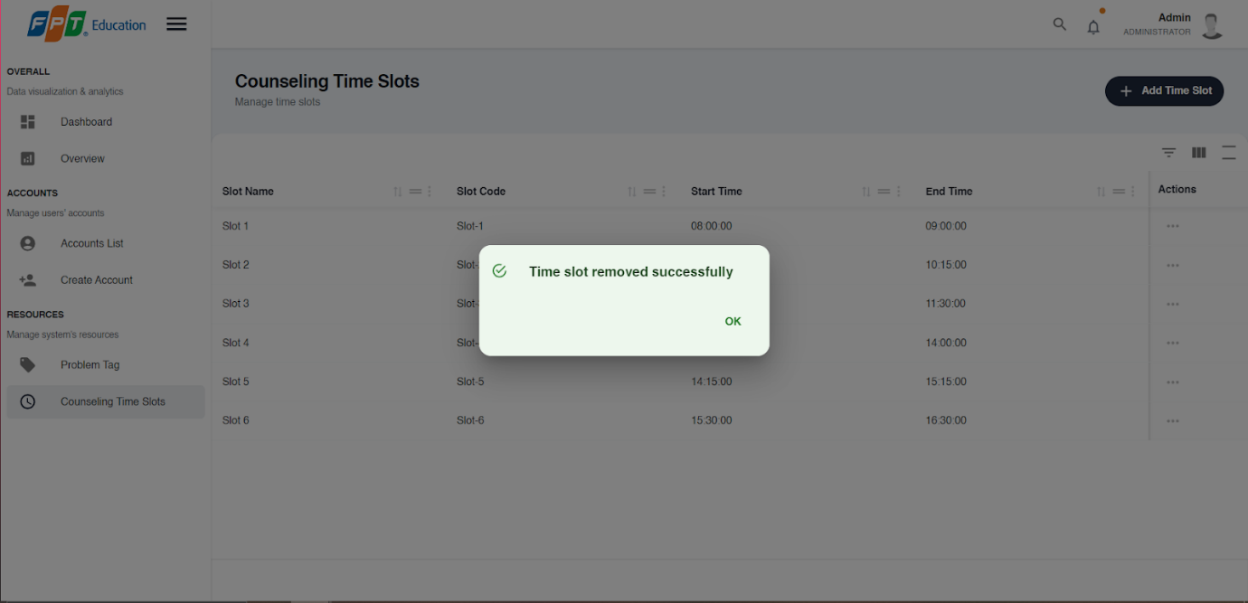

### **3.3. Mobile Application**

#### **3.3.1. Authentication**

##### **3.3.1.1. Login**

**3.3.1.1.1. Description**

Use this guideline to login into SCSS with an email account. This mobile application supports login with email account that has been added as a counselor and a student.

3.3.1.1.2. Guide Steps

**Step 1:** Access SCSS at mobile application**.** Then fill in “Email” and “Password”

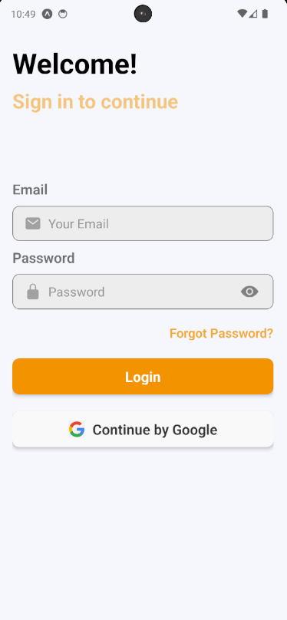

**Step 2:** Press “Login” Button

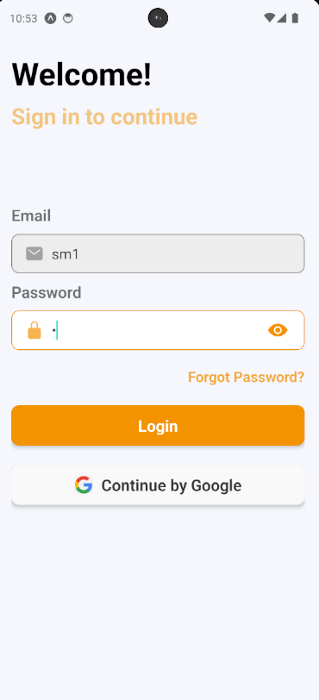

Figure 60 - Login in moblie

After logging in successfully, user is directed to the Home screen with account authenticated.

##### 3.3.1.2. Reset Password

3.3.1.2.1. Description

Use this guide so users can reset their email account password when they forget their password.

**Step 1:** Access SCSS at mobile application**.** Then press “Forgot password?”.

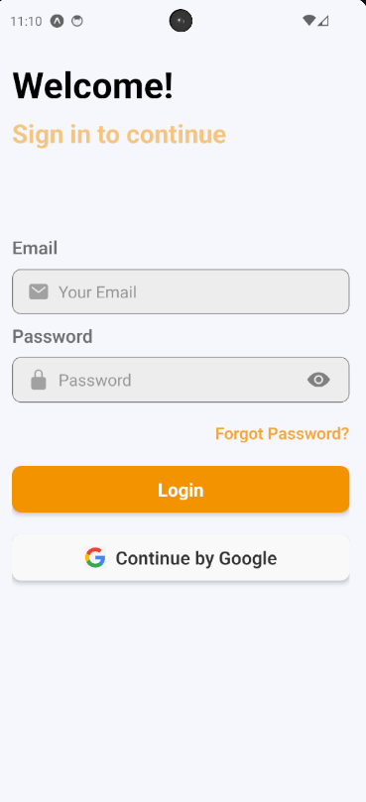

Figure 61 - Reset password in mobile

**Step 2:** Then fill in “Email”

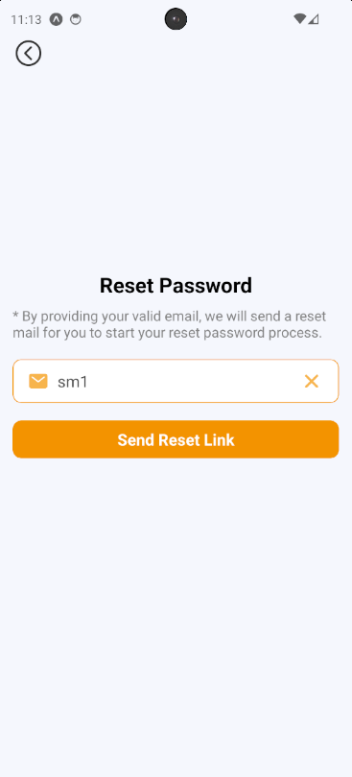

Figure 62 - View resset password screen

**Step 3**: Press “Send Reset Link” button

After sending the email successfully, the user is redirected to the Verify OTP Page with the email that sent the OTP authentication code.

##### **3.3.1.3. Edit Password**

**3.3.1.3.1. Description**

Use this guide so users can update their email account password when they want to edit their password.

This web application supports updating passwords for actors: Counselor and student.

3.3.1.3.2. Guide Steps

Step 1: Access SCSS at mobile application. After logging in successfully, press the avatar image on the up-right corner of the screen.

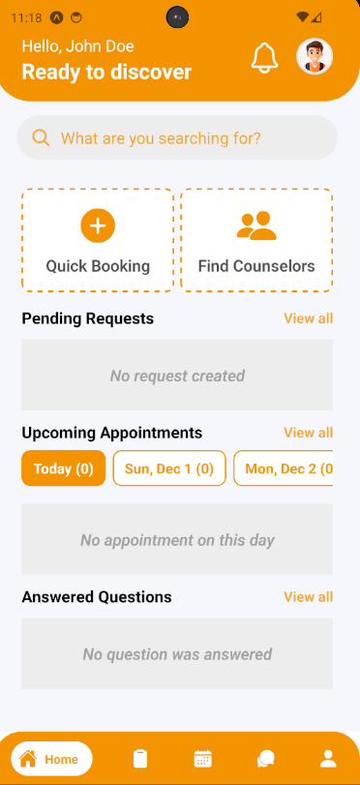

Figure 63 - View home screen

After pressing, it will navigate the user to Profile Screen.

**Step 2:** Press Change Password to navigate to Change Password Screen

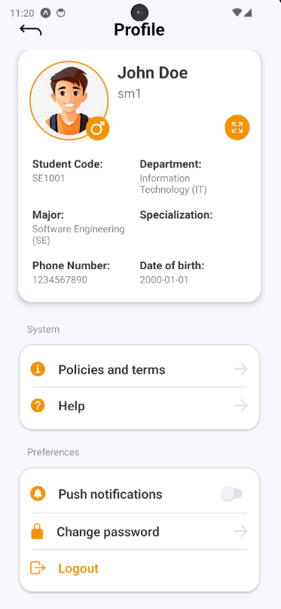

Figure 64 - View profile screen

**Step 3:** Fill in “Current password”, “New password” and “Confirm password”, then press “Save Changes” button

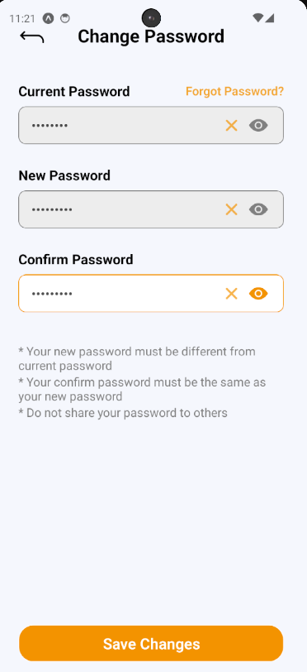

Figure 65 - Edit password

#### **3.3.2.  Booking counseling appointment**

##### **3.3.2.1. Quick booking a counselor**

**3.3.2.1.1. Description**

Use this guideline to log into the SCSS student account to book counseling appointments quickly.

**Step 1:** Access SCSS at mobile application**.** Then fill in “Email” and “Password” of the student account



Figure 66 - View login screen

**Step 2:** Press “Login” Button



Figure 67 - Login

**Step 3:** From Home Screen, choose “Quick Booking” to quickly navigate to Quick Booking Screen

.

Figure 68 - View home screen

**Step 4:** Select and fill in all the required information to booking counseling appointment in the corresponding sequence: “What are your concerns” (mean Reason for booking appointment), “Select date”, “Select slot time”, “Select counselor type”, “Select couselor's gender (optional)”, “Select Department” and “Select Major” (if counselor type is “Academic”)(optional)

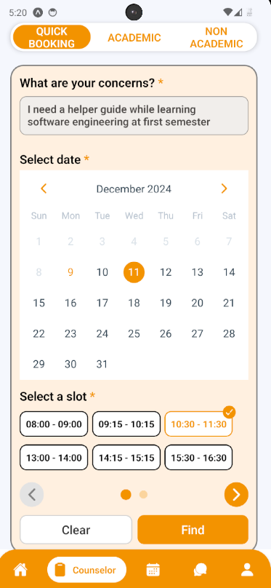

Figure 69 - View quick booking screen

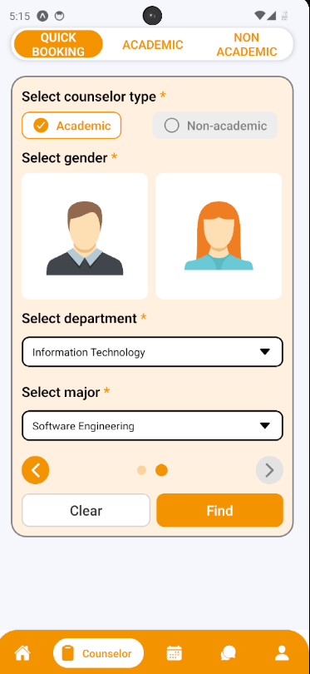

Figure 70 - Find counselor

**Step 5:** After selecting and filling all the required information, press “Find” to find a counselor.

**Step 6:** The system will match you with a counselor, and you can then select a counseling type: 'Online' or 'Offline.' After that, press the ‘Booking Appointment' button. A confirmation will appear for you to check again inputted information. Press “Yes” to proceed with booking appointment or “No” to proceed with cancel booking

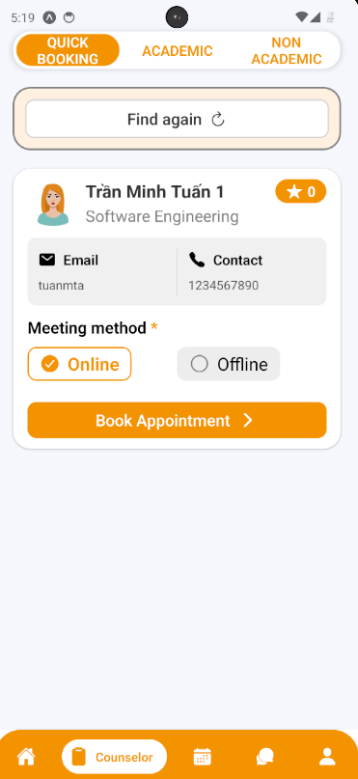

Figure 71 - Book appointment

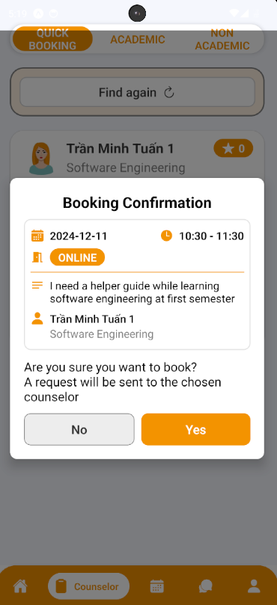

Figure 72 - Confirm book appointment

**Step 7:** After pressing “Yes” to proceed with booking an appointment, a success message will appear and you can see your sent request by pressing “See your requests” or just stay at this screen by pressing “Return” button

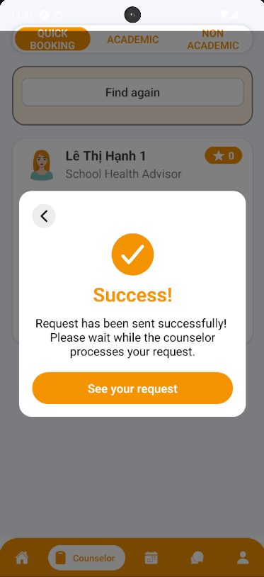

Figure 73 - Display Successfully

##### **3.3.2.2. Booking a specific counselor**

**3.3.2.2.1. Description**

Use this guideline to log into the SCSS student account to book a specific counselor.

**Step 1:** Access SCSS at mobile application**.** Then fill in “Email” and “Password” of the student account



Figure 74 - View login screen

**Step 2:** Press “Login” Button



Figure 75 - Login

**Step 3:** From Home Screen, choose “Find Counselor” to quickly navigate to Academic Screen

.

Figure 76 - View home screen

**Step 4:** From Academic Screen, you can choose filter options to narrow down counselors based on the preferences of students, including availability, academic fields/expertise, rating, counseling type, gender or search by keyword.

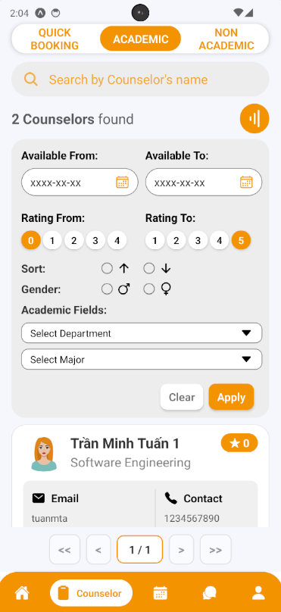

Figure 77 - View booking counselor screen

**Step 5:** Select a counselor by pressing the button “Book Appointment”

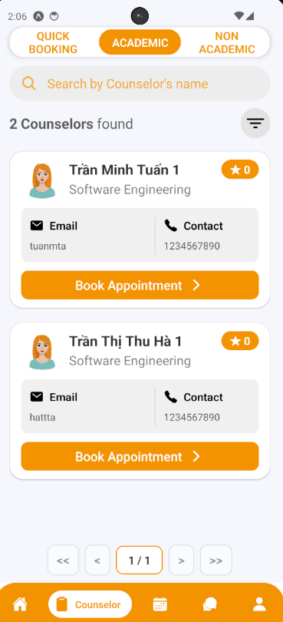

Figure 78 - Book appointment

**Step 6:**  See through the selected counselor information and fill in all the required information to book an appointment including: “Select date”, “Select slot”, “Select meeting type“, and “Reason“:

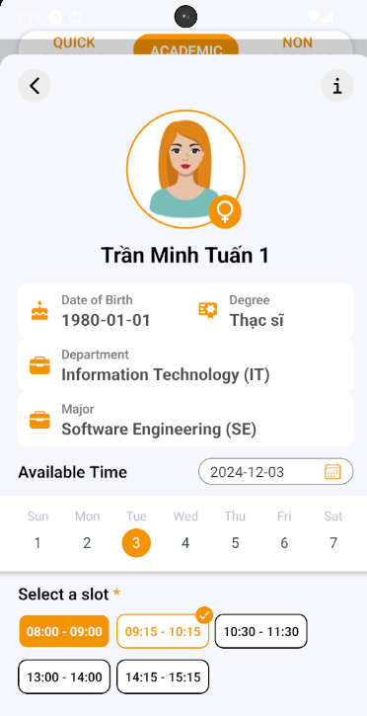

Figure 79 - Choose counseling slot

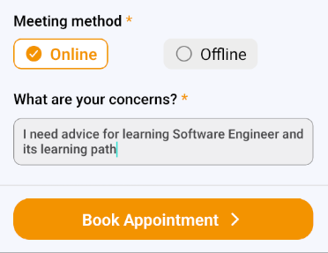

Figure 80 - Enter resson and meeting method

**Step 7:** Press “Book Appointment”. A confirmation will appear for you to check again inputted information. Press “Yes” to proceed with booking the appointment or “No” to proceed with cancel booking

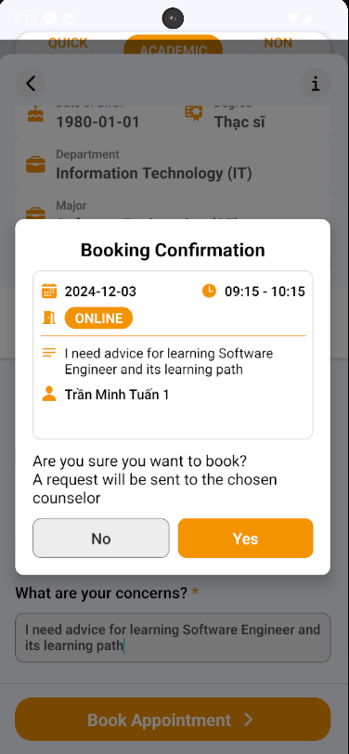

Figure 81 - Booking confirm

**Step 8:** After pressing “Yes” to proceed with booking an appointment, a success message will appear and you can see your sent request by pressing “See your requests” or just stay at this screen by pressing “Return” button

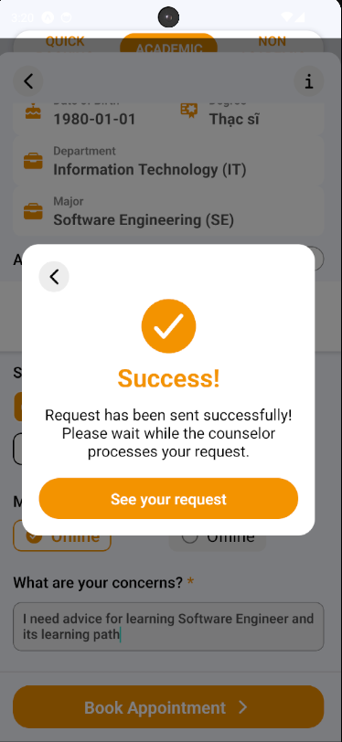

Figure 82 - Display successfully

##### **3.3.2.3. Approve Appointment Request**

**3.3.2.3.1. Description**

Use this guideline to log into the SCSS counselor account to approve student appointment request.

**Step 1:** Access SCSS at mobile application**.** Then fill in “Email” and “Password” of the counselor account



Figure 83 - View login screen

**Step 2:** Press “Login” Button

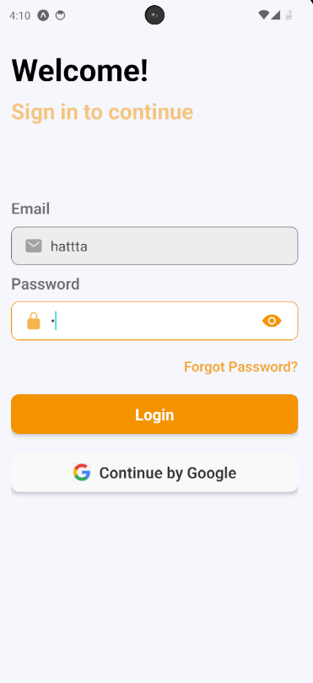

Figure 84 - Login

**Step 3:** From Home Screen:

Option 1: Choose Tab number 5 (personal icon) at the bottom of the screen to navigate to Personal Screen and from that screen will navigate to Request Screen 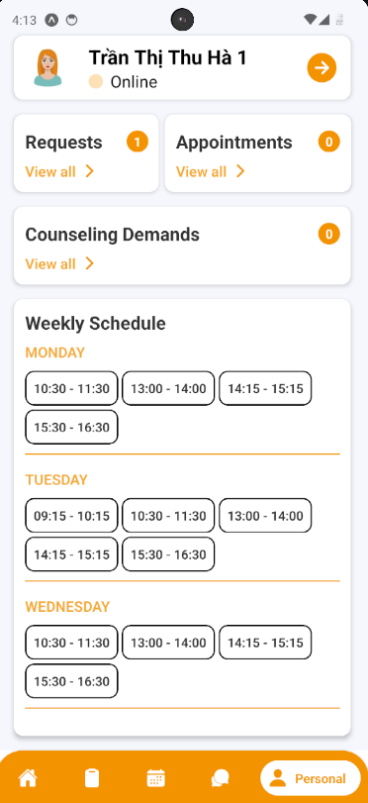

Figure 85 - Tracking schedule

Option 2: For quick navigation, press View all at Pending Request to navigate to Request Screen

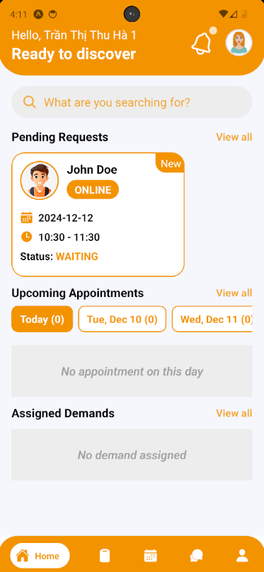

Figure 86 - View counseling request

**Step 4:** In Request Screen, find a request using filter section by request date, meeting method, and status

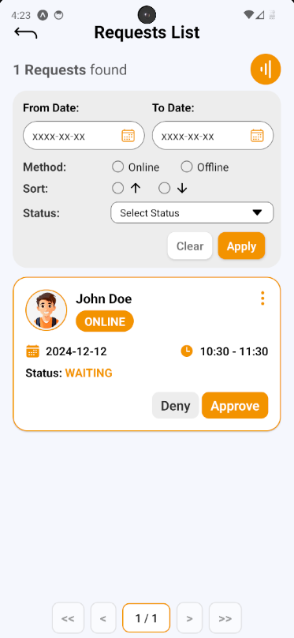

Figure 87 - View request detail

**Step 5:** After finding and considering student request, press Approve Button on request card, a request approve confirmation will open. Based on the meeting method, this confirmation require the counselor provide Meet URL (if Online) or Address (if Offline). After fill required field, press “Yes” Button to approve request, and “No” Button to cancel confirmation

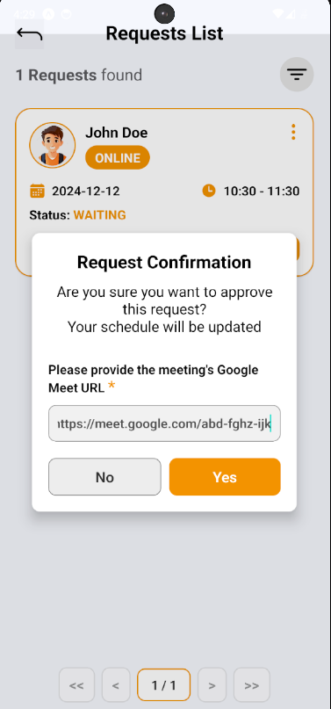

Figure 88 - Approve request

**Step 6:** After approving student request, student request’s status is updated to “APPROVED”,  appointment and schedule of both student and counselor will update. To see appointment list, access though navigate to appointment section in Personal Screen.

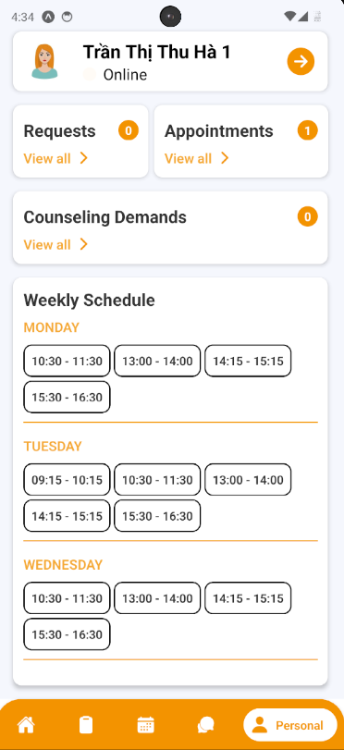

Figure 89 - Tracking appointment

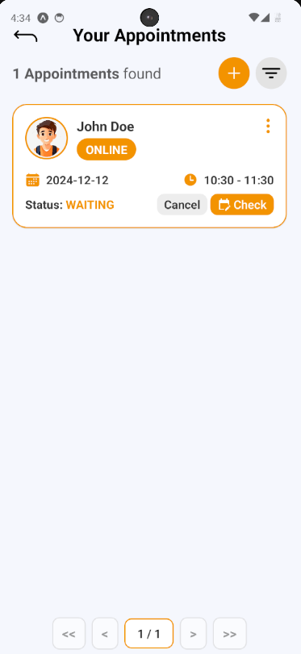

Figure 90 - View appointment list

**Step 7:** Choose Tab number 3 (calendar icon) at the bottom of the screen to navigate to Schedule Screen to view appointment schedule

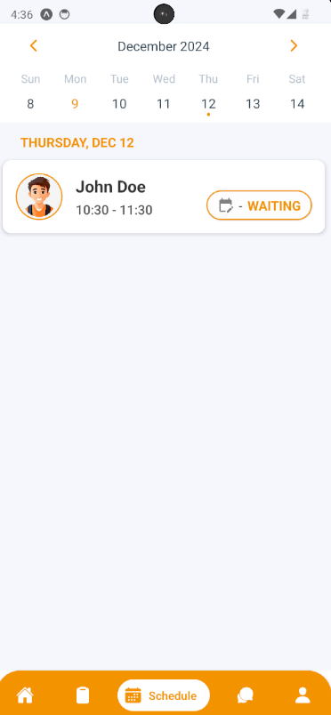

Figure 91 - Tracking appointment schedule

##### 3.3.2.4. Deny Appointment Request

3.3.2.4.1. Description

Use this guideline to log into the SCSS counselor account to deny student appointment request.

**Step 1:** Access SCSS at mobile application**.** Then fill in “Email” and “Password” of the counselor account



Figure 92 - View login screen

**Step 2:** Press “Login” Button



Figure 93 - Login

**Step 3:** From Home Screen:

Option 1: Choose Tab number 5 (personal icon) at the bottom of the screen to navigate to Personal Screen and from that screen will navigate to Request Screen

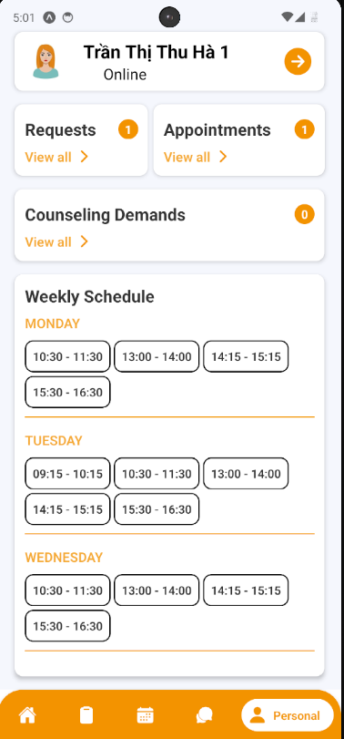

Figure 94 - Tracking request

Option 2: For quick navigation, press View all at Pending Request to navigate to Request Screen

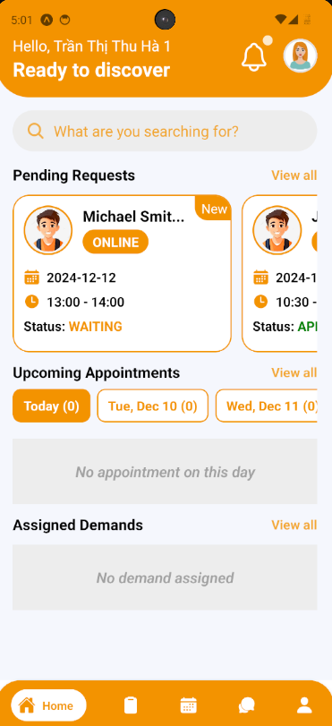

Figure 95 - View appointment request

**Step 4:** In Request Screen, find a request using filter section by request date, meeting method, and status

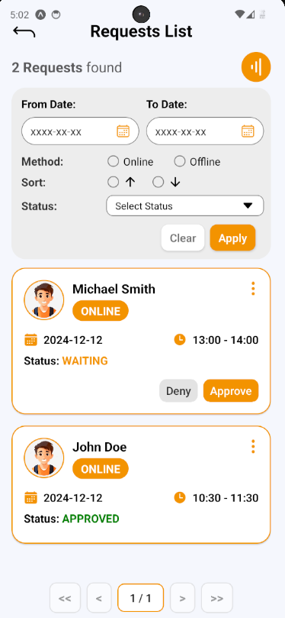

Figure 96 - View request detail

**Step 5:** After finding and considering student request, press Deny Button on request card, a request deny confirmation will open. Press “Yes” Button to deny request, and “No” Button to cancel confirmation

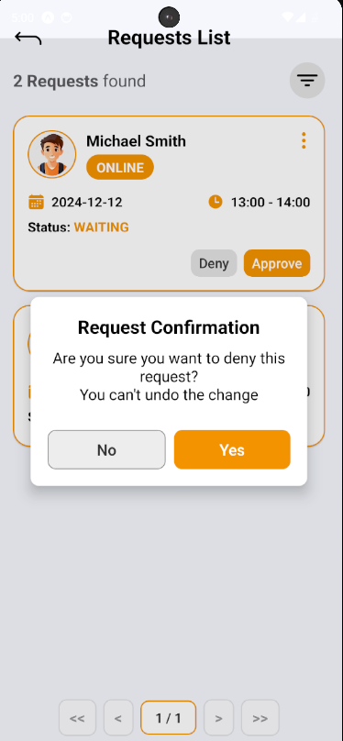

Figure 97 - Deny appointment request

**Step 6:** After denying student request, student request’s status is updated to “DENIED”

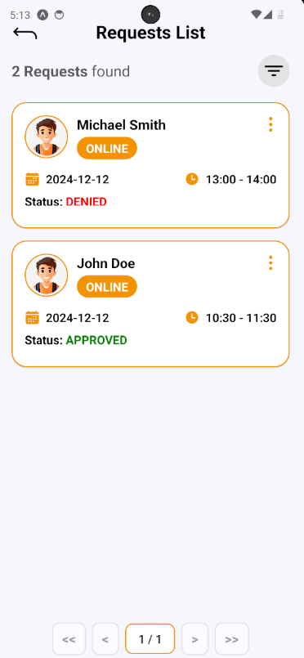

Figure 98 - View request list

##### **3.3.2.5. Take Attendance for Appointment**

**3.3.2.5.1. Description**

Use this guideline to log into the SCSS counselor account to take attendance for appointment

**Step 1:** Access SCSS at mobile application**.** Then fill in “Email” and “Password” of the counselor account



Figure 99 - View login screen

**Step 2:** Press “Login” Button



Figure 100 - Login

**Step 3:** From Home Screen:

Option 1: Choose Tab number 5 (personal icon) at the bottom of the screen to navigate to Personal Screen and from that screen will navigate to Appointment Screen

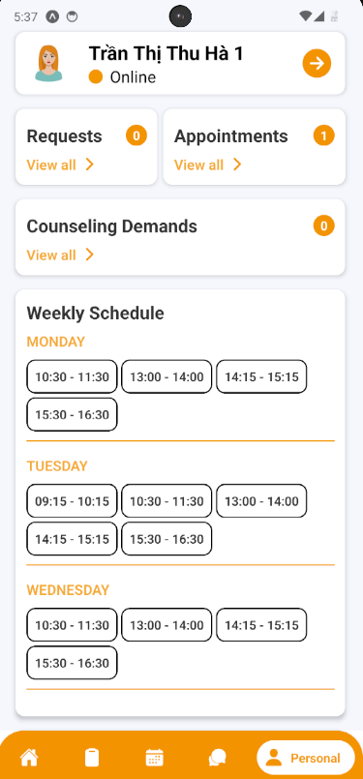

Figure 101 - Tracking appointment

Option 2: For quick navigation, press View all at Upcoming Appointments to navigate to Appointment Screen



Figure 102 - View home screen

**Step 4:** In Appointment Screen, find an appointment using filter section by meeting date, and status

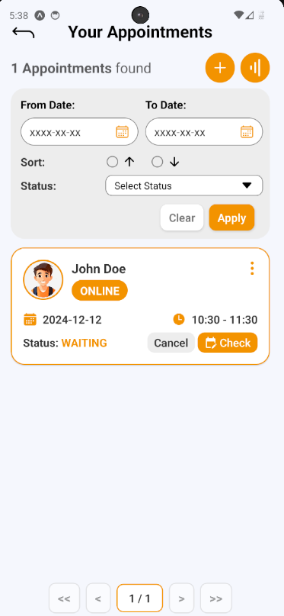

Figure 103 - View appointment detail

**Step 5:** After finding appointment, press “Check” Button to open Take Attendance section on appointment card, a take attendance confirmation will open. Press “ATTEND” or “ABSENT” to change status of chosen appointment

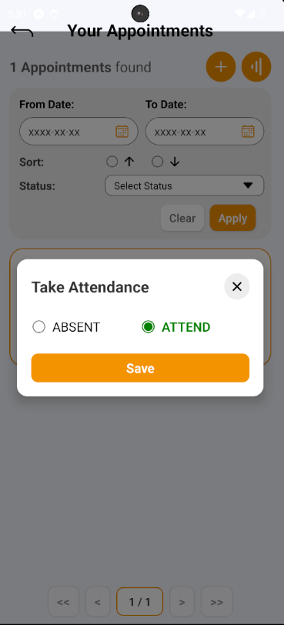

Figure 104 - Take attendance

**Step 6:** After taking attendance, the status of appointment will change to “ATTEND” or “ABSENT”

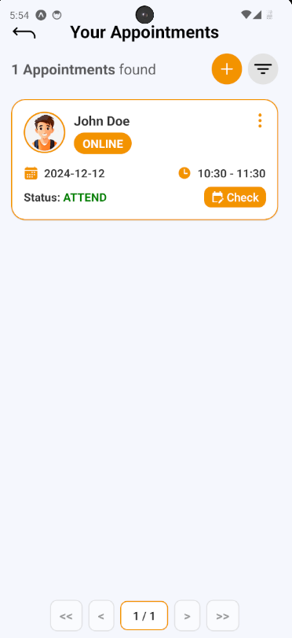

Figure 105 - View attendance status

##### **3.3.2.6. Write Feedback for Appointment**

**3.3.2.6.1. Description**

Use this guideline to log into the SCSS student account to write feedback for appointment

**Step 1:** Access SCSS at mobile application**.** Then fill in “Email” and “Password” of the student account



Figure 106 - View login screen

**Step 2:** Press “Login” Button



Figure 107 - Login

**Step 3:** From Home Screen:

Option 1: Choose Tab number 5 (personal icon) at the bottom of the screen to navigate to Personal Screen and from that screen will navigate to Appointment Screen

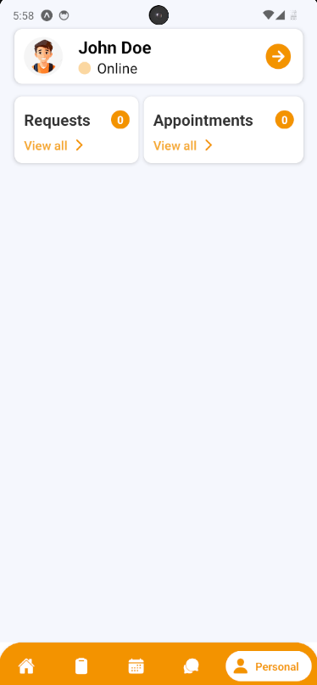

Figure 108 - View profile screen

Option 2: For quick navigation, press View all at Upcoming Appointments to navigate to Appointment Screen

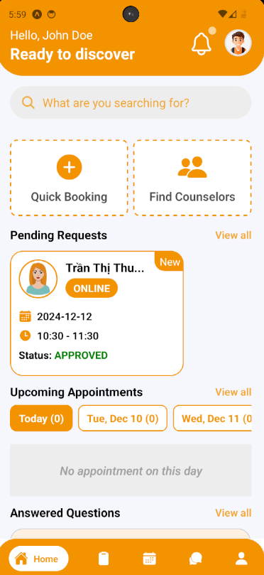

Figure 109 - View home screen

**Step 4:** In Appointment Screen, find an appointment using filter section by meeting date, and status

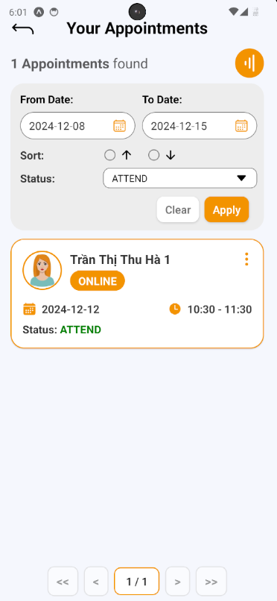

Figure 110 - View appointment list

**Step 5:** After finding a appointment (which status is “ATTEND”), press Info Button (shown as “vertical-ellipsis” icon) to show that appointment information

**Step 6:** In that appointment information, there’s a section called “Leave a review”, press it and open “Write a review” confirmation.

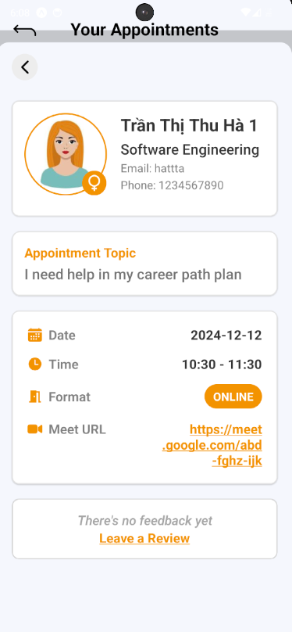

Figure 111 - View appointment detail

**Step 7:** Fill in feedback content include message and rating. Then submit it by pressing “Save” Button, or cancel by pressing “Cancel” Button

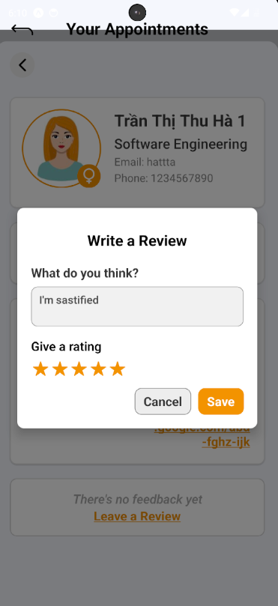

Figure 112 - Write feedback

**Step 8:** View feedback after submitting in appointment information.

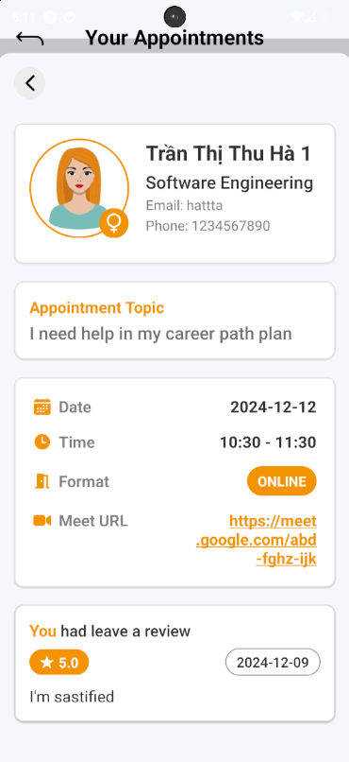

Figure 113 - View feedback

##### **3.3.2.7. Write Report for Appointment**

**3.3.2.7.1. Description**

Use this guideline to log into the SCSS counselor account to write report for appointment

**Step 1:** Access SCSS at mobile application**.** Then fill in “Email” and “Password” of the counselor account



Figure 114 - View login sceen

**Step 2:** Press “Login” Button



Figure 115 - Login

**Step 3:** From Home Screen:

Option 1: Choose Tab number 5 (personal icon) at the bottom of the screen to navigate to Personal Screen and from that screen will navigate to Appointment Screen 

Figure 116 - View profile screen

Option 2: For quick navigation, press View all at Upcoming Appointments to navigate to Appointment Screen



Figure 117 - View home screen

**Step 4:** In Appointment Screen, find an appointment using filter section by meeting date, and status

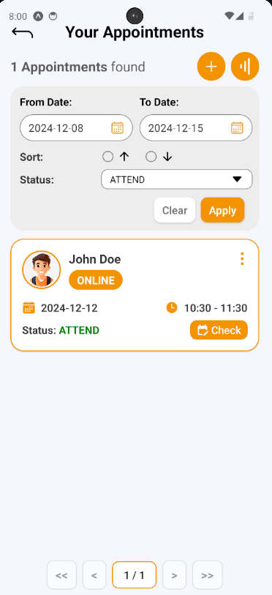

Figure 118 - View appointment list

**Step 5:** After finding a appointment (which status is “ATTEND”), press Info Button (shown as “vertical-ellipsis” icon) to show that appointment information

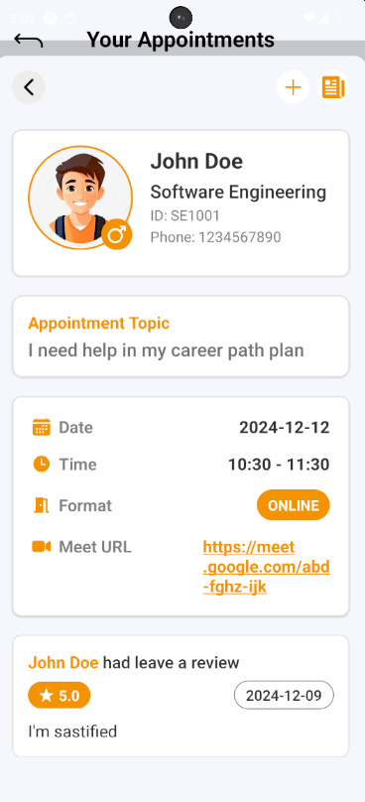

Figure 119 - View appointment detail

**Step 6:** After appointment information open, press “Add” Button (shown as an icon with the “+” symbol) to open Create Report section

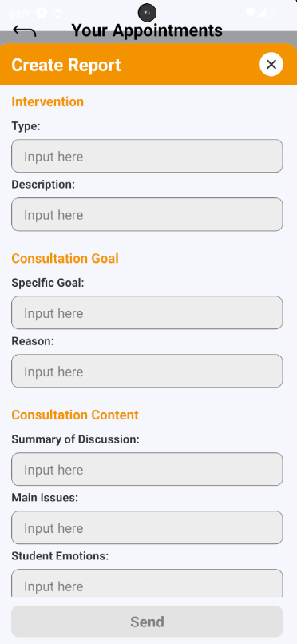

Figure 120 - View report form

**Step 7:** After filling all required fields, press “Send” button to create report for chosen appointment

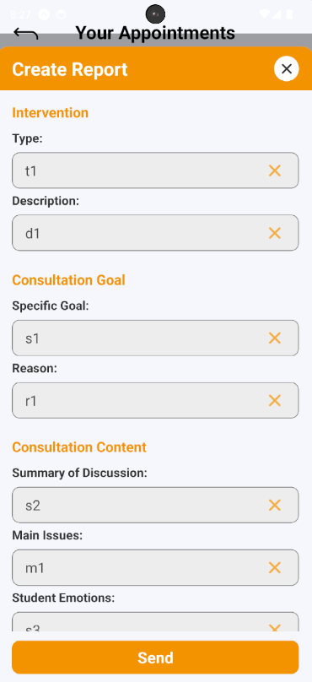

Figure 121 - Fill report form

**Step 8:** After creating report successfully, press “Report” Button (shown as “newspaper” icon) to view appointment report



Figure 122 - View appointment detail

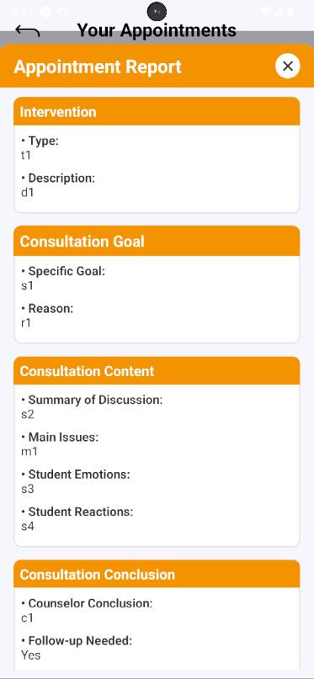

Figure 123 – View report review

##### **3.3.2.8. Cancel Appointment**

**3.3.2.8.1. Description**

Use this guideline to log into the SCSS student or counselor account to cancel an appointment

**Case 1:**

**Step 1:** Access SCSS at mobile application**.** Then fill in “Email” and “Password” of the student account



Figure 124 - View login screen

**Step 2:** Press “Login” Button



Figure 125 - Login

**Step 3:** From Home Screen:

Option 1: Choose Tab number 5 (personal icon) at the bottom of the screen to navigate to Personal Screen and from that screen will navigate to Appointment Screen

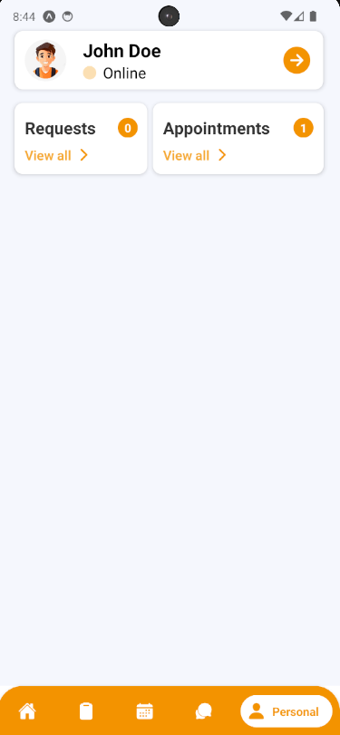

Figure 126 - View profile

Option 2: For quick navigation, press View all at Upcoming Appointments to navigate to Appointment Screen

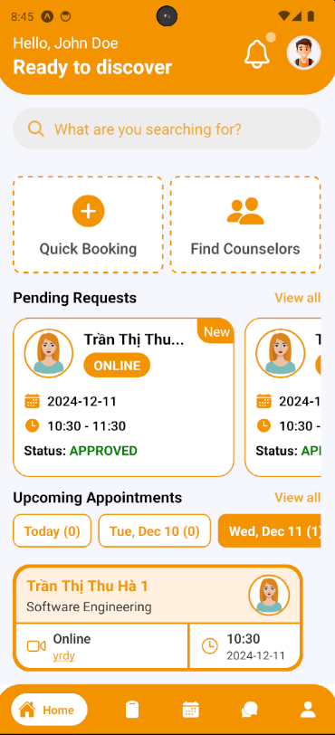

Figure 127 - View home screen

**Step 4:** In Appointment Screen, find an appointment using filter section by request date, and status

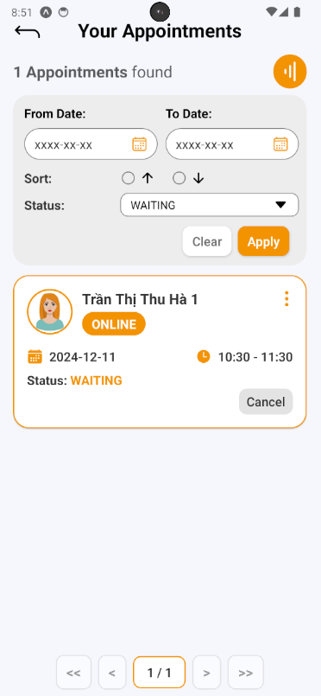

Figure 128 - View appointment list

**Step 5:** After finding appointment, press “Cancel” Button to open Cancel Appointment section on appointment card, a cancel appointment confirmation will open. Fill in reason then press “Yes” Button to cancel appointment, and “No” Button to cancel confirmation

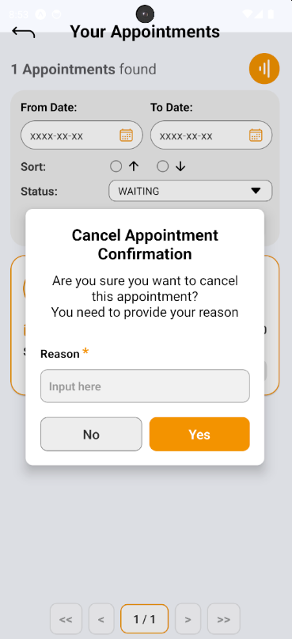

Figure 129 - Cancel appointment comfirmation

**Step 6:** After cancelling appointment successfully, the appointment’s status change to “CANCELED”, then press “Info” Button (shown as “vertical-ellipsis” icon) and view canceled reason

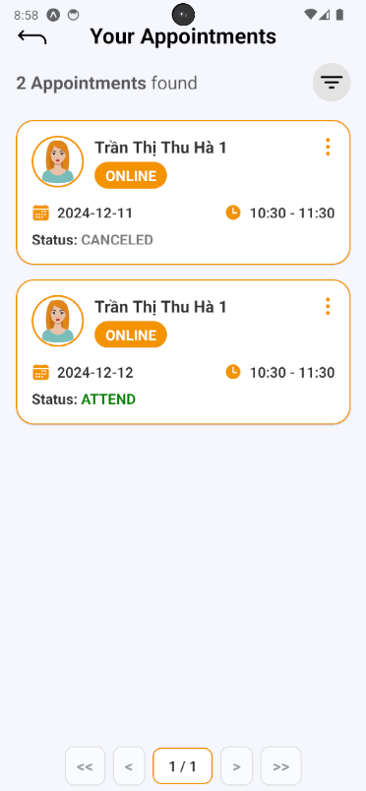

Figure 130 - View appointment list

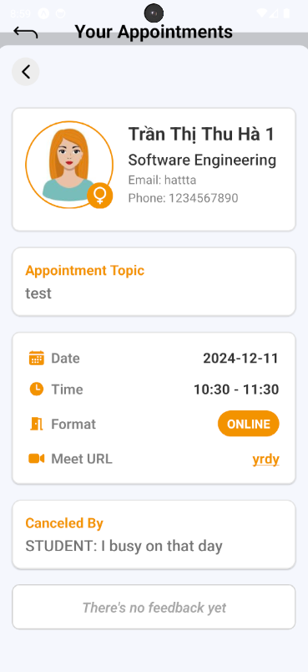

Figure 131 - View appointment detail

**Case 2:**

**Step 1:** Access SCSS at mobile application**.** Then fill in “Email” and “Password” of the counselor account



Figure 132 - View login screen

**Step 2:** Press “Login” Button



Figure 133 - Login

**Step 3:** From Home Screen:

Option 1: Choose Tab number 5 (personal icon) at the bottom of the screen to navigate to Personal Screen and from that screen will navigate to Appointment Screen

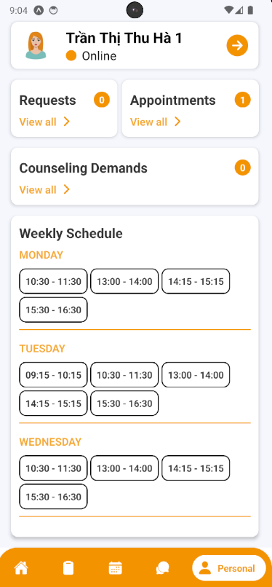

Figure 134 - View profile screen

Option 2: For quick navigation, press View all at Upcoming Appointments to navigate to Appointment Screen

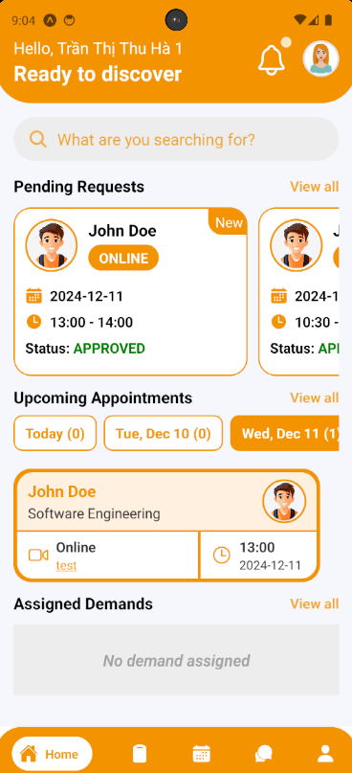

Figure 135 - View home screen

**Step 4:** In Appointment Screen, find an appointment using filter section by request date, and status

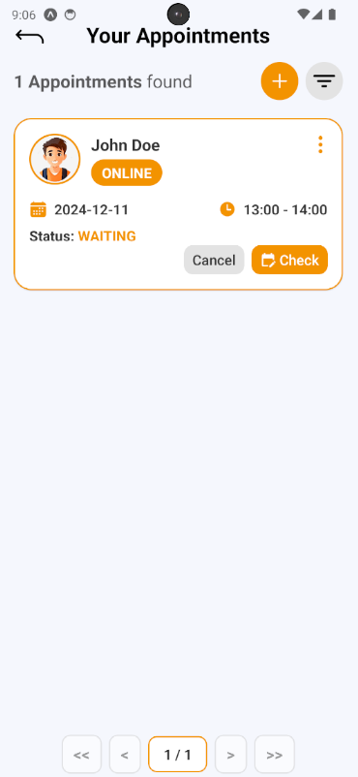

Figure 136 - View appointment list

**Step 5:** After finding appointment, press “Cancel” Button to open Cancel Appointment section on appointment card, a cancel appointment confirmation will open. Fill in reason then press “Yes” Button to cancel appointment, and “No” Button to cancel confirmation

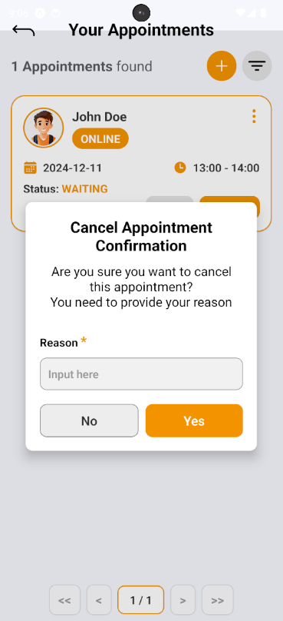

Figure 137 - Cancel appointment confirmation

**Step 6:** After cancelling appointment successfully, the appointment’s status change to “CANCELED”, then press “Info” Button (shown as “vertical-ellipsis” icon) and view canceled reason

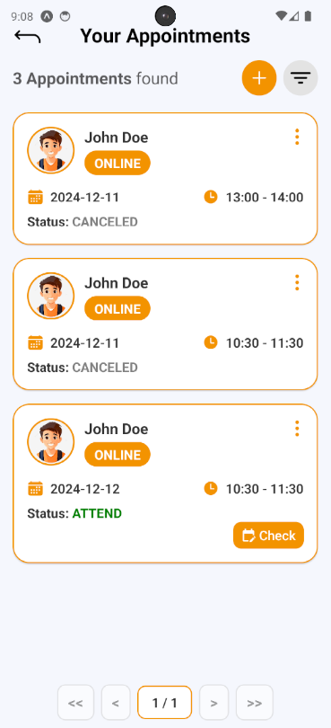

Figure 138 -View appointment list

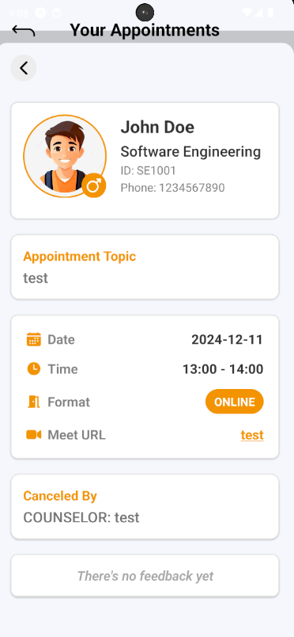

Figure 139 - View appointment detail

#### **3.3.3.  Question and Answer**

##### **3.3.3.1. Create a question**

**3.3.3.1.1. Description**

Use this guideline to create a question for the counselor

**3.3.3.1.2. Guide Steps:**

**Step 1:** Access SCSS at mobile application**.** Then fill in “Email” and “Password” of the student account



Figure 140 - View login screen

**Step 2:** Press “Login” Button



Figure 141 - Login

**Step 3:** From Home Screen, choose Tab number 4 (chat-bubble icon) at the bottom of the screen to navigate to My Q&A Screen

.

Figure 142 - View home screen

**Step 4:** In My Q&A Screen, press “Add” button (shown as an icon with the “+” symbol) to open Create Question section

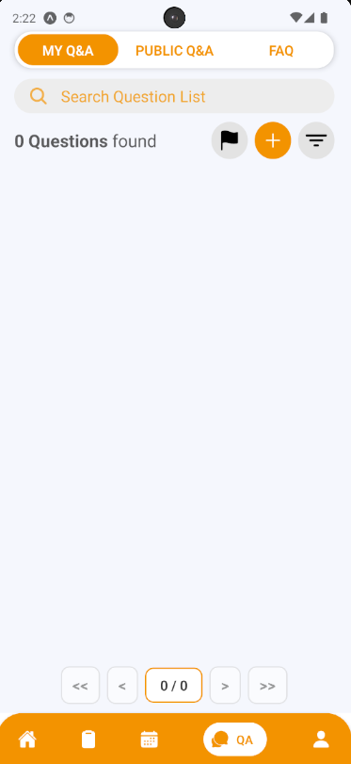

Figure 143 - View my Q&A screen

**Step 5:** Choose the question type and fill in the question title, content if there are similar questions, it will be suggested to students before submitting in case there are duplicate question. Then after fill all required fields, press “Create Question” Button

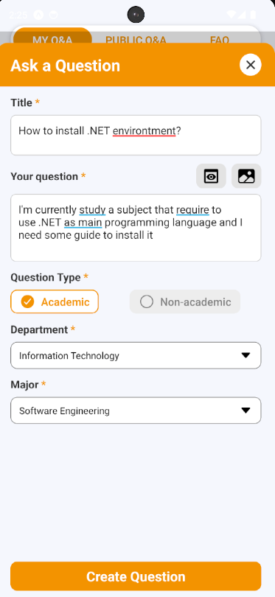

Figure 144 - View create a question screen

**Step 6:** View your created question, and information of counselor that currently in charge of this question.

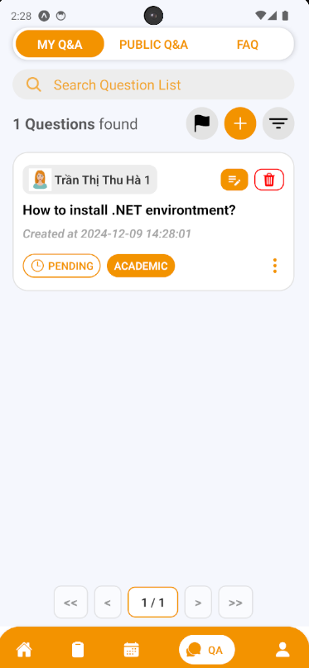

Figure 145 - View my Q&A screen

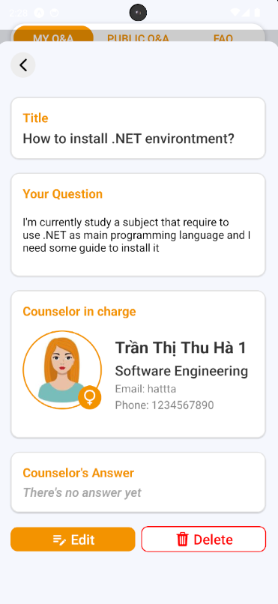

Figure 146 - View Q&A screen

##### **3.3.3.2. Edit a question**

**3.3.3.2.1. Description**

Use this guideline to edit your question’s content

**3.3.3.2.2. Guide Steps:**

**Step 1:** Access SCSS at mobile application with student account**.** Navigate to My Q&A screen, and press “Edit” (shown as “pencil-note” icon) to open Edit Question section that lay on the question card, or inside the information of question card



Figure 147 - View my Q&A screen



Figure 148 - View Q&A screen

**Step 2:** You can see current question information inside these input field and you can change it (some fields are required, so it can not empty). Then after fill all required fields, press “Edit” Button.

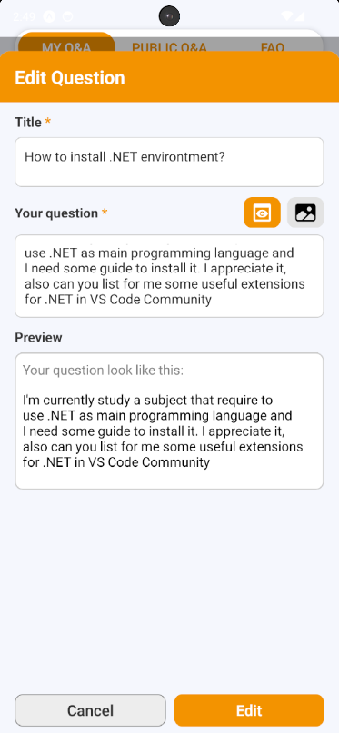

Figure 149 - View edit question screen

**Step 3:** View your question after editing.

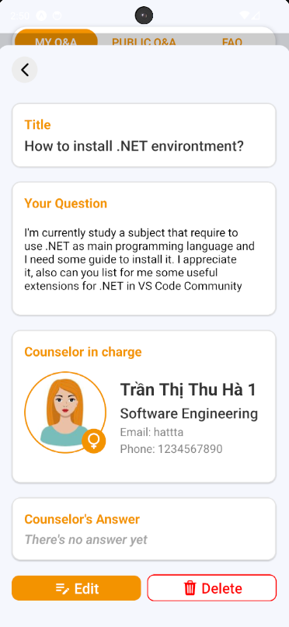

Figure 150 - View Q&A screen

##### **3.3.3.3. Delete a question**

**3.3.3.3.1. Description**

Use this guideline to delete your question

3.3.3.3.2. Guide Steps:

**Step 1:** Access SCSS at mobile application with student account**.** Navigate to My Q&A screen, and press “Delete” (shown as an icon with the “trash” symbol) to open Delete Question section that lay on the question card, or inside the information of question card



Figure 151 - View my Q&A screen



Figure 152 - View Q&A screen

**Step 2:** After pressing, Delete Question Confirmation will open. If you want to delete your question press “Yes” Button to delete it, and “No” Button if not. After deleting successfully, that question will be disappear of My Q&A screen

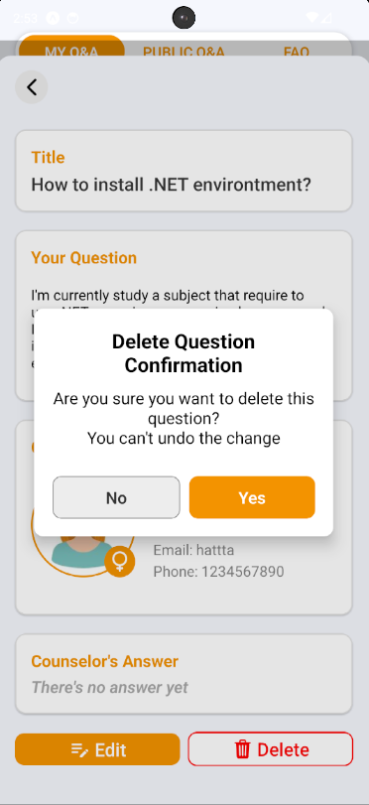

Figure 153 - Delete question confirmation

##### **3.3.3.4. Answer a question**

**3.3.3.4.1. Description**

Use this guideline to answer a question

**3.3.3.4.2. Guide Steps:**

**Step 1:** Access SCSS at mobile application**.** Then fill in “Email” and “Password” of the counselor account



Figure 154 - View login screen

**Step 2:** Press “Login” Button



Figure 155 - Login

**Step 3:** From Home Screen, choose Tab number 4 (chat-bubble icon) at the bottom of the screen to navigate to My Q&A Screen

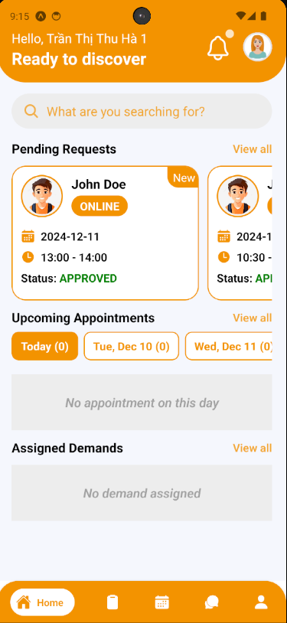

**Step 4:** In My Q&A Screen,  find a question using filter section by student code

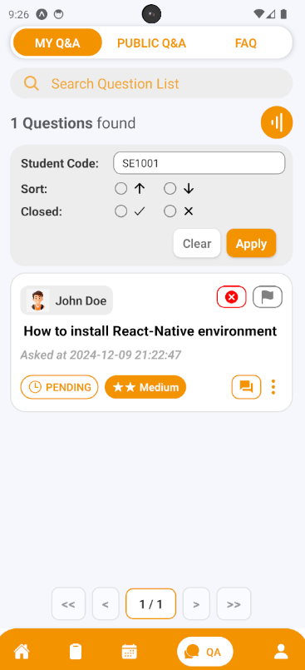

**Step 5:** After finding question, press “Answer” Button (shown as “text-box” icon) to open Answer Question section.

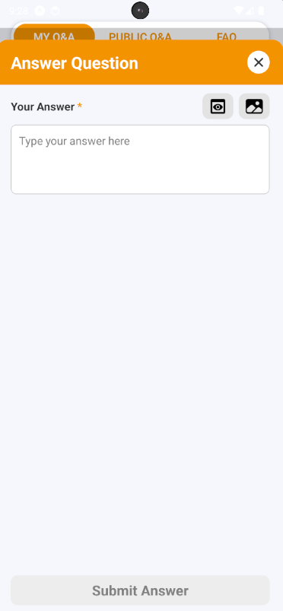

**Step 6:** After filling answer, press “Submit Answer” Button to submit answer for the chosen question

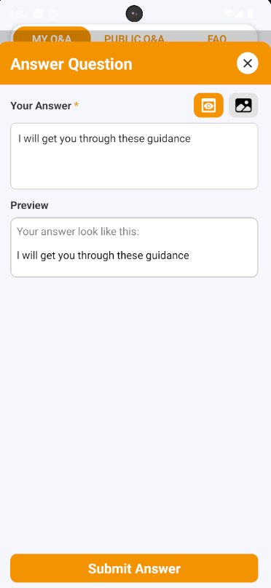

**Step 6:** After answering question, view your answer on the question card or by pressing “Info” Button (shown as “vertical-ellipsis” icon ) to show question information

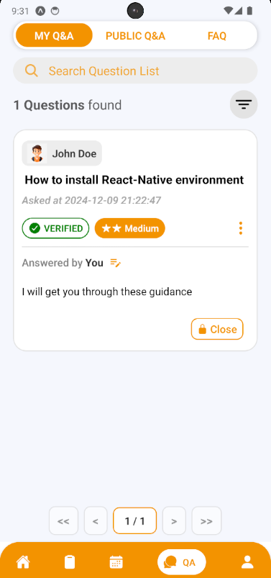

##### 3.3.3.5. Edit Answer of a question

3.3.3.5.1. Description

Use this guideline to edit answer of a question

3.3.3.5.2. Guide Steps:

**Step 1:** Access SCSS at mobile application with counselor account**.** Navigate to My Q&A screen, and press “Edit” (shown as “pencil” icon) to open Edit Answer section that lay on the question card



**Step 2:** You can see current answer information inside this input field and you can change it (this field is required, so it can not empty). Then after fill all required fields, press “Edit” Button.

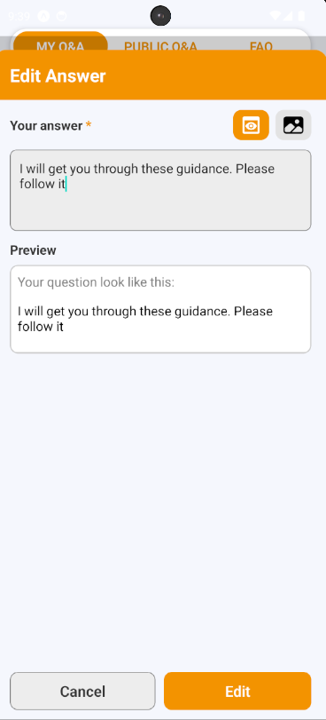

**Step 3:** View your answer after editing.

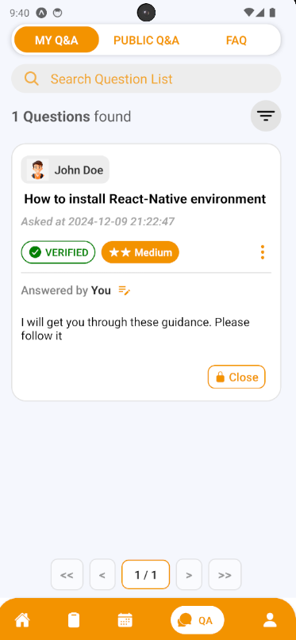

##### 3.3.3.6. Create a chat session

3.3.3.6.1. Description

Use this guideline to create a chat session for your question

3.3.3.6.2. Guide Steps:

**Step 1:** Access SCSS at mobile application with student account**.** Navigate to My Q&A screen, and press “Start a chat” (shown as “chat-bubble” icon) to open Create Chat Session section that lay on the question card (this button will only show when this question is verified and has already answered by counselor in charge)

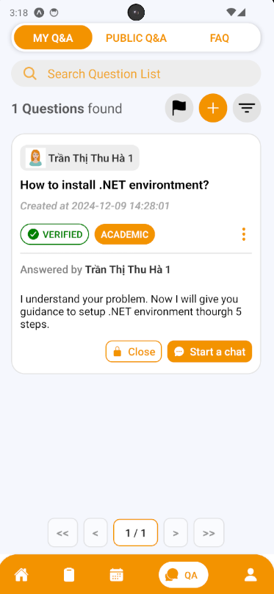

**Step 2:** After pressing, Start a Conversation Session Confirmation will open. If you want to start a chat inside your question press “Yes” Button to create it, and “No” Button if not. After creating successfully, that chat session will show on the screen and can be open through Chat Button.

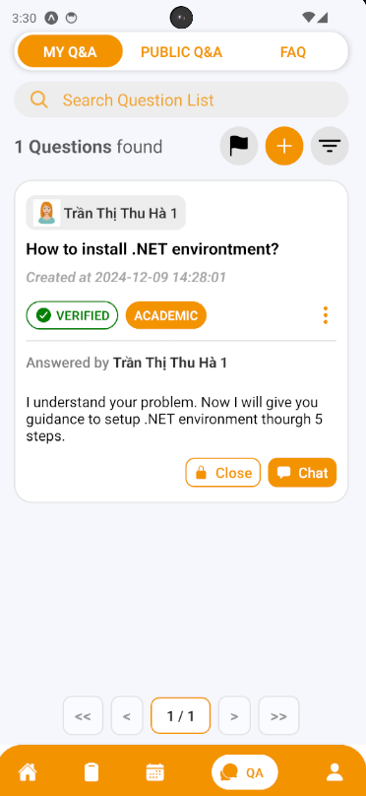

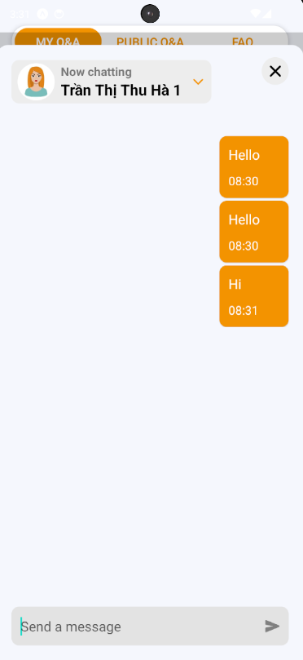

##### 3.3.3.7. Close a question

3.3.3.7.1. Description

Use this guideline to close your question

3.3.3.7.2. Guide Steps:

**Case 1:**

**Step 1:** Access SCSS at mobile application with student account**.** Navigate to My Q&A screen, and press “Close” (shown as “lock” icon) to open Close Question section that lay on the question card, or inside the information of question card



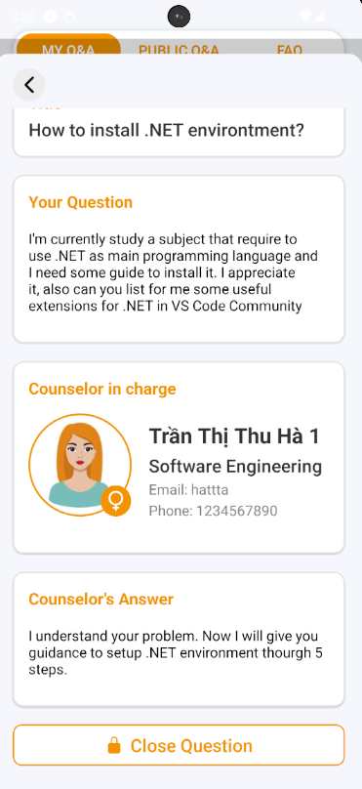

**Step 2:** After pressing, Close Question Confirmation will open. If you want to close your question press “Yes” Button to close it, and “No” Button if not.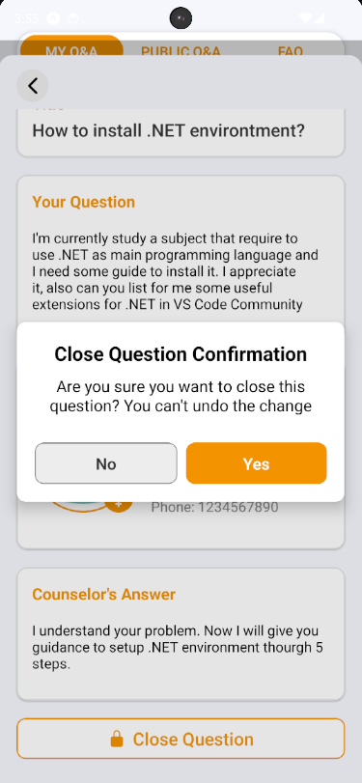

**Step 3:**  After closing successfully, that question will be closed, and cannot chat anymore

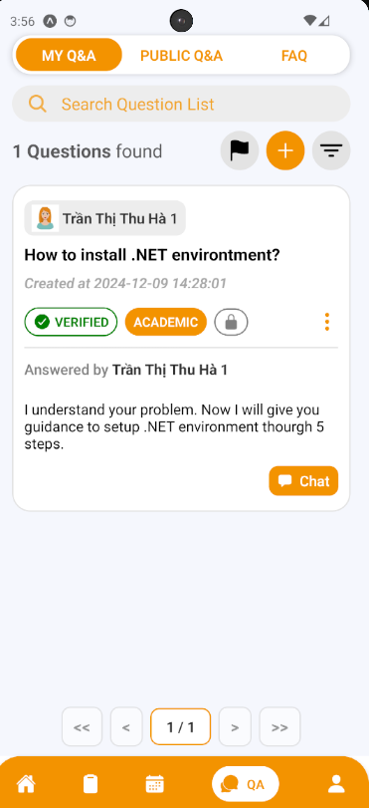

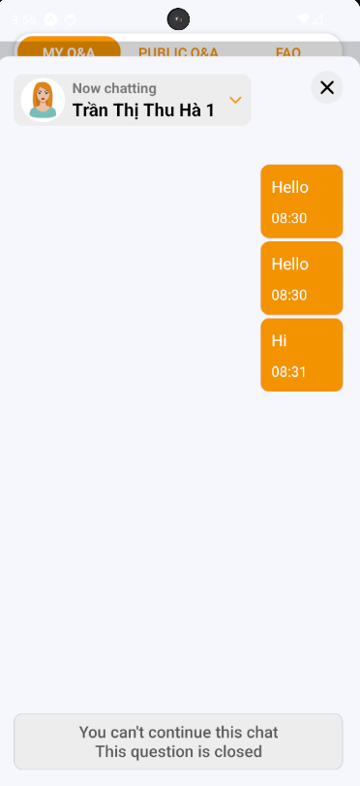

**Case 2:**

**Step 1:** Access SCSS at mobile application with counselor account**.** Navigate to My Q&A screen, and press “Close” (shown as “lock” icon) to open Close Question section that lay on the question card, or inside the information of question card

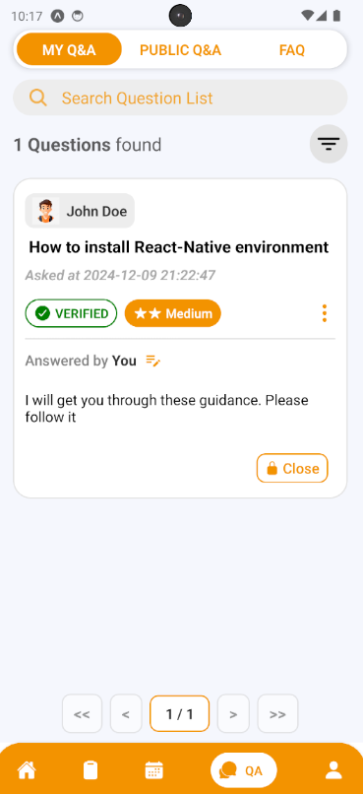

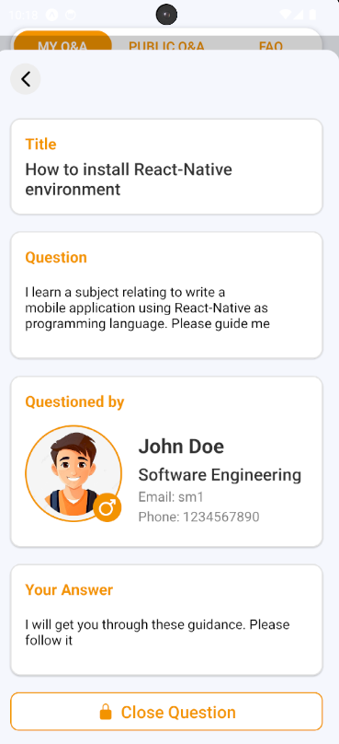

**Step 2:** After pressing, Close Question Confirmation will open. If you want to close your question press “Yes” Button to close it, and “No” Button if not.

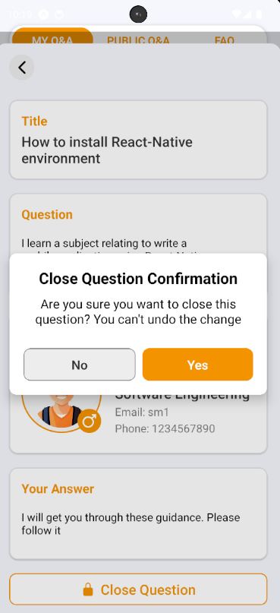

**Step 3:**  After closing successfully, that question will be closed, and cannot chat anymore

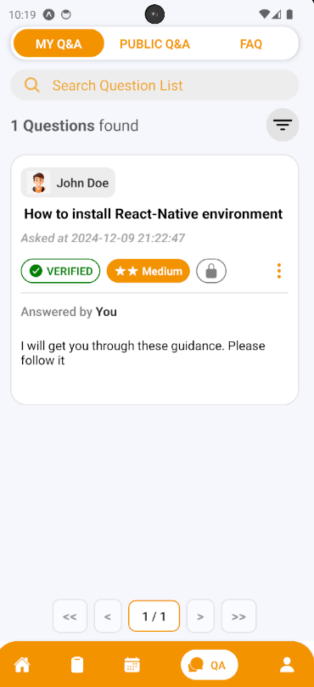

##### 3.3.3.8. Create a contribution question

3.3.3.8.1. Description

Use this guideline to create a contribution question

3.3.3.8.2. Guide Steps:

**Step 1:** Access SCSS at mobile application**.** Then fill in “Email” and “Password” of the counselor account



**Step 2:** Press “Login” Button



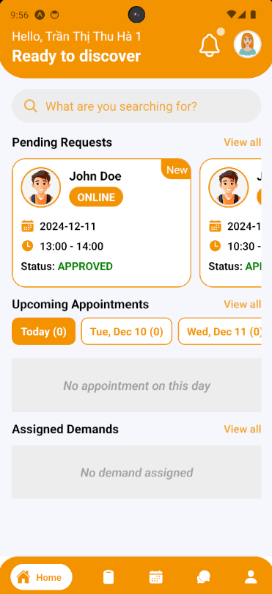**Step 3:** From Home Screen, choose Tab number 4 (chat-bubble icon) at the bottom of the screen to navigate to My Q&A Screen

**Step 4:** In My Q&A Screen, swipe to the right to navigate to FAQ Screen

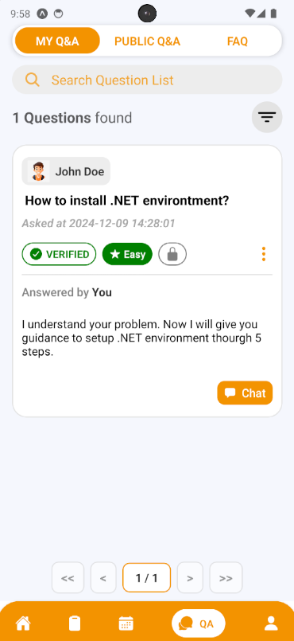

**Step 5:** In FAQ Screen, press “Add” button (shown as an icon with the “+” symbol) to open Contribute Question section

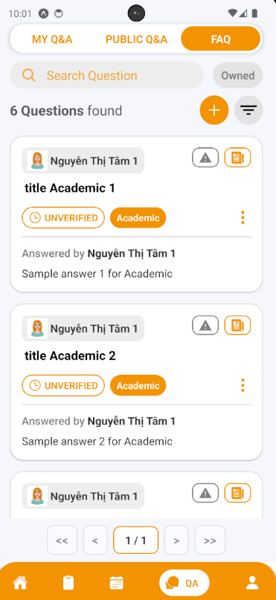

**Step 6:** Choose the question type and fill in the question title, content, category and answer if there are similar questions, it will be suggested to students before submitting in case there are duplicate question. Then after fill all required fields, press “Create Question” Button

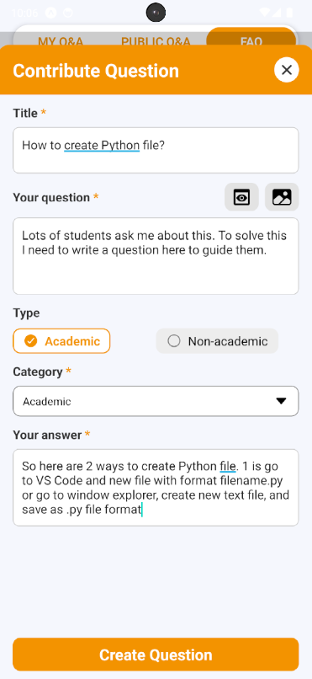

**Step 7:** View your created question, and information of this question.

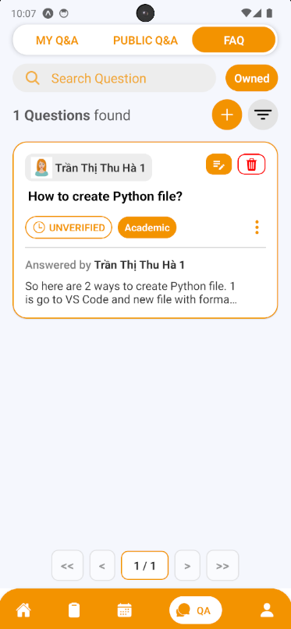

##### 3.3.3.9. Edit a contribution question

3.3.3.9.1. Description

Use this guideline to edit your contribution question

3.3.3.9.2. Guide Steps:

**Step 1:** Access SCSS at mobile application with counselor account**.** Navigate to My Q&A screen, then swipe to the right to navigate to FAQ Screen and press “Edit” (shown as “pencil-note” icon) to open Edit Question section that lay on the question card, or inside the information of question card

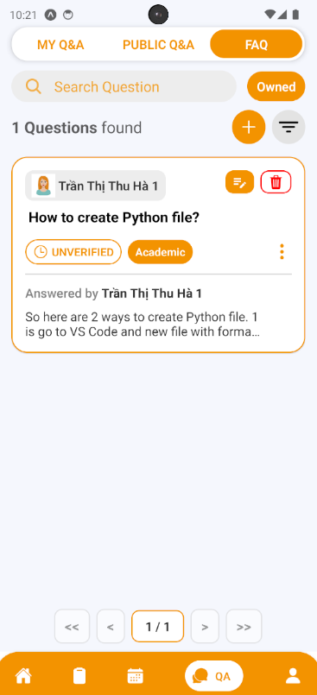

**Step 2:** You can see current question information inside these input field and you can change it (some fields are required, so it can not empty). Then after fill all required fields, press “Edit” Button.

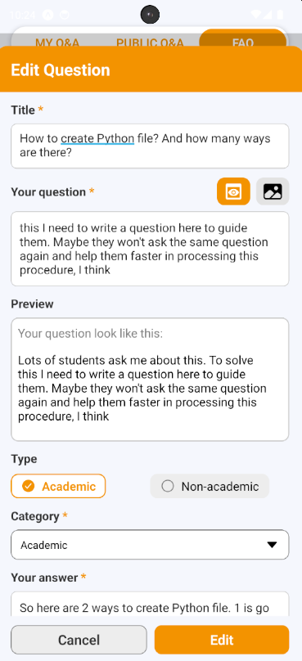

**Step 3:** View your question after editing.

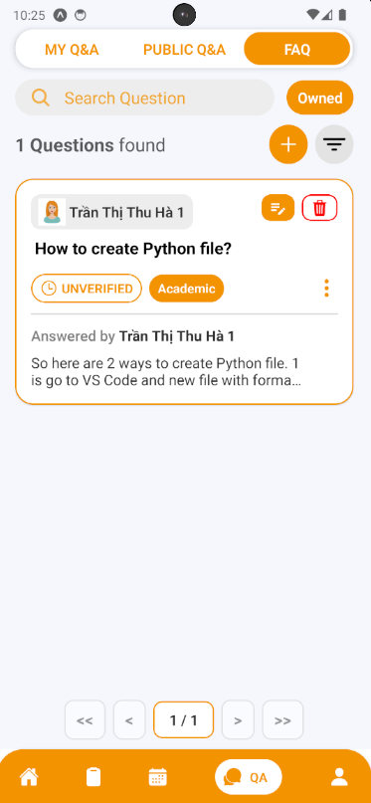

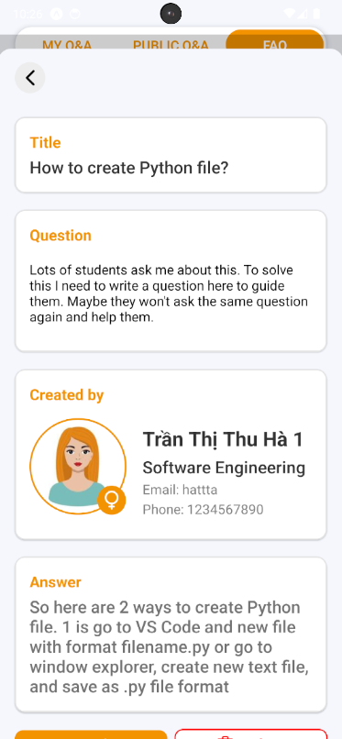

##### 3.3.3.10. Delete a contribution question

3.3.3.10.1. Description

Use this guideline to delete your contribution question

3.3.3.10.2. Guide Steps:

**Step 1:** Access SCSS at mobile application with counselor account**.** Navigate to My Q&A screen, then swipe to the right to navigate to FAQ Screen and press “Delete” (shown as an icon with the “trash” symbol) to open Delete Question section that lay on the question card, or inside the information of question card

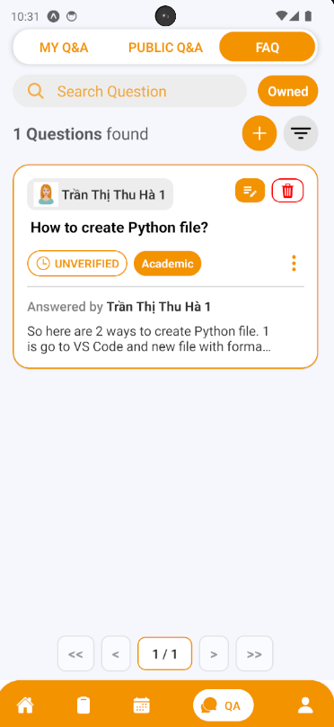

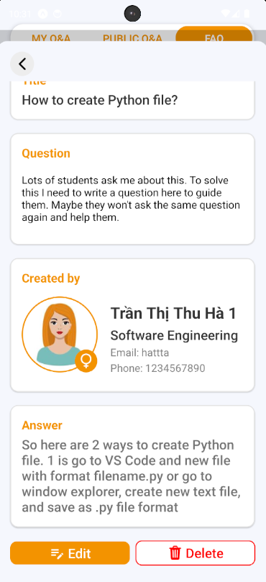

**Step 2:** After pressing, Delete Question Confirmation will open. If you want to delete your question press “Yes” Button to delete it, and “No” Button if not. After deleting successfully, that question will be disappear of FAQ screen

#### 3.3.4. Counseling Demands

##### 3.3.4.1. View Demands List

3.3.4.1.1. Description

Use this guideline to view demands list that assigned to specific counselor

3.3.4.1.2. Guide Steps:

**Step 1:** Access SCSS at mobile application**.** Then fill in “Email” and “Password” of the counselor account



**Step 2:** Press “Login” Button



Option 1: Choose Tab number 5 (personal icon) at the bottom of the screen to navigate to Personal Screen and from that screen will navigate to Counseling Demands Screen

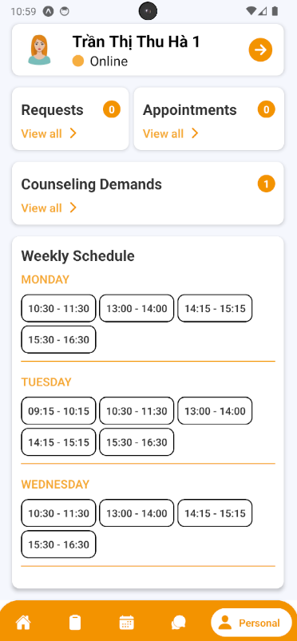

Option 2: For quick navigation, press View all at Assigned to navigate to Counseling Demands Screen

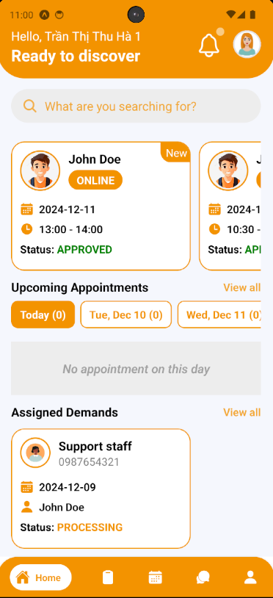

**Step 4:** In Counseling Demands Screen, find a demand using filter section by status

e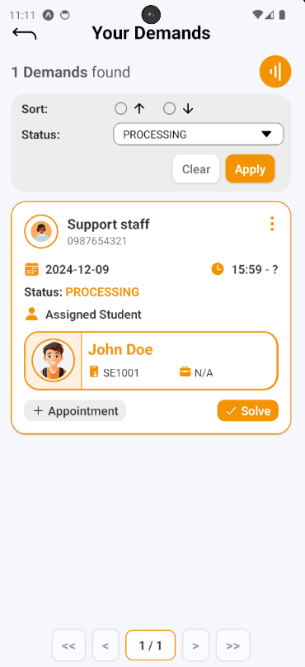

##### 3.3.4.2. Create Appointment through Demand

3.3.4.2.1. Description

Use this guideline to create appointment through demand

3.3.4.2.2. Guide Steps:

**Step 1:** After finding demand, press “Create Appointment” Button on demand card to open Create Appointment section.



**Step 2:** Filling all required fields including date, time, meeting method, Meet Url/Address, Purpose and Student information (assigned through demand). After filling done, press “Create Appointment” Button to create appointment.

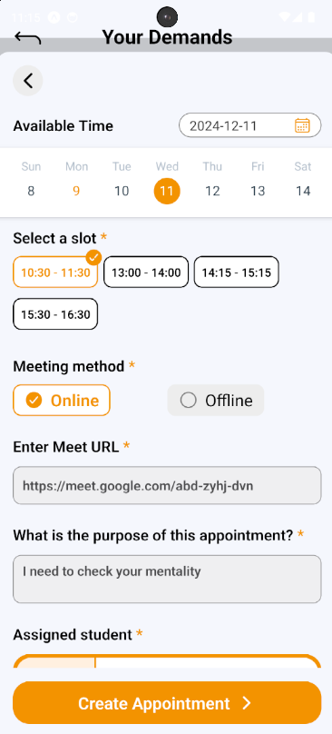

**Step 3:** View new appointment created in Appointment Screen

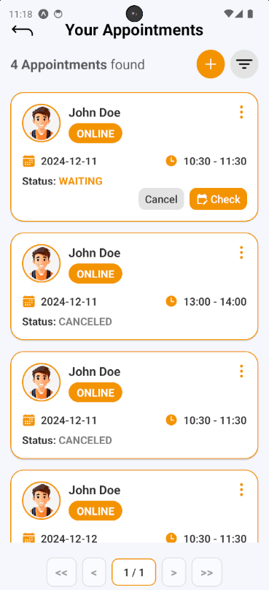

##### 3.3.4.3. Solve Demand

3.3.4.3.1. Description

Use this guideline to solve demand

3.3.4.3.2. Guide Steps:

**Step 1:** After finding demand, press “Solve” Button on demand card to open Solve Demand section.

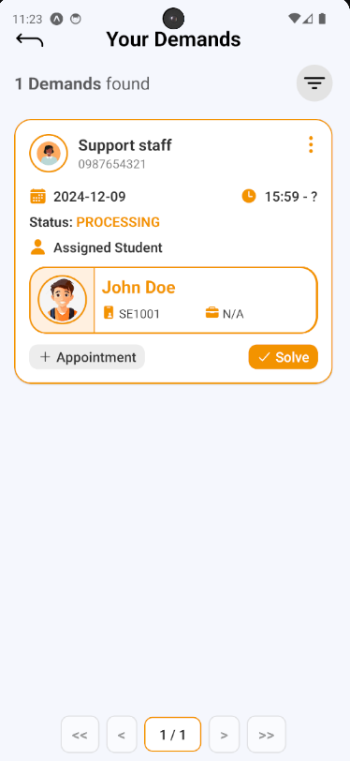

**Step 2:** After pressing, a Solve Demand Confirmation will open, fill your note, then press “Yes” Button to solve this demand, and “No” Button to cancel solve

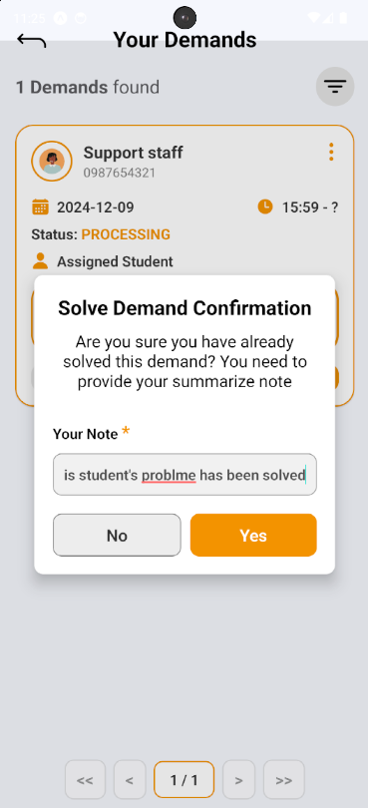

**Step 3:** The solved demand will be marked with “DONE” status



 